TASEP

# Exercise 1: TASEP (8 points) As shown in the lecture, the TASEP with parallel update corresponds to rule 184. Here we consider the TASEP with N = 50 sites and periodic boundary conditions.

**A)The main loops of the code:**

def TASEP(self):

#apply the rule of TASEP and get the whole configuration

next_row = np.zeros(self.n_sites,dtype = int)

for row_i in range(self.Nt):

for i in range(self.n_sites):

next_row [i]= self.Rule()[7-(self.confi[row_i,(i-1+self.n_sites)%self.n_sites]*4+self.confi[row_i,i]*2+self.confi[row_i,(i+1+n_sites)%self.n_sites]*1)]

# apply the rule 184 with the periodic boundary condition

self.confi = np.append(self.confi,[next_row],axis=0)

if self.confi[row_i,-1]==1 and self.confi[row_i,0]==0:

self.num_N_1 +=1

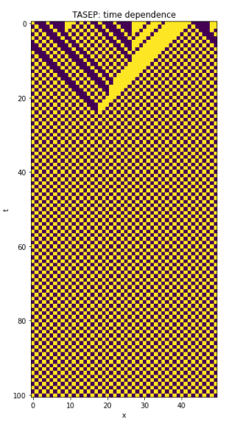

Choose M=25, N=50 ,Nt =100, we can get the figure above. The average flow for Nt=100 time steps is about 0.49

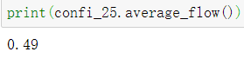

B) **The main loops of the code:**

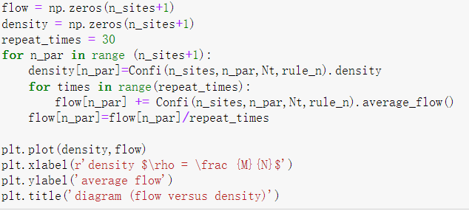

To improve the quality of data, we choose repeat time as 30, and start the particle number from 0 to 50, and get the corresponding average flow of 30 times.

