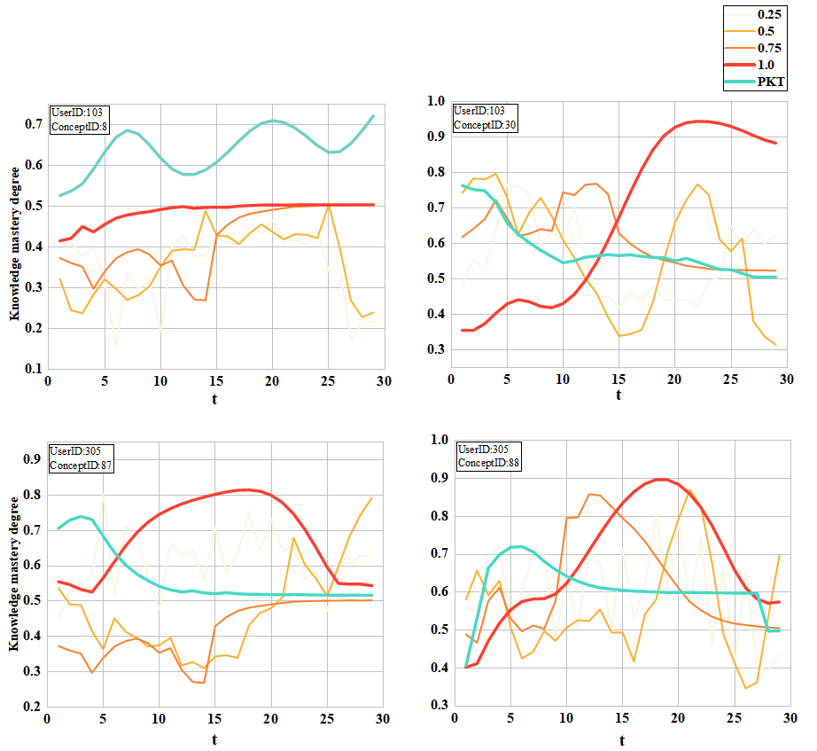

Figure R1: The advantage of sequence information in explaining the consistency between students’ knowledge states and learning processes. Here, the horizontal axis represents the order in which target concepts are answered, and the vertical axis represents the mastery level of concepts by users obtained by SPKT under a specific perturbation ratio.

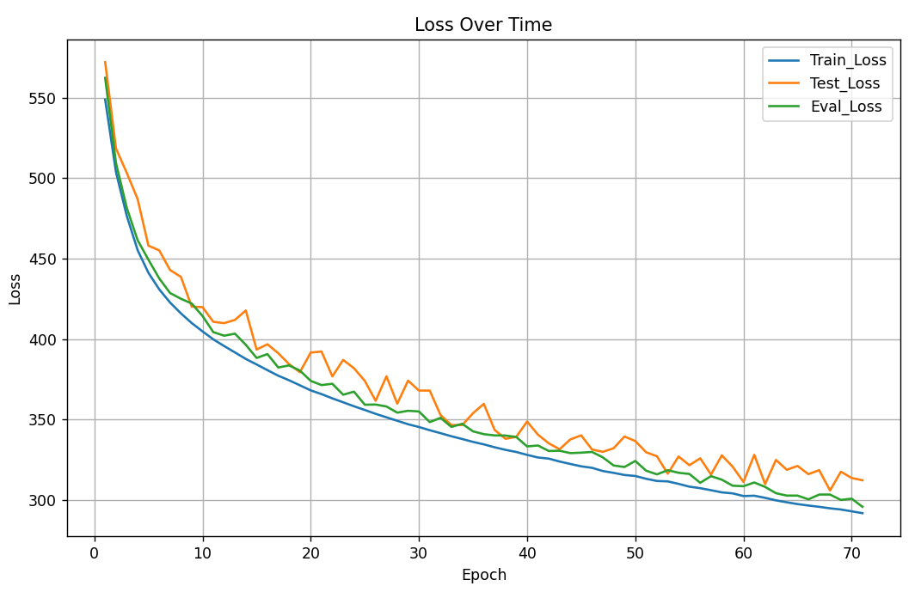

Figure R2: Changes of Train_Loss, Test_Loss, Eval_Loss with the increase of epochs

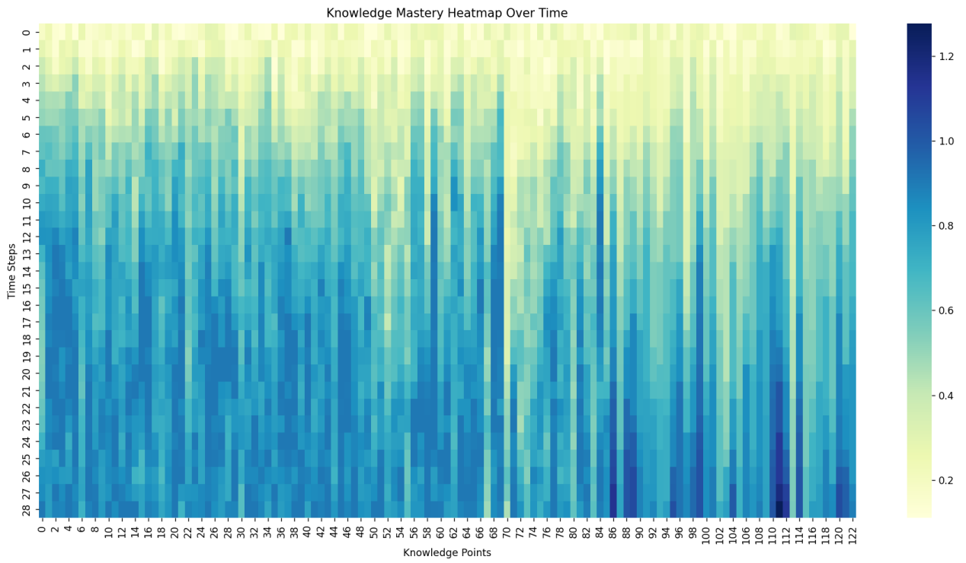

Figure R3: Knowledge Mastery Heatmap Over Time

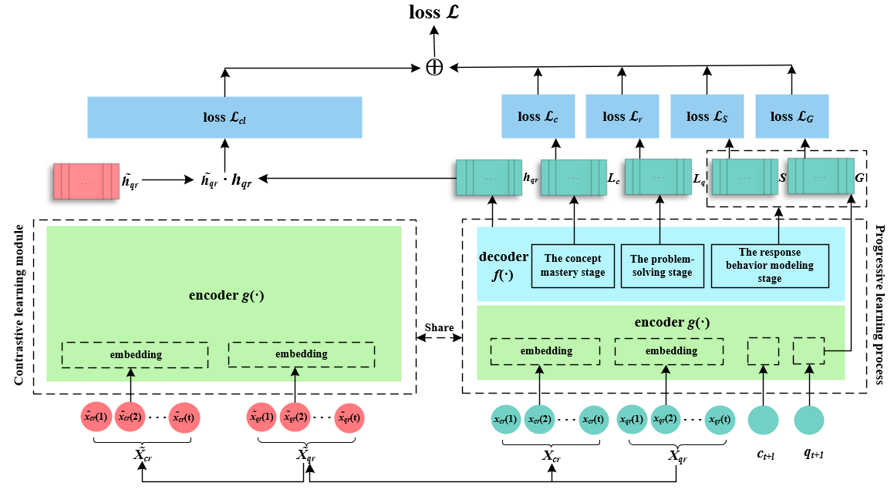

Figure R4: The SPKT Framework.