**REPORT LAB 2:**

**Online Wesite Learning (LearnX)**

**Lab 1_Group 3**

1. **Context diagram:**

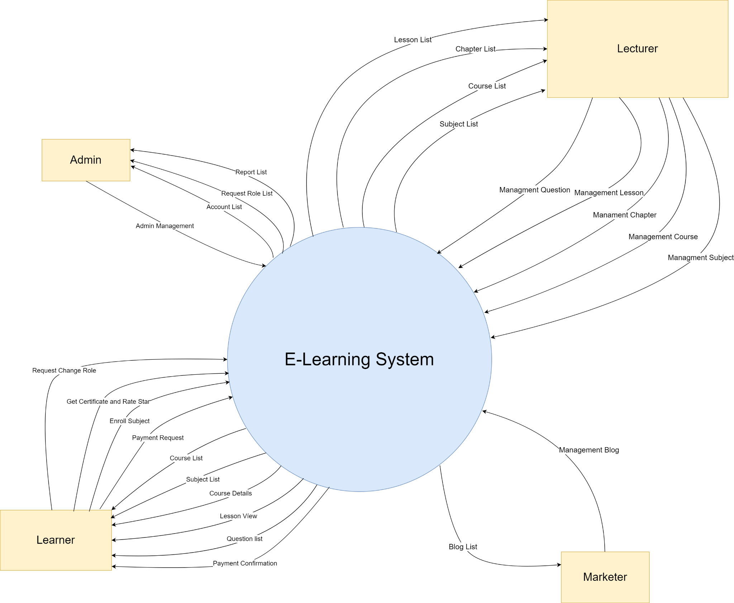

1. **Feature tree (fishbone):**

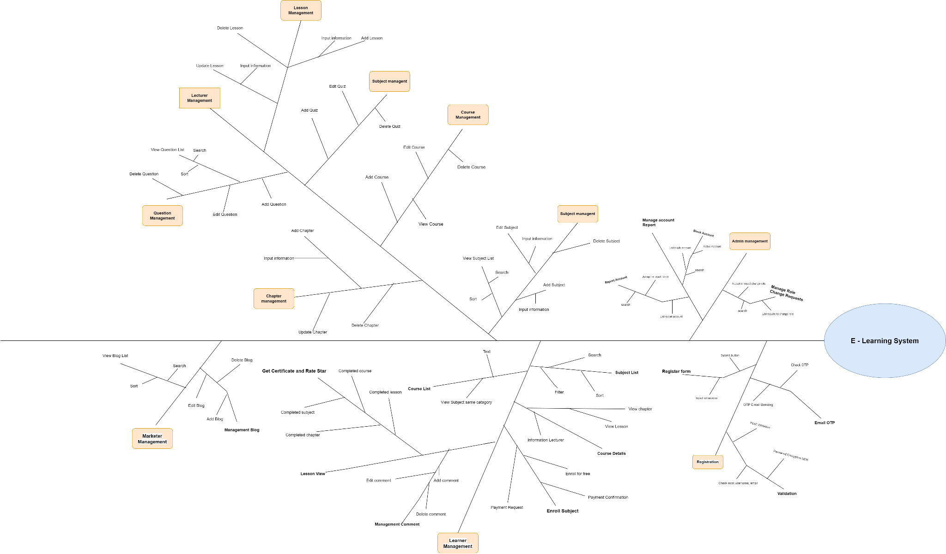

1. **Activity Diagram:**
2. **Registration:**

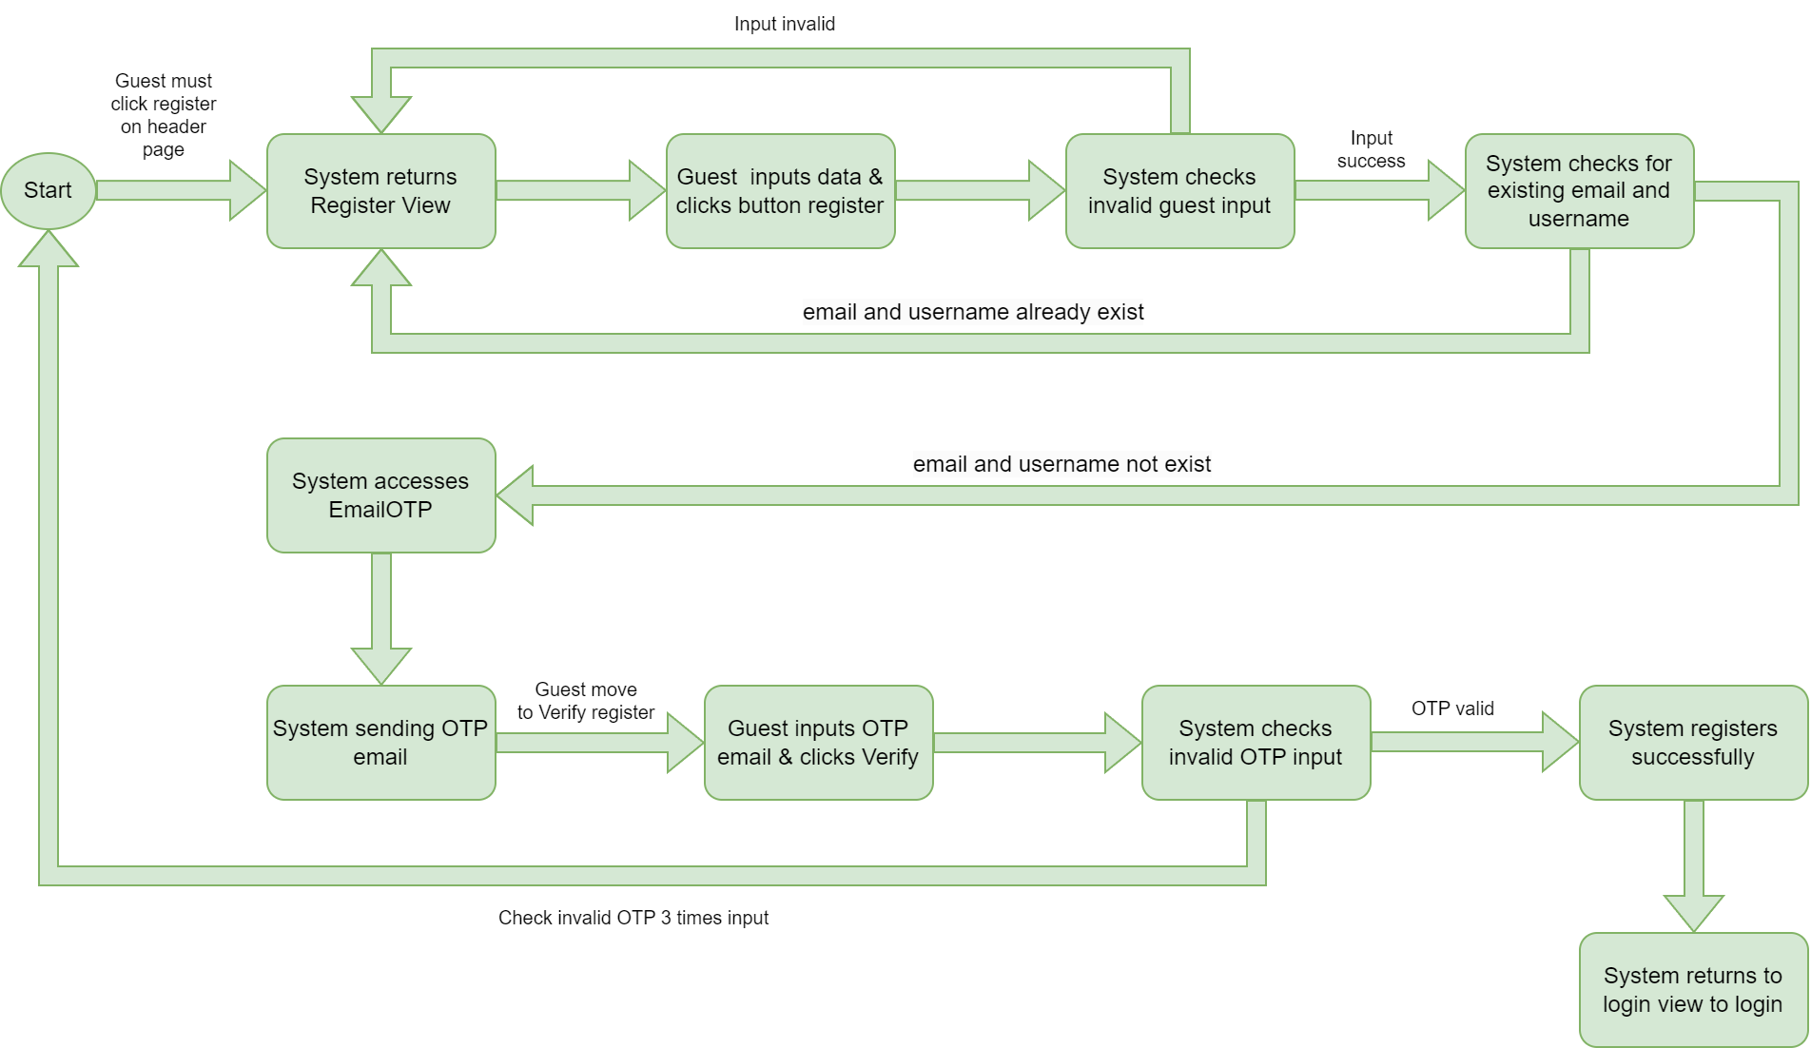

1. **Add Subject**

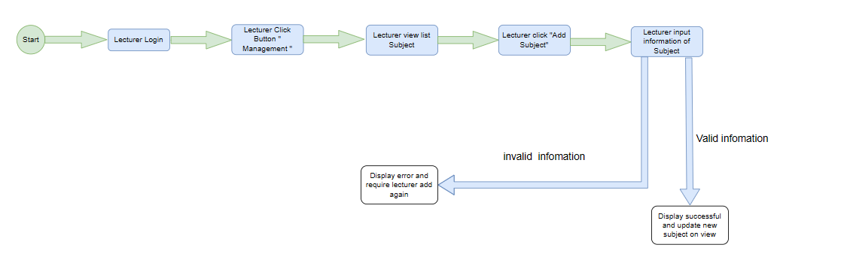

1. **Found courses**

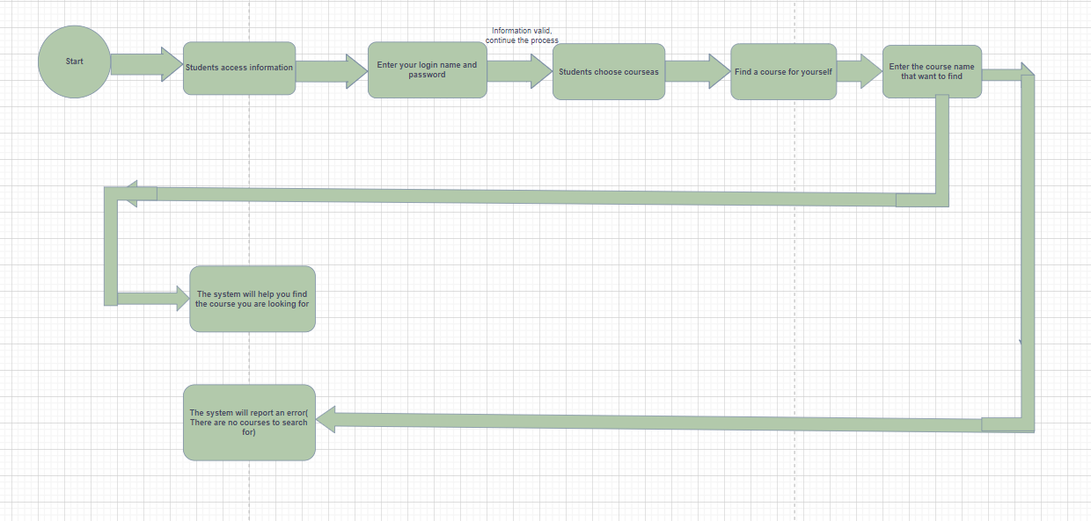

1. **Lesson View**

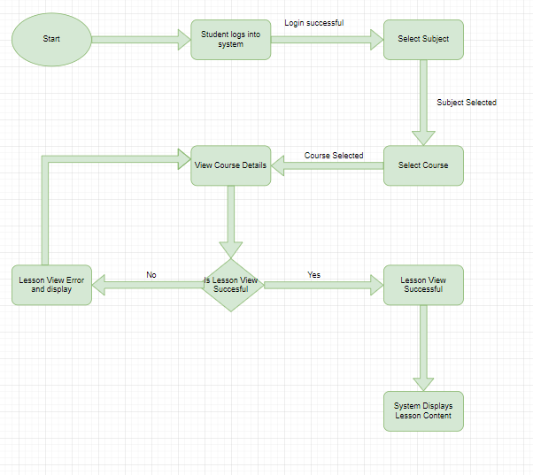

**4. Class diagram**

1. **Registration**

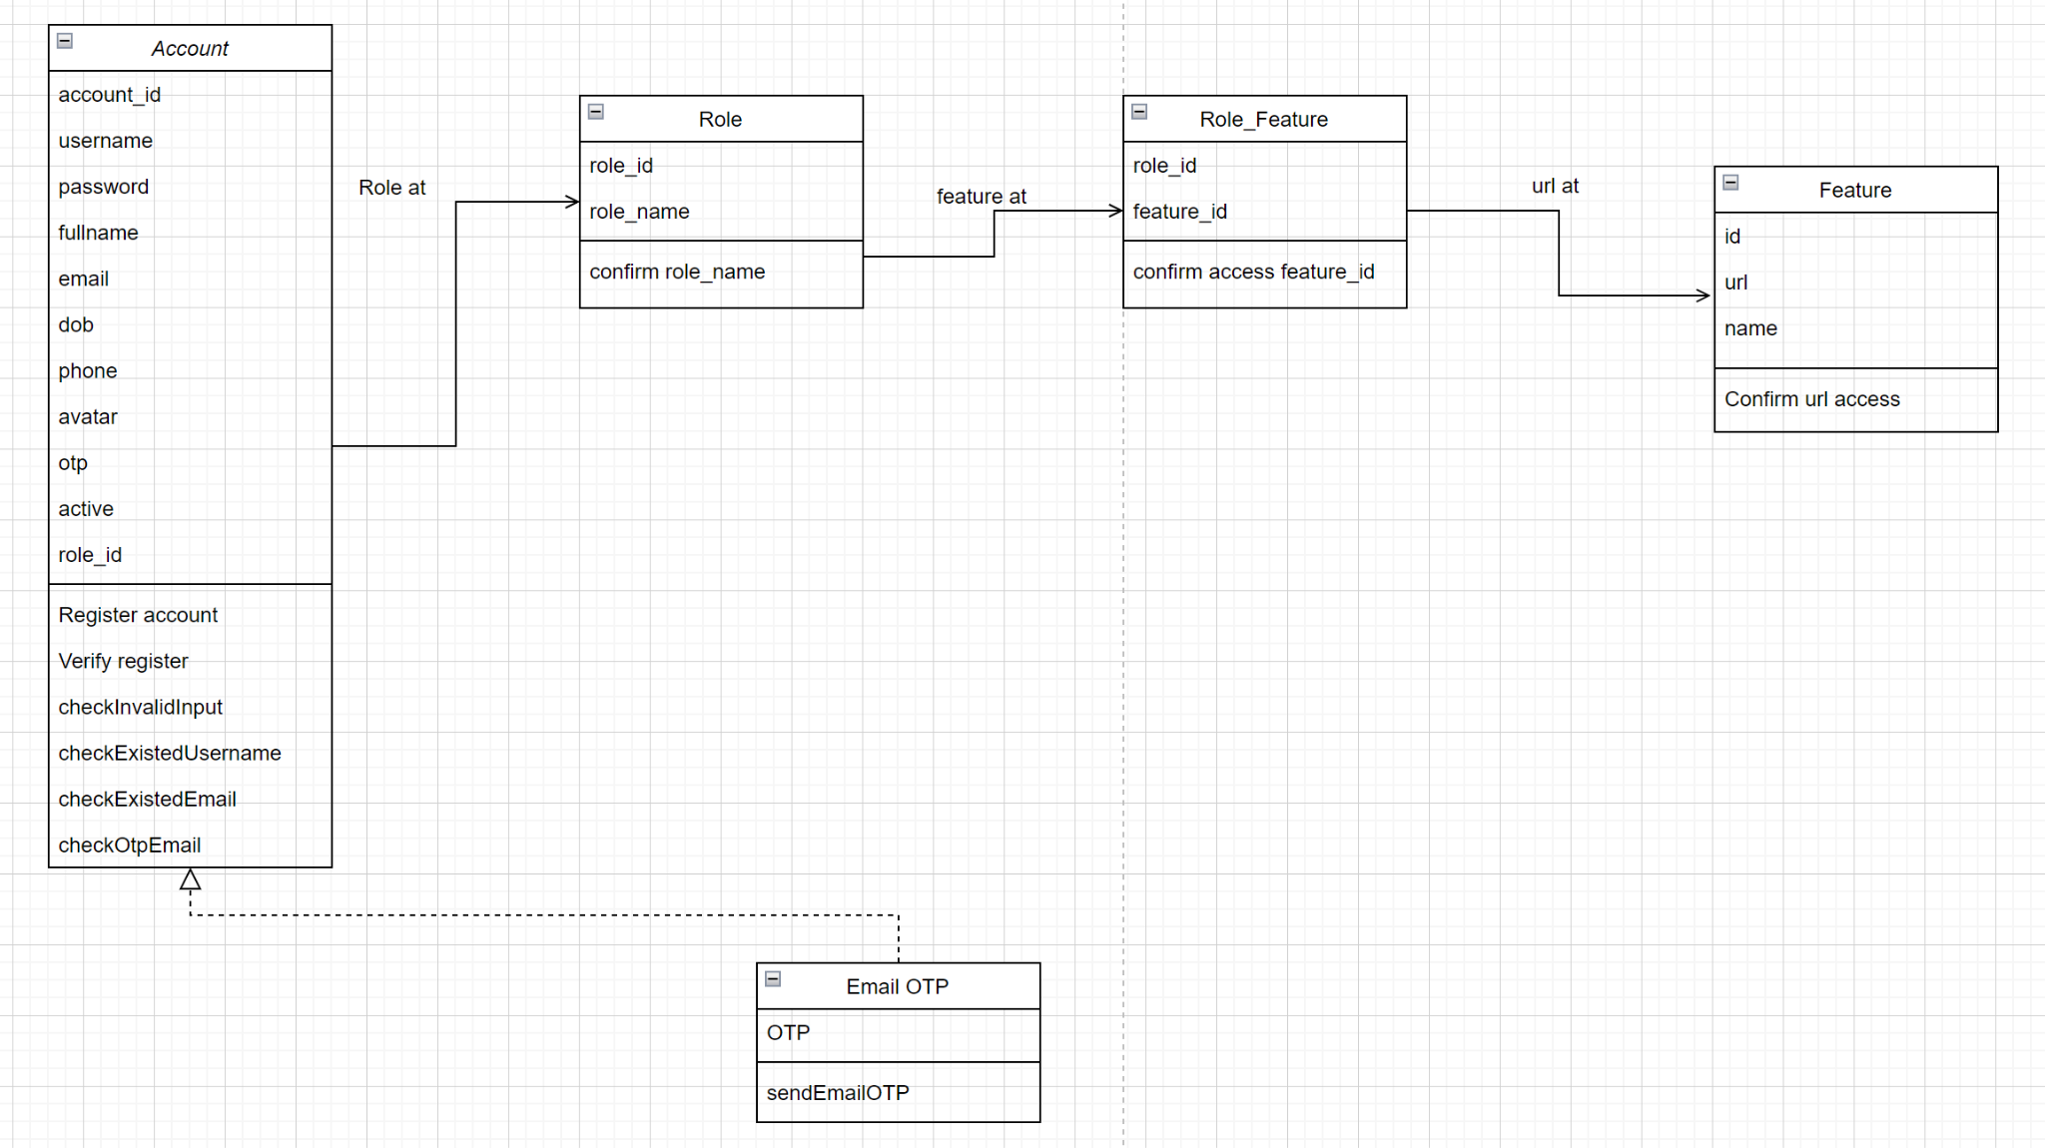

1. **Payment:**

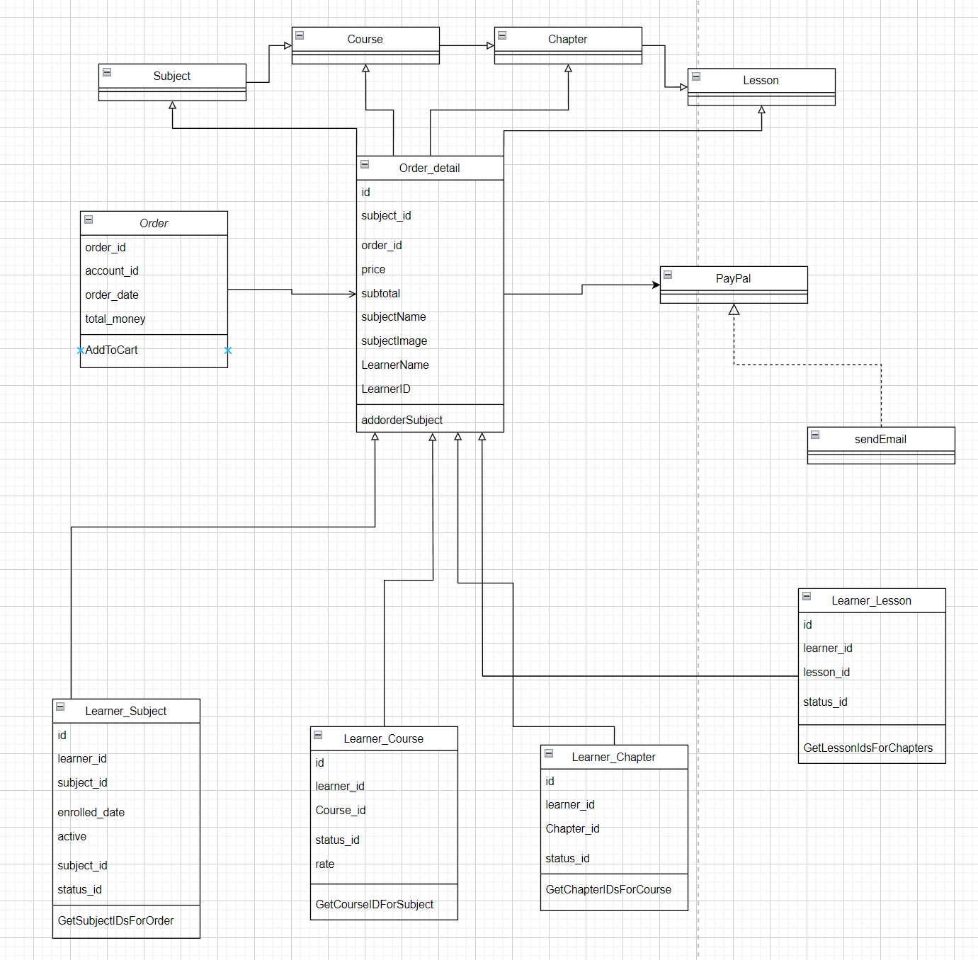

1. **Management Course**

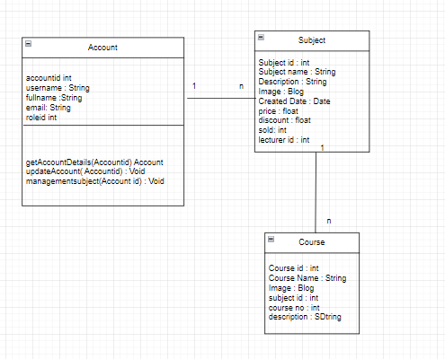

1. **Course Details**

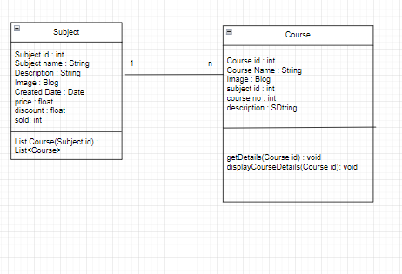

1. **Subject**

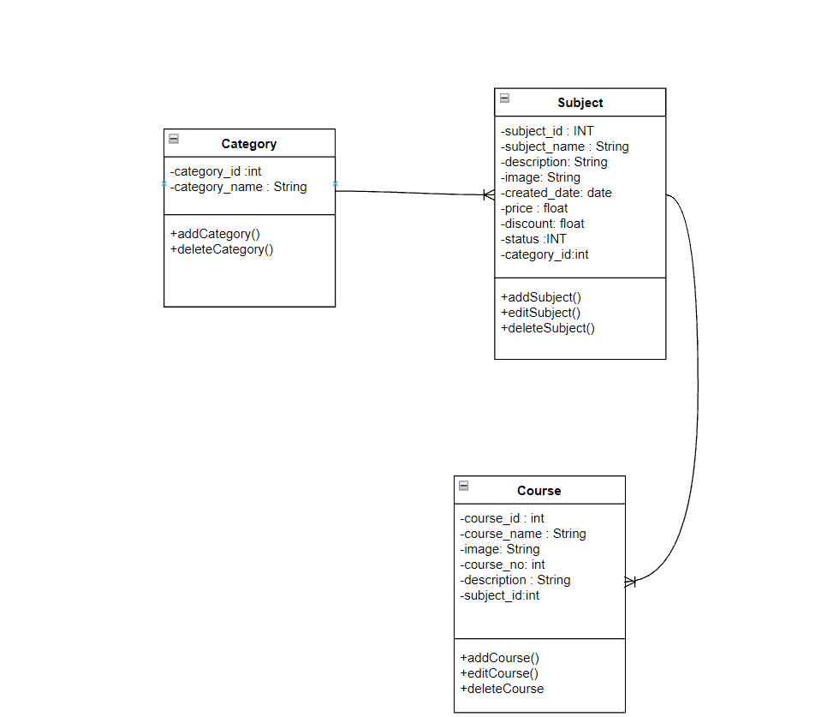

1. **Quiz**

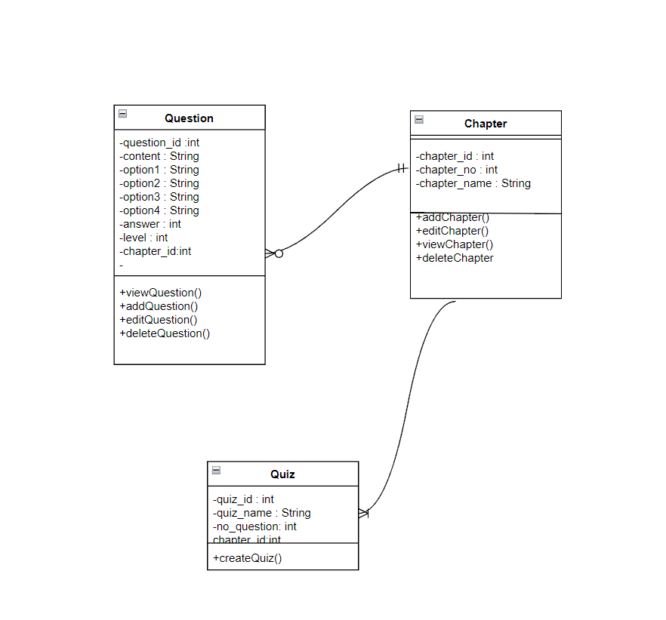

**g,Manage blogs**

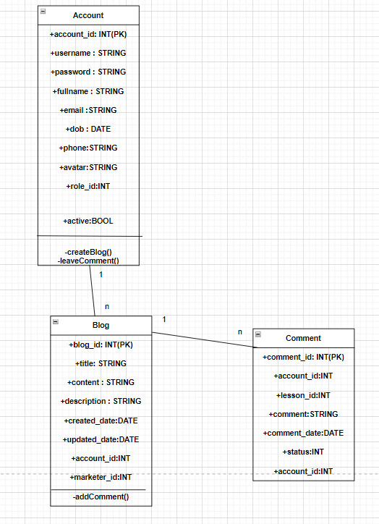

**h,lesson management**

