VW VR6 later than Aug 1995 with coil packs

www.ExtraEFI.co.uk
VW ECU Pin No |  | Device Attached | MS ECU Pin no. | www.ExtraEFI.co.uk loom
 |  |  | db15Pin Plug! | Spark Wiring Loom
8 |  | Spark A | db15 pin 1+2 | Grey (Spark Loom) A
60 |  | Spark C | db15 pin 5+6 | White (Spark Loom) C
52 |  | Spark B | db15 pin 3+4 | Blue (Spark Loom) B
 |  |  | db37Pin Plug! | Main Wiring Loom
42 |  | Lambda pin 3
20 |  | Lambda pin 4 | 23 | Pink
2 |  | Injector 6 | 33, 32 | White
3 |  | Injector 2 | 33,32 | White
4 |  | Injector 4 | 33,32 | White
24 |  | Injector 1 | 34,35 | Green
25 |  | Injector 5 | 34,35 | Green
26 |  | Injector 3 | 34,35 | Green
67 |  | Crank Sensor pin 1 | 24 | Red inside screened
68 |  | Crank Sensor pin 2 | 8 | Black inside screened
56 |  | Crank Sensor pin 3 | 8 | Braided of screened
36 |  | Inlet Air Temp Sensor pin 1 | 20 | Grey/Blue
33 |  | Inlet Air Temp Sensor pin 2 (GROUND) | 9 | Green/Yellow
14 |  | Coolant Temp Sensor pin 1 | 21 | Purple
33 |  | Coolant Temp Sensor pin 2 (GROUND) | 10 | Green/Yellow
41 |  | TPS +5V | 26 | Grey
33 |  | TPS Ground | 11 | Green/Yellow
40 |  | TPS Sig | 22 | Blue
23 |  | 12V Ignition Supply | 28 | Red (1.5mm)
22 |  | Tacho output | 3 | Orange (SPR1)
53 |  | Idle Control | 30 | Brown
6 |  | Fuel Pump Relay | 37 | Black
28 |  | Lambda Heater Relay | 37 | Black
27 |  | LINK to VW ECU pin 23 | See description | See description
1,7,58,55,57 |  | Grounds | 12,13,14,15,16 | Black (4mm)

Note:
- Use a relay to switch VW ECU pin 9 to ground when the ignition is turned ON. This controls the power to the MS ECU, fuel injectors, etc. Ensure the 12V that switches the relay does NOT turn off during cranking like the radio feed does, it MUST BE ON ALL THE TIME THE IGNTION IS ON!!!!

- Connect pin 23 of VW ECU to pin 27 of VW ECU via a 3A in-line fuse to feed the idle valve.

- The VW ECU must have been gutted and only the plug is used so its an interface between the VW main loom and the MegaSquirt ECU.

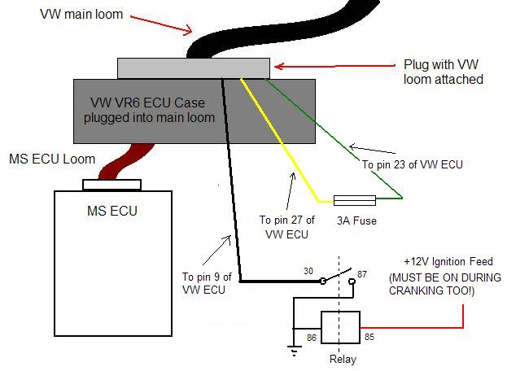

Please Note: All this is for information only and needs checking with your wiring manual and your vehicle. No warranty expressed or implied!
Use at your own risk!

www.ExtraEFI.co.uk

