实验三 软件详细设计
- 实验目的
学会运用几种常用的软件详细设计工具，如程序流程图、盒图、PAD图和判定表，将给定的软件问题描述转化为过程设计结果，同时进行环路复杂度计算，判断结构化设计结果的复杂性。
第一题
- 算法流程图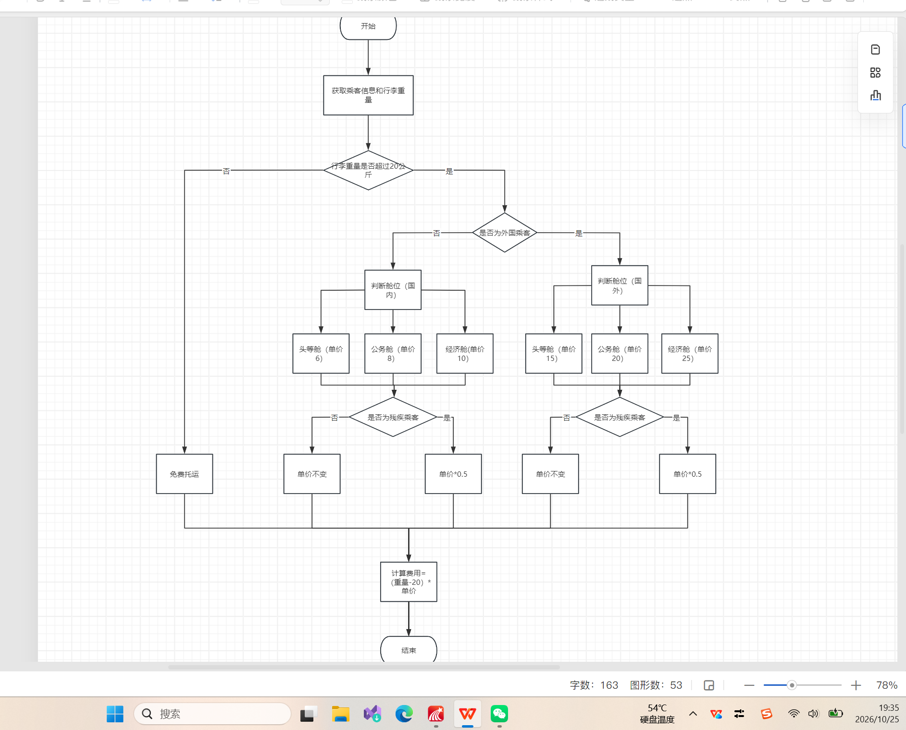
- 判定表如附件
- double calculateLuggageFee(double luggageWeight, int cabinType, boolean isForeign, boolean isDisabled) {
- final double FREE_LIMIT = 20.0;
- if (luggageWeight <= FREE_LIMIT) {
- return 0.0;
- }
- double overWeight = luggageWeight - FREE_LIMIT;
- double basePrice;

- switch(cabinType) {
- case 0: basePrice = 6.0; break;
- case 1: basePrice = 8.0; break;
- case 2: basePrice = 10.0; break;
- default: return -1;
- }
- if (isForeign) {
- basePrice = basePrice * 1.5;
- }
- if (isDisabled) {
- basePrice = basePrice * 0.5;
- }

- double totalFee = overWeight * basePrice;
- return totalFee;
- }
- 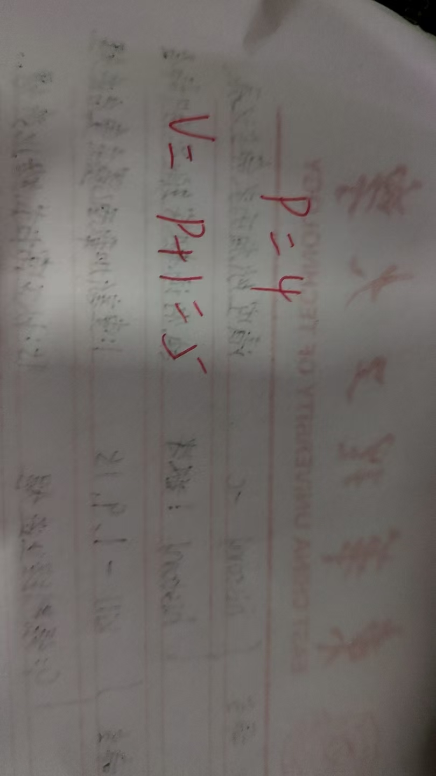
第二题
磁盘调度算法sstf部分
1流程图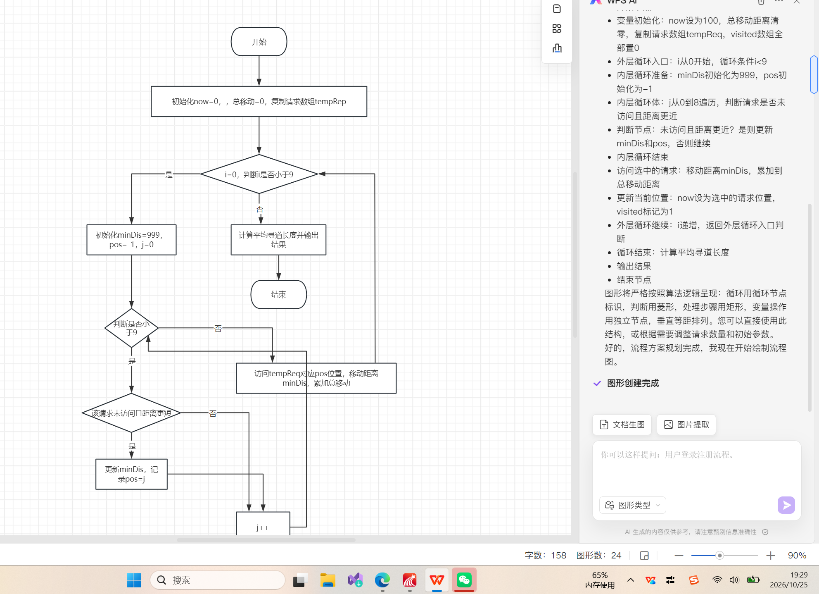
2判定表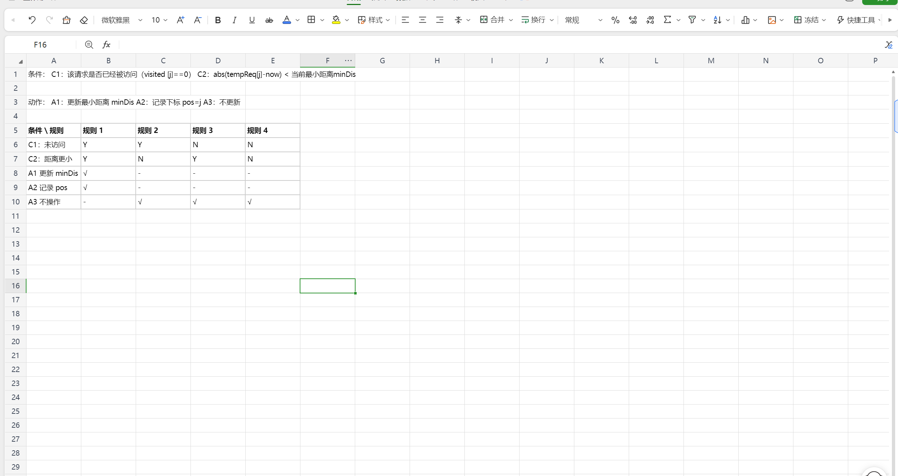
3伪码部分
输入：请求队列 request[]，当前磁头位置 cur
输出：访问序列
while request 不为空
min_dist = ∞
select_idx = -1
for i from 0 to len(request)-1
dist = abs(request[i] - cur)
if dist < min_dist
min_dist = dist
select_idx = i
访问 request[select_idx]
cur = request[select_idx]
删除 request[select_idx]
end while
4复杂度计算
