流程图
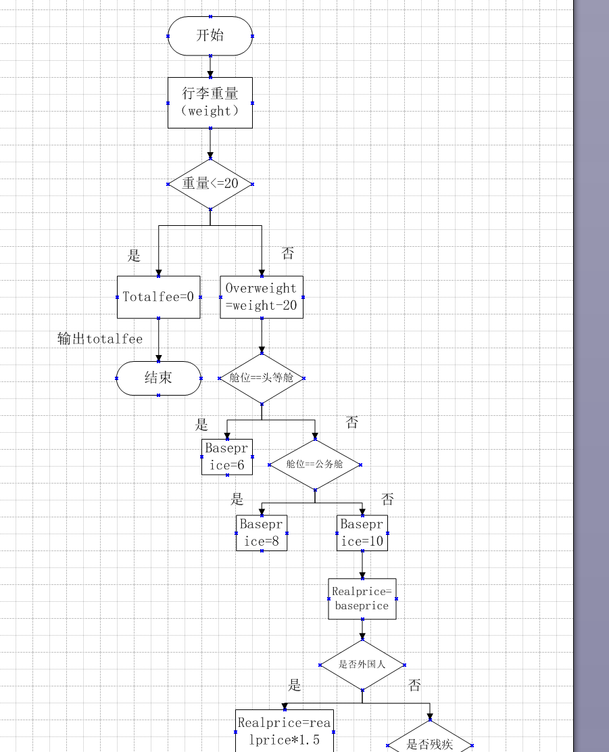

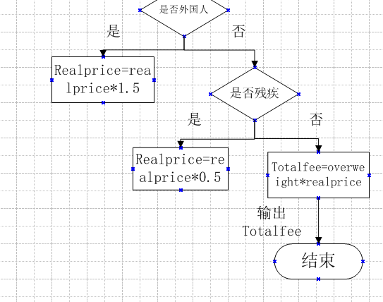
伪代码
double calcBaggageFee(double weight, String cabin, boolean isForeign, boolean isDisabled){
double totalFee = 0;
double basePrice = 0;
double overWeight;
double realPrice;

if(weight <= 20){
totalFee = 0;
}else{
overWeight = weight - 20;
if(cabin.equals("头等舱")){
basePrice = 6;
}else if(cabin.equals("公务舱")){
basePrice = 8;
}else if(cabin.equals("经济舱")){
basePrice = 10;
}
realPrice = basePrice;
if(isForeign){
realPrice = realPrice * 1.5;
}
if(isDisabled){
realPrice = realPrice * 0.5;
}
totalFee = overWeight * realPrice;
}
return totalFee;
}

判定表
条件 / 动作 | 1 | 2 | 3 | 4 | 5 | 6 | 7 | 8 | 9 | 10 | 11 | 12
C1 重量≤20 | Y | N | N | N | N | N | N | N | N | N | N | N
C2 头等舱 | - | Y | Y | Y | Y | N | N | N | N | N | N | N
C3 公务舱 | - | N | N | N | N | Y | Y | Y | Y | N | N | N
C4 经济舱 | - | N | N | N | N | N | N | N | N | Y | Y | Y
C5 外国乘客 | - | N | Y | N | Y | N | Y | N | Y | N | Y | N
C6 残疾乘客 | - | N | N | Y | Y | N | N | Y | Y | N | N | Y
A1 运费 = 0 | √
A2 基础单价 6 |  | √ | √ | √ | √
A3 基础单价 8 |  |  |  |  |  | √ | √ | √ | √
A4 基础单价 10 |  |  |  |  |  |  |  |  |  | √ | √ | √
A5 ×1.5 外籍 |  |  | √ |  |  |  | √ |  |  |  | √
A6 ×0.5 残疾 |  |  |  | √ |  |  |  | √ |  |  |  | √
A7 ×1.5×0.5 |  |  |  |  | √ |  |  |  | √
A8 总费用 = 超重 × 单价 |  | √ | √ | √ | √ | √ | √ | √ | √ | √ | √ | √

环形复杂度
运用公式V(G)=E-N+2（E 为边数，N 为节点数），因为E=17，N=14，所以环形复杂度为5
流图
