

British Petroleum
WebPOPV User Guide

by Telaeris, Inc.

Revised 9/15/2009

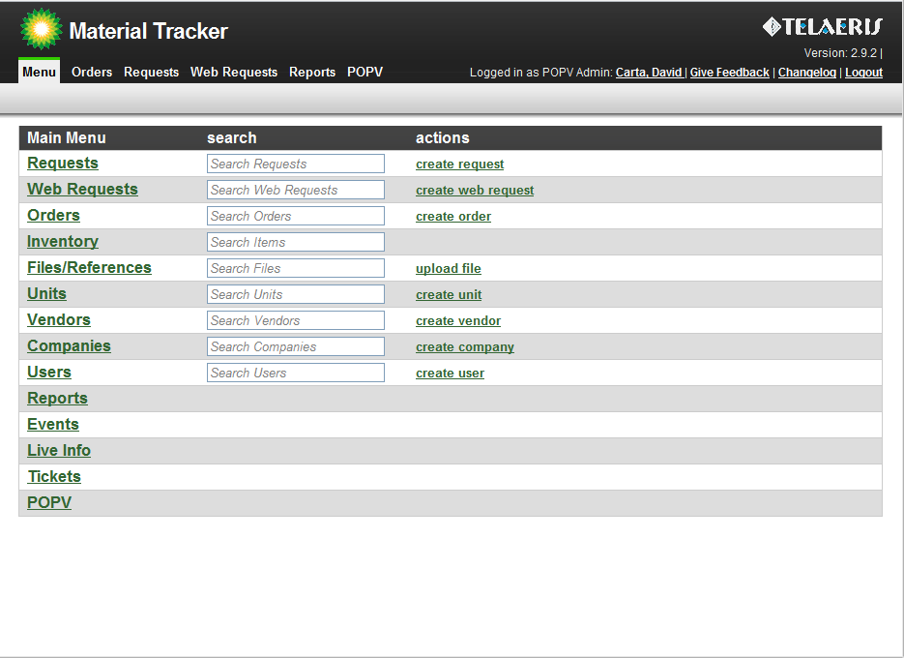
Basic Features
The standard Material Tracker navigation bar is available at the top of the page. Clicking on these links will take you back to the Material Tracker site, and out of the POPV application. It is recommended to open a new browser window before starting the POPV Online Application. You are brought by default to the Revision History and Piping Classes tab in the GRID area. Once the page has loaded, you will notice we have three main areas:
- NAVIGATION menu on the left
- GRID area on the top right
- FORM area on the bottom right.
Navigation Bar:  This contains a list of all resources available within the POPV application. This will always be visible. Clicking on any of these items will open a new tab in the area to the right or focus on a tab that is already open.  Grid:  The grid area shows summaries of all the data for a section. Multiple tabs can be opened in this area. The grid area also contains a Pagination bar and a Search filter.  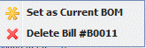  Right-clicking on a row in the grid can open a context menu showing useful options for that row.  Sorting: Grids can be sorted by clicking on the appropriate column.  Pagination: If many items are available in the grid, the pagination bar can be used to help find the appropriate record.  Search Filter: Enter a search term (such as a tracking # or employee name) and click the magnifying glass. The grid will be filled with data which matches your search. Clear the search by clicking the “X”.  Form:  Only Administrators can edit the main POPV information, but each user can create, edit and delete their own Bill of Materials records. The Form area can also be used as an advanced search. | WebPOPV Overview  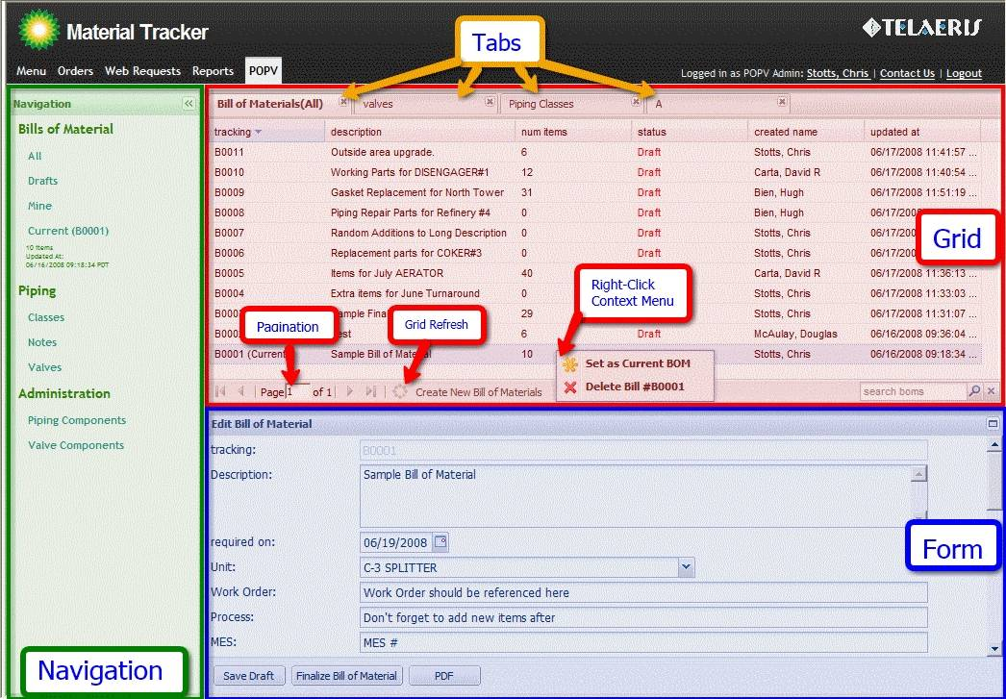
Bill of Materials
Bill of Materials Navigation:  There are 4 resource views available for Bills of Materials.  All: will show all bills of materials, including other users.  Drafts: Will show only your own Draft bill of materials  Mine: Will show all bill of materials created by you.  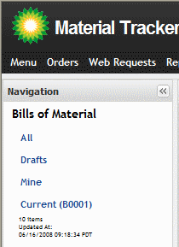  Current: Will highlight and maximize the form on your current bill. All users have a “Current” bill of materials. This is the bill they are actively editing, and adding items to. Any Components added from the Piping Classes will be added to your current bill of material. | Bills Line Items (Refer to Figures 2.1 and 2.2):  Editing: To edit a bill of materials line items, open the bill of material. At the bottom of the form, there will be a list with all of the line items available on that bill. Clicking the pencil icon on the right will bring up the Edit Bill Item window.  Directly Editing: Double clicking on the Qty, Description, Sizes, or Notes fields on the Bill of Material Items table will open up an editor where you can directly edit the bill.  Tab will add/change the value you’ve entered.  Once you’re done editing, “Save” and “Undo” icons will appear on the right.  Manually Adding: The window for adding items manually to a bill of materials can be opened by clicking the small “Plus” icon in the upper right corner of the Bill of Material Items  Piping Component Adding: Items may also be added from the piping components tab. See below for more info.
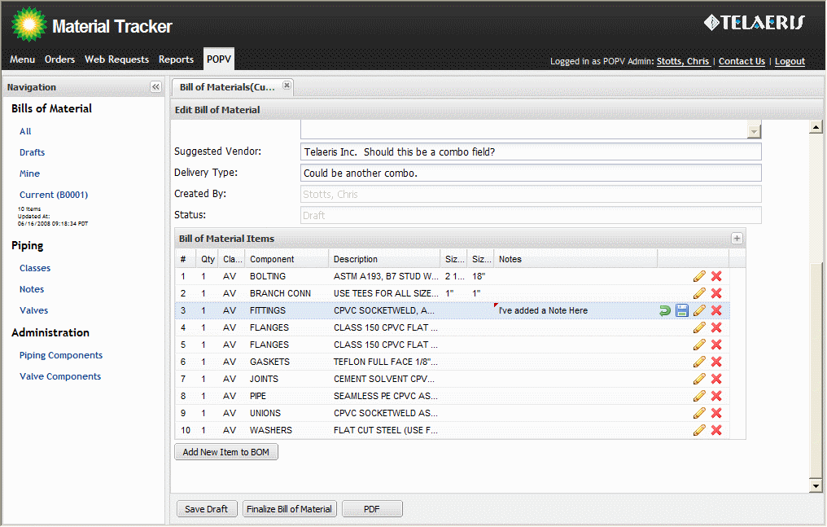  Figure 2.1 |  | Edit Bill Items Window  Editing a bill of materials, or its line items is only available to POPV Admins, or to the creator of the Bill of Materials. All bills can currently be viewed by anyone.  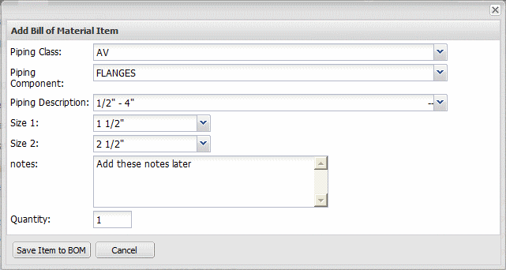  Figure 2.2
Piping Classes and Details
Piping Classes Tab  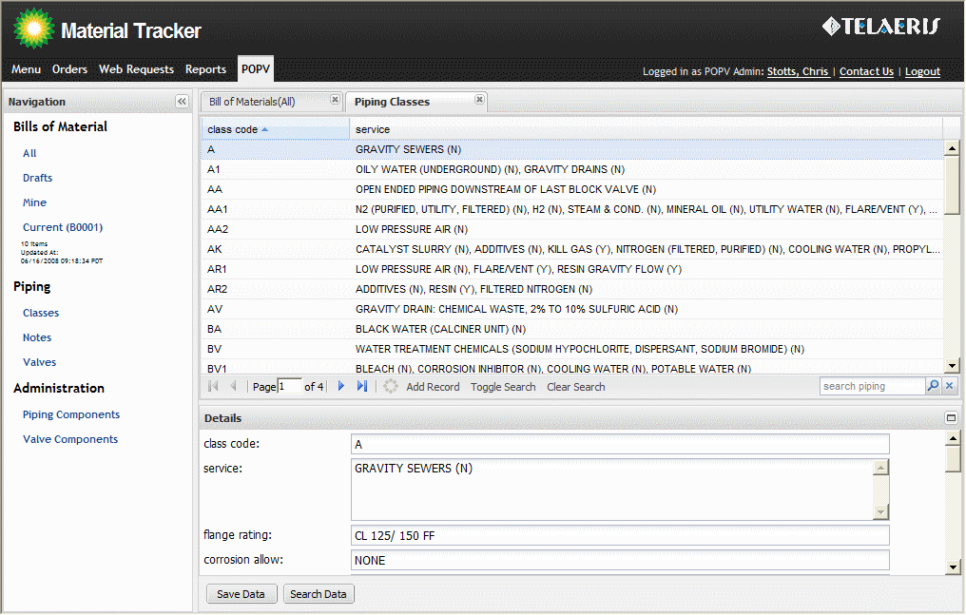 |  | Piping Classes  Overview:  The Piping Classes Resource has the ability to view and edit all details for each Piping Class.  This includes the special note, and maintenance note fields.  Piping Class Details:  To pull up the Piping Components for any given Piping Class, double click on the appropriate row in the grid.
Piping Class Details  Editing:  As with other resources, a POPV Admin can edit or change any of the values for the piping components.  Adding to Current BOM:  Select a single component or a group of components by dragging or CTRL/SHIFT clicking. Right Click on a selected item in the grid. This will bring up a context menu: “Add Selected Components to BOM”. Clicking this item will add all selected Piping Components to the user's current Bill of Materials. | Piping Class Detail Tab  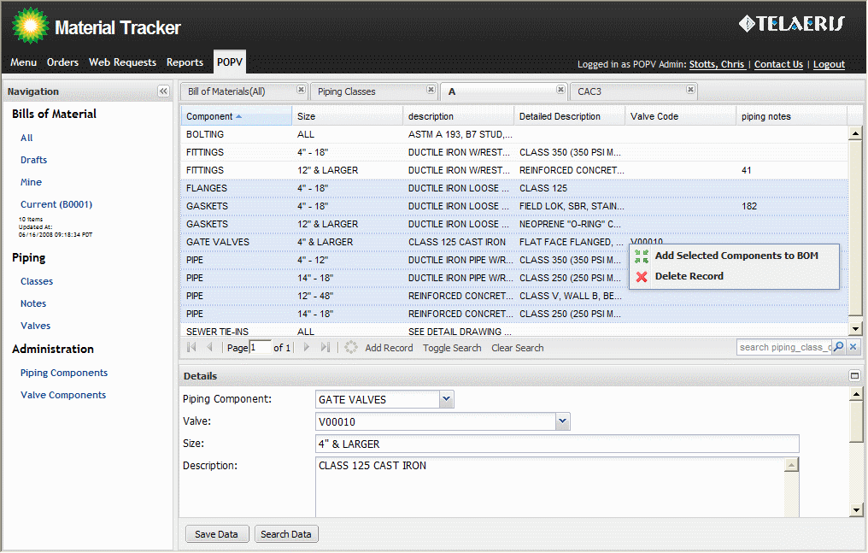

Tickets: Bug Reporting and Feature Requests

Listing Tickets  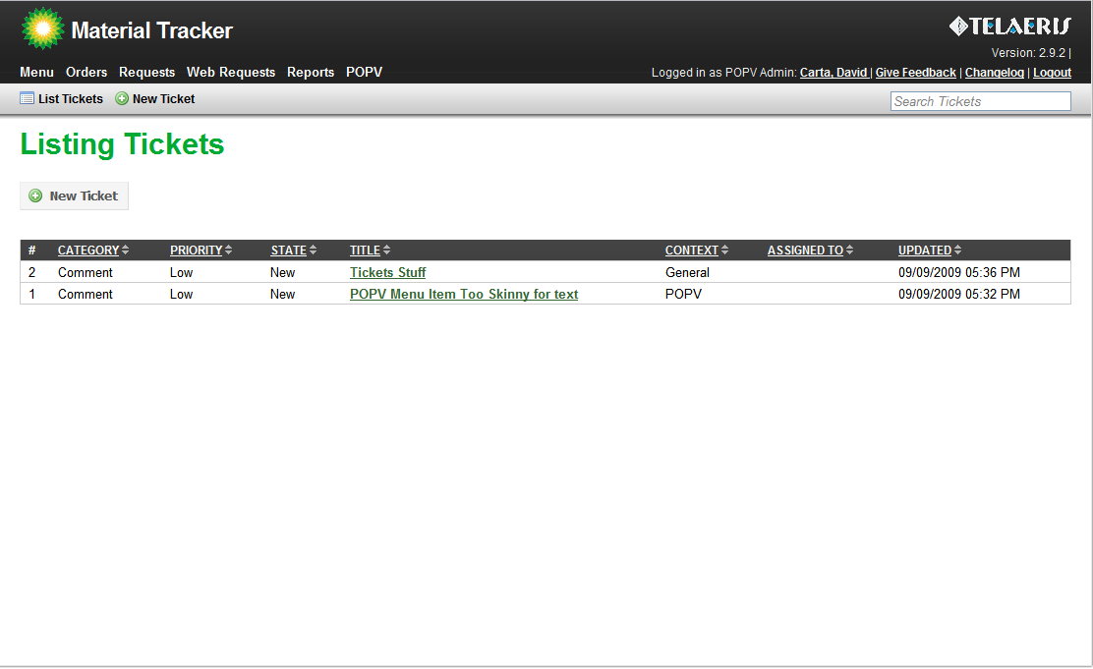 |  | Listing Tickets  Overview:  Tickets can be viewed by clicking on the Menu link in the top-left section of the page and then clicking on Tickets.
Creating a New Ticket  Creating:  Any user can create a ticket to report bugs, suggest features, or provide feedback. To get the New Ticket page, simply click on the “Give Feedback” link in the upper right of the window. | Creating a new Ticket  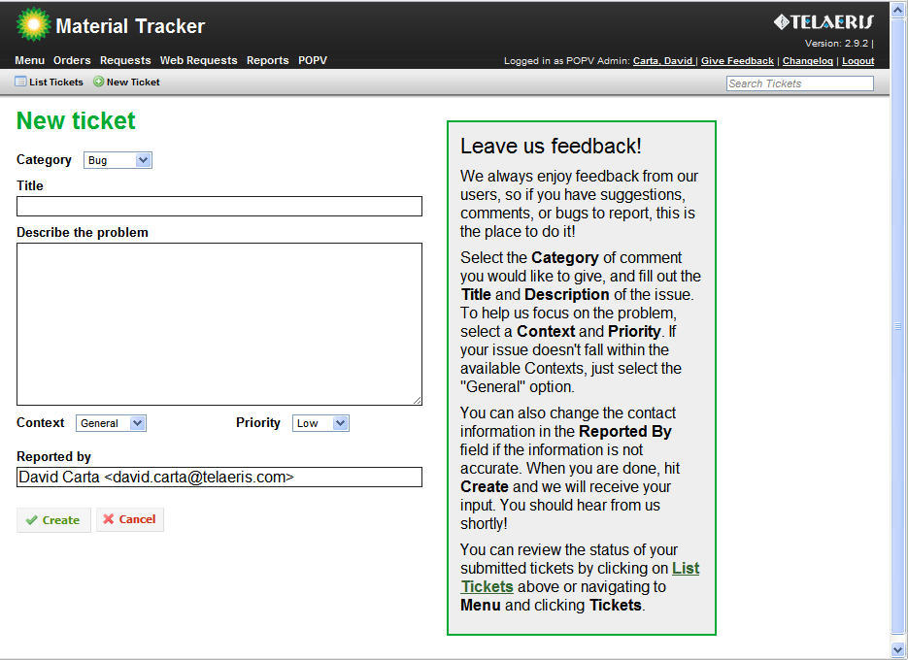
Using WebPOPV
List of WebPOPV Reports

There are several Reports available for the different resources in WebPOPV:
(Locations of the Report Buttons are in parentheses)

Bill of Materials:
- RFQ (form): Prints out a “Request For Quote” PDF of the selected Bill.
- CSV (form): Generates a CSV of each Line Item in the Bill.
- PDF (form): Prints out the full information for the Bill in PDF format.
- Excel (form): Downloads a Microsoft Excel compatible form with the Bill info and all Line Items that can be modified and printed.

Piping Classes:
- All Piping Classes PDF (grid): Generates a report of all the Piping Classes, including the Notes, Comments, and each Class Detail.
- Class Details PDF (form): Selecting a Piping Class from the grid and then pressing this report button will give a report on that Class' Details. It is essentially the same report that goes into the All Piping Classes PDF, only it is for one class.
- Class Valves PDF (form): Once a Piping Class has been selected, this button will generate a report with all the Valve Sheets that are tied to this Class.

Piping Class Details:
- View Valve Sheet PDF (form): Select a Detail in the grid above and then use this button to generate a report that will give you the Valve Sheet for the Detail's Valve, if there is one.

Revision History:
- CSV (form): Generates a CSV (a spreadsheet with comma-seperated values) of the entire Revision History log.

Valves:
- All Valves PDF (grid): Generates a report with all the Valve Sheets combined.
- View Valve Sheet PDF (form): You can access the Valve Sheets through this button.

For the reports that are PDFs, clicking on a Report Button does something extra. A window will pop up, allowing the user to download the PDF, or if desired, they can click on the “Email PDF” tab to send the PDF as an email attachment to anyone they choose.
Valves
Listing Valves  To get to the Valves resource, click the “Valves” link in the Navigation menu. Once opened, you can view all the valves and their details by clicking on them. To group the Valves by Type, Body, or Rating, click th e “Toggle Grouping” button at the top. You can change the column by which the records are grouped by click on the downward-arrow at the right-hand side of any column. In the menu that pops up, select “Group By This Field”. To ungroup, press the “Toggle Grouping” button once more. | 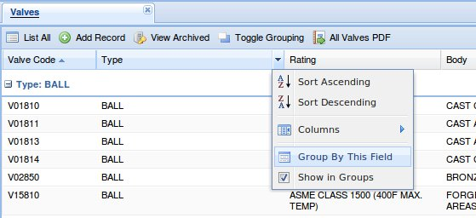
Viewing Valve Details  Clicking on a Valve row will show the valve specifics in the form below. Scrolling down in the form allows for viewing of the Valve's Components, associated manufacturers and figure no's, and the Piping Classes that this valve is present in. Only admins can modify any of these relationships. |  | 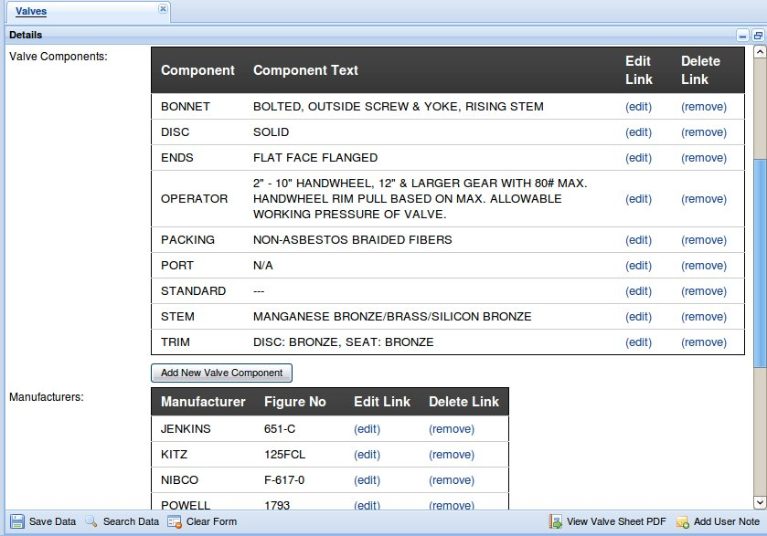

Revision History

Adding Comments  The Revision History records get automatically created whenever certain resources get created, updated or deleted. An administrator might want to add additional comments to the history records, either for adding additional information or clarifying changes. To do this, an Admin must click on the row they'd like to modify, and then edit whatever information they'd like. We recommend only changing the “Comment” field, but every field is editable. | 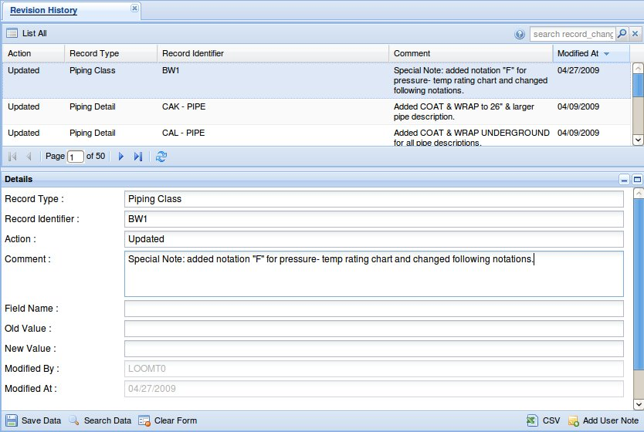

References
Add New References  References provide the ability to attach files and custom web links to certain resources. This allows Administrators to include branch charts and other specification documents along with specific valves and classes. To add references, find a resource that includes an “Add Reference” button at the bottom of the form. Upon clicking this button, a window opens that gives the options to attach a current Reference, or create a new one. To create a new Reference, click the “Create Reference” tab, and fill in the fields. Give your Reference a Description and provide it with either a custom URL (a normal web link, ex: “http://www.google.com”) or click “Browse” to find a file on your computer to upload. | 