- Download From Github
Download the program on Github as a .zip file.

- Installing JDK and NetBeans
This program should be run on NetBeans.
Be sure that you've downloaded the latest version of JDK and NetBeans.
- JDK
You must install JDK before you install NetBeans.

Step 1: Go to this website: Java Downloads | Oracle
Step 2: Download the appropriate installer based on your system.
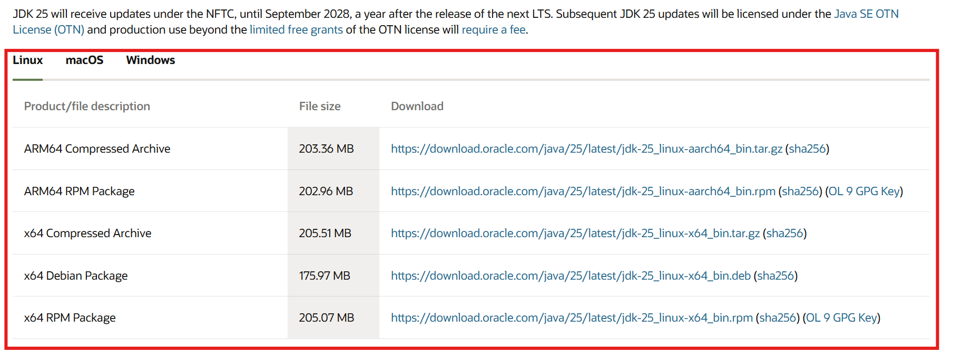
Step 3: Run the installer to install. (You can modify the directory for installation.)

- NetBeans
Step 1: Go to this website: Welcome to Apache NetBeans
Step 2: Download the appropriate installer based on your system.

- Import and Run the Program
Step 1: Run NetBeans.
Step 2: Go to File → Import Project → From ZIP
Step 3: Browse and select the downloaded .zip and hit “Import”.
Step 4: Hit this button (circled) to run.

Then you will see a GUI like this.
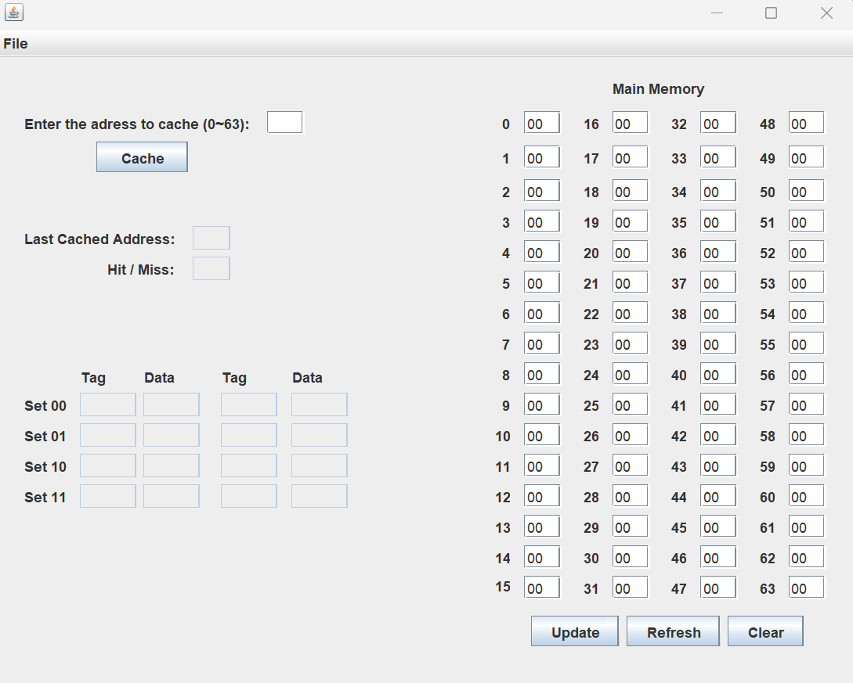
- Test the Program
- Open File
Step 1: Go to File → Open File
Step 2: Select a file to open. The file must be exactly 64 lines (no empty lines), and each line must have exactly 2 hex characters (0~9, A~F) without whitespace. The first line will be stored at address 0, and the second line at 1, and third line at 2, and so on. “example.txt” is a valid file to output.

- Modify Memory Data
You can modify the memory data by type in a value. Hit “Update” to accept modification or hit “Refresh” to discard. You can also hit “Clear” to reset all memory data to “00”.

- Cache Data
Enter the address of the data that you want to cache and hit the cache button. If the address is found in the cache and the data is the same as the memory, it will output “Hit” on the screen, otherwise, it will output “Miss”. If “Miss” is output, and the address is found in the cache, it will update the data. If the address is not found in the cache, the address and the corresponding data will be added to the cache, and if the cache is full in that set, one address will be replaced.

