Task 1

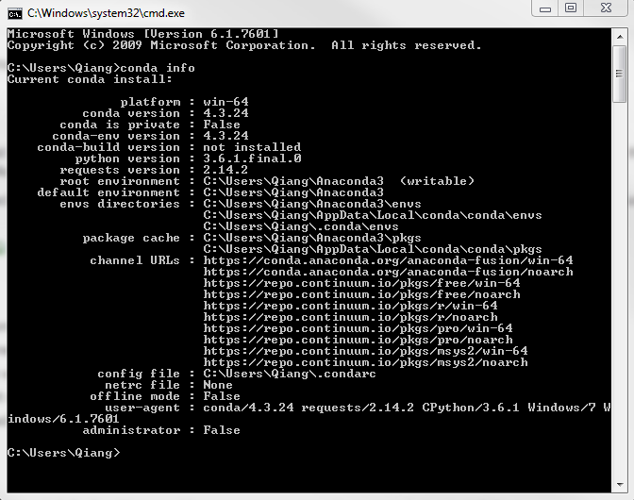

Task 2

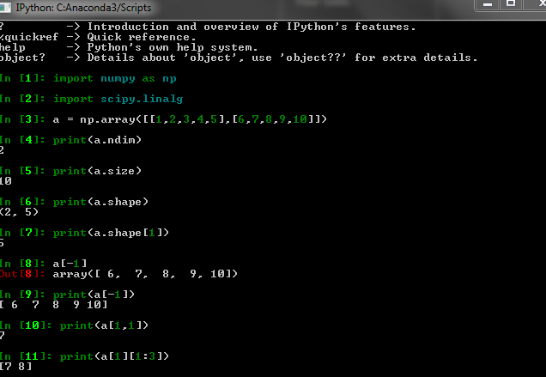

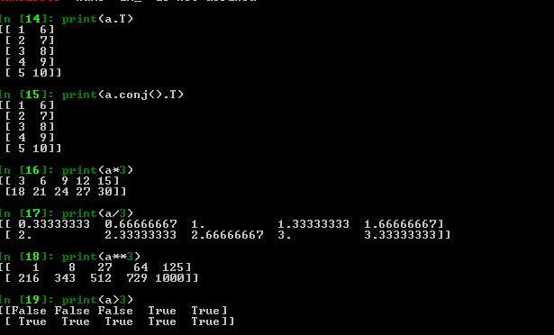

Task 4

import matplotlib.pyplot as plt

plt.plot([1,2,3,4],[1,2,7,14])

plt.axis([0,6,0,20])

plt.show()

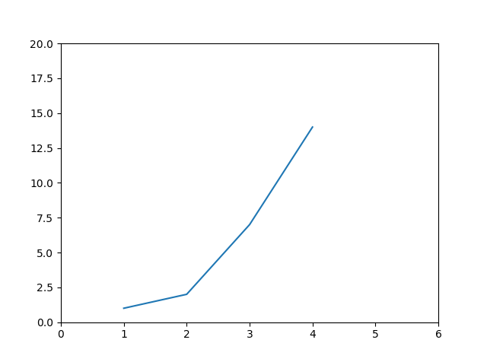

Task 5

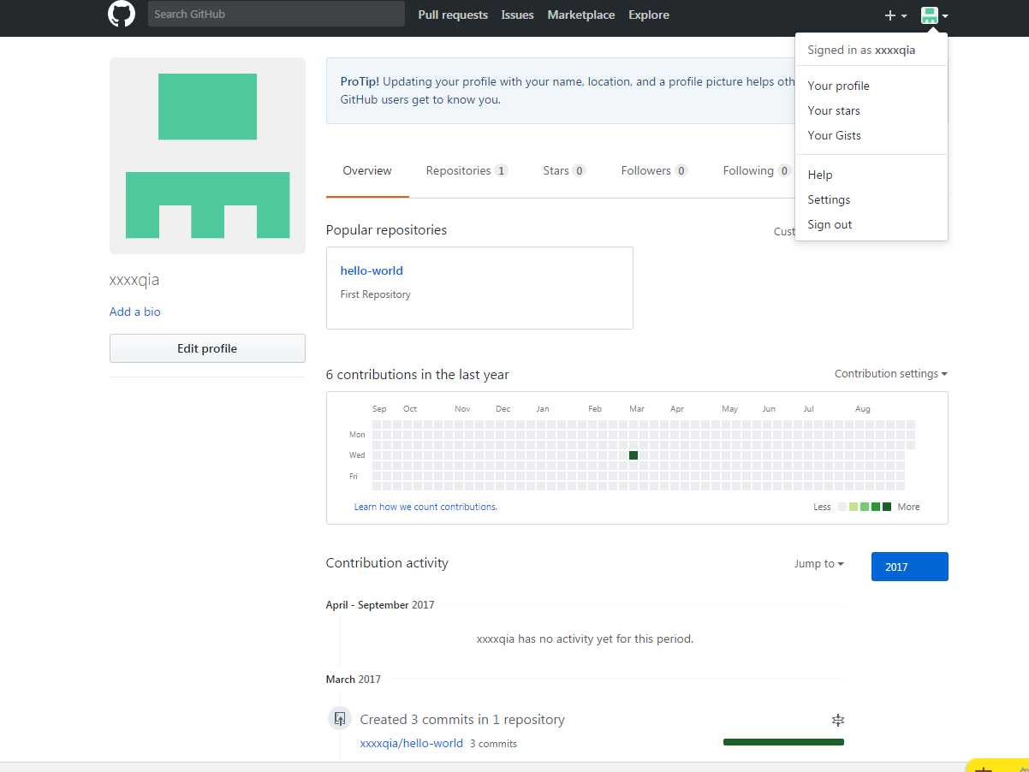

Task 6

https://github.com/xxxxqia/COMP576