**Homework 5: Car Tracking**

Part I. Implementation (20%):

* Part 1

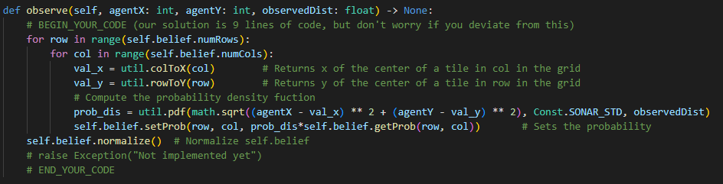

* Part 2

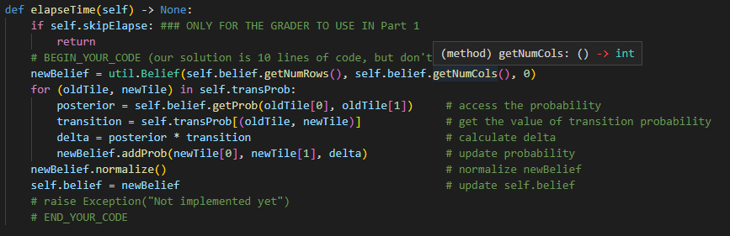

* Part 3-1

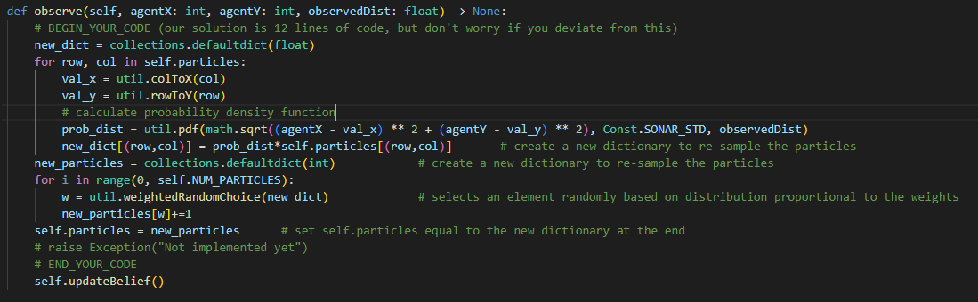

* Part 3-2

