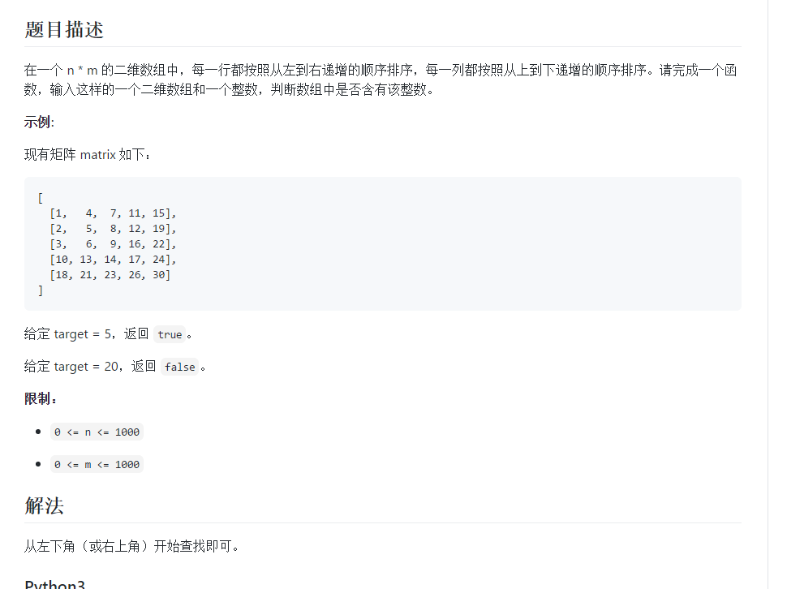

class Solution {

public boolean findNumberIn2DArray(int[][] matrix, int target) {

if(matrix == null || matrix.length ==0 || matrix[0] == null || matrix[0].length == 0){

return false;

}

int rows =matrix.length,cols = matrix[0].length;

int i = rows - 1,j =0;

while(i>=0 && j<cols){

if(matrix[i][j] == target) {

return true;

}

if(matrix[i][j] > target) {

--i;

}else {

++j;

}

}

return false;

}

}

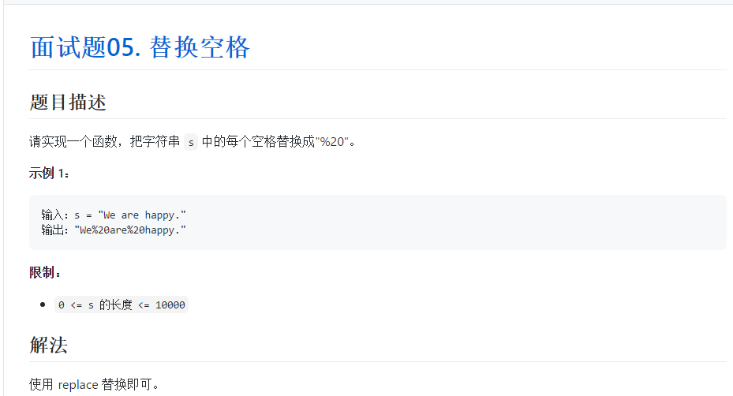

class Solution {

public String replaceSpace(String s) {

return s.replaceAll (" ","%20");

}

}