Hex to 7 seg code

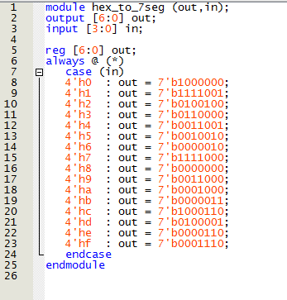

Top-level code

