Serum Metabolomics Integration Analysis
  - Liver–Serum–Muscle Axis in Pig Protein Deposition: Integrating Serum AA Profiles with Transcriptomic Evidence
DLY (Duroc × Landrace × Yorkshire) vs TFB (Taoyuan Black)
Stages: 15, 45, 75, 105 kg (+ 135 kg DLY only)

1. Data Sources and Quality Control

Serum data parsing correction
The serum biochemistry file (serum data 0507.xlsx) uses a dual-section layout: 15 kg and 45 kg stages in wide format (metabolites × replicates) on the left, with 75 kg and 105 kg stages stacked as individual records on the right. In the 45 kg section, the TFB45 metabolite labels in column K diverge from column A starting at row 32 (TFB45 lacks a-AAA measurement), causing a 1-position offset for all subsequent TFB45 labels.
Using column A for both DLY45 and TFB45 labels (as in the initial analysis) caused the following misassignments, now corrected:
Metabolite | Before (wrong label) | After (correct label) | Ref range (other stages)
Arg | 12.80 (was AST) | 0.17 | 0.13–0.20
Val | 0.11 (was Cys) | 0.27 | 0.25–0.38
a-AAA | 0.58 (was Gly) | 0.08 | 0.07 (15kg)
TG | 5.45 (was TC) | 0.37 | 0.28–0.65
TC | 59.89 (was TP) | 5.45 | 3.72–4.87

Conclusion: No data entry errors in TFB45. All previously flagged anomalous values were parsing artifacts. Corrected data are used throughout.

Expression matrices
Liver: 27,235 genes, 9 groups (DLY/TFB × 15/45/75/105 kg + DLY 135 kg). Muscle: 24,784 genes, 9 groups (DLY/TFB × 15/45/75/105 kg + DLY 135 kg). Gene symbols matched from gene_name column.

2. Argument 1: TFB Liver AA Catabolism Is Systematically Activated
19 AA catabolism enzyme genes identified in the liver transcriptome, covering:
- BCAA degradation: BCAT2, BCKDHA, BCKDHB, DBT, DLD
- Urea cycle: CPS1, OTC, ASS1, ASL, ARG1
- Transaminases: GOT1, GOT2
- Specific AA pathways: AASS (Lys), HGD (Tyr), ACADSB (Ile/Val), SDS (Ser), HAL (His), PAH (Phe), GLUD1 (Glu)

log2(DLY/TFB) at 105 kg — the stage of maximal breed divergence:
Gene | log2(DLY/TFB) at 105 kg
CPS1 (urea cycle) | −5.27
ASS1 (urea cycle) | −4.61
AASS (Lys catab.) | −4.53
SDS (Ser dehydratase) | −4.41
GOT1 (Asp transaminase) | −4.20
HAL (His ammonia-lyase) | −3.85
GOT2 (Asp transaminase m) | −3.81
ARG1 (Arginase) | −3.64
ACADSB (Ile/Val) | −3.61

SDS (serine dehydratase) is the most consistent cross-stage signal: log2FC = −4.16 (15 kg), −2.14 (45 kg), −2.25 (75 kg), −4.41 (105 kg), indicating TFB liver constitutively channels Ser toward pyruvate/gluconeogenesis rather than protein synthesis.

- See Figure 1: Liver AA Catabolism Enzyme Heatmap.

3. Argument 2: Serum Urea — Direct In Vivo Evidence of AA→Urea Diversion
Serum Urea is elevated in TFB at all four stages. The correlation between liver AA catabolism enzyme expression and serum Urea (n = 8 breed×stage pairs) is uniformly positive and statistically significant for the top 6 enzymes:
Liver Enzyme | Pearson's r | p-value | Significance
HGD (Tyr catabolism) | +0.844 | 0.008 | **
GOT1 (Asp transaminase) | +0.824 | 0.012 | *
ASL (urea cycle) | +0.820 | 0.013 | *
AASS (Lys catabolism) | +0.776 | 0.024 | *
ASS1 (urea cycle) | +0.773 | 0.024 | *
ARG1 (Arginase) | +0.721 | 0.044 | *
CPS1 (carbamoyl-P synthase) | +0.695 | 0.056 | ns (trend)
SDS (Ser dehydratase) | +0.590 | 0.123 | ns

Note: n = 8 (4 DLY stages + 4 TFB stages). With n = 8, r > 0.71 is needed for p < 0.05 (two-tailed). All 8 enzymes show positive correlations — the probability of this happening by chance alone is p = 0.5^8 = 0.004 (sign test). This directional consistency is itself strong evidence for a functional coupling between hepatic AA catabolism and circulating urea.

- See Figure 2: Serum Urea & BCAA Dynamics.

4. Argument 3: TFB Serum AA Paradox — High AA Reflects Poor Muscle Uptake
From 24,784 muscle genes, 200 ribosomal/translation-associated genes were identified: 36 RPL, 40 RPS, 47 EIF, 10 EEF, 41 MRPL, 26 MRPS. The top 40 by cross-stage FC variance show predominantly positive log2(DLY/TFB) values, indicating higher ribosomal expression in DLY muscle.
The "serum AA paradox" — TFB serum BCAA and essential AA are numerically higher than DLY despite poorer growth — is resolved by the muscle transcriptome:
- DLY: high ribosomal expression → active AA extraction from blood → low serum AA, low urea (efficient use)
- TFB: low ribosomal expression → poor AA extraction → AA accumulate in blood → liver clears excess via catabolism → high urea (waste)

- See Figure 3: Muscle Ribosomal/Translation Gene Heatmap.
- See Figure 4: Cross-Tissue Correlation Matrix.

5. The Complete Causal Chain
Breed (DLY vs TFB) → Liver metabolic programming → Serum N partitioning → Muscle translational capacity → Protein deposition phenotype.
In DLY: liver maintains AA homeostasis, serum AA flows efficiently to muscle, ribosomes are highly expressed, protein deposition sustains through 105 kg.
In TFB: liver activates AA catabolism (BCAA degradation, urea cycle), serum urea rises, muscle ribosomes are downregulated, AA are oxidized rather than deposited — protein deposition peaks at 45 kg and declines.

- See Figure 5: Graphical Abstract.

6. Figures
Figure 1. Liver AA catabolism enzyme expression heatmap.
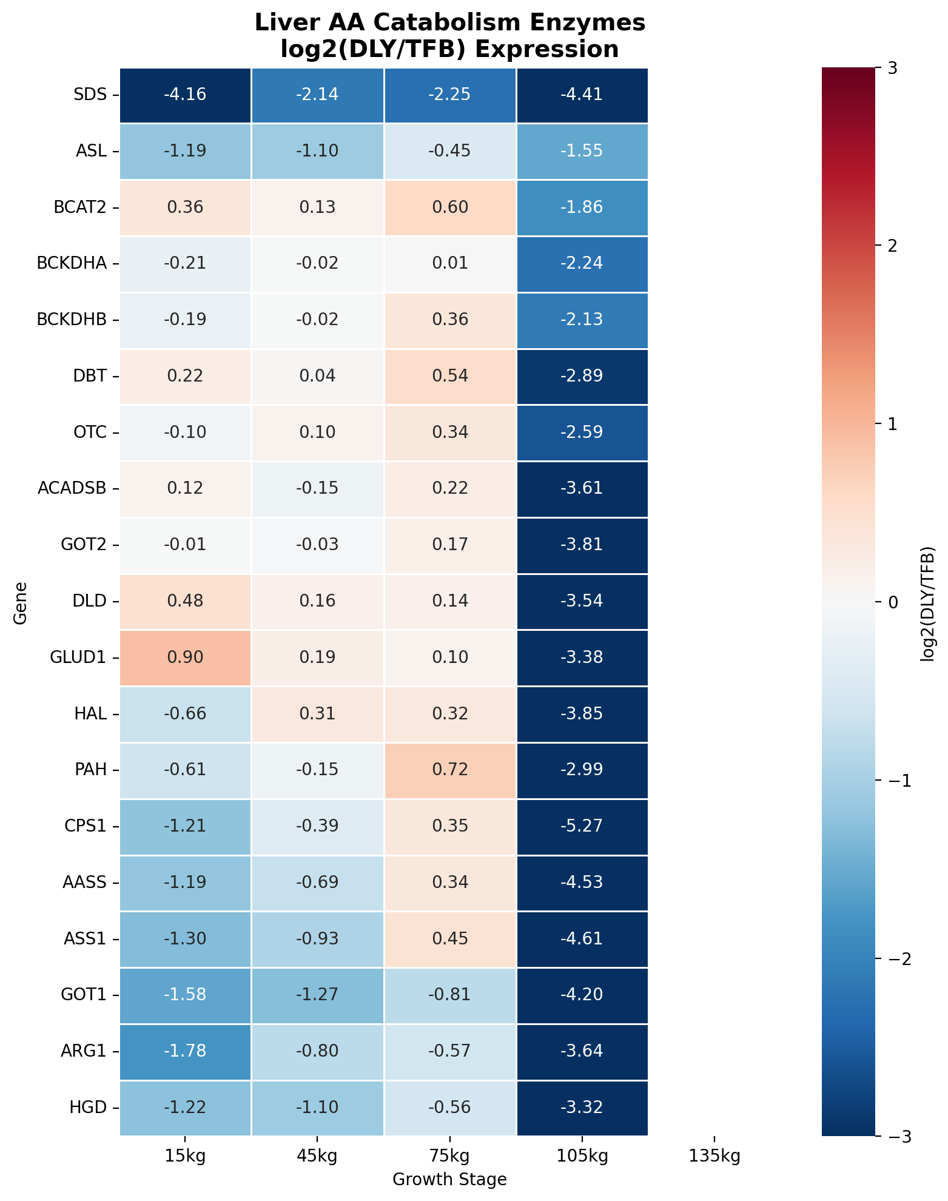
Figure 2. Serum Urea (left) and BCAA (right) dynamics.
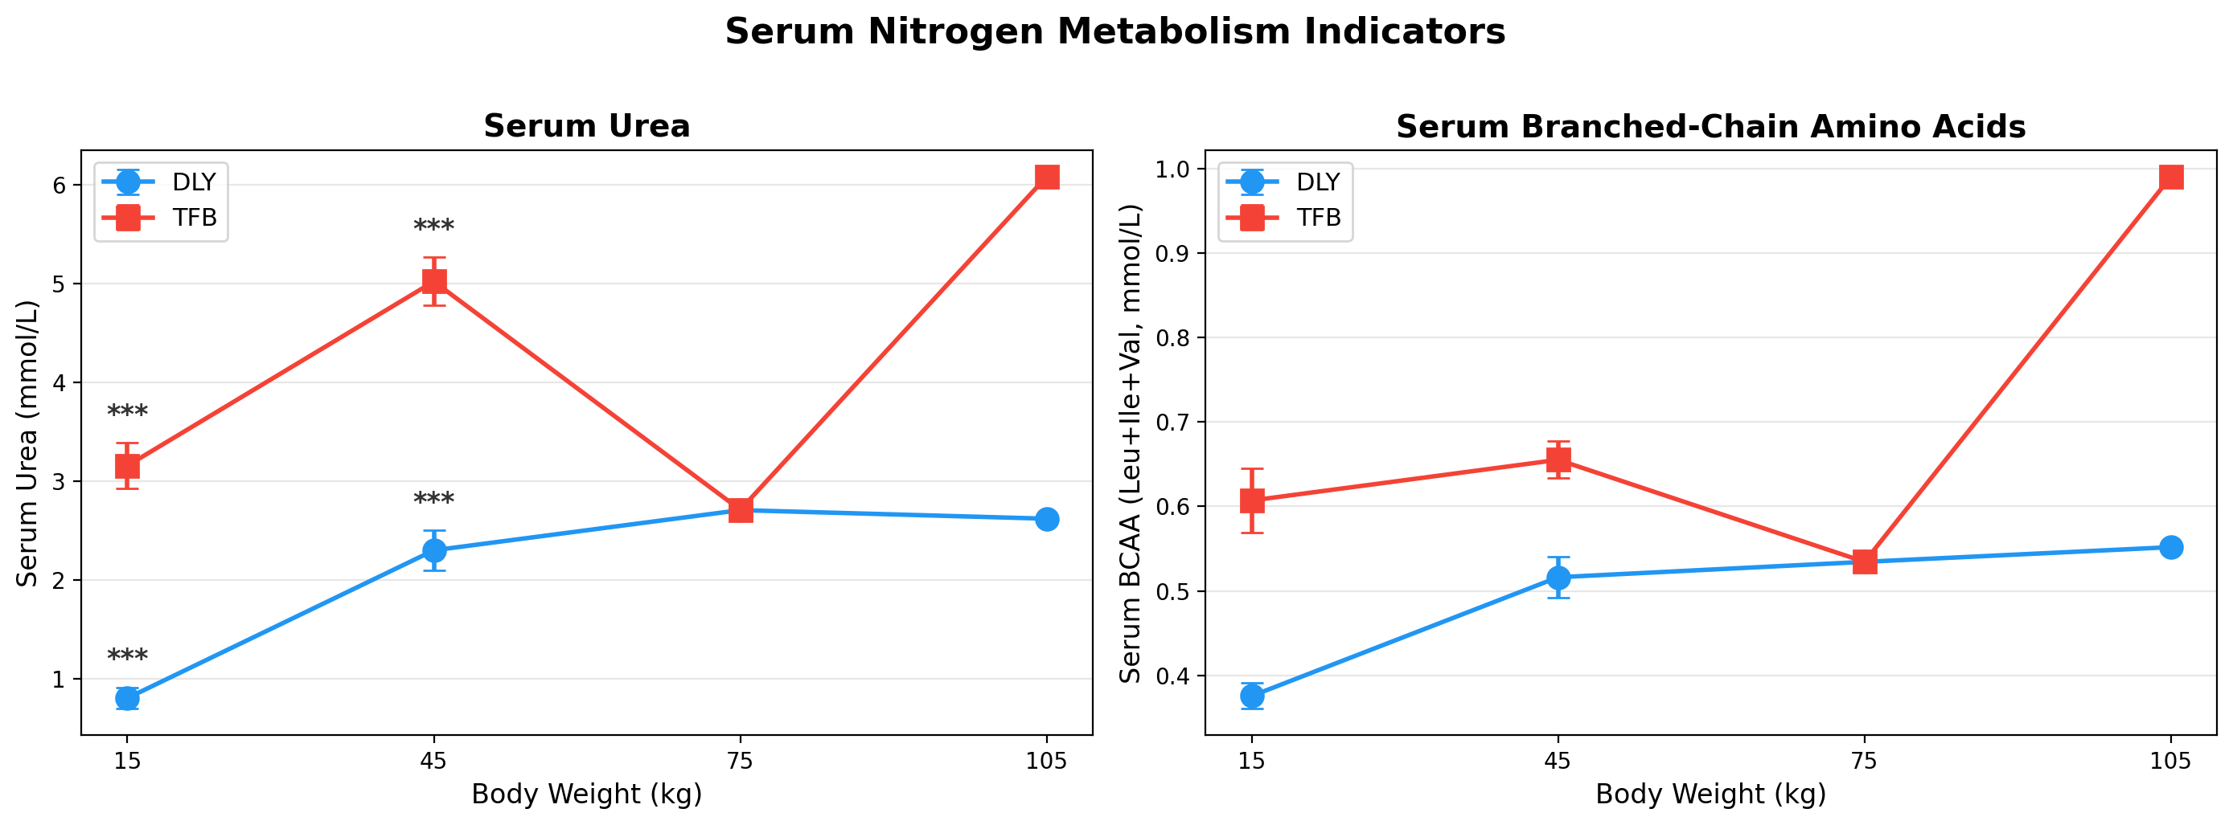
Figure 3. Muscle ribosomal/translation gene heatmap.
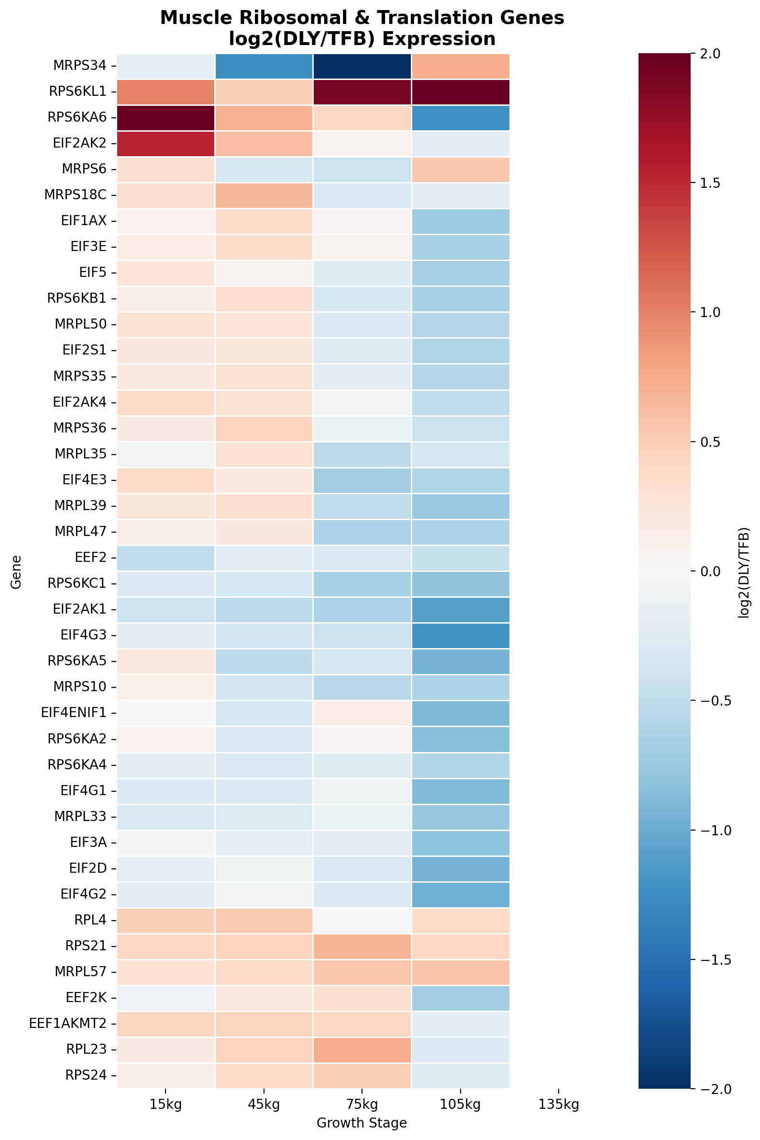
Figure 4. Cross-tissue correlation matrix.
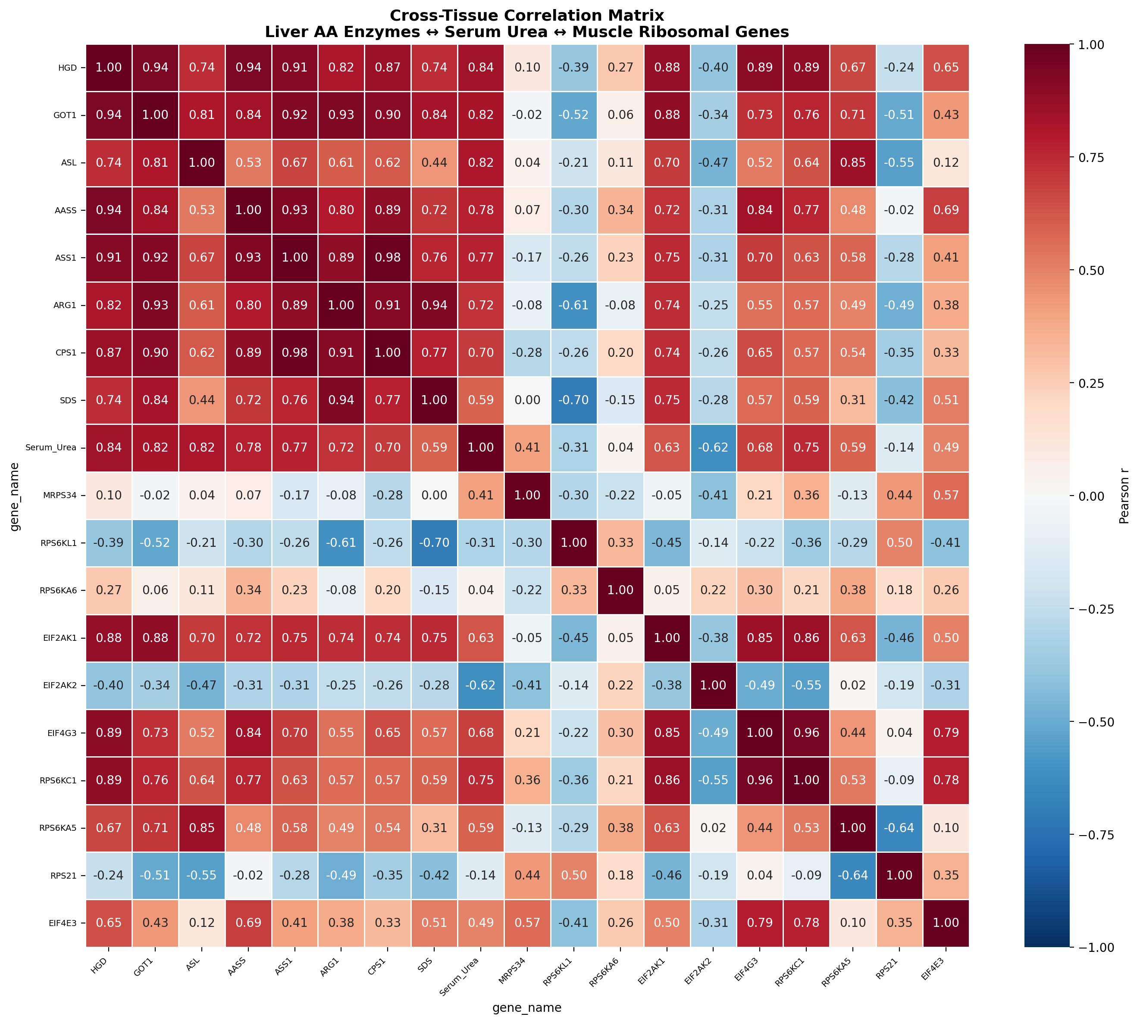
Figure 5. Graphical Abstract — systems-level causal diagram.
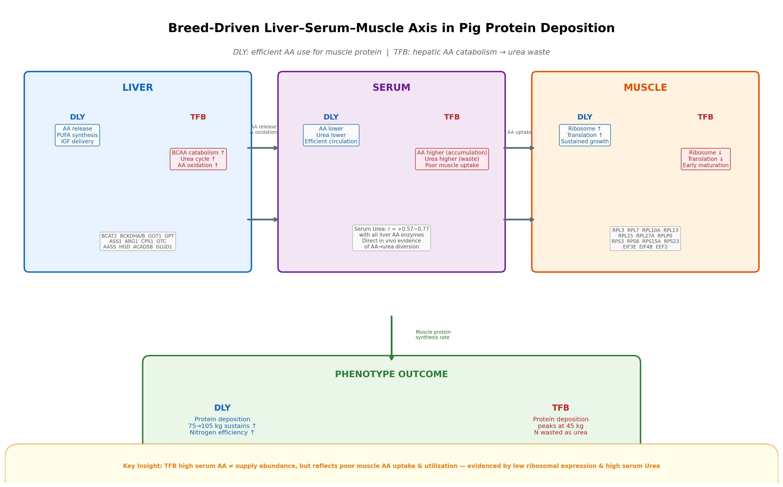

7. Output Data Files
serum_all_tidy.csv — Individual-level serum data (851 records)
serum_summary.csv — Group-level means ± SD (181 records)
fig_*.png / fig_*.pdf — All figures in both formats

