# 配置如下，依次执行即可

## ubuntu配置jupyter的部分步骤

conda create -n train39 python=3.9  
  
conda activate train39  
  
pip install jupyter  
pip install ipykernel  
  
  
apt-get install vim  
  
jupyter notebook --generate-config  
  
vim ~/.jupyter/jupyter_notebook_config.py  
  
  
直接顶部添加以下内容，允许远程访问  
c.NotebookApp.ip = '*'  
c.NotebookApp.open_browser = False  
c.NotebookApp.port = 8888  
  
jupyter notebook --allow-root  
  
出现以下信息

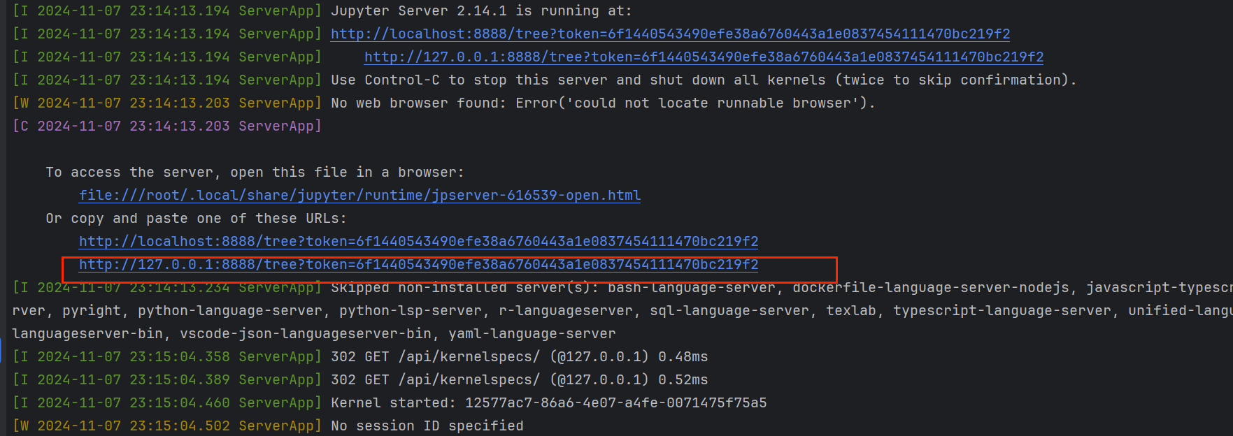

然后自己把相应框选链接全部内容配置到server，配置完再次点击会出现下图。

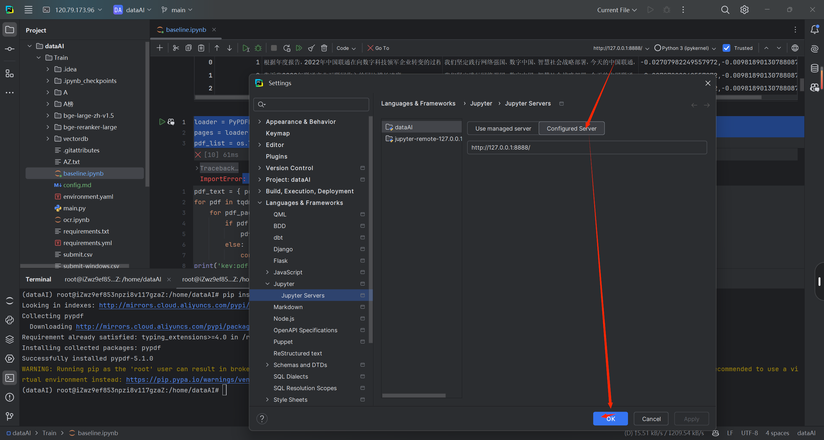

## jupyter切换内核-原本解释器是3.9

<https://juejin.cn/post/7065481886121852935>

## Conda环境配置 创建一个新环境 python=3.9即可

pip cache purge 出现什么类找不到的问题，可能是网络问题导致文件确实，清空缓存，卸载重装即可
  
pip install langchain==0.3.3
  
pip install langchain_community==0.3.2
  
pip install langchain_core==0.3.15
  
pip install faiss-gpu==1.7.2
  
pip install rank_bm25==0.2.2
  
pip install cryptography==3.1
  
pip install pydantic==2.7.4
  
pip install pypdf
  
pip install sentence-transformers
  
pip install modelscope
  
pip install pandas
  
pip install IPython
  
pip install torch
  
pip install jieba
  
pip install vectordb
  
pip install protobuf
  
pip install tiktoken
  
pip install faiss-gpu（windows使用conda安装pip会找不到）
  
  
  
推荐使用这个，git直接克隆下载可能会因为网络问题、带宽限制导致某些文件下载不成功，导致报错
  
modelscope download --model Xorbits/bge-reranker-large
  
modelscope download --model AI-ModelScope/bge-large-zh-v1.5
  
  
如果依旧有某些bin文件没有下载成功，使用如下命令
  
modelscope download --model AI-ModelScope/bge-large-zh-v1.5 <文件名> --local_dir <位置>
  
  
示例如下（这三个文件很大（>1g），单独下载比较靠谱）
  
modelscope download --model AI-ModelScope/bge-large-zh-v1.5 model.safetensors --local_dir ./bge-large-zh-v1.5
  
modelscope download --model AI-ModelScope/bge-large-zh-v1.5 pytorch_model.bin --local_dir ./bge-large-zh-v1.5
  
modelscope download --model Xorbits/bge-reranker-large model.safetensors --local_dir ./bge-reranker-large
  
modelscope download --model Xorbits/bge-reranker-large sentencepiece.bpe.model --local_dir ./bge-reranker-large
  
  
建议安装-作用大概和计算加速有
  
pip install nvidia-cublas-cu12==12.4.5.8
  
pip install nvidia-cuda-cupti-cu12==12.4.127
  
pip install nvidia-cuda-nvrtc-cu12==12.4.127
  
pip install nvidia-cuda-runtime-cu12==12.4.127
  
pip install nvidia-cudnn-cu12==9.1.0.70
  
pip install nvidia-cufft-cu12==11.2.1.3
  
pip install nvidia-curand-cu12==10.3.5.147
  
pip install nvidia-cusolver-cu12==11.4.5.127
  
  
其它的一些库
  
openai==1.54.1
  
opentelemetry-api==1.19.0
  
opentelemetry-exporter-otlp==1.19.0
  
opentelemetry-exporter-otlp-proto-common==1.19.0
  
opentelemetry-exporter-otlp-proto-grpc==1.19.0
  
opentelemetry-exporter-otlp-proto-http==1.19.0
  
opentelemetry-exporter-prometheus==0.41b0
  
opentelemetry-instrumentation==0.40b0
  
opentelemetry-instrumentation-aiohttp-client==0.40b0
  
opentelemetry-instrumentation-asgi==0.40b0
  
opentelemetry-instrumentation-fastapi==0.40b0
  
opentelemetry-instrumentation-grpc==0.40b0
  
opentelemetry-proto==1.19.0
  
opentelemetry-sdk==1.19.0
  
opentelemetry-semantic-conventions==0.40b0
  
opentelemetry-util-http==0.40b0
  
  
pip install markdown-it-py==3.0.0
  
pip install matplotlib==3.9.2
  
pip install mdurl==0.1.2
  
  
下面是原本
  
其余是ide提示需要安装的依赖
  
pip install accelerate==1.1.0
  
aiofiles==23.2.1
  
aioprometheus==23.12.0
  
asgiref==3.8.1
  
backoff==2.2.1
  
bcrypt==4.2.0
  
click==8.1.7
  
cloudpickle==3.1.0
  
contourpy==1.3.0
  
cryptography==43.0.3
  
cycler==0.12.1
  
Deprecated==1.2.14
  
distro==1.9.0
  
docarray==0.40.0
  
docker==7.1.0
  
ecdsa==0.19.0
  
faiss-gpu==1.7.2
  
fastapi==0.115.4
  
ffmpy==0.4.0
  
fonttools==4.54.1
  
googleapis-common-protos==1.65.0
  
gradio==4.44.1
  
gradio_client==1.3.0
  
grpcio==1.57.0
  
grpcio-health-checking==1.57.0
  
grpcio-reflection==1.57.0
  
hnswlib==0.8.0
  
httptools==0.6.4
  
importlib-metadata==6.11.0
  
ipywidgets==8.1.5
  
jcloud==0.3
  
jina==3.27.20
  
jina-hubble-sdk==0.39.0
  
jiter==0.7.0
  
jupyter==1.1.1
  
jupyter-console==6.6.3
  
jupyterlab_widgets==3.0.13
  
kiwisolver==1.4.7
  
langchain-core==0.3.10
  
langchain-text-splitters==0.3.0
  
markdown-it-py==3.0.0
  
matplotlib==3.9.2
  
mdurl==0.1.2
  
nvidia-cublas-cu12==12.4.5.8
  
nvidia-cuda-cupti-cu12==12.4.127
  
nvidia-cuda-nvrtc-cu12==12.4.127
  
nvidia-cuda-runtime-cu12==12.4.127
  
nvidia-cudnn-cu12==9.1.0.70
  
nvidia-cufft-cu12==11.2.1.3
  
nvidia-curand-cu12==10.3.5.147
  
nvidia-cusolver-cu12==11.6.1.9
  
nvidia-cusparse-cu12==12.3.1.170
  
nvidia-ml-py==12.560.30
  
nvidia-nccl-cu12==2.21.5
  
nvidia-nvjitlink-cu12==12.4.127
  
nvidia-nvtx-cu12==12.4.127
  
openai==1.54.1
  
opentelemetry-api==1.19.0
  
opentelemetry-exporter-otlp==1.19.0
  
opentelemetry-exporter-otlp-proto-common==1.19.0
  
opentelemetry-exporter-otlp-proto-grpc==1.19.0
  
opentelemetry-exporter-otlp-proto-http==1.19.0
  
opentelemetry-exporter-prometheus==0.41b0
  
opentelemetry-instrumentation==0.40b0
  
opentelemetry-instrumentation-aiohttp-client==0.40b0
  
opentelemetry-instrumentation-asgi==0.40b0
  
opentelemetry-instrumentation-fastapi==0.40b0
  
opentelemetry-instrumentation-grpc==0.40b0
  
opentelemetry-proto==1.19.0
  
opentelemetry-sdk==1.19.0
  
opentelemetry-semantic-conventions==0.40b0
  
opentelemetry-util-http==0.40b0
  
passlib==1.7.4
  
pathspec==0.12.1
  
peft==0.13.2
  
pillow==10.4.0
  
pipdeptree==2.23.4
  
protobuf==4.25.5
  
pyasn1==0.6.1
  
pydub==0.25.1
  
pyparsing==3.2.0
  
python-jose==3.3.0
  
python-multipart==0.0.17
  
quantile-python==1.1
  
regex==2024.9.11
  
rich==13.9.4
  
rsa==4.9
  
ruff==0.7.2
  
semantic-version==2.10.0
  
sentencepiece==0.2.0
  
shellingham==1.5.4
  
sse-starlette==2.1.3
  
starlette==0.41.2
  
tabulate==0.9.0
  
tblib==3.0.0
  
tiktoken==0.8.0
  
timm==1.0.11
  
tomlkit==0.12.0
  
torchvision==0.20.1
  
tqdm==4.66.6
  
triton==3.1.0
  
typer==0.12.5
  
types-requests==2.31.0.6
  
types-urllib3==1.26.25.14
  
uvicorn==0.23.1
  
uvloop==0.21.0
  
vectordb==0.0.21
  
watchfiles==0.24.0
  
websockets==12.0
  
widgetsnbextension==4.0.13
  
wrapt==1.16.0