

The Experiment Report of Machine Learning

SCHOOL: SCHOOL OF SOFTWARE ENGINEERING

SUBJECT: SOFTWARE ENGINEERING

|  |  |
| --- | --- |
| *Author:*  San Zhang | *Supervisor:*  Mingkui Tan |
|  |  |
| *Student ID:*  202010100001 | *Grade:*  Undergraduate |

2020-10-24

# Linear Regression, Linear Classiﬁcation and Gradient Descent

***Abstract—The short abstract is intended to give the reader an overview of the experiment. It should be brief and to the point.***

## INTRODUCTION

This section introduces the problem to solved and leads the reader on to the main part. Detailed motivation is necessary. What’s more, you can show your expected results and contributions.

## METHODS AND THEORY

In this section, you are asked to give a complete introduction to the experiment. For instance, the chosen methods, the related theories, the related equations (loss function), the derivation process (taking the gradient) and so on.

## EXPERIMENT

### Dataset

This section represents the related information of datasets, such as the content, the number of data, the training set, the validation set and so on.

### Implementation

All detailed implementation in your experiment: initialization, process, results, all kinds of parameters. In a word, describe clearly What you do and how you do. Figures and tables should be labeled and numbered, such as in Table I and Fig. 1.

TABLE I

SIMULATION PARAMETERS

|  |  |
| --- | --- |
| Information message length | *k* = 16000 bit |
| Radio segment size | *b* = 160 bit |
| Rate of component codes | R = 1/3 |

## CONCLUSION

This section summarizes the paper. In our experiments, you can also write your gains and inspirations in here.

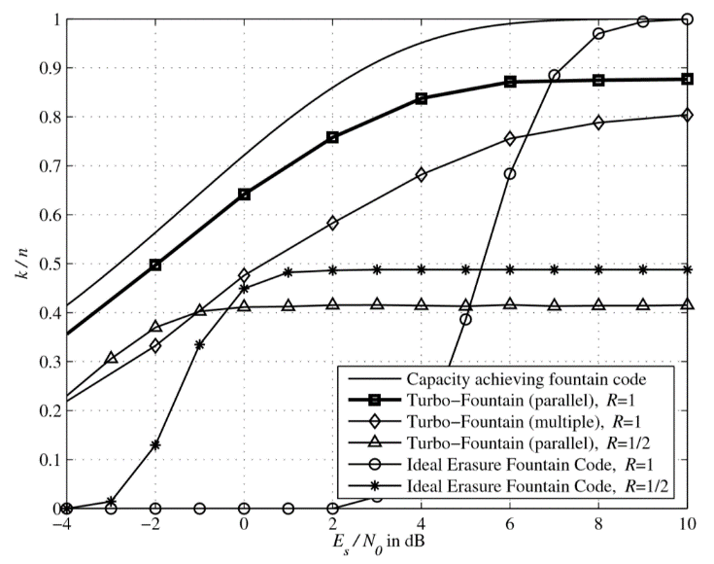Figure. 1. Simulation results on the AWGN channel.