**City University of Hong Kong**

CS3343 Software Engineering Practice

2023/24 Semester A

Project Plan

Project Title: Connect Four Game

|  |  |
| --- | --- |
| **Name** | **Student Number** |
| Fong Tsz Wai | 57156110 |
| JI Xin | 40147182 |
| Ka Lam Mark Alexander LEE | 56759365 |
| LIN Xiaoyang | 57126676 |
| SONG Rui | 57126559 |

Table of Contents

1. Project Overview 3

1.1. Project Background 3

1.2. Project Target 3

1.3. Project Constraints 3

2. Project Organization 4

2.1. Project Team 4

2.2. Stakeholder Analysis 4

3. Project Schedule 5

3.1 Objectives 5

3.2 Product-type Work Breakdown Structure (WBS) 6

3.3 Process-type Work Breakdown Structure (WBS) 6

3.4 Critical Path Analysis 9

4. Configuration Management 9

4.1 Development Tools 10

4.2 Change Control 10

4.3 Version Control 10

5. Risk Management 11

5.1 Risk Analysis 11

5.2 Risk Avoidance Measure 11

# Project Overview

## Project Background

Our client, Larry, is a board game enthusiast. He would like us to help develop a Connect Four Game program that allows him to compete with friends, featuring both relatively simple and highly challenging AI opponents. The program should include the ability to undo moves, seek AI advice, and customize the number of times these options can be used. Most importantly, it should allow post-game analysis and the freedom to review past game records.

## Project Target

We planned to design and develop an Intelligent Connect-4 Game. The Intelligent Connect-4 Game is a classic Connect-4 experience enhanced with artificial intelligence elements, allowing users to engage in thrilling matches against either human opponents or a sophisticated AI adversary. This project combines the simplicity of the beloved Connect-4 game with advanced features, such as AI-driven suggestions and user-friendly settings to control the gameplay experience.

The project duration is estimated to be 13 weeks (about 3 months). A group of 5 members is assigned to complete the project with the following roles: Project Manager, Assistant Project Manager, Program Developer and Program Tester.

## Project Constraints

1. **Scope:** 
   * The client has yet to confirm certain specifications, so the project scope is anticipated to continue evolving. As requirements shift, developers may need to constantly incorporate new features, necessitating extra effort in adjusting software design and code. Prolonged development could negatively impact the project, causing delays, exceeding budgets, or even resulting in project failure. To address this, it is essential to ensure open communication with the client and create an adaptable development strategy that can accommodate any emerging needs.
2. **Time:**
   * Our client, Larry, has requested that we should complete the project and release the final product to him by December 11th, 2023. A clear stipulation in the contract also states that the project should be completed within 13 weeks (3 months).
3. **Cost:**
   * The project's budget is set at 60,000 Hong Kong dollars, with no additional funds available. Based on limited budget, we cannot afford to train an AI model for the Connect Four Game. Therefore, we decided to develop an AI algorithm as the substitute solution of training an AI model in our project. As a result, our main expenses will be focused on internal labour costs.

# Project Organization

## Project Team

|  |  |  |
| --- | --- | --- |
| Role | Name | Task Assigned |
| Project Manager | LIN Xiaoyang | • Planning and resource allocation  • Risk management and team leadership  • Program Development |
| Assistant Project Manager | SONG Rui | • Assisting the management of the project  • Progress monitoring and quality assurance  • Program Development |
| Program Developer | JI Xin | • Mainly Developing AI Algorithm  • Program Development |
| Program Developer | Fong Tsz Wai | • Developing game framework  • Program Development  • Program Testing |
| Program Tester | Ka Lam Mark LEE | • Partial Development  • Program Testing |

## Stakeholder Analysis

|  |  |  |
| --- | --- | --- |
| Role | Internal/External | Description |
| Project Managers | Internal | • Planning and resource allocation  • Risk management and team leadership  • Progress monitoring and quality assurance  • Communication with clients |
| Project Team | Internal | • Program Development  • Program Testing  • Program Maintaining |
| Client | External | • Presentation of requirements  • Provision of resources |
| End-User | External | • Fundamental source of requirements  • Probably Larry and his friends or the other game collectors |

# Project Schedule

## 3.1 Objectives

1. **Game Modes:**
   * *Human vs Human:*  Challenge your friends or family in battles.
   * *Human vs AI:* Face off against an intelligent AI opponent for a single-player experience.

***[Artificial Intelligence]*:**

* + - The AI opponent employs advanced algorithms of different difficulty level to make strategic moves.
    - AI provides users with suggestions for the optimal next move, enhancing the learning experience and challenging players to improve their skills.

1. **User Controls:**
   * *Select to be Opener or Second player in each game.*
   * *Control the number of AI suggestions in each game to tailor the difficulty level.*
   * *Control the number of undo actions available to each human players, allowing for a fair and engaging gameplay experience.*
2. **Intuitive Interface:**
   * *User-friendly design for seamless navigation and an immersive gaming experience.*
   * *The simple chessboard interaction commands and clean user interface provide users with a smooth and user-friendly gaming experience.*
3. **Game Reviews:**
   * *The programme includes a storage field that temporally store users’ recently played chess games. This enables users to review their games easily.*
   * *Users can learn from the perspectives of both sides and enhance their skills and judgment through facing different situation.*

## 3.2 Product-type Work Breakdown Structure (WBS)

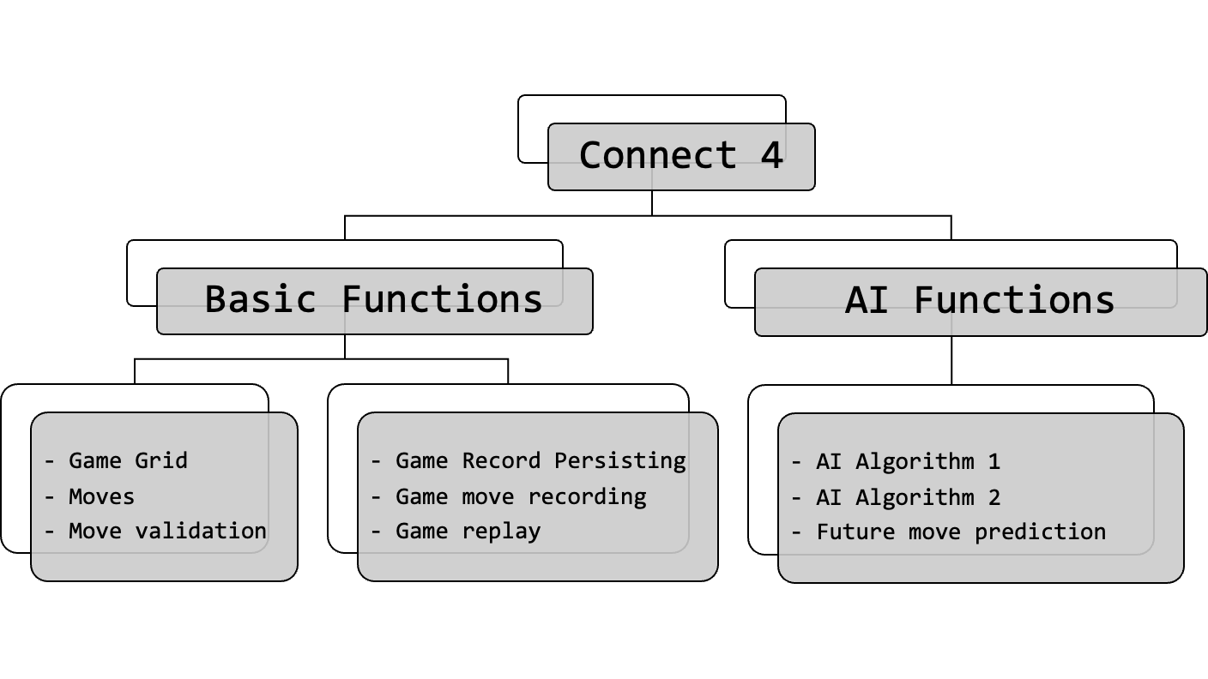

Figure 3.2.1 Product-type WBS

As shown in Figure 3.2.1, the Connect4 project mainly consists of the development of Basic functions and AI functions. The basic functions include game elements such as the game board, moves, move validation, and features like storing game records and reviewing past games.

On the other hand, the AI functions involve the implementation and development of two different difficulty levels of AI algorithms, as well as future step predictions and suggestions based on the AI algorithms.

## 3.3 Process-type Work Breakdown Structure (WBS)

Our project follows a combined approach of the Iterative Model and Test-driven Development (TDD), as depicted in Figure 3.3.1. By adopting the Iterative Model, we aim to enhance the quality of our project through an iterative and continuous development process. This approach allows us to focus on specific functionalities in each iteration, making it easier to identify and rectify any issues that arise.

Each iteration begins with planning and requirements analysis. During this phase, we create a detailed plan that includes task allocation, scheduling, and analysis. We also determine the features and requirements to be implemented in the current iteration.

During the development stage, we create test cases that are in accordance with the identified requirements and reflect our anticipated program functionality. The test cases serve as a benchmark to verify the correctness of the code during development.

Next, we execute the written test codes to test the functionality. This step checks if the code meets the expected functional requirements. If the tests pass, it indicates that the functional code has correctly implemented the requirements. However, if the tests fail, we return to the developing step, fix the test codes, and rerun the tests until all tests passes.

After passing all test cases, we review the code to ensure its quality and maintainability. Refactoring will be done, and all tests will be run again till there are well structured functional codes passing all test cases. Subsequently, we integrate the code from this iteration with other parts of the system to ensure overall stability and availability.

At the end of each iteration, we evaluate and review the process, summarizing our experiences to gather insights for the next iteration. Our project will consist of two iterations. The first iteration will primarily focus on developing the basic functions, while the second iteration will emphasize the development of AI-related functionalities.

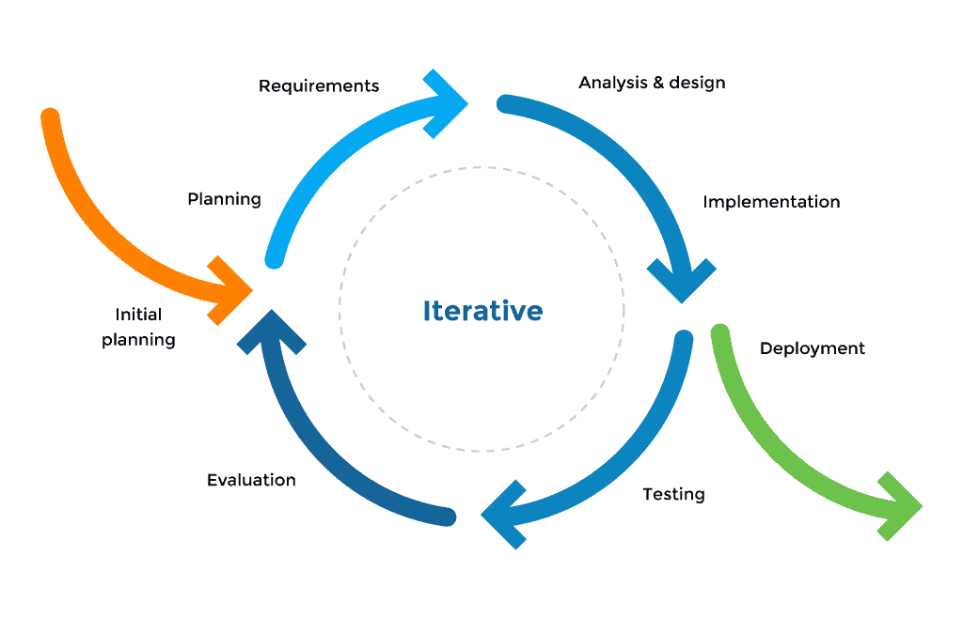

Figure 3.3.1 Iterative Model

In addition, we have carefully planned the project schedule, as presented in Figure 3.3.2. The schedule will be strictly followed throughout the project's duration.

Starting on September 12, 2023, we will dedicate approximately one and a half weeks to requirement analysis and scope analysis, as indicated by the light blue section in the chart.

Following that, on September 22, we will conduct a targeted analysis of the basic functionality of Connect4 based on our previous findings. On October 6, we will officially commence the first round of development, focusing on implementing the basic functions.

After two and a half weeks, we will initiate the second round of design, concentrating on AI-related features. Subsequently, on November 10, we will begin the second round of development and testing.

We have carefully planned and structured our development approach and schedule to ensure a systematic and efficient development process throughout the project.

To have a clearer Process-type WBS, we will present it in an indented structure, and based on this structure, we will create a Gantt chart. At the same time, this will facilitate subsequent Critical Path Analysis.

Indented structure:

0.0 Requirements Gathering

*0.1 Topic brainstorming & Research*

*0.2 Requirements Gathering*

*0.3 Requirements & Scope refinement*

1.0 Design & Implementation

*1.1 High level function planning*

*1.2 Implementing Game Basic Structure*

*1.3 Implementing Game Logic*

2.0 Testing

*2.1 Unit Testing*

*2.2 Integration Testing*

*2.3 System Testing*

3.0 Documentation

4.0 Deployment

Gantt Chart:

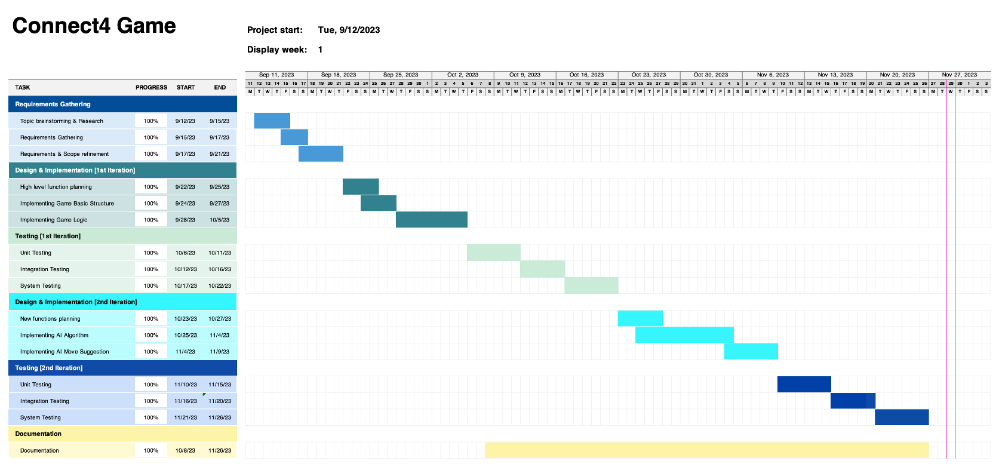

Figure 3.3.2 Gantt Chart (Project Schedule)

The entire project is planned to be completed by November 27. Finishing two weeks ahead of schedule is intended to account for any potential time cost losses due to unforeseen circumstances.

## 3.4 Critical Path Analysis

From the project schedule in Figure 3.3.2, we have compiled the following table. For each activity, we have listed the activity name, immediately preceding activities, and duration. This table is provided for conducting critical path analysis.

|  |  |  |  |
| --- | --- | --- | --- |
|  | Activity | Immediately Preceding Activities | Duration |
| A | Topic Brainstorming & Research |  | 3 |
| B | Requirements Gathering | A | 2 |
| C | Requirements & Scope Refinement | B | 4 |
| D | High-Level Function Planning | C | 3 |
| E | Implementing Game Basic Structure | D | 3 |
| F | Implementing Game Logic | D | 7 |
| G | Testing | E, F | 14 |
| H | New Functions Planning | G | 4 |
| I | Implementing AI Algorithm | H | 10 |
| J | Implementing AI Move Suggestion | I | 5 |
| K | Testing | J | 15 |
| L | Documentation | B | 50 |
| M | Deployment | K, L | 1 |

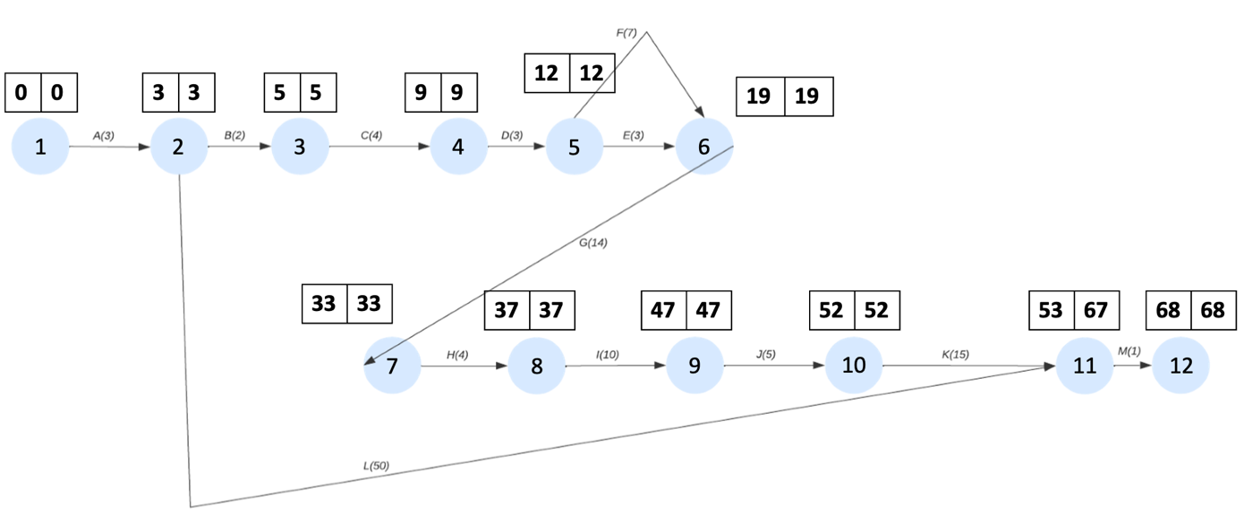

Figure 3.4.1 Critical Path Analysis

Based on the above table, Figure 3.4.1 can be drawn step by step. We performed a critical path analysis on Figure 3.4.1.

Critical Path: A->B->C->D->F->G->H->I->J->K->M.

# Configuration Management

## 4.1 Development Tools

|  |  |
| --- | --- |
| **Development Tools** | **Aims** |
| Eclipse IDE | Develop the JAVA software |
| VS Code | Develop the JAVA software |
| JUnit 5 | Write test cases for testing systematically |
| GitHub Issue | Report Bug |
| Asana | Project Management |
| Azure DevOps | Project Management and Maintenance |
| Visual Paradigm | Design and system model |
| OneDrive | Public shared cloud disk |
| Git & GitHub | Version Control |

## 4.2 Change Control

Any change, including documentation, code, design, or functionality, must be submitted as a formal Change Request (CR) with a brief description, rationale, and impact on the project. Avoid design changes when possible. If necessary, review and approve with relevant development team members and stakeholders. Review proposed functional changes with the development team to ensure alignment with project goals and no introduction of new risks. Obtain approval from the appropriate authority (e.g., development team, stakeholders) before implementing the change. Implement the approved change and monitor its impact on the project, taking corrective action if necessary. Record all approved changes in a Change Control Log for future reference.

## 4.3 Version Control

Our team utilizes GitHub for version control to ensure a streamlined and organized workflow. Only the Project Manager and Assistant Project Manager have the authority to directly push code to the main branch. Other team members must first update their code and commit locally before pushing to their personal branches or task-specific branches, such as "feature/undo".

Upon pushing their changes to their respective branches, the Project Manager will review the code and, if approved, merge it into the main branch. Following this, the Test Programmer will pull the most recent version of the main branch to their local environment for testing. Once the testing is complete, the Test Programmer will push the test code to a dedicated testing branch.

The Assistant Manager will then review and confirm that the test cases have achieved 100% branch coverage or provide justifiable reasons for not reaching 100%. Finally, the test code will be merged into the main branch, stored within a folder that begins with the prefix "test."

# Risk Management

## 5.1 Risk Analysis

We identify, assess, and develop contingency plans to address risks that may have a negative impact on the project. This helps to deal with potential issues in advance, reducing the likelihood of project delays or failures.

Upon analysis, our main potential issue is the failure of AI algorithm development due to insufficient technical capabilities. As mentioned earlier, we cannot train AI models due to cost constraints, nor do we have the time to acquire large amounts of training data and game records. Therefore, we can only develop the AI algorithms ourselves. However, it is unpredictable whether we can successfully research and develop the two Connect Four AI required by the client before the planned time or even the release date.

Apart from this one risk, the likelihood of our project being delayed or failing is quite low. To provide extra assurance, we have scheduled the project completion time to be two weeks ahead of the release date specified in the contract.

## 5.2 Risk Avoidance Measure

To avoid project delays or failures, we plan to have the main person in charge of the AI algorithm conduct research in the relevant field during the first iteration. This person will multitask during the initial stages, both developing the basic functionality and logic of the Connect Four game and preparing for the development of the AI algorithm.