**Tutorial 5**

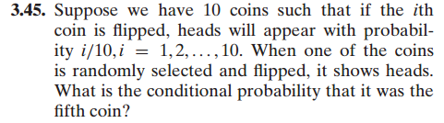

----------------------------------------------------------------------------------------------------------------------

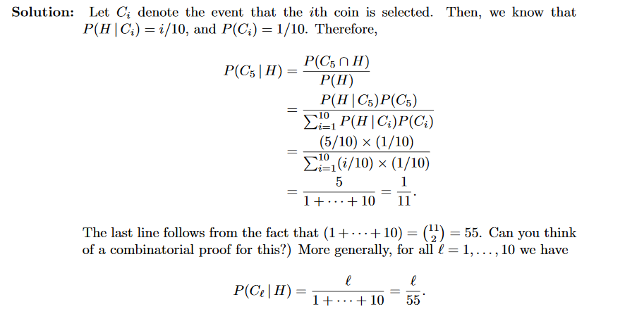

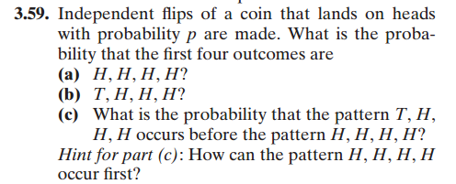

----------------------------------------------------------------------------------------------------------------------

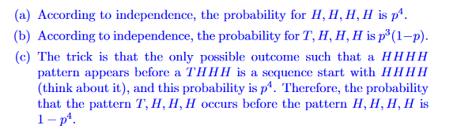

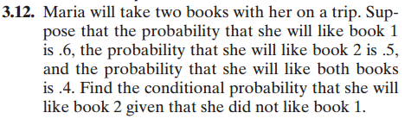

----------------------------------------------------------------------------------------------------------------------

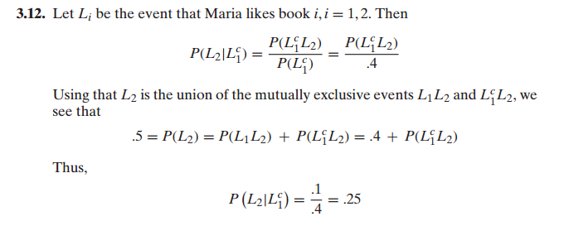

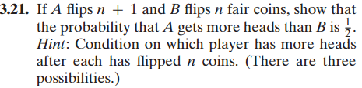

----------------------------------------------------------------------------------------------------------------------

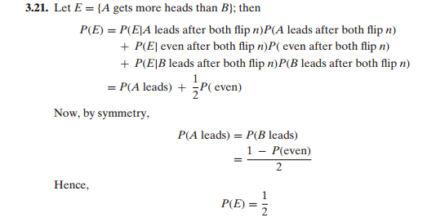

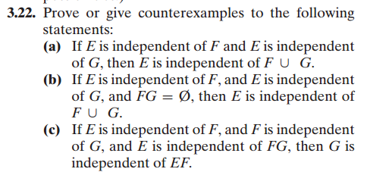

----------------------------------------------------------------------------------------------------------------------

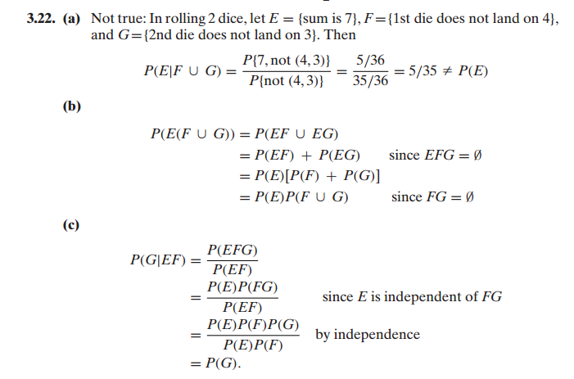



----------------------------------------------------------------------------------------------------------------------

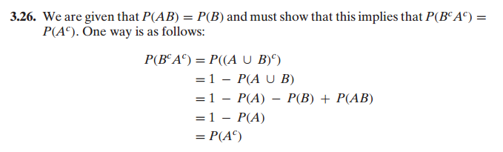

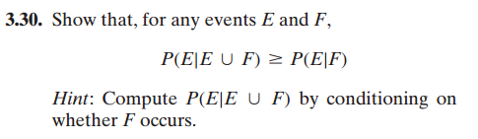

----------------------------------------------------------------------------------------------------------------------

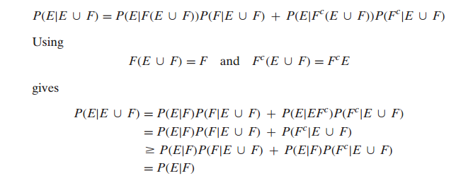

**3.31**

There is a 60% chance that event A will occur, if A does not occur, then there is a 10% percent chance that B will occur.

What is the probability that at least one of the events A or B will occur?

----------------------------------------------------------------------------------------------------------------------