Chart 1: One-off rebound from SARS adds to underlying traffic recovery

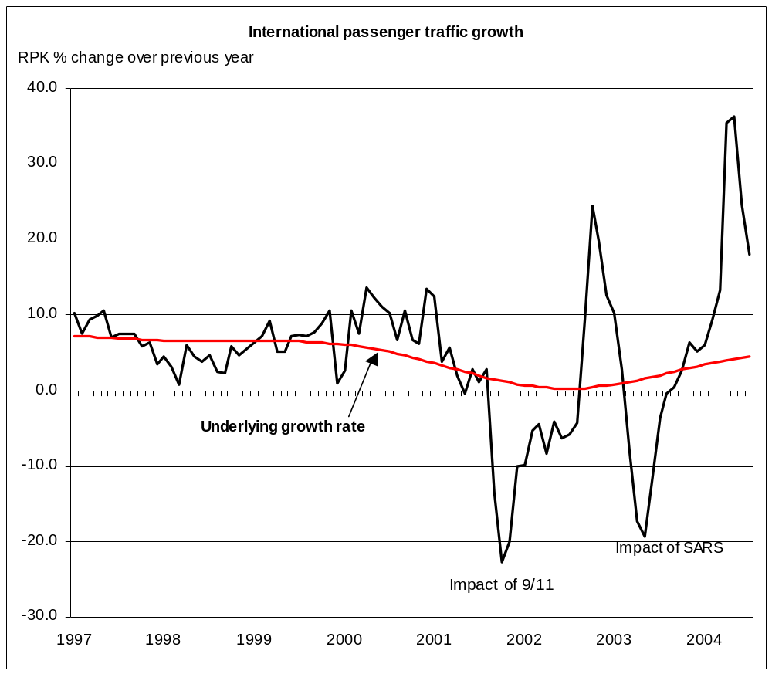
Source: IATA Economics

