Demo Documentation
Fashion Retail Assistant
This document demonstrates the Fashion Retail Assistant in action across three query types: SQL analytics, RAG product knowledge, and hybrid (SQL + RAG combined). Each example shows the agent's reasoning process: tool selection, refinement, and final synthesis.
How to run: uv run src/gui.py

Example 1: SQL Analytics — Store Performance Analysis
Query: "Which of our stores performed the best in 2024?"
Depth: 3 (Deep)
Tools used: query_sql (x2)

Agent Reasoning Process
The agent's plan-execute-reflect loop is visible in the TUI:
Iteration 1 Initial query: The agent generates a SQL query joining transactions and stores tables, grouping by store with revenue, units, and invoice counts. The reflect node identifies that the query did not explicitly filter by year 2024, even though all data in the database is from 2024, the agent adds the date filter for correctness.
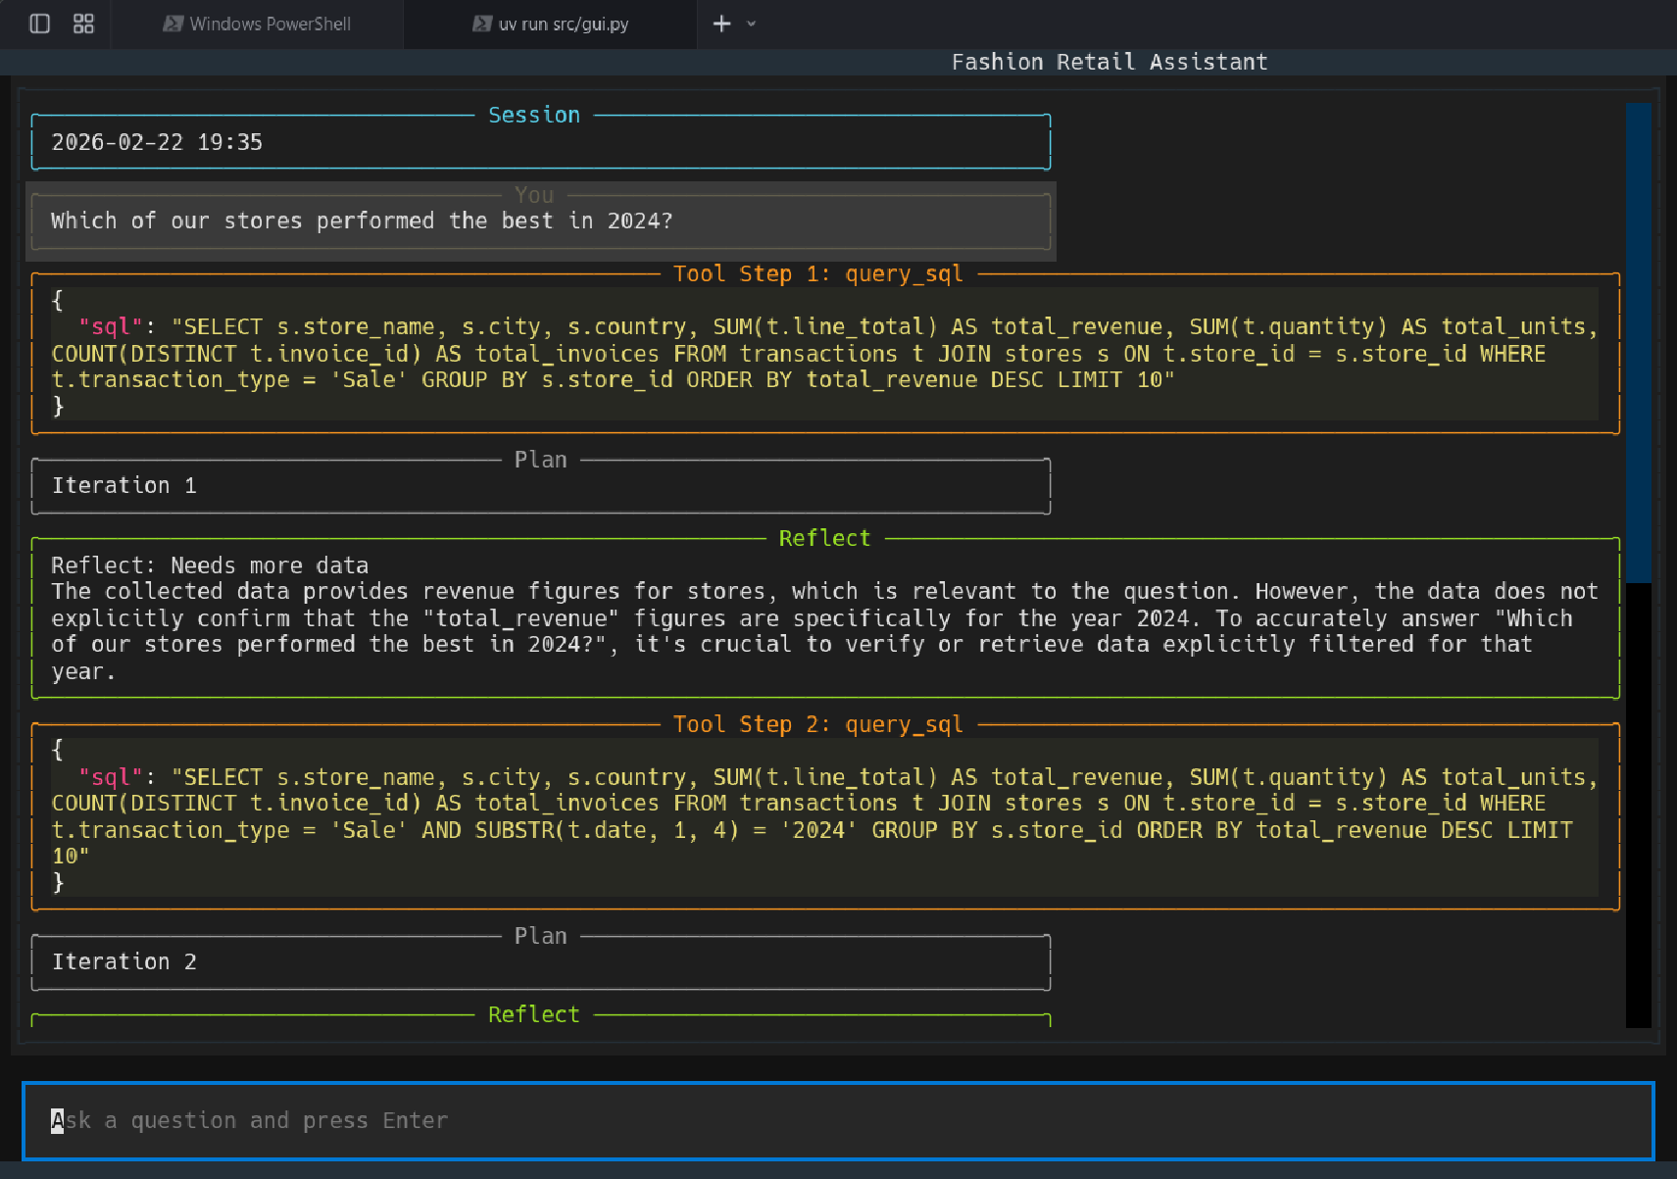
Iteration 2 Refined query: The agent re-executes the query with SUBSTR(t.date, 1, 4) = '2024' added to the WHERE clause. The reflect node is now satisfied that the data is explicitly scoped to 2024.
Synthesized Answer: The agent returns a formatted table of the top 10 stores ranked by total revenue, with columns for store name, city, country, revenue, units sold, and total invoices. Key insights:
- China Dominance All top 5 stores are in China, led by Store Beijing with 1.59M in revenue
- US Performance Store New York ranks 6th with 214K revenue, significantly lower than even the 5th Chinese store
- Units vs Revenue US stores show higher unit counts but lower revenue, indicating a different pricing/product mix compared to China
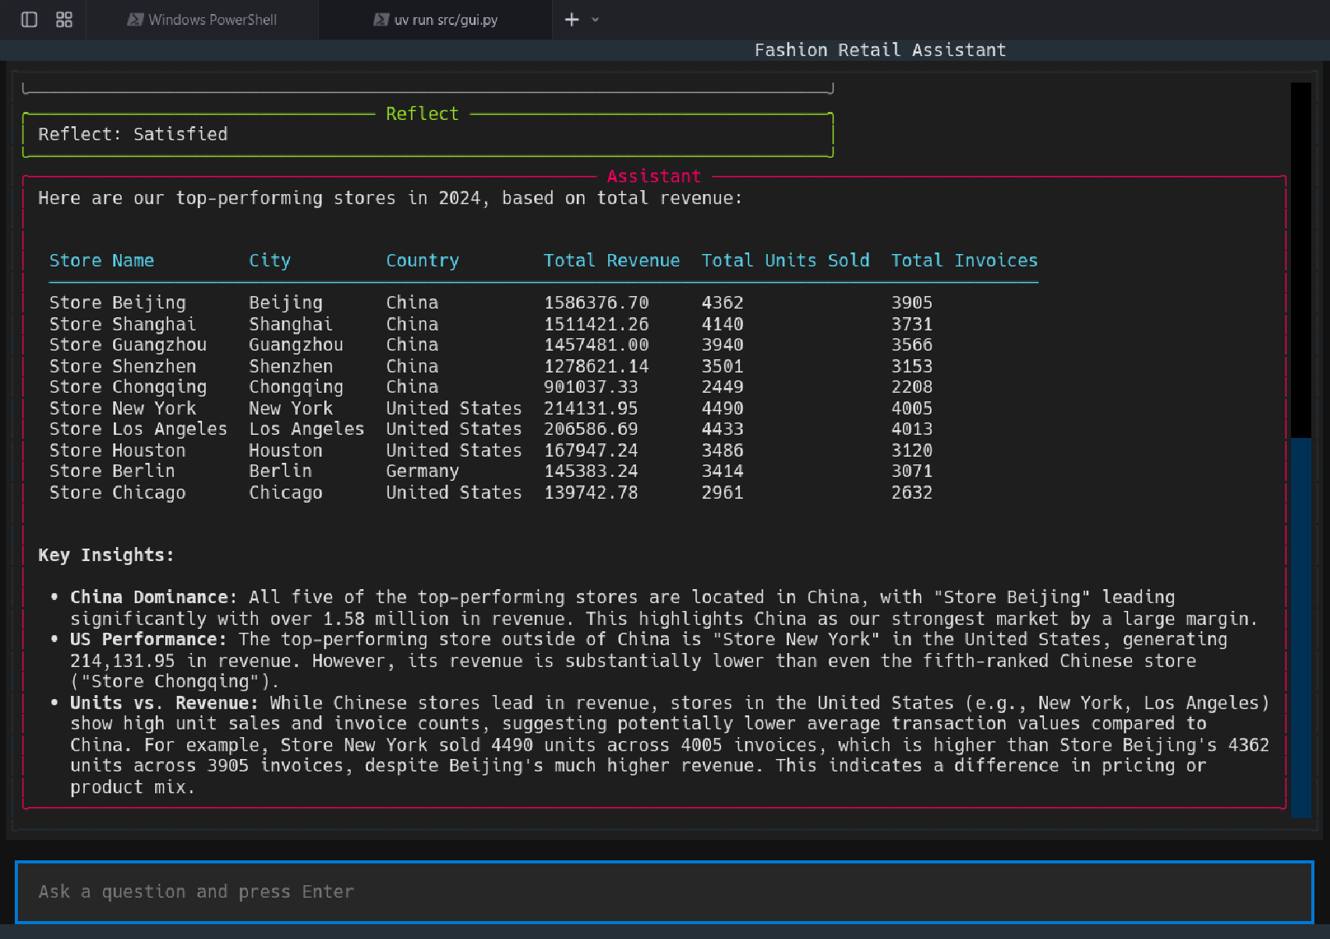

Example 2: RAG Product Knowledge — Material Information
Query: "What material is the Apex Recovery Sweatshirt made of?"
Depth: 3 (Deep)
Tools used: query_rag (x1)

Agent Reasoning Process
The router classifies this as a product knowledge question and routes to the plan-execute-reflect loop.
Iteration 1 RAG retrieval: The agent calls query_rag with the question. The RAG tool performs a semantic search over the 635 embedded chunks from 200 product technical sheet PDFs, retrieves the top-5 most relevant chunks, and synthesizes a grounded answer using Gemini 2.5 Flash with structured output.
Reflect Satisfied immediately: The reflect node determines the retrieved data fully answers the question, no additional iterations needed.
Synthesized Answer:
"The Apex Recovery Hooded Sweatshirt is made from a premium blend of 78% Cotton and 22% Recycled Polyester."
The answer includes a Sources section citing 10314.pdf, the specific product technical sheet PDF the answer was grounded on. Source tracking uses structured output (RAGResponse) so the LLM explicitly declares which PDFs it relied on.
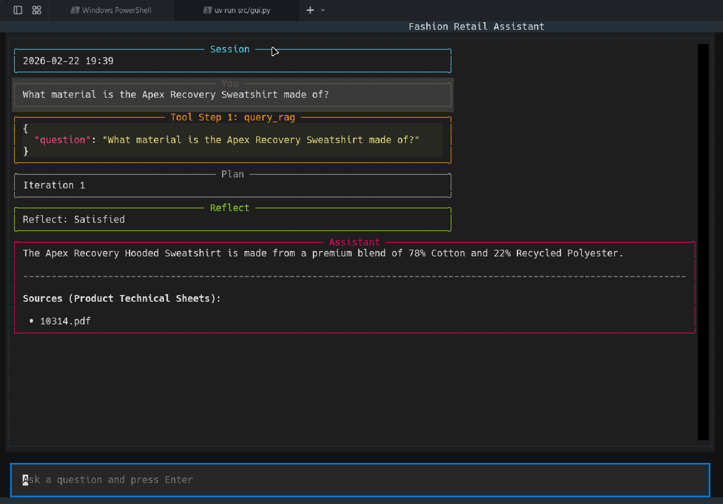

Example 3: Hybrid Query — SQL + RAG Cross-Source Analysis
Query: "Whats the material of the 5 most sold products in Germany in 2024?"
Depth: 3 (Deep)
Tools used: query_sql (x1) + query_rag (x5)

Agent Reasoning Process
This is the most complex query: it requires data from two completely separate sources (sales database + product PDF knowledge base) and the agent must chain them together autonomously.
Iteration 1 SQL discovery: The agent calls query_sql to find the top 5 products by units sold in Germany, joining transactions, products, and stores tables. Results: Turquoise Sports Printed (108), Short Skirt Of Satin Fabric With Belt (103), High-Sustaining Female Sports Top (100), Sports Jacquard Blue Embroidered (100), Lilac Leather Retro With Pockets (99).
Reflect Needs more data: The reflect node recognizes that sales rankings are complete, but material information is not in the SQL database — it exists only in the product technical sheet PDFs. The agent decides to query the RAG tool for each product.
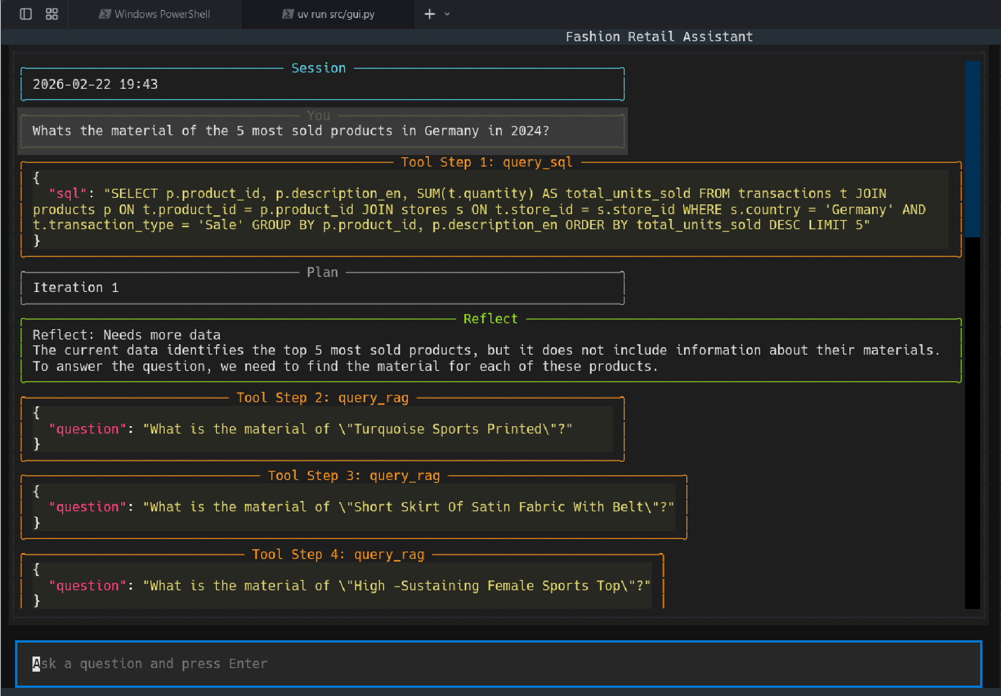
Iteration 2 Five RAG lookups: The agent launches 5 separate query_rag calls, one per product:
- "What is the material of Turquoise Sports Printed?"
- "What is the material of Short Skirt Of Satin Fabric With Belt?"
- "What is the material of High-Sustaining Female Sports Top?"
- "What is the material of Sports Jacquard Blue Embroidered?"
- "What is the material of Lilac Leather Retro With Pockets?"
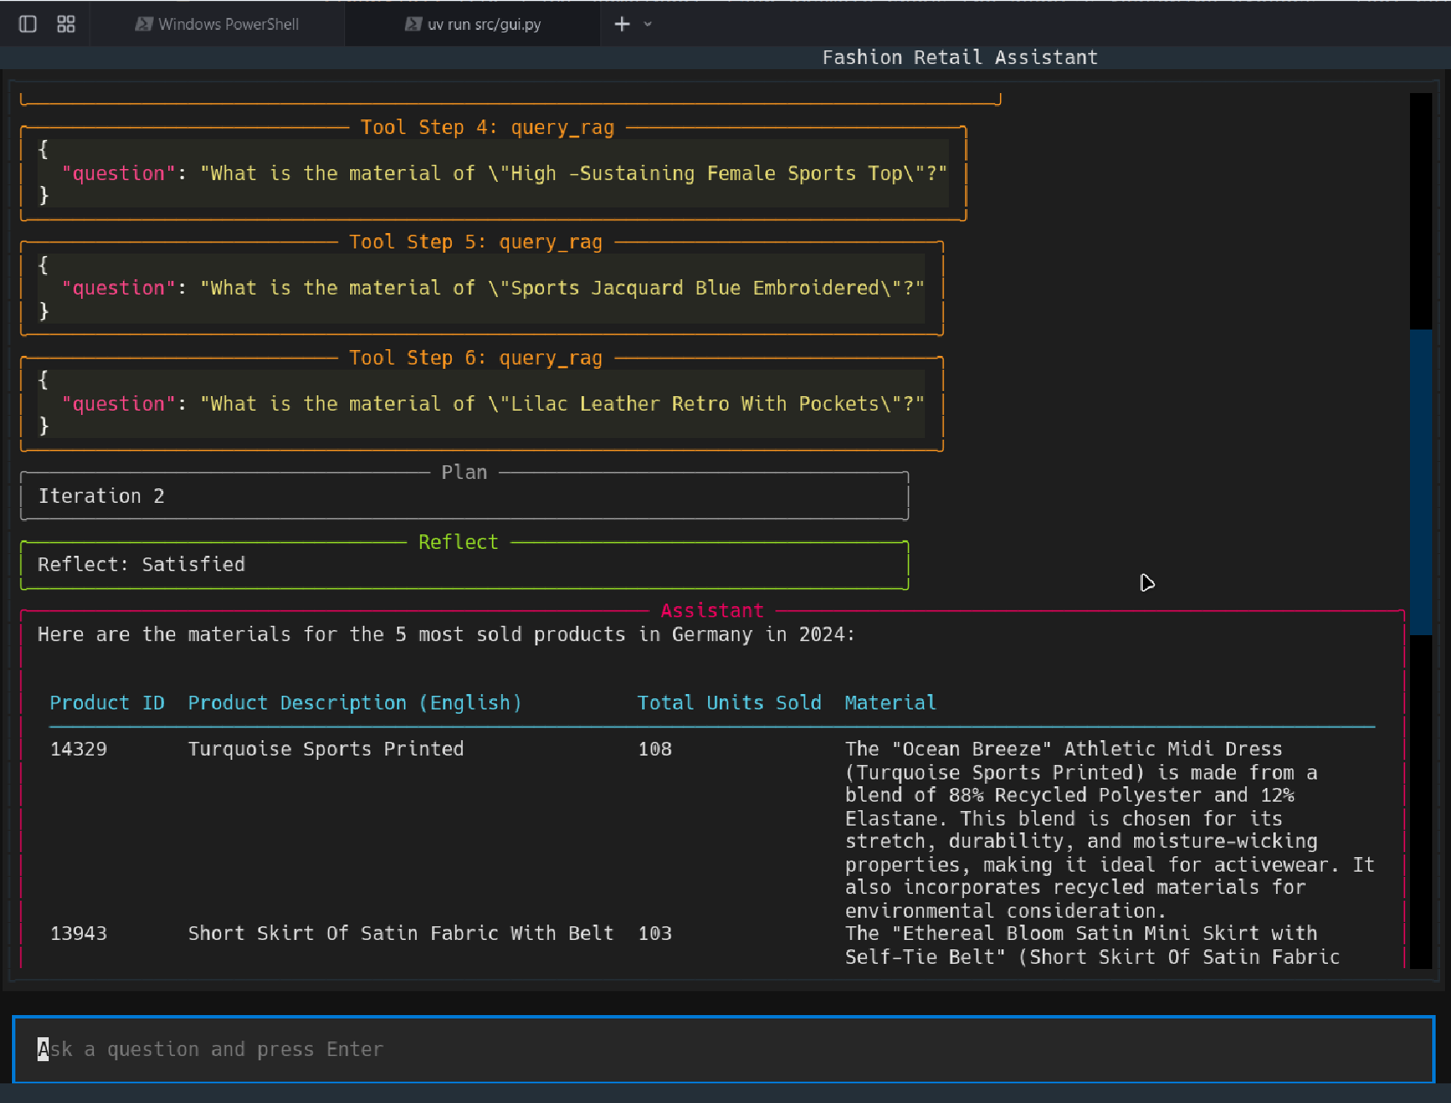
Reflect Satisfied: All 5 RAG lookups returned material data. The agent has both sales rankings (from SQL) and material details (from RAG).
Synthesized Answer: The agent produces a unified table combining data from both sources:
Product ID | Product Description | Units Sold | Material
14329 | Turquoise Sports Printed | 108 | 88% Recycled Polyester, 12% Elastane
13943 | Short Skirt Of Satin Fabric With Belt | 103 | Premium soft-touch satin fabric
12099 | High-Sustaining Female Sports Top | 100 | Proprietary ZenithFlex blend
12233 | Sports Jacquard Blue Embroidered | 100 | 70% Cotton, 30% Recycled Polyester
13378 | Lilac Leather Retro With Pockets | 99 | Premium leather-mimic blend
Sources cited: 13378.pdf, 12233.pdf, 12099.pdf, 13943.pdf, 14329.pdf — one PDF per product, all verified.
