LEO Satellite Site Suitability Engine
Starlink Installation Feasibility Analysis for North Carolina

Xihan Yao
The University of Texas at Austin
xyaoaf@utexas.edu
March 2026

1. Executive Summary
U.S. states have awarded LEO satellite providers grant funding to deliver broadband to underserved communities, but environmental obstructions—terrain, vegetation, and buildings—can degrade signal quality at specific locations. This system evaluates whether ~4.67 million candidate Starlink installation sites across North Carolina can receive usable service.
The engine integrates four public geospatial datasets into a deterministic analysis pipeline. For each candidate location, it composites terrain, canopy, and building data into a unified obstruction surface, performs vectorized ray-casting across 72 azimuth directions, evaluates six hard feasibility constraints, and produces a 0–100 risk score. Locations that fail are automatically searched for better nearby alternatives within 50 meters.
The system has been validated on 850+ North Carolina locations and provides five output modes: single-point diagnostics, batch processing, an interactive web map with on-demand analysis, area-of-interest selection, and zonal aggregation at county and census block group levels.

2. Analytical Framework
The system answers a single question: given a candidate location, is it suitable for Starlink dish installation, and if not, where nearby is better?
The pipeline integrates three spatial data layers into a unified elevation surface:

2.1 Terrain
Sourced from the USGS 3D Elevation Program (3DEP) via py3dep, with a four-level resolution fallback ladder (1 m → 3 m → 10 m → 30 m). Terrain is assessed at two scales: far-field (1,500 m radius) for ridges and hills that block low-elevation satellite links, and near-field (100 m) for local slope and micro-topography affecting dish mounting.

2.2 Vegetation
Canopy height data from the Meta Global Canopy Height model (Tolan et al., 2024). Primary source: 1 m resolution via Google Earth Engine. Fallback: 27 m Meta ALSGEDI product from AWS S3. Trees act as both geometric obstructions (blocking the FOV) and signal attenuators (reducing throughput even when not fully blocking). Assessed within a 100 m radius.

2.3 Buildings
Microsoft ML Building Footprints provide vector polygons with ML-predicted heights (primary for CONUS). Google Open Buildings v3 serves as fallback for non-CONUS regions. Buildings are dual in nature: obstacles when adjacent, but also rooftop installation opportunities that elevate the dish above surrounding obstructions. Assessed within a 100 m radius.

2.4 Horizon Ray-Casting
The three layers are composited into a unified elevation surface (terrain + canopy + buildings per pixel). A vectorized NumPy ray-casting engine samples 72 azimuth directions (every 5°) from the candidate point. For each azimuth within Starlink’s northward Field of View (±50° around North, i.e., azimuths 310°–50°), the algorithm computes the maximum obstruction elevation angle. Directions exceeding the blockage threshold are classified as obstructed, with each direction labeled by dominant obstruction type (terrain, vegetation, or building).

3. Risk Scoring & Feasibility

3.1 Deterministic Risk Score (0–100)
Three independent components are summed:
Component | Max Points | Logic
FOV Blockage | 50 | Fraction of northward FOV obstructed; linear 0%→0, 100%→50
Angle Severity | 30 | How far above threshold the worst obstruction reaches; higher = worse
Permanence | 20 | Terrain: 1.0×, Buildings: 1.0×, Vegetation: 0.6× (seasonal discount)

Tiers: Low (0–19) | Moderate (20–44) | High (45–69) | Critical (70–100).

3.2 Six Feasibility Constraints
A location is feasible only if all six binary constraints pass (logical AND):
Constraint | Threshold | Rationale
Far-field terrain | ≤10% FOV blocked | Regional topography—cannot be mitigated
Local slope | <20° | Ground-mount stability limit
Canopy at dish | <1 m (1m res) / <8 m (27m res) | No tree directly at installation point
Vegetation FOV | ≤15% FOV blocked | Seasonal obstruction, moderate tolerance
Building FOV | ≤5% FOV blocked | Hard, permanent obstruction
Roof usability | No overhang degradation | Evaluated for rooftop candidates

3.3 Local Neighborhood Search
If a location is infeasible or scores above 20, the system automatically searches ~50 candidate points within a 50 m radius. Each alternative is scored with the full pipeline plus a distance penalty (0.3 pts/m). The best candidate, improvement delta, and explanation are returned. This addresses the reality that input coordinates are approximate (geocoding error of 10–50 m).

4. Output Workflows
The system supports five distinct modes:
- 1. Single-point diagnostic:
Full analysis of one location producing a 5-panel diagnostic PNG (terrain hillshade, canopy + buildings overlay, constraint map, polar horizon profile, neighbourhood suitability) and a structured JSON report.
- 2. Batch processing:
Analyzes hundreds of points with spatially uniform sampling, concurrent workers (capped by 3DEP rate limits), and automatic skip of already-analyzed points. Tested on 850+ NC locations.
- 3. Interactive web map:
FastAPI + Leaflet.js application with multi-scale visualization. Pre-computed results displayed as color-coded markers. Clicking any point triggers on-demand analysis (~30 s) with results cached persistently.
- 4. AOI / region analysis:
Draw a rectangle on the map to select an area of interest. The system filters the 4.67M dataset, samples up to 100 points with spatial uniformity, and runs batch analysis.
- 5. Zonal aggregation:
Results aggregated at county (100 polygons) and census block group (7,111 polygons) levels. Metrics: points processed, % feasible, dominant failure mode per zone. Choropleth maps with continuous color gradient.

5. Results

5.1 Dataset Overview
The DATA_CHALLENGE_50 dataset contains 4,670,543 candidate locations across all 100 North Carolina counties. The density map below shows the spatial distribution, with concentrations in the Charlotte, Raleigh–Durham, and Triad metro areas.
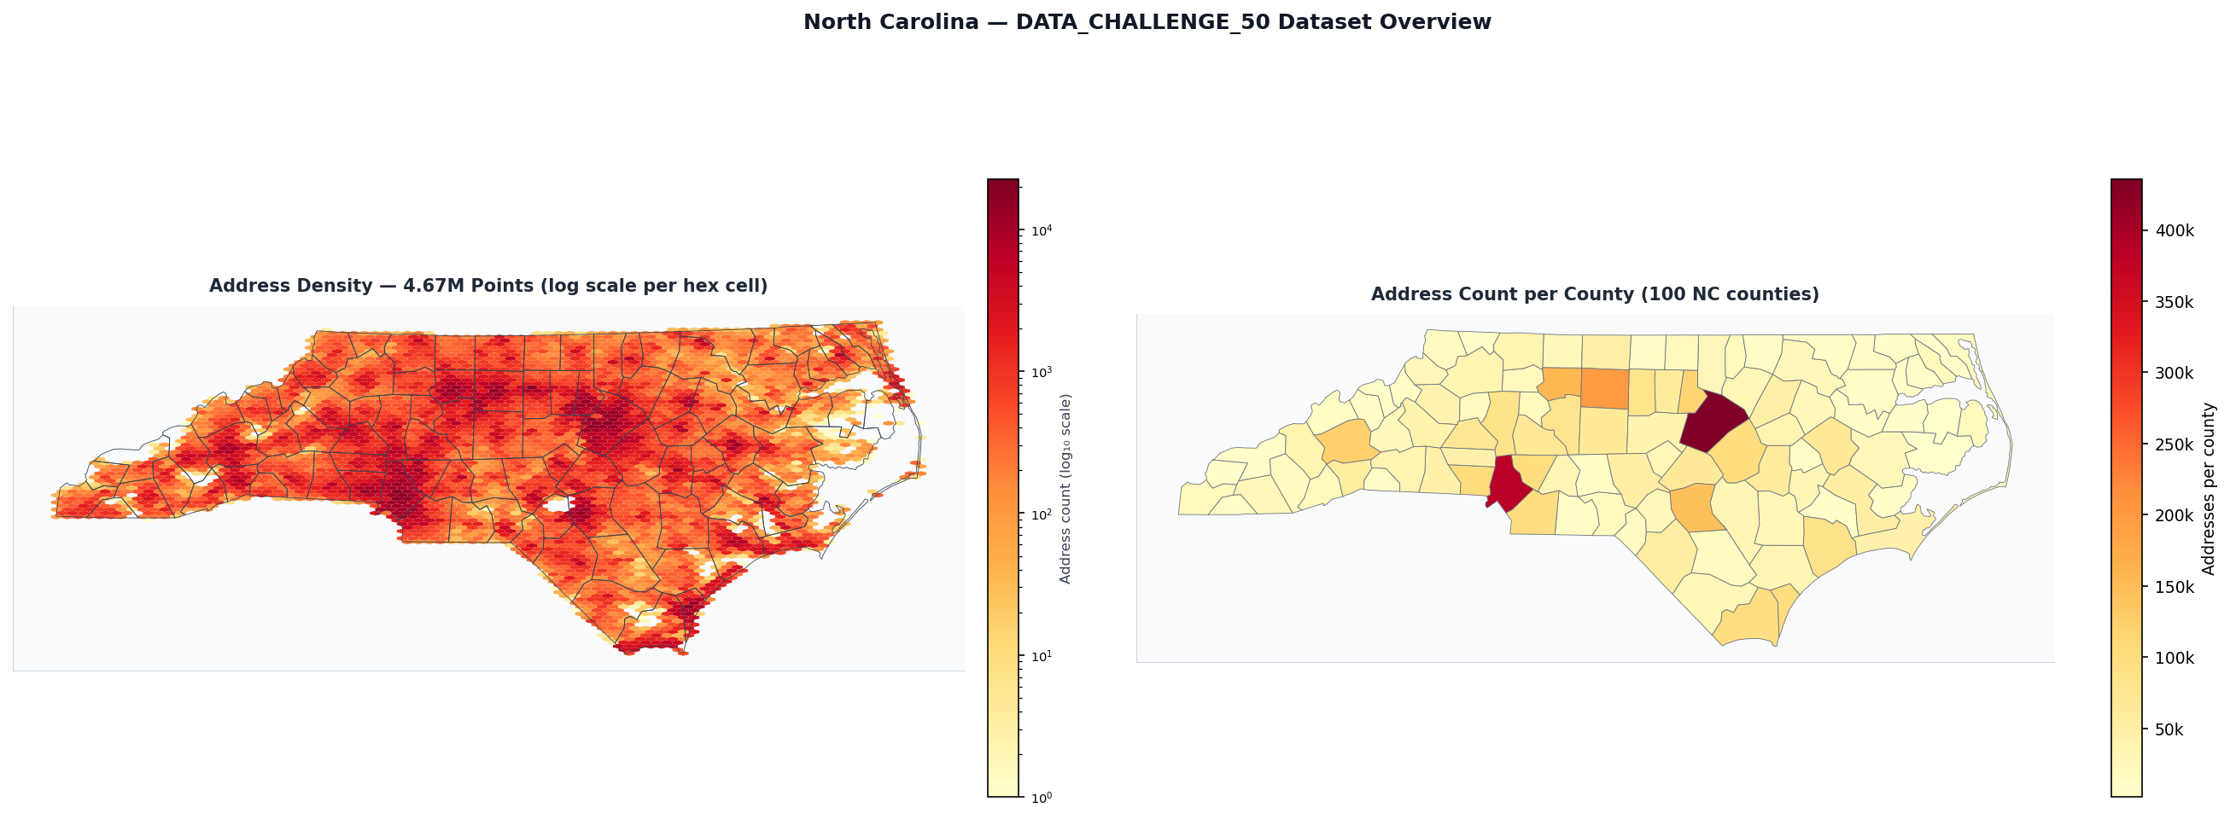
Figure 1. Spatial distribution of 4.67M candidate locations and address density across North Carolina.

5.2 County-Level Risk Aggregation
After analyzing 850+ locations across NC, results were aggregated at the county level. The choropleth below shows three views: mean risk score, percentage of infeasible locations, and percentage of critical-risk locations.
Western NC counties in the Appalachian mountains show consistently higher risk scores and infeasibility rates, driven by terrain obstruction. Piedmont and Coastal Plain counties are generally low-risk with open sky conditions. Counties with dense urban canopy (e.g., Durham, Orange) show moderate risk from vegetation.
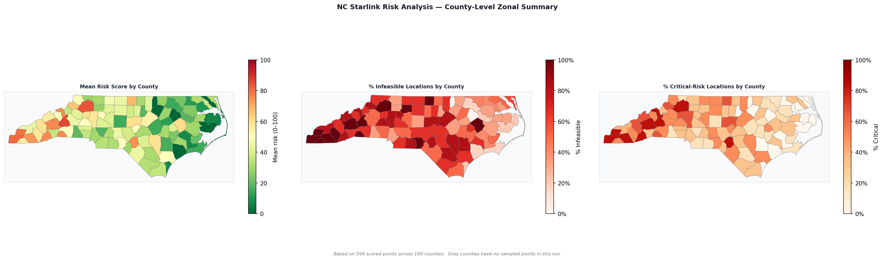
Figure 2. County-level aggregation: mean risk score (left), % infeasible (center), % critical (right).

5.3 Key Patterns
Three distinct geographic risk regimes emerge:
- Western NC: Mountain counties (Avery, Watauga, Ashe): 50–70% infeasibility rates. Terrain is the dominant constraint—ridgelines block the northward FOV at distances up to 1.5 km.
- Central NC: Piedmont and urban counties: 10–30% infeasibility. Mixed vegetation and building obstructions, with rooftop installation often viable.
- Eastern NC: Coastal Plain counties: <10% infeasibility. Flat terrain with minimal obstructions. Risk driven primarily by isolated tree canopy.

6. System Design Highlights
- Multi-scale terrain modeling (far-field 1,500 m + near-field 100 m)
- Unified elevation surface compositing terrain + canopy + buildings
- Vectorized NumPy ray-casting engine (72 directions, fully deterministic)
- Four-level resolution fallback ladders for terrain and canopy data
- Deterministic scoring formula (no ML dependency, fully reproducible)
- Automatic local search for actionable relocation recommendations
- Multi-scale web visualization (county → block group → individual dots)
- Progressive data loading (viewport-based, never loads all 4.67M at once)
- Continuous choropleth gradient with live zonal statistics updates
- Claude-orchestrated agent interface for natural-language queries

7. Limitations & Future Work

7.1 Current Limitations
- USGS 3DEP rate limiting caps throughput at ~500 locations/hour single-threaded
- Canopy height is a static snapshot (~2022); seasonal and recent changes not captured
- Building heights are ML-estimated (±2–5 m uncertainty for tall structures)
- Scoring weights (50/30/20) are engineering-calibrated, not empirically validated
- Binary obstruction threshold (25°) may overestimate infeasibility for marginal cases
- No uncertainty quantification—single score without confidence interval

7.2 Future Improvements
- Terrain tile pre-caching by county for 10× batch throughput
- Temporal satellite modeling via TLE orbit propagation
- Sub-threshold vegetation attenuation model (partial signal loss)
- ML-based score calibration against real Starlink signal quality data
- PostGIS persistence layer for concurrent access and spatial indexing
- GPU-accelerated ray-casting for real-time analysis

8. Reproducibility

8.1 Environment Setup
conda activate cs378
export ANTHROPIC_API_KEY=sk-ant-...
cd leo_risk_analysis && uvicorn app:app --port 8000

8.2 Key Directories
Path | Contents
src/ | Core pipeline: terrain, canopy, buildings, horizon, scoring, feasibility
outputs/ | Pre-computed results: JSON + PNG per analyzed point
outputs/zonal/ | County and block group summary CSVs + choropleth PNGs
data/boundaries/ | TIGER/Line county + block group GeoJSON (NC)
templates/map.html | Interactive Leaflet.js frontend
app.py | FastAPI web server

8.3 Data Files (Google Drive)
Large data files not included in the repository are available on Google Drive:
- DATA_CHALLENGE_50.csv (~600 MB) — 4.67M NC candidate locations
- outputs/ (~200 MB) — pre-computed analysis results
- Demo video (.mp4) — screen recording of full workflow

