DEVELOPING A TRUST-BASED COMMERCIAL ECOSYSTEM:

THE ROLE OF PEER-TO-PEER ESCROW SERVICES IN ENHANCING

THE SECURITY AND RELIABILITY OF NIGERIAN E-COMMERCE

TRANSACTIONS ON THE NIGERIAN BANKING INFRASTRUCTURE

BY

EKERE PRECIOUS JOSEPH

2018/1/72069CS

DEPARTMENT OF CYBER SECURITY SCIENCE

FEDERAL UNIVERSITY OF TECHNOLOGY

MINNA

AUGUST, 2024
DEVELOPING A TRUST-BASED COMMERCIAL ECOSYSTEM: THE ROLE OF PEER-TO-PEER ESCROW SERVICES IN ENHANCING THE SECURITY AND RELIABILITY OF NIGERIAN E-COMMERCE TRANSACTIONS ON THE NIGERIAN BANKING INFRASTRUCTURE
BY

EKERE, Precious Joseph
2018/1/72069CS

PROJECT SUBMITTED TO THE DEPARTMENT OF COMPUTER

SCIENCE, SCHOOL OF INFORMATION AND

COMMUNICATION TECHNOLOGY, FEDERAL UNIVERSITY OF

TECHNOLOGY, MINNA, NIGERIA IN PARTIAL FULFILLMENT

OF THE REQUIREMENT FOR THE AWARD OF THE DEGREE

OF BACHELOR OF TECHNOLOGY IN COMPUTER SCIENCE

(CYBER SECURITY)

AUGUST, 2024

DECLARATION

I hereby declare that this project titled: Developing a Trust-Based Commercial Ecosystem: The Role of Peer-to-Peer Escrow Services in Enhancing The Security and Reliability of Nigerian E-Commerce Transactions on the Nigerian Banking Infrastructure is a collection of my original project work and it has not been presented for any other qualification anywhere.

Information from other sources (published or unpublished) has been duly acknowledged.

EKERE, Precious

2018/1/72069CS Signature and Date

Federal University of Technology,

Minna, Nigeria.

CERTIFICATION

The project titled Developing a Trust-Based Commercial Ecosystem: The Role of Peer-To-Peer Escrow Services in Enhancing the Security and Reliability of Nigerian E-Commerce Transactions on the Nigerian Banking Infrastructure by EKERE, Precious, (2018/1/72069CS)

meets the regulations governing the award of Bachelor of Technology (B.Tech.) in

Computer Science of the Federal University of Technology, Minna.

Prof. Victor Waziri

Project Supervisor

Prof. Ismaila Idris

Head of Department

External Examiner
Signature and Date

Signature and Date

Signature and Date

ACKNOWLEDGEMENTS

I would like to express my deepest gratitude to my parents Mr and Mrs Ekere J.A for their unwavering support, love, and encouragement throughout my academic journey. Their belief in me has been my greatest motivation.
I am also immensely grateful to my elder brother Mr Bezalel Ekere and my immediate younger brother Covenant Ekere for their constant financial and moral support.
I extend my heartfelt appreciation to my project supervisor, Prof. Victor Waziri, the Head of Department, Cyber Security Science, Prof. Ismaila Idris and the Departmental Project Coordinator Dr. Subairu S.O for their invaluable guidance, insightful feedback, and continuous support throughout the duration of this project. Their combined expertise, leadership, and encouragement have been instrumental in the successful completion of this work.
Also, a special thank you to my two favorite aunts Mrs Victoria McCarthy & Miss Roseline Ademu and my favorite uncle Mr John Ademu for always being there for me, offering their love and support in countless ways. Your presence and words of wisdom has been a source of great comfort and strength.
Finally, I would like to extend my heartfelt thanks to my two best friends, Samuel Durotifa and Gospel Emeka, for their companionship and support. Our friendship has been a pillar of support throughout this journey.

ABSTRACT

This project explores the development of a trust-based commercial ecosystem through the integration of peer-to-peer (P2P) escrow services into Nigerian banking infrastructure, with the goal of enhancing the security and reliability of e-commerce transactions. The principal aim is to develop and execute a safe escrow payment system that can be easily integrated into current fintech and banking applications in Nigeria, thereby tackling common apprehensions regarding commitment adherence and transaction security. In addition, this research identifies and discusses the financial, legal, and technical obstacles to the implementation of these services, offering workable solutions. The project also seeks to increase user acceptance and trust of escrow services through focused education and awareness campaigns, which will promote wider adoption. It is anticipated that the result will greatly improve Nigeria's e-commerce environment, guaranteeing more secure and dependable financial transactions for all parties concerned.

TABLE OF CONTENTS

DECLARATION ii

CERTIFICATION iii

ACKNOWLEDGEMENTS iv

ABSTRACT v

TABLE OF CONTENTS vi

LIST OF FIGURES ix

GLOSSARY x
CHAPTER ONE 1
1.0 INTRODUCTION 1
1.1 Background of the Study 1
1.2 Problem Statement 2
1.3 Aim and Objectives 3
1.4 Significance of the Study 4
1.5 Scope of the Study 4
CHAPTER TWO 6
2.0 LITERATURE REVIEW 6
2.1 Introduction 6
2.2 Trust in E-commerce Transactions 6
2.3 Peer-to-Peer Escrow Services 7
2.4 Role of Nigerian Banking Sector in Escrow Services for E-commerce 8
2.5 Security and Reliability Enhancement 9
2.6 Regulatory Environment 10
2.7 Challenges and Considerations 10
2.7.1 Infrastructure Technological: 11
2.7.2 Regulatory Environment: 11
2.7.3 User Trust and Adoption: 12
2.7.4 Cybersecurity: 12
2.7.5 Financial Inclusion: 13
2.7.6 Cultural Factors: 13
2.7.7 User Experience: 13
2.7.8 Economic Impact: 14
2.7.9 Scalability: 14
2.8 Conclusion 15
CHAPTER THREE 16
3.0 SYSTEM ANALYSIS AND DESIGN: DEVELOPING A TRUST-BASED COMMERCIAL ECOSYSTEM 16
3.1 Introduction 16
3.2 Requirements Analysis 16
3.2.1 Stakeholder Identification and Analysis 16
3.2.2 Materials Used 20
3.3 Functional Requirements 23
3.4 Non-Functional Requirements 26
3.5 Methodology 26
3.6 Summary 27
CHAPTER FOUR 28
4.0 SYSTEM IMPLEMENTATION AND TESTING 28
4.1 Introduction 28
4.2. Implementation Strategy 28
4.2.1 Integration Planning 29
4.2.2 Development Preparation 29
4.2.3 Development and Integration 30
4.2.4 Deployment and Rollout 30
4.2.5 Launch and Post-Launch Support 30
4.3 Summary 37
CHAPTER FIVE 38
5.0 SUMMARY, CONCLUSION, AND RECOMMENDATIONS 38
5.1 Summary 38
5.2 Conclusion 39
5.3 Recommendations 39
5.3.1 Recommendations for System Improvement 39
5.3.2 Recommendations for Banking Institutions 40
5.3.3 Recommendations for Policymakers 40
5.4 Suggestions for Further Work 40
5.4.1 Explore Advanced Technologies 40
5.4.2 Explore Integration with Other Financial Services. 41

LIST OF FIGURES
fig 4.1 32
fig 4.2 33
fig 43 34
fig 4.4 34
fig 4.5 35
fig 4.6 35
fig 4.7 36
fig 4.8 36

GLOSSARY

Commercial Ecosystem: A network of interconnected businesses and services that work together to provide goods and services in a market.

Compliance: Adherence to laws, regulations, guidelines, and specifications relevant to a business or industry.

Dashboard: A central interface that provides an overview of all active and completed transactions, including pending actions.

Data-driven Analysis: Analyzing data to inform decision-making and strategies.

Digital Transactions: Financial transactions conducted electronically over the internet.

Dispute Resolution: The process of resolving conflicts or disputes that arise during a transaction.

E-commerce: The buying and selling of goods and services over the internet.

Escrow: A financial arrangement where a third party holds and regulates payment of the funds
required for two parties involved in a given transaction.

Fintech (Financial Technology): Innovative technology and solutions designed to improve and
automate the delivery and use of financial services.

Fraud: Wrongful or criminal deception intended to result in financial or personal gain.

Mobile Banking Applications: Software applications that allow users to conduct financial transactions via mobile devices.

Regulatory Constraints: Legal and regulatory limitations that can impact the implementation of new services or systems.

Scalability: The capability of a system, network, or process to handle a growing amount of work, or its potential to be enlarged to accommodate that growth.

Security Protocols: Rules and processes designed to protect data and ensure secure communication.

Sustainability: The ability to maintain or improve certain processes or systems over the long term without depleting resources or causing harm.

Transaction Security: Measures and protocols put in place to protect transactions from fraud, theft, and other risks.

Trust: Reliance on the integrity, strength, ability, or character of a person or thing; confidence.

User Interface (UI): The visual part of a system that users interact with, including dashboards and other interface elements.

User Support: Resources and channels provided to help users with the system, including help resources and feedback mechanisms.

CHAPTER ONE

INTRODUCTION

1.1 Background of the Study
The swift growth of online shopping in Nigeria has presented both prospects and difficulties. Concerns about security, dependability, and trust have grown in importance as more Nigerians transact online. The growth of the e-commerce industry in Nigeria is hindered significantly by fraud and a lack of trust in online transactions. Novel approaches, like peer-to-peer (P2P) escrow services, are being investigated and considered as a way to deal with these problems.

In order to prevent fraud and guarantee that both buyers and sellers carry out their end of the bargain, escrow services operate as impartial third parties that hold money during a transaction until all requirements are satisfied. Integrating P2P escrow services into the fintech and banking systems already in place could greatly improve the security and dependability of transactions, purchases, and exchanges in the context of Nigerian e-commerce.
Although Nigeria's banking system is well-established, there is still little to no interaction between it and online shopping portals. The convenience and accessibility of mobile banking applications have led to their widespread acceptance by the general public. However, their effectiveness in combating fraud and poor product or service delivery issues faced by customers who use these mobile banking applications to complete financial transfers to sellersᅳor, conversely, sellers experiencing underpayment from buyersᅳis limited by the absence of built-in security features and functionalities tailored for e-commerce transaction security. Peer-to-peer escrow services integrated into these apps could take advantage of their current infrastructure and user base to establish a more secure transactional environment.
A viable option for establishing escrow services is through fintech applications, which are renowned for their inventiveness, adaptability, and accessibility. Without a question, these platforms are more adept than the conventional banking system in quickly integrating new features and responding to market demands. Fintech apps that incorporate escrow services can provide enhanced security and foster a higher level of trust among users who plan to complete transactions, which is essential for the further expansion of e-commerce in Nigeria.
There are certain obstacles to using escrow services in Nigerian fintech applications, even with the apparent advantages. Concerns about user trust, financial ramifications, legal restrictions, and technical difficulties must all be addressed. Overcoming these barriers requires a strategic approach involving stakeholder collaboration, regulatory reforms, cost-effective solutions, and robust user education campaigns.
By integrating and implementing P2P escrow services into the current banking and fintech infrastructure, this study seeks to investigate how these services can improve the security and dependability of e-commerce transactions in Nigeria. This research aims to support the development of a trust-based economic ecosystem in Nigeria by identifying potential barriers and offering suggestions for how to overcome them.

1.2 Problem Statement
Nigeria's e-commerce sector has undoubtedly grown, but mistrust and security worries keep it from progressing past its current state. Nigerian consumers regularly experience scams and unfulfilled orders, eroding confidence in digital transactions. Online fraud and inconsistent transaction procedures discourage numerous potential users from participating in e-commerce every day, impeding the industry's potential (Oluwaseun, 2021).
However, the integration of such services into Nigeria's current banking infrastructure and fintech applications faces certain challenges. Technical complexities, regulatory constraints, cost implications, and issues related to user trust and acceptance must be addressed for successful implementation and widespread adoption (Eze, 2020; Aluko & Adeyemi, 2022). Nevertheless, peer-to-peer (P2P) escrow services, which act as impartial third parties to keep user funds secure during transactions, present a compelling resolution for these major concerns.
Existing mobile banking applications in Nigeria lack integrated security features tailored towards combating transactional fraud for e-commerce transactions, and although fintech platforms exhibit innovation, they need to incorporate robust escrow services to foster user trust and fortify transaction security. Without overcoming these barriers, the full potential of e-commerce in Nigeria remains unreachable, leaving consumers exposed to considerable risks whilst carrying out online purchases or transactions.
This study strives to expose the role of P2P escrow services in boosting security and dependability for Nigerian e-commerce users. It will pinpoint potential obstacles to their execution within the prevailing banking and fintech infrastructure, proposing certain tactical solutions to surmount these challenges and contribute towards the cultivation of a trust-based commercial ecosystem in Nigeria.

1.3 Aim and Objectives
Aim
By creating and deploying a peer-to-peer (P2P) escrow service that is integrated with Nigerian commercial banking and fintech applications, this development project aims to increase the security and dependability of e-commerce transactions. To tackle the present issues confronting Nigerian e-commerce, the project intends to create a commercial ecosystem based on trust, which will lower fraud and increase user confidence.
Objectives
- Design an exhaustive prototype and provide a comprehensive roadmap for the integration of a secure peer-to-peer escrow service within Nigerian commercial banking and fintech applications to enhance transaction security and compliance.
- Identify and address technical, regulatory, and cost barriers to ensure the successful implementation of P2P escrow services in Nigeria.
- Improve user trust and acceptance of escrow services through targeted education and awareness campaigns highlighting their benefits and safety measures.

1.4 Significance of the Study
Because it looks at how trust functions in Nigeria's online marketplace and trade, especially with peer-to-peer escrow services, this research is essential. There is a significant knowledge vacuum regarding consumer trust in digital transactions that is filled by understanding how these services make online transactions safer and more reliable (Beldad, de Jong, & Steehouder, 2010). Putting Nigeria in the spotlight contributes to broader discussions about building commercial ecosystems based on trust in developing nations (Kshetri, 2018).
Financial institutions, e-commerce businesses, and legislators can all benefit from this study's findings as they work to improve the environment for digital commerce (Straub, Boudreau, & Gefen, 2004). The conversation is enhanced by details regarding the scalability and sustainability of peer-to-peer escrow models in comparable economies (Chen & Chen, 2018). The study highlights how these services use data-driven analysis to reduce risks and boost customer confidence in online shopping (Komiak & Benbasat, 2006).
This research contributes to our understanding of consumer behavior in online marketplaces by revealing strategies for establishing trust in digital spaces (Corritore, Kracher, & Wiedenbeck, 2003). The results can help Nigeria's banking sector design more secure digital payment systems (Kim & Prabhakar, 2004). Overall, this study adds to our understanding and useful applications by providing significant insights into the reliability, security, and trust of e-commerce transactions.

1.5 Scope of the Study

We're looking into how peer-to-peer escrow services can help make online shopping in Nigeria safer and more trustworthy. Here's what we'll be focusing on:
- Understanding how these services work and how they can be used in online shopping platforms.
- Exploring how trust works in online marketplaces and how escrow services can help build that trust.
- Checking out how escrow services impact the security and reliability of online transactions, like preventing fraud and solving disputes.
- Taking a close look at Nigeria's unique e-commerce scene, including regulations, consumer behavior, and specific challenges in the market.
- Providing useful insights for people who make policies and run e-commerce platforms, financial institutions, and others who can shape the future of online shopping in Nigeria.
- Being aware of any limitations like sample size and data availability, and understanding that our findings might not apply to other countries.
Our goal is to contribute to the understanding of trust in online shopping, especially in emerging markets like Nigeria, and offer practical solutions to make online transactions more secure and reliable.

CHAPTER TWO

2.0 LITERATURE REVIEW

2.1 Introduction
Recent technical breakthroughs and rising internet penetration have greatly changed the face of electronic commerce (e-commerce) in Nigeria (Nwoye, 2018; Olufemi & Adebisi, 2020). But despite this expansion, issues with security and trust continue to be major roadblocks to the industry's full potential. Building confidence in online transactions between customers and sellers is essential to the long-term growth of e-commerce ecosystems. In Nigeria, where issues with payment disputes, non-delivery of products, and fraud are common, creative solutions are required to increase customer trust and enable safe transactions.

2.2 Trust in E-commerce Transactions

Trust is the cornerstone of successful e-commerce transactions, encompassing the confidence that buyers and sellers have in each other's integrity and ability to fulfill their obligations (Akinola & Dada, 2019). Unlike traditional face-to-face transactions, where trust is often built on personal interactions and established reputations, online transactions require alternative mechanisms to mitigate risks and assure parties of fair dealings. Trust is a complex notion in e-commerce that affects many facets of online transactions. Research highlights the crucial role that trust plays in enabling effective interactions between online buyers and sellers, emphasizing the significance of reputation-based trust evaluation methods in e-commerce contexts (Wang & Lin, 2008). Because online transactions are more unpredictable than conventional commerce, trust difficulties are particularly prominent in e-commerce (Lee et al., 2018). Building trust in e-commerce requires protecting buyer privacy, which has a direct impact on how people perceive trust in online transactions (Antoniou & Batten, 2011). Building trust between participants in online transactions is essential for both the success of individual transactions and the general expansion of the e-commerce sector, particularly in developing nations (Meskaran & Ismail, 2012). The many elements of trust that contribute to the overall degree of confidence in online transactions include payment security, courier services, product delivery, and e-commerce businesses (Subroto, 2018).
Furthermore, in e-commerce, customer behavior and perceptions are strongly correlated with trust. For online transactions to be successful, trust must be established and maintained. This will affect customers' willingness to reveal personal information, make purchases, and heed vendor advice—all of which are essential for e-commerce to become widely used (F, 2024; McKnight et al.,2002).
Beyond merely security measures, trust in e-commerce is a complicated cognitive process driven by a number of variables, such as personal characteristics and transaction history data (Gao & Wu, 2010).

2.3 Peer-to-Peer Escrow Services

Peer-to-peer (P2P) escrow services are one novel approach that is gaining popularity worldwide, especially in developing nations like Nigeria (Akinyemi & Olokundun, 2019). In order to make sure that all parties fulfill their responsibilities before the deal is finalized, escrow includes having a reliable third party hold money or items temporarily throughout a transaction. By lowering the possibility of fraud and non-performance, this technique improves transaction security and builds confidence between buyers and sellers. P2P escrow services offer a regulated framework that protects transactions and promotes market participation from both consumers and companies in the Nigerian e-commerce setting, where worries over payment security and product authenticity are common. Trust models have been created in the context of P2P e-commerce systems to identify and manage risks, improving the quality of service delivery (Shen & Liu, 2012). By holding money until transactions are properly completed, escrow services, as a risk-relief tool in e-commerce, protect transactions and foster confidence (Kusumawati & Achjari, 2019). In e-service contexts, trust-building strategies like privacy declarations and escrow services are essential for promoting loyalty and trust (Mäntymäki, n.d.).
In essence, encouraging confidence, security, and dependability in online transactions requires the incorporation of peer-to-peer escrow services into Nigerian e-commerce platforms. Through the utilization of institutionally based trust mechanisms such as escrow services, Nigerian enterprises may effectively tackle obstacles, improve client happiness, and foster the expansion of the local e-commerce ecosystem.

2.4 Role of Nigerian Banking Sector in Escrow Services for E-commerce

Although it has it’s issues with trust and security, Nigeria's financial infrastructure is essential to the facilitation of e-commerce (Agwu & Nnadi, 2021). P2P escrow services can help close this gap by providing an impartial platform on which sellers can be sure that money is received before completing orders, and purchasers can release funds only after verifying receipt of goods or services. This approach nurtures an atmosphere that is favorable to the growth of sustainable e-commerce by promoting fairness and transparency in addition to mitigating the risks associated with online transactions. The Nigerian banking infrastructure plays a pivotal role in facilitating e-commerce transactions but faces challenges related to trust and security (Agwu & Nnadi, 2021). P2P escrow services can bridge this gap by offering a neutral platform where buyers can release payment only after confirming receipt of goods or services, and sellers can be assured that payment is secured before fulfilling orders. This model not only mitigates risks associated with online transactions but also promotes fairness and transparency, thereby nurturing a conducive environment for sustainable e-commerce growth. By boosting e-commerce turnover and improving credit conditions for small enterprises, fintech indirectly supports economic growth by promoting financial literacy and inclusive financial management in Micro, Small, and Medium Enterprises (MSMEs) (Hamid, 2024; Secretariat, 2022). In e-commerce platforms, escrow services act as a trust mechanism that moderates trust relationships and repurchase intents (Kusumawati & Achjari, 2019). Economic growth, infrastructural development, and the promotion of confidence in online transactions depend on the financial sector's participation in e-commerce (Chen et al., 2021; Kardaras & Papathanassiou, 2001). Building confidence, guaranteeing secure transactions, and advancing financial inclusion in Nigerian e-commerce depend heavily on the banking and fintech industries working together to provide and improve escrow services. Through the utilization of fintech technologies and regulatory assistance, Nigeria has the potential to enhance its e-commerce infrastructure and propel economic growth.

2.5 Security and Reliability Enhancement

Integrating Peer-to-Peer escrow services improve security and dependability in Nigeria's e-commerce ecosystem in a number of important ways. First off, escrow services increase customer trust and desire to participate in online transactions by reducing the danger of fraud through verification procedures and safe money management (Iwu & Uddin, 2020). Second, by providing procedures for quick and equitable dispute resolution, these services guarantee that disagreements resulting from transactions may be settled in a timely and objective manner. This enhances the user experience and strengthens the legitimacy of e-commerce sites. Additionally, escrow services draw in more buyers and sellers by offering a safe payment channel, which grows the market and propels economic growth in the digital economy.

2.6 Regulatory Environment

Nigeria's regulatory environment has a big influence on how digital transactions are developing, especially e-commerce and online payments. For the nation to advance electronic payment systems and promote innovation, the government must remove regulatory obstacles Kasie & Nwaolisa (2012). The adoption of the cashless policy in 2011 marked Nigeria's shift to electronic payment systems, which included mobile banking, ATMs, and internet banking (Virginia, 2023). Notwithstanding these developments, problems like usability problems on e-commerce platforms continue to exist and impede the expansion of e-commerce businesses in Nigeria (Abraham et al., 2021). The regulations that govern Nigeria's electronic retail payment systems are essential for improving user acceptance and addressing payment-related problems. This highlights the importance of a regulatory environment that is supportive in fostering trust and encouraging the uptake of digital payment solutions (Kasie & Nwaolisa, 2012). Additionally, a review of how the cashless policy affected small and medium-sized businesses (SMEs) in Southeast Nigeria highlights how crucial e-payment governance is to promoting financial inclusion and economic growth (Virginia, 2023).

2.7 Challenges and Considerations

Establishing trust is essential for the success of web-based businesses because it influences consumers' willingness to engage in transactions (Salam et al., 2005). Additionally, customer satisfaction in e-commerce settings is directly impacted by the reliability of service quality (Omar et al., 2015). Developing a trust-based commercial ecosystem in Nigerian e-commerce, specifically focusing on the role of peer-to-peer (P2P) escrow services within the Nigerian banking infrastructure, presents a number of challenges and considerations.

2.7.1 Infrastructure Technological:

The present examination of internet penetration, speed, and stability in Nigeria's various regions pertains to the dependability of internet services in that country. Think about the differences between urban and rural areas and how they could impact the uptake of P2P escrow services. Also, examine the technical difficulties in integrating new P2P escrow platforms with legacy banking systems. Integration with current banking systems. Examining API integrations, problems with data synchronization, and possible system incompatibilities may be part of this.
(Oluyinka et al., 2013) investigated factors influencing e-commerce adoption, including technological readiness. (Ayo et al., 2016) examined how the quality of technological infrastructure impacts e-banking adoption in Nigeria.

2.7.2 Regulatory Environment:

Compliance with Nigerian financial regulations by examining the country's current financial laws, paying particular attention to those governing escrow services, digital payments, and e-commerce. Think about the ways in which these laws might need to change to allow for P2P escrow services. In the same vein, Laws governing peer-to-peer escrow services; Examine the current legal framework and note any gaps so that P2P escrow services can be supported. Contract law, consumer protection, and dispute resolution are a few examples of these.
(Akintoye & Araoye, 2011) looked at the legal aspects of stopping e-fraud in electronic payment systems, and (Kshetri, 2018) gave information about the cybersecurity regulatory environment in Africa.

2.7.3 User Trust and Adoption:

Overcoming skepticism about online transactions by prospective and active users by examining the causes of Nigerian users' skepticism, such as unfamiliarity with digital transactions or prior fraud experiences. Think about methods to increase credibility and trust. Also, developing user trust in P2P escrow services; Look into ways to create and preserve user trust in P2P escrow services, such as trust signals, user education, and transparency policies.
While (Babalola & Babalola, 2013) examined the economic factors influencing the adoption of e-commerce, (Olusola et al., 2013) investigated factors influencing the adoption of e-banking in Nigeria, including trust.

2.7.4 Cybersecurity:

Preventing fraud and cyberattacks by analyzing the Nigerian e-commerce industry's present cybersecurity risks and consider possible security solutions for P2P escrow services. This could involve fraud detection algorithms, multi-factor authentication, and encryption techniques. Also, Providing security and privacy for data; Examine the best practices for data security in financial transactions and how P2P escrow services in Nigeria can benefit from them. Take into account both international and local data protection regulations.

ICT effects on small businesses, including cybersecurity issues, were covered by (Akomea-Bonsu & Sampong, 2012), whereas (Okeke, 2017) focused on security issues with Nigerian e-payment systems.

2.7.5 Financial Inclusion:

Accessibility for underbanked populations by investigating how P2P escrow services can be tailored to cater to Nigeria's underbanked or unbanked populace. This could entail taking into account credit scoring or other forms of identification. Also, Integration with existing mobile money platforms; Since these platforms have been successful in reaching unbanked populations in other African countries, look into the possibility of integrating P2P escrow services with them.
Digital financial services in Nigeria and their impact on financial inclusion were examined by David-West et al. (2018), while Asongu & Nwachukwu (2018) examined technological advancements in inclusive development.

2.7.6 Cultural Factors:

Adapting P2P escrow services to the cultural context of Nigeria by taking into account how Nigerian cultural norms and values may affect the creation and uptake of P2P escrow services. This could involve perspectives on money transactions, community, and trust. As well as taking preferences for cash transactions into account; Examine ways to get around Nigerians' inclination toward cash transactions, as this could be a major obstacle to the uptake of digital escrow services.
While (Olakunle et al., 2017) looked at cultural influences on electronic payment systems, (Adeyeye, 2008) examined cultural aspects of e-commerce adoption in Nigeria.

2.7.7 User Experience:

Creating user-friendly interfaces for a wide range of users: Take into account Nigeria's heterogeneous user base, which includes differences in linguistic preferences, educational attainment, and technological literacy. Examine UI design concepts that can take this diversity into account. Also, finding ways to combine strong security measures with ease of use; Looking into ways to make the platform more user-friendly while still implementing strong security measures. This could entail investigating cutting-edge authentication techniques or evolving security features.
While (Ayo et al., 2016) looked at user behavior in e-banking services, (Adeyeye, 2008) touched on aspects of the user experience of e-commerce in Nigeria.

2.7.8 Economic Impact:

Analyzing effects on conventional banking services by examining the potential effects of the introduction of P2P escrow services on Nigeria's traditional banking services. Possible changes to revenue streams or adjustments to customer relationships may fall under this category. Relatively, projecting possibility of job displacement or creation; Examine the economic effects of P2P escrow services, taking into account the possibility of job displacement in traditional financial services roles as well as the creation of jobs in the tech and customer service sectors.

While David-West et al. (2018) investigated the economic effects of digital financial services in Nigeria, Asongu & Nwachukwu (2018) talked about the wider economic effects of financial technology.

2.7.9 Scalability:

Handling increased transaction volumes by Investigating technical solutions for ensuring that P2P escrow platforms can handle growing transaction volumes as adoption increases. This might involve cloud computing solutions or distributed systems architectures. In the same light, considerations for maintaining service quality during peak periods; Explore strategies for maintaining high service quality and fast transaction processing even during peak usage periods, such as holidays or promotional events.
(Oluyinka et al., 2013) touched on scalability issues in e-commerce adoption, while (Ayo et al., 2016) discussed service quality in e-banking contexts.

2.8 Conclusion

In conclusion, Nigerian e-commerce must create a trust-based commercial environment if it is to expand sustainably and be integrated into the global digital economy. According to Olufemi and Adebisi (2020), peer-to-peer escrow services are a crucial tool for improving transaction security and dependability in Nigeria's banking system. The growth and development of the Nigerian e-commerce industry may be greatly aided by escrow services, which solve issues with trust, security, and regulatory compliance. But given Nigeria's changing digital world, coordinated efforts are needed to get over current obstacles and maximize the potential of escrow services.

CHAPTER THREE

3.0 SYSTEM ANALYSIS AND DESIGN: DEVELOPING A TRUST-BASED COMMERCIAL ECOSYSTEM

3.1 Introduction
For Nigerian e-commerce to establish a strong and functional trust-based commercial ecosystem that makes use of peer-to-peer (P2P) escrow services, the system analysis and design phase is essential. This section describes the methodical process used to comprehend, organize, and create the features required to improve transaction security and dependability in the ecommerce sector in Nigeria. In order to create a scalable and secure platform that promotes trust and enables smooth transactions, this phase focuses on stakeholder needs, functional and non-functional requirements, architectural design, and implementation strategies.

3.2 Requirements Analysis

3.2.1 Stakeholder Identification and Analysis
With peer-to-peer escrow services being used for Nigerian e-commerce transactions, a trust-based commercial ecosystem is being developed. This stakeholder analysis offers a thorough overview of all the parties engaged or impacted by this development. It is possible to create a system that meets a variety of demands and has broad support by taking into account the interests, impacts, influences, and expectations of various stakeholders.
- Primary Stakeholders:
a) Buyers/Consumers:
Interests: Secure transactions, protection from fraud, easy-to-use interface, timely delivery of goods/services
Impact: High (direct users of the system)
Influence: Medium (can affect adoption rates)
Expectations: Increased trust in e-commerce, reduced risk of financial loss
b) Sellers/Merchants:
Interests: Guaranteed payment, increased sales, protection from chargebacks, wider customer base
Impact: High (direct users of the system)
Influence: High (their participation is crucial for system success)
Expectations: Increased sales, reduced payment disputes, improved cash flow
c) Banks/Financial Institutions:
Interests: Integration with existing systems, compliance with regulations, increased transaction volume
Impact: High (provide the underlying financial infrastructure)
Influence: High (can facilitate or hinder implementation)
Expectations: Increased revenue from transaction fees, improved security measures
- Secondary Stakeholders:
e) Nigerian Government:
Interests: Economic growth, tax revenue, consumer protection, financial inclusion
Impact: Medium (regulatory oversight)
Influence: High (can create supportive or restrictive policies)
Expectations: Increased formal economy transactions, reduced fraud in e-commerce
f) Central Bank of Nigeria (CBN):
Interests: Financial stability, monetary policy implementation, oversight of payment systems
Impact: Medium (regulatory body for financial transactions)
Influence: High (can enforce compliance and set guidelines)
Expectations: Improved financial system integrity, increased digital transactions
g) E-commerce Platforms:
Interests: Integration with escrow services, improved user trust, increased sales
Impact: Medium (potential partners or competitors)
Influence: Medium (can drive adoption through their platforms)
Expectations: Reduced transaction disputes, increased customer satisfaction
h) Payment Gateway Providers:
Interests: Integration opportunities, increased transaction volume
Impact: Medium (facilitate payment processing)
Influence: Medium (can affect system functionality)
Expectations: Revenue growth, expanded market share
- Tertiary Stakeholders:
k) Legal Firms:
Interests: Providing legal advice, handling disputes
Impact: Low (indirect involvement)
Influence: Low (can affect dispute resolution processes)
Expectations: Legal consultation fees, potential litigation work
l) Consumer Protection Agencies:
Interests: Safeguarding consumer rights, ensuring fair practices
Impact: Low (indirect involvement)
Influence: Medium (can affect public perception and trust)
Expectations: Reduced consumer complaints, improved e-commerce practices
m) Media and Press:
Interests: Reporting on the new system, its impacts and challenges
Impact: Low (indirect involvement)
Influence: Medium (can shape public opinion)
Expectations: Newsworthy stories, access to data and insights

n) Educational Institutions:
Interests: Research opportunities, case studies for teaching
Impact: Low (indirect involvement)
Influence: Low (can contribute to long-term system improvements)
Expectations: Access to data for research, collaboration opportunities
o) International Financial Organizations (e.g., World Bank, IMF):
Interests: Financial inclusion, economic development, best practices
Impact: Low (indirect involvement)
Influence: Medium (can provide funding or endorsement)
Expectations: Improved financial ecosystem in Nigeria, potential model for other countries

3.2.2 Materials Used
A range of resources are needed to build a solid foundation that would enable the integration of peer-to-peer escrow services into financial banking applications in Nigeria. These supplies include hardware, software tools, and other resources needed for development, implementation, and maintenance.
- Software Tool Used
Miro:
Miro is a collaborative online whiteboard platform designed for teams to work together visually and virtually. It provides a flexible, infinite canvas that supports real-time collaboration, making it an excellent tool for creating wireframes, prototypes, and other visual design elements.
Key Functionalities:
Infinite Canvas: Miro offers an expansive workspace that allows for unlimited design possibilities, ideal for complex system designs like your escrow payment solution.
Wireframing Tools: It provides specific tools and templates for creating wireframes, including pre-built UI elements, icons, and shapes.
Real-time Collaboration: Multiple team members can work on the same board simultaneously, facilitating collaborative design processes.
Integration Capabilities: It integrates with various tools like Jira, Trello, and Google Drive, which can be useful for project management and documentation.
Presentation Mode: This feature allows you to present your wireframes directly from the platform, useful for stakeholder meetings or reviews.
Why Miro is Suitable for This Project:
Visual Complexity Management: The infinite canvas is ideal for mapping out the complex interactions in a peer-to-peer escrow system.
Iterative Design: Easy editing and version history support the iterative nature of UX design, allowing you to refine your wireframes based on feedback.
Collaboration: As you're integrating with an existing banking application, you may need to collaborate with various stakeholders. Miro's real-time collaboration features facilitate this process.
Integration Flexibility: The ability to create custom elements allows you to accurately represent the existing banking app's UI components in your wireframes.
Presentation Capabilities: You can easily present your designs to project stakeholders, which is crucial for a sensitive financial application.
Prototyping: While primarily a wireframing tool, Miro also supports basic prototyping, allowing you to demonstrate user flows in the escrow system.
- Hardware Tools Used:
A laptop and a phone were indispensable in the process of carrying out this project. It was essential to create the user interface wireframe of your peer-to-peer escrow payment system using both a laptop and a phone for the following reasons:
Multi-platform design: Using both devices guarantees that the user experience across all screen sizes and interfaces is taken into account in your wireframe. This is crucial for a banking program that users would probably use on their desktop and mobile devices.
Testing for responsiveness enables you to see and feel how your design changes in response to various screen sizes and orientations right away, making sure that your wireframes are responsive from the start.
User perspective: You may create a better user-centric design by utilizing both devices and placing yourself in the position of users who might use the escrow service in a different way.

3.3 Functional Requirements
The wireframe prototype being developed is driven by these functional requirements in order to create a P2P escrow payment platform that is based on trust. The prototype will be easy to connect with an existing FinTech or bank application in Nigeria, guaranteeing safe, dependable, and user-friendly transactions.
1. User Authentication and Authorization
Login/Sign-up Integration: The wireframe allows users to log in or sign up using the existing bank or FinTech application's authentication system.
Role-Based Access: Different roles (Buyer, Seller, Escrow Agent) have access to different functionalities based on their role.
2. Escrow Account Management
Create Escrow Account: Users are able to initiate the creation of an escrow account for a transaction.
View Escrow Accounts: Users are able to view a list of their active and completed escrow accounts.
Account Details: Detailed view of each escrow account, including transaction information, involved parties, and current status.
3. Transaction Management
Initiate Transaction: Buyers are able to initiate a transaction by specifying transaction details such as unique user ID, unique product ID.
Approve/Reject Transaction: Sellers have the ability to approve or reject a transaction request.
Update Transaction Status: Both parties are able to update the transaction status (e.g., goods shipped, goods received).
4. Payment Handling
Deposit Funds: Buyers are able to authorize direct debit from current balance on personal and business host bank account.
Release Funds: Upon transaction completion, funds shall be released to the seller based on predefined conditions.
Refund Process: In case of a dispute resolution favoring the buyer, funds will be refunded to the buyer’s account from whence the payment was made.
5. Dispute Resolution
Raise Dispute: Either party are able to raise a dispute if there is an issue with the transaction.
View Dispute Details: Users are able to view details of the dispute, including the reason and supporting evidence.
Escrow Agent Intervention: Escrow agents will have the ability to review disputes, request additional information, and make a final decision.
6. Notification System
Transaction Updates: Users would receive notifications for key events (e.g., transaction initiation, status changes, fund release).
Dispute Notifications: Notifications will be sent when a dispute is raised, updated, or resolved.
General Alerts: Users whould receive alerts for general updates or important announcements related to the escrow service.
7. User Interface
Dashboard: A central dashboard providing an overview of all active and completed transactions, including pending actions.
Search and Filters: Users should be able to search and filter transactions based on various criteria and search parameters (e.g., unique transaction ID, date, status, amount).
8. Security and Compliance
Data Encryption: All sensitive data will be encrypted to ensure confidentiality.
Audit Trails: Comprehensive logging of all actions taken within the escrow service to ensure traceability and accountability.
Compliance Checks: The system will adhere to relevant regulatory requirements, ensuring legal and financial compliance.
9. Integration Points
API Integration: Seamless integration with the existing bank or FinTech application's APIs for authentication, payment processing, and notifications.
Data Sync: Data is consistently synchronized between the escrow service and the existing application to maintain data integrity.
10. User Support
Help and Support: Provide access to help resources and support channels within the wireframe.
Feedback Mechanism: Allow users to submit feedback or report issues related to the escrow service.

3.4 Non-Functional Requirements
Non-functional requirements specify the quality attributes and constraints that the system must adhere to:
- Performance: The system is designed with performance metrics in consideration, parameters such as response times, throughput, and scalability are enhanced to accommodate peak transaction volumes, ensure efficient resource utilization and minimal latency in transaction processing.
- Security: Stringent security measures are implemented, including data encryption, secure communication protocols, and compliance with regulatory standards (such as GDPR and PCI-DSS). Guaranteed protection of sensitive user information, transactional data, and financial details.
- Usability: The user interfaces (UI) and user experience (UX) features are intuitive and DIY enhanced to allow for ease in accessibility, navigation, and usability for diverse user groups.

3.5 Methodology
A wireframe prototype for a peer-to-peer escrow service that easily interfaces with the banking apps that are currently in use in Nigeria was produced by combining visual design, user experience (UX) concepts, functional and non-functional requirements.
The utilization of Miro, a collaborative online whiteboard platform, is the basis of this technique. Visualizing the intricate relationships inside the escrow system is made possible by Miro's enormous, endless canvas. It is possible to map out user flows, transaction procedures, and possible scenarios—including dispute resolution—using this visual method. The interactive prototypes that showcase the suggested user interface (UI) features and capabilities are made easier by Miro's wireframing tools. A smooth integration is ensured by the ability to incorporate custom elements, which enable faithful portrayal of the UI components of current banking applications.
The wireframe's creation is directed by a collection of functional criteria that delineate the principal features of the suggested escrow service. These specifications provide the fundamental functionalities of the system and cover everything from user identification and escrow account administration to transaction initiation, payment processing, dispute resolution, and security protocols. By concentrating on these specifications, the wireframe hopes to develop a dependable, safe, and user-friendly escrow service that improves openness and confidence in the Nigerian e-commerce sector.

3.6 Summary
In summary, the foundation for a robust and user-centered platform is laid by the system analysis and design stage of creating a trust-based commercial ecosystem with P2P escrow services in Nigerian e-commerce. The system intends to improve transaction security, dependability, and user confidence within the Nigerian financial infrastructure by attending to stakeholder demands, establishing thorough functional and non-functional requirements, and creating scalable architecture and user-friendly interfaces. The next stage entails testing, deployment, and implementation, clearing the path for a game-changing solution in the dynamic context of the digital economy.

CHAPTER FOUR

4.0 SYSTEM IMPLEMENTATION AND TESTING

4.1 Introduction
This chapter describes the entire process of putting the trust-based commercial ecosystem prototype into practice and testing it, with an emphasis on how peer-to-peer escrow services are integrated into the Nigerian banking system. The development of the user interface wireframe and backend integration are included in the implementation phase, which describes how the system design is translated into a working prototype. Thorough testing is carried out after the system is put into place to make sure it is secure, dependable, and generally effective in improving e-commerce transactions in Nigeria. This chapter describes the approaches, resources, and processes used in the phases of development and testing, along with the conclusions and ramifications of the testing findings.

4.2. Implementation Strategy
A P2P escrow payment solution's user interface wireframe implementation approach entails careful planning, iterative design, extensive testing, and smooth connection with the current banking application. By taking these activities, the project guarantees an escrow service that is easy to use, safe, and dependable, improving the security and dependability of e-commerce transactions.

4.2.1 Integration Planning
API Mapping: List and describe the APIs required to link the escrow service to the current banking program. Verify that all necessary endpoints are safe and operational.
Data Flow Diagrams: To illustrate the data transmission process between the banking application and the escrow service, create data flow diagrams. Make sure that the data is synchronized and intact.
Security Considerations: Make plans to put security mechanisms like authorization, authentication, and encryption into place to safeguard user information and transactions.

4.2.2 Development Preparation
Component Identification: Divide the wireframes into their component parts, such as dashboards, buttons, and forms. To make the development process go more quickly, identify reusable components.
Style Guide Creation: Develop a style guide to ensure consistency in design elements such as colors, fonts, and icons. Developers will refer to this guidance when implementing.
Development Environment Setup: Configure the development environment using the frameworks and tools that are required. Verify compatibility with the tech stack of the current banking application.

4.2.3 Development and Integration
UI Development: Start developing the UI components based on the wireframes. Make use of front-end technologies such as JavaScript, HTML, and CSS, or frameworks such as Angular, React, or Vue.js.
API Integration: Connect the created user interface to the backend APIs of the banking application. Make sure that information is sent between the frontend and backend systems accurately and securely.
Continuous Testing: Perform continuous testing during development to identify and fix issues early. Perform user acceptability testing (UAT), integration testing, and unit testing.

4.2.4 Deployment and Rollout
Staging Environment: Deploy the escrow service in a staging environment for final testing. Verify that there are no security flaws and that all features operate as intended.
Final Testing: To make sure the system is prepared for production, carry out thorough testing in the staging environment, including end-to-end and performance testing.
User Training: To acquaint end users with the new escrow service and its features, provide training sessions and documentation.

4.2.5 Launch and Post-Launch Support
Production Deployment: Deploy the escrow service to the production environment. Ensure a smooth transition with minimal disruption to existing services.
Monitoring and Support: Monitor the system closely after launch to identify any issues or user feedback. Provide ongoing support and maintenance to address any problems that arise.
Iterative Improvements: Collect feedback from users and stakeholders to make continuous improvements to the system. Release updates and new features based on this feedback.
Attached below are screenshots taken from the user interface wireframe for the development and implementation of a peer-to-peer escrow payment solution to be integrated into an already existing banking application showing core functional requirements included in the design as outlined.

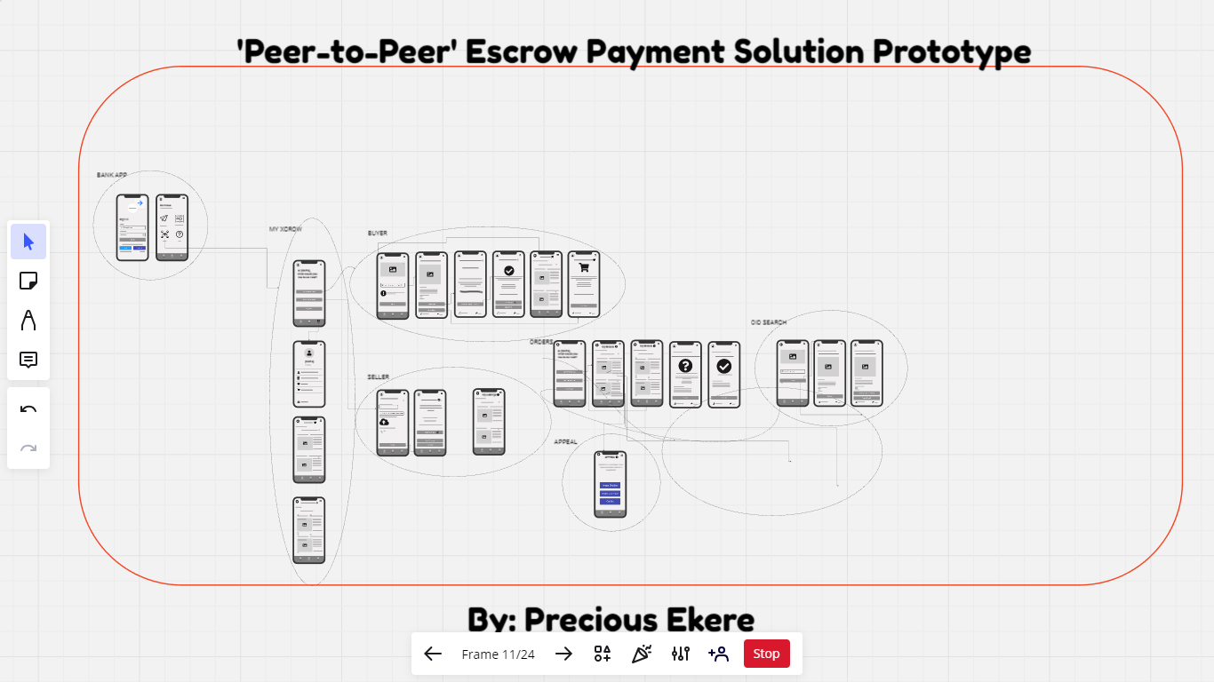
fig 4.1: Miro Worskspace
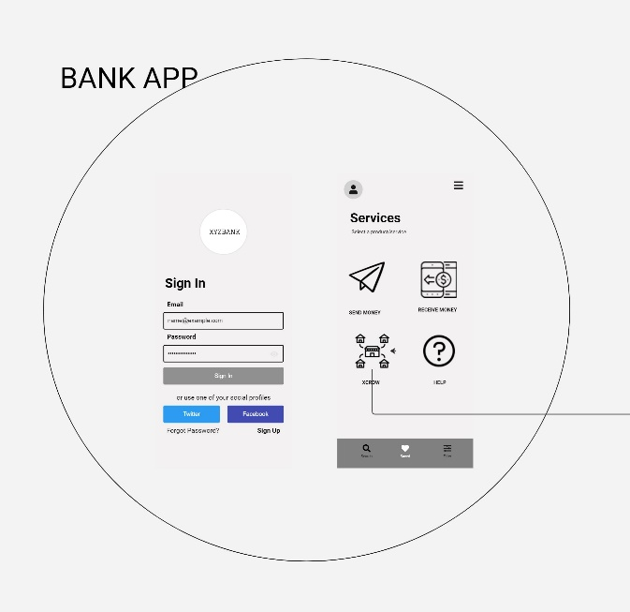
fig 4.2: Bank Mobile App Sign in & Dashboard

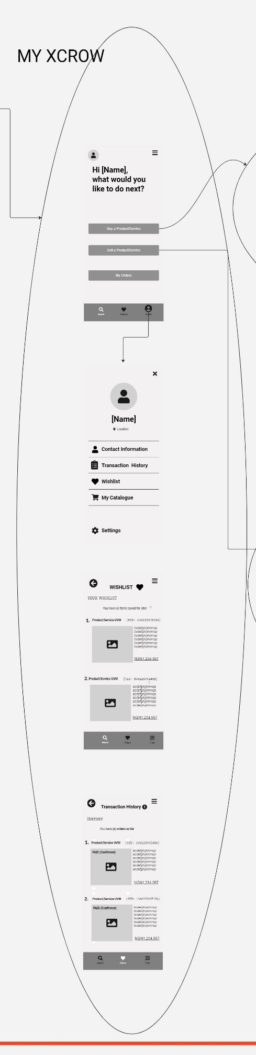 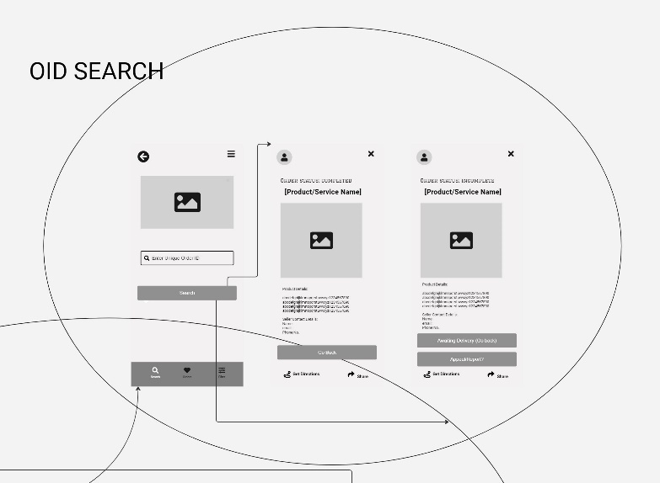fig 4.3: User Area fig 4.4: Order Search
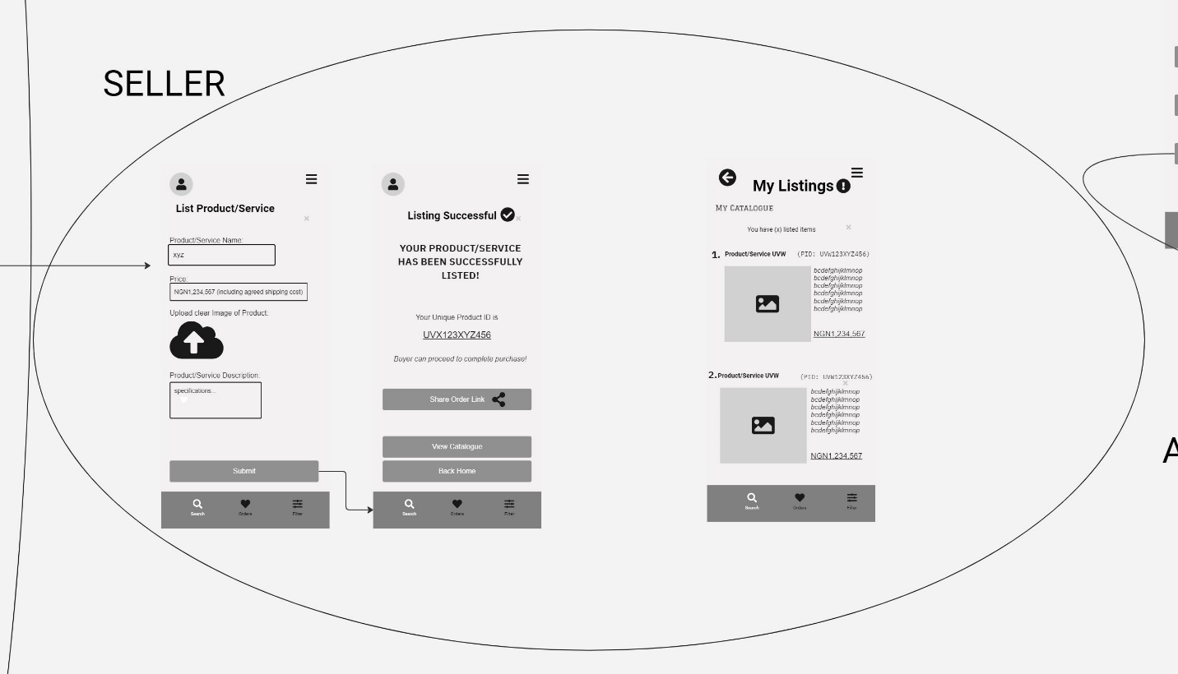

fig 4.5: Product listing

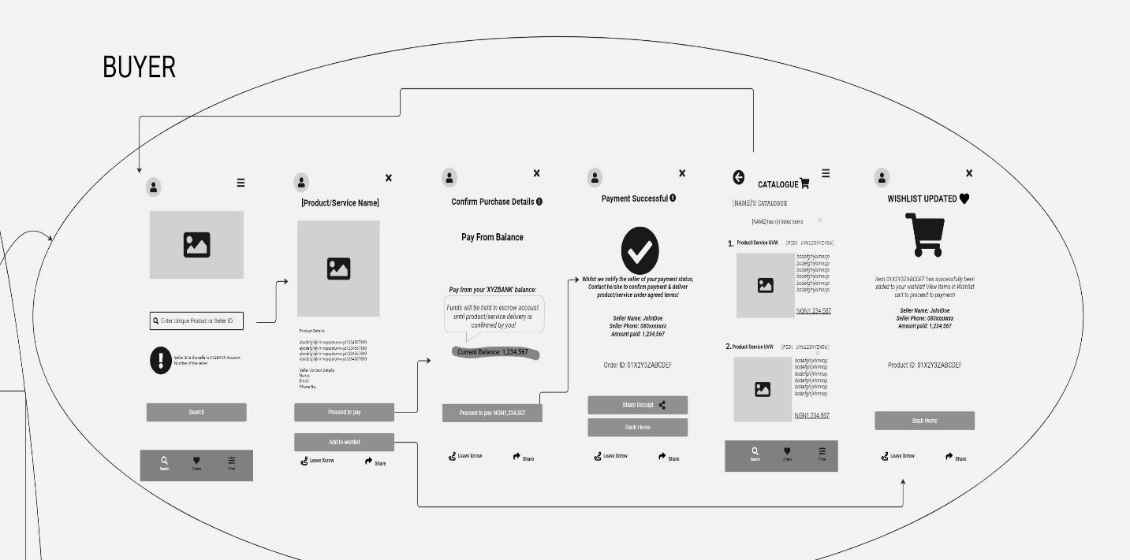fig 4.6: Trade Initiation
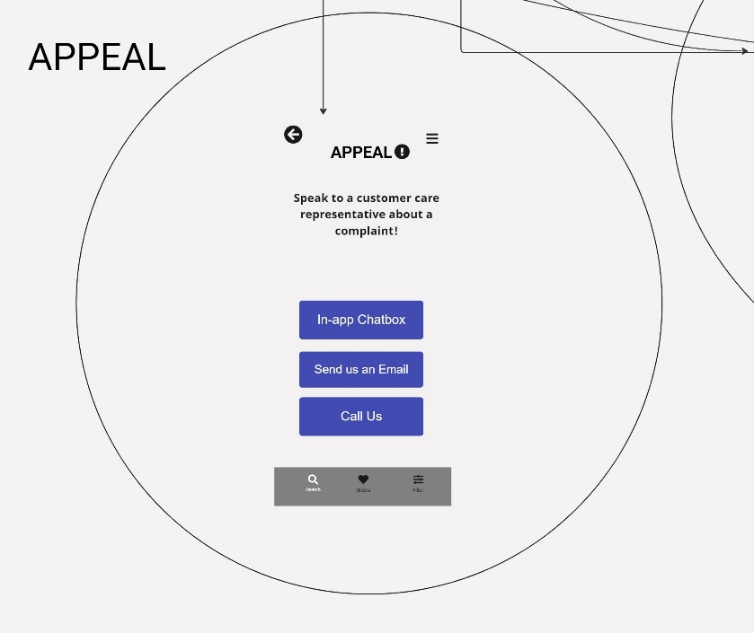

fig 4.7: Customer Appeal/Support

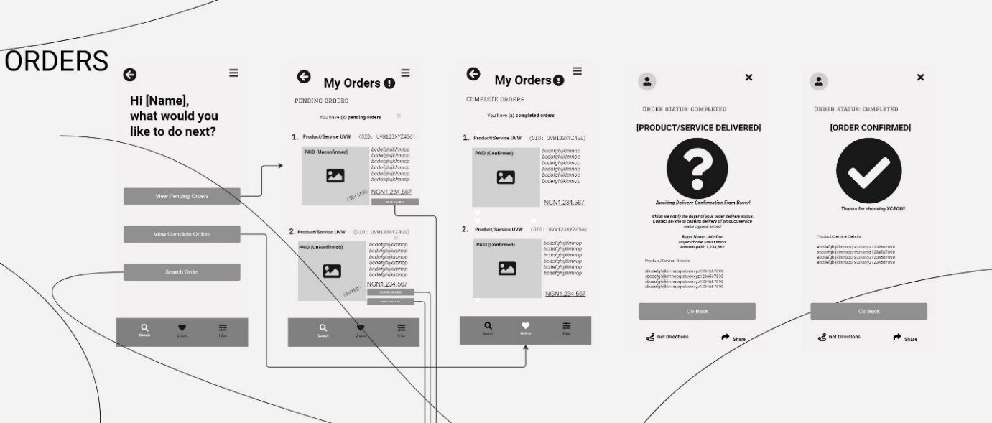

fig 4.8: Order list

4.3 Summary
With a focus on the integration of peer-to-peer escrow services into Nigeria's financial system, this chapter presented an overview of the development and testing of a prototype trust-based commercial ecosystem. This chapter outlines a comprehensive implementation strategy that includes post-launch support, deployment, integration planning, development readiness, UI development, and API integration. This painstaking procedure ensures the creation of an escrow service that is trustworthy, secure, and user-friendly. Iterative improvements based on user feedback, continuous testing, security considerations, component identification, and careful API mapping are all part of the process. By following this strategy, the project aims to enhance the security and reliability of e-commerce transactions in Nigeria, addressing unique challenges while leveraging existing banking infrastructure to foster a trust-based commercial ecosystem.

CHAPTER FIVE

5.0 SUMMARY, CONCLUSION, AND RECOMMENDATIONS

5.1 Summary
Nigeria's e-commerce sector is poised for significant growth, but a lack of trust and persistent security concerns continue to hinder its progress. Although P2P escrow services present a convincing alternative by supplying an unbiased intermediary to secure funds throughout transactions, there are several challenges associated with their execution. In addition to the technical integration into the current banking infrastructure and fintech platforms, these challenges also include the need to establish user acceptance and trust, regulatory complexities, and financial considerations. This development project aims to address these urgent issues and enable the successful integration and broad adoption of P2P escrow services in Nigeria by looking at the particular barriers that need to be removed. The research looks at the technical difficulties of integrating these services into the current financial landscape in addition to analyzing the regulatory frameworks and policies that need to be changed or created to ensure safe and compliant operation. Along with discussing the financial effects on users and service providers, it also offers suggestions for lowering adoption barriers.
Ultimately, this project aims to provide a comprehensive analysis of the challenges and opportunities presented by peer-to-peer escrow services in Nigeria. The research aims to facilitate the development of a safe and robust e-commerce ecosystem that promotes trust and broadens participation by providing feasible solutions to these issues.
The wireframe's creation is directed by a collection of functional criteria that delineate the principal features of the suggested escrow service. These specifications provide the fundamental functionalities of the system and cover everything from user identification and escrow account administration to transaction initiation, payment processing, dispute resolution, and security protocols. By concentrating on these specifications, the wireframe hopes to develop a dependable, safe, and user-friendly escrow service that improves openness and confidence in the Nigerian e-commerce sector.

5.2 Conclusion
A primary achievement of the project is the successful design and comprehensive guideline for the integration of a secure peer-to-peer escrow service into Nigeria's commercial banking and fintech environments. This achievement is a significant step toward enhancing transaction security and compliance, which will boost trust in the country's e-commerce industry.
Secondly, this project thoroughly identified and examined the financial, legal, and technological barriers preventing P2P escrow services from being widely used in Nigeria. The study's resolution of these obstacles has created a strong framework for the effective integration of these services into the nation's e-commerce environment.
Also, fostering user trust and acceptance of escrow services through targeted education and awareness campaigns was one of the project's main goals. Through highlighting the advantages and strong security features of these services, the project sought to debunk myths and promote broader adoption among customers and companies in the Nigerian e-commerce sector.

5.3 Recommendations
Peer-to-peer escrow services can significantly improve the security and dependability of e-commerce transactions within the Nigerian banking infrastructure, as this study has shown. The recommendations that follow are intended to enhance and build upon the research's findings.

5.3.1 Recommendations for System Improvement

To improve the security and usability of the developed system, multi-factor authentication and advanced encryption techniques must be implemented. To keep ahead of new threats, regular updates are also required. Moreover, it is imperative to consistently enhance the user interface through feedback from users in order to preserve its accessibility and intuitiveness, which in turn fosters increased user satisfaction and adoption.

5.3.2 Recommendations for Banking Institutions
To gain the trust of their customers, banks ought to incorporate peer-to-peer escrow services into their platforms and advertise them through awareness campaigns. Forming strategic partnerships with e-commerce platforms can enhance security and streamline transaction procedures. The seamless integration of banking systems with online marketplaces will be ensured by standardized protocols.

5.3.3 Recommendations for Policymakers
Supporting innovation through incentives for financial institutions and startups will foster research and development in secure e-commerce solutions, promoting a strong and reliable commercial ecosystem. Regulators should create policies that facilitate the implementation and use of escrow services in e-commerce, making sure these policies are flexible enough to adjust to new developments in technology.

5.4 Suggestions for Further Work

5.4.1 Explore Advanced Technologies
Extensive research on user behavior and trust-related variables will provide insightful information about the long-term effects of escrow services on the expansion of e-commerce and consumer confidence in Nigeria. Future studies should look into how blockchain technology might improve escrow services' security and transparency as well as how artificial intelligence might be used to detect and stop fraud.

5.4.2 Explore Integration with Other Financial Services.
More research could examine the feasibility of combining escrow services with insurance, remittances, and microloans. This might lead to a more comprehensive, smooth, and valuable financial ecosystem for users. For instance, combining escrow services with microloans might provide small businesses and entrepreneurs with a secure way to raise funds while ensuring that the funds are used prudently. Similarly, escrow added to insurance policies may enhance transaction security for high-value contracts.
Should these study paths are taken, interested parties will have a deeper understanding of the advantages and challenges of implementing peer-to-peer escrow services in Nigeria. This will encourage innovation, strengthen security, and boost trust in the country's e-commerce infrastructure.

REFERENCES
Abraham, G. T., Osaisai, E. F., Wariowei, D. S., Ineyekineye, A., & Tuesday, O. T. (2021). Usability issues with e-commerce websites in nigeria. Asian Journal of Computer Science and Technology, 10(1), 5-12. https://doi.org/10.51983/ajcst-2021.10.1.2694
Adeyeye, M. (2008). e-Commerce, Business Methods and Evaluation of Payment Methods in Nigeria. Electronic Journal Information Systems Evaluation, 11(1), 45-50.
Agwu, E. M., & Nnadi, E. J. (2021). The impact of escrow services on the growth of e-commerce in Nigeria. Journal of Economics and Sustainable Development, 12(7), 19-27.
Agwu, E., & Carter, A. L. (2014). Mobile phone banking in Nigeria: benefits, problems and prospects. International Journal of Business and Commerce, 3(6), 50-70.
Akinola, O., & Dada, D. (2019). Escrow services as a mechanism for enhancing trust in Nigerian e-commerce. International Journal of Business and Management Review, 7(3), 1-12.
Akintoye, K. A., & Araoye, O. I. (2011). Combating e-fraud on electronic payment system. International Journal of Computer Applications, 25(8), 48-53.
Akinyemi, O. I., & Olokundun, M. A. (2019). Peer-to-peer escrow services: A catalyst for enhancing security in Nigerian e-commerce transactions. International Journal of Engineering and Management Research, 9(5), 90-97.
Akomea-Bonsu, C., & Sampong, F. (2012). The impact of Information and Communication Technologies (ICT) on Small and Medium Scale Enterprises (SMEs) in the Kumasi Metropolis, Ghana, West Africa. European Journal of Business and Management, 4(20), 152-158.
Antoniou, G. and Batten, L. M. (2011). E-commerce: protecting purchaser privacy to enforce trust. Electronic Commerce Research, 11(4), 421-456. https://doi.org/10.1007/s10660-011-9083-3
Asongu, S. A., & Nwachukwu, J. C. (2018). Recent finance advances in information technology for inclusive development: a systematic review. NETNOMICS: Economic Research and Electronic Networking, 19(1-2), 65-93.
Ayo, C. K., Adewoye, J. O., & Oni, A. A. (2011). Business-to-consumer e-commerce in Nigeria: Prospects and challenges. African Journal of Business Management, 5(13), 5109-5117.
Ayo, C. K., Oni, A. A., Adewoye, O. J., & Eweoya, I. O. (2016). E-banking users' behaviour: e-service quality, attitude, and customer satisfaction. International Journal of Bank Marketing, 34(3), 347-367.
Babalola, Y. T., & Babalola, D. A. (2013). Economic analysis of e-commerce in Nigeria. ACTA UNIVERSITATIS DANUBIUS, 9(4), 212-226.
Chen, W., Nalluri, V., Lin, M., & Lin, C. (2021). Identifying decisive socio-political sustainability barriers in the supply chain of banking sector in india: causality analysis using ism and micmac. Mathematics, 9(3), 240. https://doi.org/10.3390/math9030240
David-West, O., Iheanachor, N., & Umukoro, I. (2018). A resource-based view of digital financial services (DFS): An exploratory study of Nigerian providers. Journal of Business Research, 88, 513-526.
Gao, Y. and Wu, X. (2010). A cognitive model of trust in e-commerce: evidence from a field study in china. Journal of Applied Business Research (JABR), 26(1). https://doi.org/10.19030/jabr.v26i1.275
Iwu, C. G., & Uddin, S. (2020). Exploring the effectiveness of escrow services in Nigerian online marketplaces. Journal of Internet Commerce, 19(2), 141-159.
Kasie, E. G. and Nwaolisa, E. F. (2012). Electronic retail payment systems : user acceptability and payment problems in nigeria. Oman Chapter of Arabian Journal of Business and Management Review, 1(9), 111-123. https://doi.org/10.12816/0002165
Kshetri, N. (2018). Cybercrime and cybersecurity in Africa. Journal of Global Information Technology Management, 21(3), 150-153.
Kusumawati, R. and Achjari, D. (2019). Peran escrow services sebagai variabel pemoderasi di marketplace. Jurnal Ekonomi Indonesia, 8(2), 279-292. https://doi.org/10.52813/jei.v8i2.22
Kusumawati, R. and Achjari, D. (2019). Peran escrow services sebagai variabel pemoderasi di marketplace. Jurnal Ekonomi Indonesia, 8(2), 279-292. https://doi.org/10.52813/jei.v8i2.22
Lee, S., Ahn, C., Song, K. M., & Ahn, H. (2018). Trust and distrust in e-commerce. Sustainability, 10(4), 1015. https://doi.org/10.3390/su10041015
Mäntymäki, M. The role of post-adoption phase trust in b2c e-service loyalty: towards a more comprehensive picture. IFIP International Federation for Information Processing, 142-152. https://doi.org/10.1007/978-0-387-75494-9_18
McKnight, D. H., Choudhury, V., & Kacmar, C. J. (2002). Developing and validating trust measures for e-commerce: an integrative typology. Information Systems Research, 13(3), 334-359. https://doi.org/10.1287/isre.13.3.334.81
Meskaran, F. and Ismail, Z. (2012). Customers' trust in e-commerce: in collective culture setting. 2012 International Conference on Information Retrieval &Amp; Knowledge Management. https://doi.org/10.1109/infrkm.2012.6205032
Nwoye, J. (2018). Enhancing trust in Nigerian e-commerce: The role of escrow services. Journal of Internet Banking and Commerce, 23(3), 1-15.
Okeke, R. I. (2017). E-payment system and its security challenges in Nigerian banking system. International Journal of Computer Science and Network Security, 17(5), 150-158.
Olakunle, O., Oludayo, O., & Oladele, J. (2017). Electronic payment system and customers' retention in banks: Implications for entrepreneurial development in Nigeria. Journal of Entrepreneurship Education, 20(3), 1-12.
Olufemi, O. A., & Adebisi, O. O. (2020). Trust in online transactions: A review of peer-to-peer escrow services in Nigeria. International Journal of Innovation and Economic Development, 6(4), 51-60.
Olusola, A. A., Oludele, A. A., Chibueze, O. N., & Udoka, S. U. (2013). Adoption of e-banking services: An empirical investigation of the Nigerian banking sector. International Journal of Academic Research in Business and Social Sciences, 3(8), 457.
Oluyinka, S., Shamsuddin, A., Wahab, E., Ajagbe, M. A., & Enegbuma, W. I. (2013). A study of electronic commerce adoption factors in Nigeria. International Journal of Information Systems and Change Management, 6(4), 293-315.
Omar, H. F. H., Saadan, K., & Seman, K. B. (2015). Determining the influence of the reliability of service quality on customer satisfaction: the case of libyan e-commerce customers. International Journal of Learning and Development, 5(1), 86. https://doi.org/10.5296/ijld.v5i1.6649
Salam, A. F., Iyer, L., Palvia, P., & Singh, R. (2005). Trust in e-commerce. Communications of the ACM, 48(2), 72-77. https://doi.org/10.1145/1042091.1042093
Secretariat, C. (2022). Commonwealth countries: driving fintech innovation.. https://doi.org/10.14217/comsec.1070
Shen, G. and Liu, H. (2012). A trust model in p2p e-commerce systems. 2012 8th International Conference on Wireless Communications, Networking and Mobile Computing. https://doi.org/10.1109/wicom.2012.6478380
Subroto, A. S. (2018). Study on indonesia consumer trust on online transaction. International Journal of Business Studies, 1(2), 41-50. https://doi.org/10.32924/ijbs.v1i2.18
Udeh, F. N., & Egbetokun, A. A. (2020). Escrow services and the development of e-commerce in Nigeria: A conceptual framework. Journal of Business and Retail Management Research, 14(3), 215-224.
Virginia, Y. M. (2023). E-payment administration and the growth of small and medium enterprises (smes) in southeast nigeria: an evaluation of cashless policy. Global Journal of Political Science and Administration, 11(2), 42-57. https://doi.org/10.37745/gjpsa.2013/vol11n24257
Wang, Y. and Lin, K. (2008). Reputation-oriented trustworthy computing in e-commerce environments. IEEE Internet Computing, 12(4), 55-59. https://doi.org/10.1109/mic.2008.84

