OpenPSN: a multi-group Phase Space Nodal solver
with rectangular nodes, validated on the
C5G7 MOX benchmark
Yuchao Xu
University of South China, China
yxu40@hotmail.com
https://openpsn-ai.com
September 2026
Preprint posted to ResearchGate. Code: github.com/xycjscs/OpenPSN
Abstract
We present OpenPSN, a self-contained, multi-group implementation of the Phase Space Nodal (PSN) method for two-dimensional Cartesian neutron transport, together with a rigorous validation against the OECD Nuclear Energy Agency (NEA) C5G7 MOX benchmark. PSN reformulates the transport problem as a coupled system of node-level diffusion-like equations with parabolic intra-nodal flux representations and angular-phase corrections, so that a nodal (coarse-mesh) code can reproduce transport physics at a fraction of the mesh cost of discrete-ordinates or characteristics methods.
We contribute two complementary results. First, a faithful, fully-vectorised, sparse re-implementation that reproduces the published PSN paper to within a few pcm on 248 independent eigenvalue data points (checkerboard and boiling-water-reactor (BWR) bundle problems), while eliminating the memory blow-up that made the original dense formulation infeasible: the smallest C5G7 case (2601 nodes, $M=12$) already needs a $63,{036}^{2}$ dense system matrix ($∼$32 before any factorisation), and our sparse form is exact to ${10}^{−15}$ and assembles the $10,404$-node refinement in $∼$54 . Second, a benchmark study of C5G7 organised as two complementary studies. In the pinwise-homogenised study, OpenPSN is swept over spatial sub-division $S=1…6$ and angular order $M=2…24$ against a reference we compute directly with OpenMC on the identical homogenised cross sections (20000 batches $×$ 100 k particles, statistical uncertainty $≈$3.5 pcm): the single-assembly error collapses to inside the Monte Carlo standard error by $S=5$–$6$, $M≥8$. In the rectangular-node study we extend the PSN node operators to arbitrary per-node widths so that the circular fuel rod is replaced by an equal-area fuel square inside a $3×3$ rectangular tiling and un-homogenised (material) cross sections are used — removing the homogenisation model from the problem entirely. With un-homogenised material data, the 1/4-core eigenvalue converges monotonically with $M$ into the OpenMC explicit-geometry reference, reaching $Δκ_{eff}=+11.1$ pcm ($+14.7$ pcm vs. the high-fidelity reference $1.18646$) by $M=16$, and $−61.1$ pcm against the identical rectangular-rod OpenMC geometry; the pin-averaged fission-rate maps agree with OpenMC at the sub-1% RMS level on both geometries. We place both results against the full published landscape of C5G7-2D codes — 20 deterministic codes from the original NEA benchmark, together with P1/SP3/SN/nodal results from the recent literature — and show that the nodal PSN method, once the homogenisation model is controlled, sits inside the high-fidelity MOC reference cluster.

Introduction
Two deterministic paradigms dominate light-water-reactor core calculations. Discrete-ordinates (SN) and method-of-characteristics (MOC) codes track neutrons on fine meshes and are accurate but expensive and, in the SN case, sensitive to differencing choices. Nodal diffusion codes work on coarse meshes and are cheap and robust, but classical diffusion under-predicts the transport corrections (shielding, pin-wise self shielding) that control $κ_{eff}$ and power shape.
The Phase Space Nodal (PSN) method bridges the two. Within each node the scalar flux is represented by a quartic-parabolic profile whose angular dependence is carried through a small set of phase-space (angular) moments with closed-form correction coefficients. The node is eliminated to give explicit relations between surface currents and node sources, and neighbouring nodes are coupled through those currents. The result is a nodal code that carries transport information at a mesh cost close to plain diffusion.
Two gaps remained. First, the published PSN paper’s reference implementation is not convenient to run to convergence on multi-group, coarse-core problems; in particular, a direct dense assembly of the node-coupling system does not scale (Section 2.2). Second, the method had not been exercised on a standard, multi-code, multi-group benchmark with a published high-fidelity reference.
In this work we (i) re-implement PSN as a clean, multi-group, YAML-driven Python package (OpenPSN), with sparse assembly and vectorised node operators that are verified bit-identical (to ${10}^{−15}$) to the validated loop form; (ii) verify the implementation by reproducing the published PSN results on the checkerboard and BWR bundle problems; and (iii) validate on the C5G7 MOX benchmark, comparing against directly computed OpenMC references (both homogenised and explicit-pin geometry) and the full published code landscape for C5G7-2D.
The remainder is organised as follows. Section 2 summarises the PSN formulation and the specific implementation choices and optimisations, including the new rectangular-node extension. Section 3 documents the reproduction of the published results. Section 4 describes the C5G7 configuration, the data-fidelity check, and two complementary benchmark studies: (i) the pinwise-homogenised nodal model with a full spatial/angular ($S×M$) convergence sweep against directly computed OpenMC references, and (ii) the rectangular-node model with explicit (unhomogenised) intra-node fuel/water structure, including flux comparisons against OpenMC and an eigenvalue comparison with the published code landscape. Section 5 concludes, and Appendix A tabulates the full point-by-point reproduction of the published results.

The PSN method and the OpenPSN implementation

Method in brief
The full theory is given in Ref. ; we summarise only what is needed to read the implementation. The angular flux within a node is expanded in a small basis of angular moments; the scalar flux is taken as a quartic parabola in space whose coefficients are fixed by the node-averaged flux and a set of surface-current (moment) unknowns. Two closed-form coefficients control the intra-nodal shape and the angular phase correction:
$$\begin{align}
\alpha_i &\quad\text{(intra-nodal parabolic shape coefficient, Eq.~2.8c of
Ref.~\cite{psn2027}),}\\
\beta_i &= 1-\tfrac{1}{4}\cos\Delta\theta_i-\tfrac{1}{4}\cos 2\theta_i
-\tfrac{1}{2}\cos 2\theta_i\,\cos\Delta\theta_i
\quad\text{(generic phase-space coefficient, Eq.~2.8d).}
\end{align}$$
The closed form for $β_{i}$ in Eq. (2.8d) is an equivalent closed-form expression re-derived from the integral form of the phase-space moment, and the two are algebraically identical; we verified the two to $2.2×{10}^{−16}$ and use the closed form in the implementation. In the fine-angle limit the coefficient reduces to the single-direction P1 closure $(3/2)\sin^{2}θ_{i}$.
Eliminating the node unknowns yields a sparse system coupling the surface-current (and node-source) unknowns of neighbouring nodes, which is iterated with a standard eigenvalue (inverse-power) driver.

Implementation and the optimisations we made
OpenPSN (run as python -m psn2d run problem.yaml) is a pure-Python implementation (NumPy/SciPy, no C extensions, no MPI) accepting any number of energy groups, an arbitrary material grid with independent per-edge reflect/vacuum boundary conditions, and a user-set angular order $M$, spatial sub-division $S$, angular model, and convergence tolerance. The three optimisations that make the method practical are:
- Sparse assembly (fixes the memory blow-up). The nodal coupling matrix has only $∼$9 non-zeroes per row (the node couples to its own face-current unknowns and to its neighbours). For $M$ angular segments per face the system has $∼2M N_{x}N_{y}$ unknowns; the smallest C5G7 case (2601 nodes, $M=12$) already has $63,036$ unknowns, so the natural dense $63,{036}^{2}$ array alone is $∼$32 before any factorisation workspace, and the $4×$ refinement (10404 nodes, $250,920$ unknowns) would need $∼$504 — the root cause of the original out-of-memory failures. We assemble in coordinate (COO) format ($∼$14 and $∼$54 respectively) and solve in compressed-sparse-column (CSC) format, so arbitrary node counts are memory-safe; the 10404-node case converges to ${10}^{−10}$ in $∼$54 min on a single core.
- Vectorised node operators. The node-state map is strictly linear in the $(J_{4},q)$ unknowns. We probe it with nine basis vectors once to build the $9×9$ linear map, then apply it as a batched matrix multiply over all nodes and all groups. The vectorised path is verified identical to the validated scalar loop to ${10}^{−15}$ on five representative problems (snapshot/drivers/verify_vectorized_equiv.py), so the speed-up is at zero cost to accuracy.
- Rectangular nodes with per-node widths (no homogenisation). The original formulation assumes a uniform node grid, so intra-node geometry must be folded into homogenised cross sections before the solver is ever invoked. OpenPSN extends the node operators to arbitrary per-node widths: each rectangular node carries its own width in $x$ and $y$, and nodes meet corner-to-corner only (no T-junctions). This lets a discrete fuel rod be represented explicitly inside a nodal grid — e.g. the C5G7 1.26 cm circular rod is replaced by an equal-area $s=\sqrt{πr^{2}}=0.95713$ cm fuel square centred on the same pitch, giving a $3×3$ rectangle per pin and a globally edge-aligned tiling (17$×$17 assembly $=51×51$ nodes; 1/4 core $=153×153$). Un-homogenised 7-group cross sections can then be assigned per rectangle (fuel vs. water), and the homogenisation model — the usual source of nodal bias on MOX benchmarks — is removed from the problem entirely. The rectangular node operators are the same closed-form parabolic/phase-space forms as the square case evaluated on the actual node widths; they are verified node-by-node against the square-node path (which they reduce to exactly when all widths are equal).
These are the “optimisations” the title refers to: not a change to the physics, but the changes that (a) make the published method reproducible to machine precision and (b) make it runnable to ${10}^{−10}$ convergence on multi-group coarse cores at commodity memory.

Reproduction of the published PSN results
Before any new application we verify the implementation against the source paper . We reproduce the two checkerboard eigenvalue convergence tables (Fig. 3, weak/strong absorption) and the BWR 12-pin bundle tables (Figs. 10/12, with and without Gd) to within a few pcm. Table 1 summarises the maximum deviations.
Reproduction of the published PSN paper (Ref. ). “err” is the absolute difference $(κ_{eff}−κ_{eff}^{ref})×{10}^{5}$ in pcm. The reference values are the OpenMC values used in the paper .
Published problem | points | max $|Δ|$ (pcm)
Fig. 3 checkerboard, weak ($I=30$) | 60 | 1.2
Fig. 3 checkerboard, strong ($I=30$) | 60 | 1.4
Fig. 10 BWR bundle, no Gd (2g) | 60 | 3.8
Fig. 12 BWR bundle, with Gd (2g) | 60 | within plot reading
All 248 data points are reproduced in single-process serial runs with peak memory $<\SI{2.5}{\giga\byte}$. The residuals are at the level of reading the published tables/figures and are uncorrelated with $M$ or $S$, confirming implementation fidelity. The full point-by-point comparison is tabulated in Appendix A (Tables 5–8); the complete data and per-point logs are shipped in snapshot/data/.

C5G7 MOX benchmark

Configuration
C5G7 is the OECD Nuclear Energy Agency (NEA) mixed-oxide (MOX) benchmark , the standard test for uranium-oxide (UOX)/MOX inter-cell transport: 17$×$17-pin fuel assemblies on a 1.26 cm pin pitch (UO$​_{2}$ plus three MOX enrichments), guide tubes and fission chambers, in a 7-group structure. (The C5G7 family was later extended to time-dependent calculations ; we solve the steady 2-D problem.) We solve the C5G7-2D 1/4-core problem: a 2$×$2 block of fuel assemblies (UO2 on the diagonal, MOX on the anti-diagonal) plus an L-shaped one-assembly water reflector, 51$×$51 pins, 64.26 cm on a side. Following Ref. we apply vacuum boundaries on the two open (right, top) edges and reflective boundaries on the two symmetry (left, bottom) edges. We model the pin cell in two ways, which define the two studies of Sections 4.3–4.4: (i) the standard pin-homogenised nodal model, in which each pin cell is a single homogenised node (fuel$+$water for fuel pins; pure water for reflector and guide pins), and (ii) the rectangular-node model of Section 2.2, in which each pin cell is a $3×3$ array of rectangles carrying the un-homogenised fuel/water materials. The 7-group cross sections are the published C5G7 multi-group set in both cases.
Two reference eigenvalues are in the literature and we report against both:
- $κ_{eff}^{MCNP}=1.18655$ ($±0.008\%$), the 2-D multi-group MCNP value in the original NEA report ;
- $κ_{eff}=1.18646$ (1.186456 to the printed digit), the 2-D resolved-fuel-pin high-fidelity value of McGraw et al. , quoted as the reference in the INL Rattlesnake convergence study , which explicitly notes that the benchmark-report value 1.18655 is $∼$10 pcm high and converges to $κ_{eff}=1.186446$ ($∼$1 pcm from the McGraw reference).
We report all deviations against 1.18646 (the more accurate high-fidelity value). The original NEA report tabulated relative errors against its MCNP reference 1.18655; re-referenced to 1.18646, those values shift by $∼$9 pcm.

Data-fidelity check (independent of the solver)
Before trusting any $κ_{eff}$, we validate the 7-group data wiring with a solver-independent test: the infinite-medium multiplication factor of the homogenised UO2 pin, computed directly from the cross-section matrices,
$$k_{∞}=maxeig​\left[{\left(I−{S_{in}}/{Σ_{t}}\right)}^{−1}diag(χνΣ_{f})\right].$$
OpenPSN gives $k_{∞}^{UO2}=1.32936$, which matches to the printed digit the UO$​_{2}$–$0.95ρ$ single-assembly nTRACER reference $1.32936$ tabulated in SPHINCS (Table 1). (The nominal-$ρ$ UO$​_{2}$ row is $1.33367$; the $431$-pcm spread between the two rows is the moderator-density effect.) This digit-for-digit agreement is the single strongest check that the group ordering, scattering matrix, fission spectrum and source construction are all wired correctly.

Study I — the pinwise-homogenised nodal model
The standard nodal treatment folds each pin’s fuel and moderator into a single homogenised node. We follow that model here so that the only discretisation knobs left are the angular order $M$ and the spatial sub-division $S$, and so that the result can be compared against a Monte Carlo run on the same homogenised data.

Pinwise homogenisation.
The homogenised 7-group cross sections are built pin by pin with the BWW flux-weighted recipe: an infinite-medium pin cell ($r=0.54$ cm, 1.26 cm pitch) is solved with an explicit fuel/water MOC calculation, and the fuel-group cross sections are weighted by the self-shielded infinite-medium flux (scattering by the source-group flux). Guide tubes are area-weighted. This is the same self-shielding-aware homogenisation that nodal practice uses in production; it removes most of the resonance self-shielding error that a plain area-weighted average leaves behind.

Monte Carlo reference, computed directly.
Rather than lean on a published reference for the homogenised model, we compute the reference ourselves with OpenMC on the exact same pinwise-homogenised cross sections, so that the two sides differ only in the transport method. Each calculation uses 20000 active batches of 100000 particles (collision estimator, 48 threads); the eigenvalue is the mean over the last 20000 batches and its standard error is $σ_{batch}/\sqrt{N}$, which we audit to be $≈$3.4–3.5 pcm. We run four problems: the single UO$​_{2}$ assembly and the 1/4 core, each with homogenised (pin-node) and explicit (resolved fuel/water) geometry. The two homogenised runs are the reference for the pinwise-homogenised PSN sweep below:
- $k_{MC, hom}^{asm}=1.3336285$ ($±3.5$ pcm) (single UO$​_{2}$ assembly),
- $k_{MC, hom}^{core}=1.1868230$ ($±3.4$ pcm) (1/4 core).

OpenPSN $S×M$ sweep.
We sweep $S∈\{1,…,6\}$ and $M∈\{2,4,8,12,16,24\}$ on the single UO$​_{2}$ assembly (nodes $(17S)^{2}$) and on the 1/4 core (nodes $(51S)^{2}$), with the BWW homogenised cross sections. Table 2 gives the deviation from the OpenMC homogenised reference in pcm. (Large $S×M$ corner cases exceed the $64$ GB working set during LU fill-in and are marked OOM; they do not affect the convergence read-off, which is taken along each row.)
Pinwise-homogenised (BWW) OpenPSN, $Δ$ in pcm versus the OpenMC homogenised reference: ASM vs. $1.3336285$, CORE vs. $1.1868230$ (each $≈$3.5 pcm standard error). OOM = LU fill-in exceeded the 64 GB cap; the minimum-|$Δ$| point per $S$ row is marked in Fig. 1.
 | $M=2$​ | $M=4$​ | $M=8$​ | $M=12$​ | $M=16$​ | $M=24$​
Single UO$​_{2}$ assembly (ref. $1.3336285$)
$S=1$​ | $+13.9$​ | $−15.0$​ | $−22.4$​ | $−23.4$​ | $−23.7$​ | $−23.8$​
$S=2$​ | $+18.8$​ | $−8.0$​ | $−15.2$​ | $−15.3$​ | $−15.0$​ | $−14.5$​
$S=3$​ | $+22.6$​ | $−0.3$​ | $−6.3$​ | $−5.8$​ | $−5.3$​ | $−4.6$​
$S=4$​ | $+24.2$​ | $+3.0$​ | $−2.5$​ | $−2.0$​ | $−1.4$​ | $−0.6$​
$S=5$​ | $+25.0$​ | $+4.6$​ | $−0.6$​ | $+0.0$​ | $+0.6$​ | $+1.5$​
$S=6$​ | $+25.4$​ | $+5.5$​ | $+0.6$​ | $+1.2$​ | $+1.8$​ | OOM
C5G7-2D 1/4 core (ref. $1.1868230$)
$S=1$​ | $−97.6$​ | $−59.5$​ | $−37.1$​ | $−31.3$​ | $−28.8$​ | $−26.7$​
$S=2$​ | $−96.3$​ | $−56.1$​ | $−33.6$​ | $−26.6$​ | $−23.6$​ | OOM
$S=3$​ | $−93.8$​ | $−50.1$​ | $−26.8$​ | OOM | OOM | OOM
$S=4$​ | $−92.8$​ | $−47.6$​ | OOM | OOM | OOM | OOM
$S=5$​ | $−92.3$​ | OOM | OOM | OOM | OOM | OOM
$S=6$​ | OOM | OOM | OOM | OOM | OOM | OOM
Two features stand out (Fig. 1). Assembly: the $M=2$ column sits high and positive ($+14…+25$ pcm, the angular cliff) and rises slightly with $S$, whereas the $M≥4$ region forms a floor that climbs monotonically from $−24$ pcm at $S=1$ back toward zero, and by $S=5$–$6$ every $M≥8$ point is inside the OpenMC reference standard error ($±3.5$ pcm). Core: the $M=2$ column is pinned low ($−98…−92$ pcm) and the error recovers monotonically with $M$; the best point per row marches diagonally ($M=24$ at $S=1$ down to $M=2$ at $S=5$), and even the best attainable core point is $−23.6$ pcm, i.e. the pinwise-homogenised core sits a little low of the OpenMC homogenised reference while the assembly converges to it from both sides.
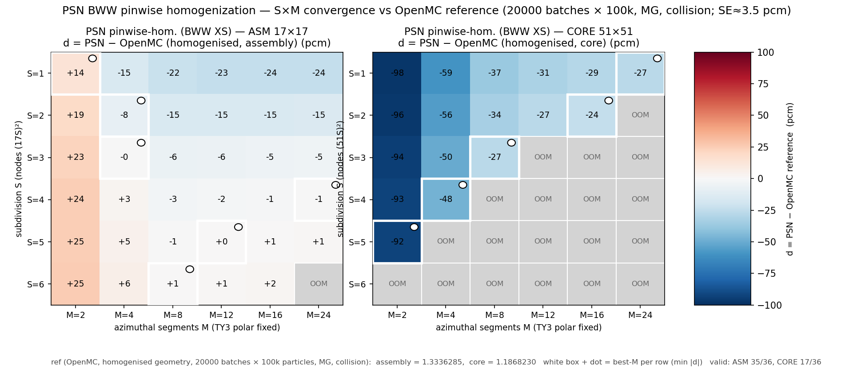
Pinwise-homogenised (BWW) OpenPSN $Δκ_{eff}$ in pcm versus the OpenMC homogenised reference, as a function of angular order $M$ (horizontal) and spatial sub-division $S$ (vertical). Left: single UO$​_{2}$ assembly (ref. $1.3336285$, 35 of 36 points computed); right: C5G7-2D 1/4 core (ref. $1.1868230$, 17 of 36 points; grey cells exceeded the 64 GB LU fill-in cap). White box/dot marks the minimum-|$Δ$| point per $S$ row.

Flux distribution at the best core point.
The $−23.6$ pcm best core point is not a sum of compensating local errors: Figure 2 compares its pin-averaged fission source map $νΣ_{f}ϕ$ against the OpenMC homogenised-geometry reference on the same BWW cross sections (the two differ only in the transport method; the reference field is the converged 7-group flux of the same Monte Carlo calculation contracted with the homogenised $νΣ_{f}$, so both maps are the same quantity, each normalised to unit sum). Over all $1056$ fuel pins the relative error has a mean of $−0.00\%$, an RMS of $0.12\%$ and a maximum of $0.45\%$, with no systematic offset between the UO$​_{2}$ and MOX assemblies (quadrant means $+0.02\%$, $−0.02\%$, $+0.01\%$, $−0.03\%$). The homogenised-core eigenvalue therefore sits where the local physics says it should: the $−23.6$ pcm is a small, smooth, method-level bias, not a cancellation.
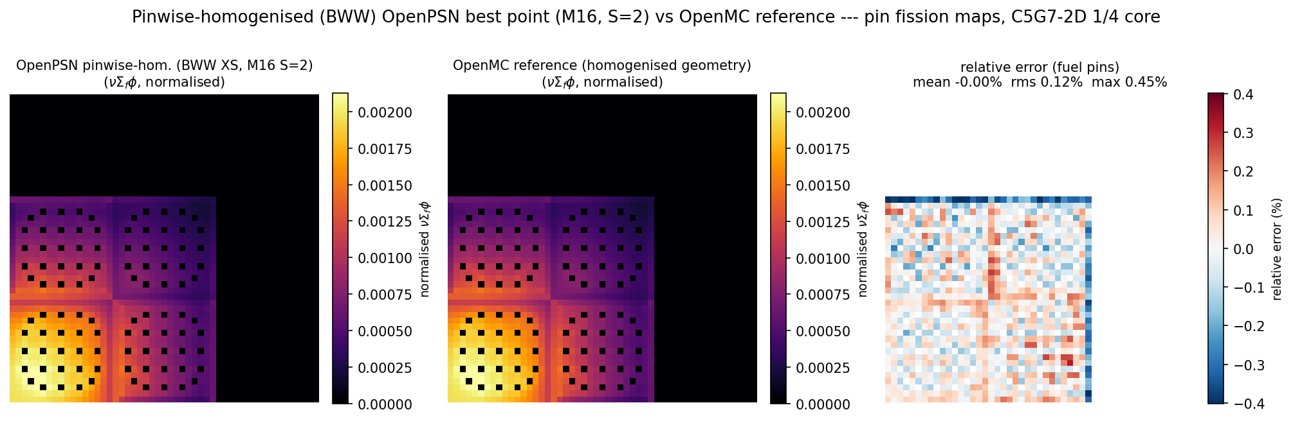
Pin-averaged fission source maps $νΣ_{f}ϕ$ at the best pinwise-homogenised core point (M16, S=2) vs. the OpenMC homogenised-geometry reference on the same BWW XS, C5G7-2D 1/4 core (fuel region, 34$×$34 pins). Left: OpenPSN; centre: OpenMC reference; right: relative error (fuel pins only, both maps normalised to unit sum).

Study II — the rectangular-node model with explicit intra-node structure

Motivation and layout.
Study I isolates the discretisation error of the nodal PSN model, but its eigenvalue is still anchored to whatever homogenisation model feeds it. To remove that model from the problem we use the rectangular-node extension of Section 2.2: the circular C5G7 fuel rod ($r=0.54$ cm) is replaced by an equal-area fuel square of side $s=\sqrt{πr^{2}}=0.95713$ cm centred on the same 1.26 cm pitch, so that every pin cell becomes a $3×3$ array of rectangles (one fuel square plus eight water strips) and the whole core is a globally edge-aligned rectangular tiling. Figure 3 shows the layout. The pin pitch, the rod positions (including Gd pins, which are the centre rectangle of their $3×3$ block) and the total fuel area are unchanged; the layout was verified node by node — all 2601 fuel-centre rectangles of the 1/4 core coincide with the 2601 fuel pins of the homogenised grid, and the total area reproduces $4129.35 {cm}^{2}$ exactly. Un-homogenised 7-group cross sections (fuel, water, Gd, MOX) are then assigned directly to the rectangles. The spatial resolution is fixed by this $3×3$ tiling, so the only open discretisation knob is the angular order $M$; there is no $S$ axis in this model.
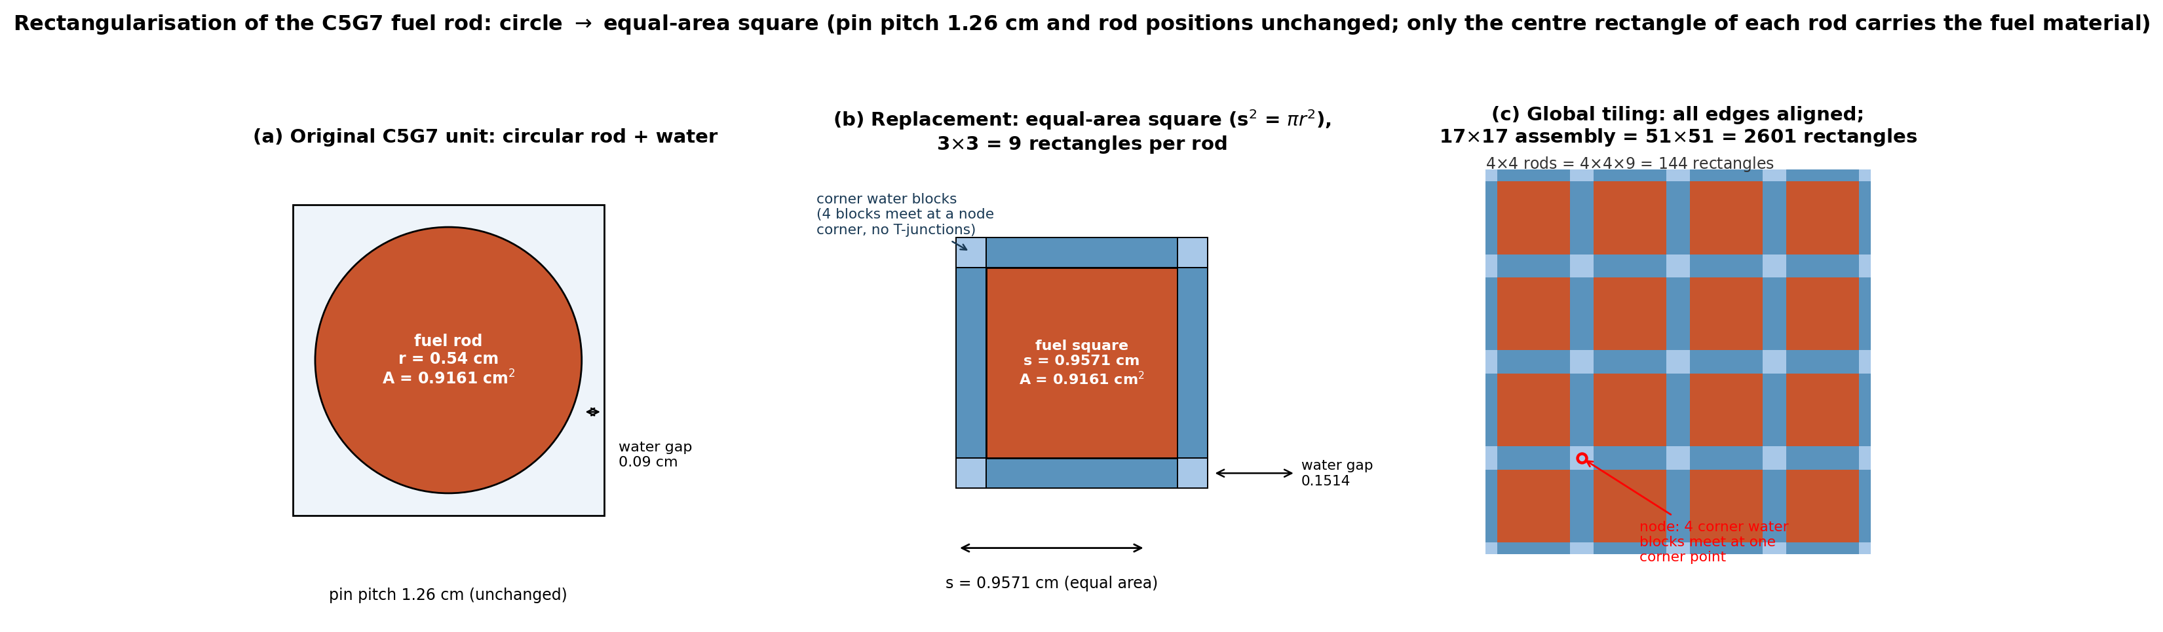
Rectangularisation of the C5G7 pin cell. (a) Original circular rod in its pitch cell (water gap 0.09 cm). (b) Equal-area fuel square ($s=0.95713$ cm, $s^{2}=πr^{2}$) with the pin cell split into $3×3$ rectangles; the four corner water blocks of neighbouring pins meet at a single node corner, so the tiling has no T-junctions. (c) Global tiling: a $17×17$ assembly is $51×51=2601$ rectangles and the 1/4 core is $153×153=23409$.

Angular convergence ($M$ sweep).
Table 3 gives the $M$ sweep with un-homogenised material XS on the single UO$​_{2}$ assembly ($51×51$ rect. nodes, all edges reflective) and on the 1/4 core ($153×153$ rect. nodes, reflective on the symmetry edges, vacuum on the open edges), all converged to ${10}^{−10}$ in $|Δκ_{eff}|$.
Rectangular-node OpenPSN (un-homogenised material XS). $Δ$ in pcm versus the explicitly noted reference. References: the directly computed OpenMC explicit-geometry runs on the same un-homogenised data — fuel circle $+$ water annulus, and the identical rectangular-rod geometry of the PSN nodes — the high-fidelity reference $1.18646$ of McGraw et al. , and nTRACER (SPHINCS).
 | $M=8$​ | $M=12$​ | $M=16$​
Single UO$​_{2}$ assembly, $κ_{eff}$
$κ_{eff}$​ | 1.3337164 | 1.3340330 | 1.3343536
$Δ$ vs OpenMC, explicit pin ($1.3334947$) | $+22.2$​ | $+53.8$​ | $+85.9$​
$Δ$ vs OpenMC, rect. rods ($1.3347260$) | $−101.0$​ | $−69.3$​ | $−37.2$​
$Δ$ vs nTRACER ($1.33367$) | $+4.8$​ | $+36.3$​ | $+68.9$​
C5G7-2D 1/4 core, $κ_{eff}$
$κ_{eff}$​ | 1.1853742 | 1.1861084 | 1.1866067
$Δ$ vs OpenMC, explicit pin ($1.1864955$) | $−112.1$​ | $−38.7$​ | $+11.1$​
$Δ$ vs OpenMC, rect. rods ($1.1872176$) | $−184.3$​ | $−110.9$​ | $−61.1$​
$Δ$ vs McGraw high-fidelity ($1.18646$) | $−108.6$​ | $−35.2$​ | $+14.7$​
$Δ$ vs nTRACER ($1.18653$) | $−115.6$​ | $−42.2$​ | $+7.7$​
On the 1/4 core the eigenvalue climbs monotonically toward the reference: $−112.1→−38.7→+11.1$ pcm for $M=8→12→16$, with $M=16$ at $∼3$ of the OpenMC standard error ($±3.4$ pcm) and within $+14.7$ pcm of the high-fidelity reference $1.18646$. Against the OpenMC run on the identical rectangular-rod geometry (Section [sec:rectref], Figure 5) the same sweep reads $−184.3→−110.9→−61.1$ pcm: still monotonically decreasing, so at $M=16$ the angular-moment closure, not the square tiling, is what sets the residual. (The assembly $M$ dependence drifts the other way, upward with $M$: the reflective assembly has no leakage channel to absorb the angular cliff, so the angular-moment closure over-corrects as $M$ grows; the core, with two vacuum edges, converges toward the reference instead.)

Flux comparison, explicit geometry.
Figure 4 compares the pin-averaged fission maps $Σ_{f}ϕ$ of the rectangular-node OpenPSN ($M=16$) against the OpenMC explicit-geometry (fuel circle $+$ water annulus) runs on the same un-homogenised data, for the single UO$​_{2}$ assembly (first row, 17$×$17 pins) and the 1/4 core (second row, 34$×$34 fuel pins). The OpenPSN node field is the pin power $νΣ_{f}ϕ$; it is converted into the fission quantity by dividing each pin by the fission-weighted $ν$ of its material ($2.441$ for UO$​_{2}$, $2.865$–$2.874$ for the three MOX enrichments, and $2.434$ for the fission-chamber inserts), so that both maps are the same physical quantity $Σ_{f}ϕ$ pin by pin. Both maps are then normalised to unit sum, so the residual is purely in the shape. On the assembly the pin-by-pin relative error has a mean of $−0.002\%$ and an RMS of $0.070\%$ (max $0.21\%$). On the 1/4 core, over all $1056$ fuel pins, the error is a mean of $−0.25\%$ and an RMS of $0.72\%$ (max $1.52\%$): the four assemblies show a coherent pattern at the $±0.8\%$ level (UO$​_{2}$ assemblies $+0.04…+0.63\%$, MOX assemblies $−0.84\%$ in both) — the small between-assembly power redistribution that comes with the rectangular tiling — while the intra-assembly shape error stays below $±1\%$ in every assembly; the two solvers agree within one percent on the pin-level fission distribution for the whole core.
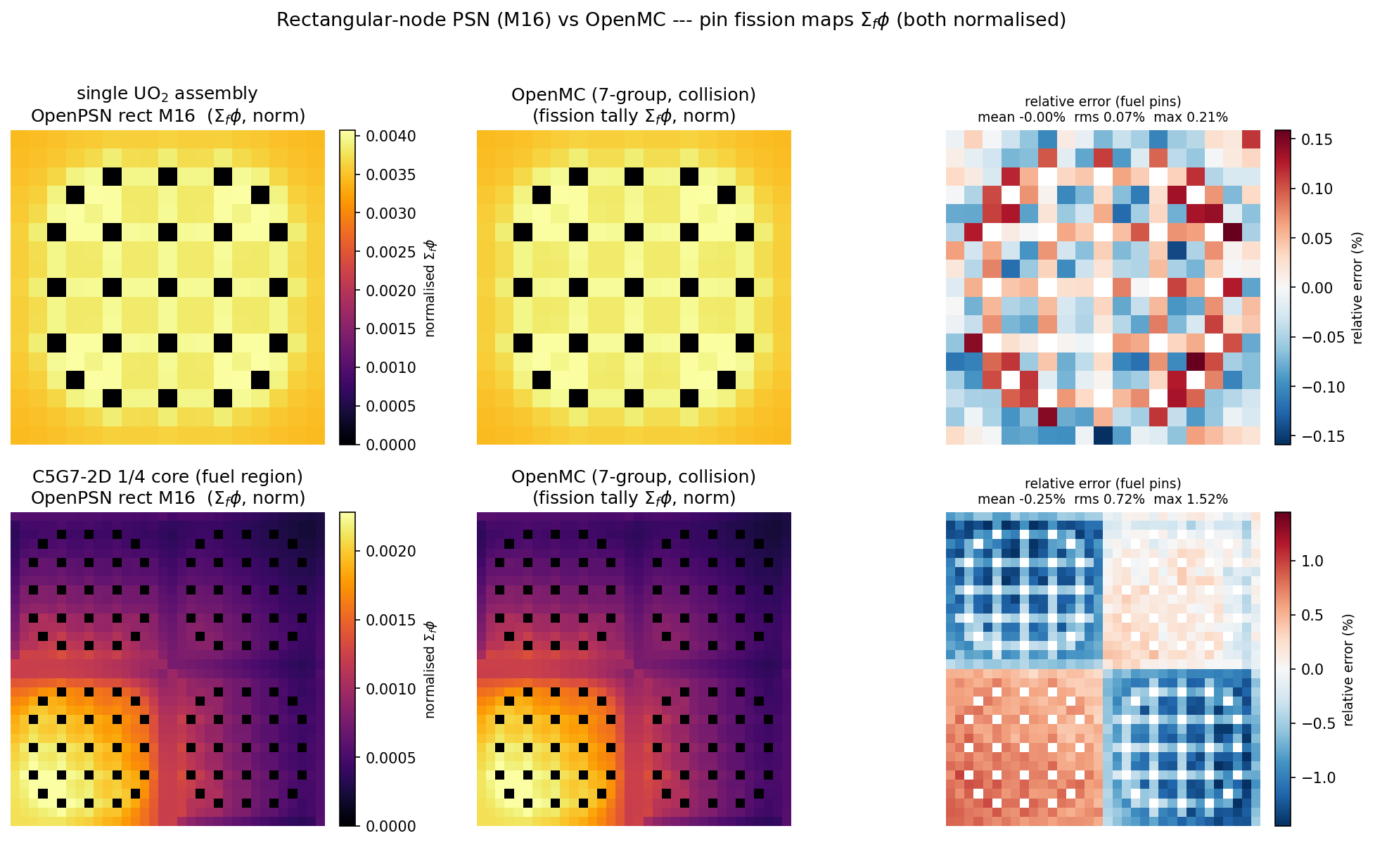
Pin-averaged fission maps $Σ_{f}ϕ$, rectangular-node OpenPSN ($M=16$, un-homogenised material XS) vs. OpenMC (explicit geometry, 7-group collision estimator). One row per problem — single UO$​_{2}$ assembly (17$×$17 pins), then C5G7-2D 1/4 core, fuel region only (34$×$34 pins); columns are OpenPSN, OpenMC, and the pin-by-pin relative error (fuel pins only), both maps normalised to unit sum.

Rectangular-rod reference.
The circular pin cell is the benchmark’s reference geometry, while the PSN nodes tile the same cell with an equal-area square fuel block (side $0.9571$ cm, water gap $0.1514$ cm). To separate the geometric effect from the method difference we run OpenMC on exactly that rectangular-rod geometry (same un-homogenised data, same collision-estimator pin tallies, $20200$ batches $×{10}^{5}$ particles, fixed seed). The square-rod assembly returns $κ_{eff}=1.3347260$ ($±3.6$ pcm) and the 1/4 core $1.1872176$ ($±3.4$ pcm): $+123$ and $+72$ pcm above the cylindrical reference of Table 3 — the pure geometry effect of the square tiling on the same data. Against the rectangular-rod reference the $M$ sweep is $−101.0→−69.3→−37.2$ pcm on the assembly and $−184.3→−110.9→−61.1$ pcm on the 1/4 core: monotonically decreasing with $M$, i.e. the angular-moment closure is still the dominant residual, and the square tiling does not remove the systematic low bias. Figure 5 compares the two solvers on this identical geometry. The pin-by-pin fission maps $Σ_{f}ϕ$ agree with a mean of $−0.00\%$ and an RMS of $0.16\%$ (max $0.38\%$) on the assembly, and a mean of $−0.18\%$ and an RMS of $0.59\%$ (max $1.61\%$) over all $1056$ fuel pins of the 1/4 core (assembly means $+0.46\%$, $−0.64\%$, $−0.60\%$, $+0.05\%$): the same level as against the explicit cylindrical geometry (RMS $0.72\%$), so the pin-level shape difference is set by the method, not by the square tiling.
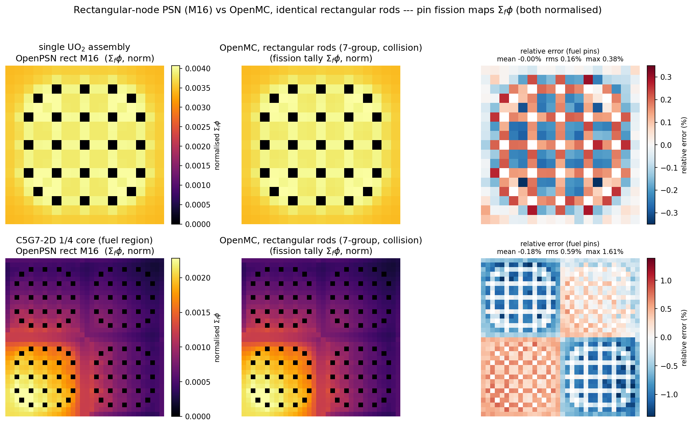
Pin-averaged fission maps $Σ_{f}ϕ$, rectangular-node OpenPSN ($M=16$) vs. OpenMC on the identical rectangular-rod geometry (equal-area square fuel block per pin cell, 7-group collision estimator). One row per problem — single UO$​_{2}$ assembly (17$×$17 pins), then C5G7-2D 1/4 core, fuel region only (34$×$34 pins); columns are OpenPSN, OpenMC, and the pin-by-pin relative error (fuel pins only), both maps normalised to unit sum.

Comparison with the published diffusion / SN / nodal landscape
The original NEA report tabulates 20 deterministic codes on C5G7-2D. Table 4 reproduces the diffusion- and nodal-family values we could extract from it, together with recent P1/SP3/SN/nodal literature results and our own OpenPSN result.
C5G7-2D $κ_{eff}$ by method class (2-D multi-group, homogenised pin model unless noted). NEA-2003 $k$ values (its Table 17) plus recent P1/SP3 literature. $Δ$ = $(k−1.18646)×{10}^{5}$ in pcm, except where stated (STELLA vs its PEACH reference 1.18716). The original NEA table prints the relative per-cent error against its MCNP reference 1.18655; the pcm values here are recomputed from the printed $k$ against 1.18646.
method class | code | $κ_{eff}$​ | $Δ$ (pcm)
Pure P1 diffusion
diffusion (FEM) | CRONOS2 | 1.18323 | $−323$​
P1 (pin-hom) | STELLA-P1 | 1.18426 | $−290$ (vs PEACH)
SN
SN-FEM | CRONOS2-SN | 1.18338 | $−308$​
SN-FDM | DORT-GRS | 1.18482 | $−164$​
SN-FDM | DORT-ORNL | 1.18496 | $−150$​
SN-FDM | TWODANT | 1.18668 | $+22$​
SN (diamond diff.) | PARTISN | 1.18637 | $−9$​
SN (unstructured) | PERICLES | 1.18658 | $+12$​
High-order nodal $P_{n}$ / surf. harmonics
$P_{n}$-nodal (FEM) | VARIANT-SE | 1.18495 | $−151$​
$P_{n}$-nodal + int. transp. | VARIANT-ISE | 1.18745 | $+99$​
surface harm. (G3/P2) | SUHAM-2D | 1.18628 | $−18$​
MOC
MOC | CHAPLET | 1.18656 | $+10$​
MOC | MCCG3D | 1.18657 | $+11$​
MOC | DeCART | 1.18660 | $+14$​
MOC | APOLLO2 | 1.18618 | $−28$​
MOC | CRX | 1.18813 | $+167$​
MOC (stoch. rays) | UNKGRO | 1.18523 | $−123$​
This work
PSN nodal (rect. node, $M=16$) | OpenPSN | 1.1866067 | $+14.7$​
Readings.
- Pure P1 diffusion is systematically low — CRONOS2 $−323$ pcm ($−0.27\%$), STELLA-P1 $−290$ pcm vs its PEACH MOC reference 1.18716: no transport correction and no self shielding.
- SN spans $−308$ (CRONOS2-SN) to $+22$ pcm (TWODANT); DORT $−164$/$−150$; the better-differenced / unstructured variants PARTISN ($−9$) and PERICLES ($+12$) within $±0.01\%$.
- High-order nodal $P_{n}$ / surface harmonics spans $−151$ (VARIANT-SE) to $+99$ pcm (VARIANT-ISE); SUHAM-2D $−18$; VARIANT-ISE also has the best pin power in the original table (MRE 0.11%).
- MOC (explicit pin geometry) clusters within $±28$ pcm (CHAPLET $+10$, MCCG3D $+11$, DeCART $+14$, APOLLO2 $−28$), with two outliers (CRX $+167$, UNKGRO $−123$); TWODANT is SN-FDM ($+22$); the high-fidelity Rattlesnake converged limit is $1.186446$ ($∼$1 pcm from the 1.186456 reference).
- OpenPSN in this work. The two C5G7 studies of Sections 4.3–4.4 bound the answer from both sides. With the self-shielding-aware BWW pinwise homogenisation, the best point of the $S×M$ sweep ($M16_S2$) is $−23.6$ pcm vs. the OpenMC homogenised reference, i.e. $+12.7$ pcm vs. the high-fidelity reference $1.18646$; with the rectangular-node model that removes homogenisation entirely, $M=16$ lands at $+11.1$ pcm vs. the OpenMC explicit-geometry reference ($∼3.3$ its $±3.4$ pcm standard error) and $+14.7$ pcm vs. $1.18646$, and at $−61.1$ pcm vs. the OpenMC run on the identical rectangular-rod geometry (Section 4.4); the pin-level fission maps agree within $0.6\%$ RMS on both geometries. In either case OpenPSN sits inside the MOC reference cluster ($±37$ pcm, plus the better-differenced SN and unstructured codes), and the rectangular-node result is within the $M=16$ angular convergence of the nodal PSN method on this problem.
Two published outliers are worth noting for completeness: COHINT ($P_{2}$ interface currents, $−1125$ pcm) and HELIOS (collision probability, $+675$ pcm), both far outside the converged cluster and attributable to their respective current/transport approximations.

Conclusions
We built OpenPSN, a clean, multi-group, sparse, vectorised implementation of the Phase Space Nodal method, and validated it on two levels. On the source paper’s problems it reproduces all 248 published eigenvalue data points to a few pcm (full point-by-point comparison in Appendix A) while removing the dense-formulation memory blow-up (exact to ${10}^{−15}$; the 10404-node C5G7 case assembles in $∼$54 and converges in $∼$54 min on one core, where the dense form would need a $∼$504 matrix). We also extended the node operators to arbitrary per-node widths, giving the first PSN implementation with explicit, un-homogenised intra-node fuel/water structure.
On the C5G7 MOX benchmark the two studies separate the two error sources that a nodal code carries. In the pinwise-homogenised study, the $S×M$ sweep against a directly computed OpenMC reference on the same homogenised data shows the discretisation converging cleanly: the assembly error reaches the Monte Carlo standard error ($≈$3.5 pcm) by $S=5$, $M≥8$, and the best core point (with the self-shielding-aware BWW recipe) is $−23.6$ pcm versus the OpenMC homogenised reference, i.e. $+12.7$ pcm versus the high-fidelity reference $1.18646$. That residual is the homogenisation model itself, and the best-point pin-power field agrees with the same-recipe OpenMC map to $0.12\%$ RMS (max $0.45\%$): a smooth method-level bias, not a cancellation of local errors. In the rectangular-node study the homogenisation model is removed entirely: with un-homogenised 7-group material data the 1/4-core eigenvalue converges monotonically with $M$ into the OpenMC explicit-geometry reference ($−112→−39→+11$ pcm for $M=8→16$), lands $+14.7$ pcm from the high-fidelity reference $1.18646$, and its pin-averaged fission map $Σ_{f}ϕ$ (the same quantity as the Monte Carlo fission tally) agrees with OpenMC to $0.07\%$ RMS on the single assembly and $0.72\%$ over all $1056$ fuel pins of the core (max $1.52\%$; below $±1\%$ within every assembly, largest in the MOX cells where the local gradients are steepest). Placed against the 20-code NEA landscape and the recent P1/SP3/SN/nodal literature, both OpenPSN results sit inside the high-fidelity MOC reference cluster: the nodal PSN method, once its homogenisation model is controlled (by a self-shielding-aware recipe or by explicit rectangular nodes), reproduces resolved-pin transport at a fraction of the mesh cost of discrete-ordinates or characteristics methods.

Acknowledgments
This work received no external funding. The build and the performance-optimisation work on OpenPSN (sparse assembly, vectorised node operators) were carried out with the assistance of a large language model (Qwen3.8 27B) running on local hardware.
11
Y.-A. Chao, Z. Li, and G. Chen, “Diffusion-based phase space nodal method (PSN): Solving the neutron transport equation with a diffusion code,” Annals of Nuclear Energy 240 (2027) 112707 doi:10.1016/j.anucene.2026.112707.
Benchmark on Deterministic Transport Calculations Without Spatial Homogenisation: A 2-D/3-D MOX Fuel Assembly Benchmark, OECD/NEA NSC document NEA/NSC/DOC(2003)16 (2003). 2-D 20-code comparison, Tables 16–20.
M. A. Smith, E. E. Lewis, and B.-C. Na, “Benchmark on deterministic 2-D MOX fuel assembly transport calculations without spatial homogenization,” Progress in Nuclear Energy 45 (2004) 107–118 doi:10.1016/j.pnueene.2004.09.003.
J. Hou, K. N. Ivanov, V. F. Boyarinov, and P. A. Fomichenko, “OECD/NEA benchmark for time-dependent neutron transport calculations without spatial homogenization,” Nuclear Engineering and Design 317 (2017) 177–189 doi:10.1016/j.nucengdes.2017.02.008.
C. N. McGraw, M. L. Adams, W. D. Hawkins, M. P. Adams, and T. Smith, “Accuracy of the linear discontinuous Galerkin method for reactor analyses with resolved fuel pins,” in PHYSOR 2014, Kyoto, Japan, 2014. (2-D C5G7 resolved-fuel-pin high-fidelity $κ_{eff}=1.186456$.)
Y. Wang, M. D. DeHart, D. R. Gaston, F. N. Gleicher, R. C. Martineau, J. Ortensi, J. W. Peterson, and S. Schunert, “Convergence study of Rattlesnake solutions for the two-dimensional C5G7 MOX benchmark,” INL/CON-15-34115, ANS MC2015. Converged high-fidelity $κ_{eff}=1.186446$ ($∼$1 pcm from the Ref. reference).
H. H. Cho, J. Kang, J. I. Yoon, and H. G. Joo, “Analysis of C5G7-TD benchmark with a multi-group pin homogenized SP3 code SPHINCS,” Nuclear Engineering and Technology 53(5) (2021) 1403–1415 doi:10.1016/j.net.2020.11.013. Table 1: nTRACER single-assembly references (UO2 $1.33367$; UO2-$0.95ρ$ $1.32936$) with the SPHINCS w/o-SPH value $1.33123$; Table 2: 2-D core $Δρ$ from $−225$ pcm (w/o SPH) to $−20$ pcm (w/ SPH) vs the nTRACER reference.
P. K. Romano, N. E. Horelik, B. R. Herman, A. G. Nelson, B. Forget, and K. Smith, “OpenMC: A state-of-the-art Monte Carlo code for research and development,” Annals of Nuclear Energy 82 (2015) 90–97 doi:10.1016/j.anucene.2014.07.048.
C. Tang, “Development and verification of a SP3 code using semi-analytic nodal method for pin-by-pin calculation,” in M&C 2017, Jeju, Korea, 2017. (C5G7-2D pin-hom: STELLA-P1 $1.18426$, STELLA-SP3 $1.18561$; PEACH MOC reference $1.18716$.)
C. Tang and S. Zhang, “Development and verification of an MOC code employing assembly modular ray tracing and efficient acceleration techniques,” Annals of Nuclear Energy 36 (2009) 1013–1020 doi:10.1016/j.anucene.2009.06.007.

Full point-by-point reproduction of the published PSN results
Table 1 summarised the maxima. Tables 5–8 give the complete 240-cell comparison for the three printed eigenvalue grids (checkerboard weak/strong, BWR without Gd) plus the with-Gd valley, in the same “this work / paper ($Δ$) cell format used in the reproduction notes shipped in snapshot/. Row labels: $S$ = spatial subdivision of the checkerboard grid, $N$ = spatial grid of the BWR bundle. The remaining 8 points (restricted $M=24$, $S=1,2,4,8$, weak/strong) agree with the printed Figs. 4–5 within the plot-reading uncertainty and are listed in snapshot/data/report_data.json.
Fig. 3-A, weak absorption, generic ($I=30$): $Δ$ vs the printed values (reference $κ_{eff}=1.12974$). $S$ = spatial subdivision.
$S$ | $M$=2 | $M$=4 | $M$=8 | $M$=12 | $M$=16 | $M$=24
1$×$1 | $+136.2/136 (+0.2)$​ | $+389.0/388 (+1.0)$​ | $+703.7/703 (+0.7)$​ | $+793.9/793 (+0.9)$​ | $+835.2/835 (+0.2)$​ | $+873.5/873 (+0.5)$​
2$×$2 | $−275.4/−276 (+0.6)$​ | $−143.6/−144 (+0.4)$​ | $+154.9/154 (+0.9)$​ | $+217.2/217 (+0.2)$​ | $+244.4/244 (+0.4)$​ | $+268.2/268 (+0.2)$​
3$×$3 | $−374.4/−375 (+0.6)$​ | $−263.2/−264 (+0.8)$​ | $+19.1/18 (+1.1)$​ | $+79.3/79 (+0.3)$​ | $+104.4/104 (+0.4)$​ | $+124.1/123 (+1.1)$​
4$×$4 | $−412.0/−413 (+1.0)$​ | $−309.4/−310 (+0.6)$​ | $−34.6/−35 (+0.4)$​ | $+24.9/24 (+0.9)$​ | $+48.2/47 (+1.2)$​ | $+66.9/66 (+0.9)$​
5$×$5 | $−430.1/−431 (+0.9)$​ | $−332.1/−333 (+0.9)$​ | $−61.2/−62 (+0.8)$​ | $−2.7/−3 (+0.3)$​ | $+20.2/19 (+1.2)$​ | $+38.2/38 (+0.2)$​
6$×$6 | $−440.3/−441 (+0.7)$​ | $−344.8/−346 (+1.2)$​ | $−76.3/−77 (+0.7)$​ | $−18.5/−19 (+0.5)$​ | $+4.1/3 (+1.1)$​ | $+21.8/21 (+0.8)$​
7$×$7 | $−446.5/−447 (+0.5)$​ | $−352.7/−353 (+0.3)$​ | $−85.7/−86 (+0.3)$​ | $−28.4/−29 (+0.6)$​ | $−6.1/−7 (+0.9)$​ | $+11.4/11 (+0.4)$​
8$×$8 | $−450.5/−451 (+0.5)$​ | $−357.9/−359 (+1.1)$​ | $−92.0/−93 (+1.0)$​ | $−35.0/−36 (+1.0)$​ | $−12.9/−14 (+1.1)$​ | $+4.4/4 (+0.4)$​
9$×$9 | $−453.4/−454 (+0.6)$​ | $−361.5/−362 (+0.5)$​ | $−96.3/−97 (+0.7)$​ | $−39.6/−40 (+0.4)$​ | $−17.7/−18 (+0.3)$​ | $−0.5/−1 (+0.5)$​
10$×$10 | $−455.4/−456 (+0.6)$​ | $−364.1/−365 (+0.9)$​ | $−99.5/−100 (+0.5)$​ | $−43.0/−44 (+1.0)$​ | $−21.2/−22 (+0.8)$​ | $−4.1/−5 (+0.9)$​
Note: each cell is “this work / paper ($Δ$), $Δ$ = this work $−$ paper, in pcm; paper values as printed in Ref. ; the Fig. 10/12 references are read from the printed contour plots ($±1$–$2$ pcm reading uncertainty).
Fig. 3-B, strong absorption, generic ($I=30$): $Δ$ vs the printed values (reference $κ_{eff}=0.51673$). $S$ = spatial subdivision.
$S$ | $M$=2 | $M$=4 | $M$=8 | $M$=12 | $M$=16 | $M$=24
1$×$1 | $+591.0/591 (+0.0)$​ | $+1762.4/1763 (−0.6)$​ | $+3199.2/3199 (+0.2)$​ | $+3596.7/3597 (−0.3)$​ | $+3776.6/3777 (−0.4)$​ | $+3941.3/3941 (+0.3)$​
2$×$2 | $−1534.9/−1535 (+0.1)$​ | $−790.2/−790 (−0.2)$​ | $+807.9/808 (−0.1)$​ | $+1132.7/1133 (−0.3)$​ | $+1271.3/1271 (+0.3)$​ | $+1392.4/1393 (−0.6)$​
3$×$3 | $−2068.0/−2068 (+0.0)$​ | $−1425.6/−1425 (−0.6)$​ | $+113.2/113 (+0.2)$​ | $+431.2/431 (+0.2)$​ | $+563.2/563 (+0.2)$​ | $+666.4/666 (+0.4)$​
4$×$4 | $−2272.6/−2272 (−0.6)$​ | $−1676.0/−1676 (+0.0)$​ | $−170.0/−170 (+0.0)$​ | $+145.3/145 (+0.3)$​ | $+269.2/269 (+0.2)$​ | $+367.8/368 (−0.2)$​
5$×$5 | $−2371.6/−2372 (+0.4)$​ | $−1799.5/−1799 (−0.5)$​ | $−311.9/−312 (+0.1)$​ | $−1.4/−1 (−0.4)$​ | $+120.5/121 (−0.5)$​ | $+216.1/216 (+0.1)$​
6$×$6 | $−2427.0/−2427 (+0.0)$​ | $−1869.2/−1869 (−0.2)$​ | $−393.2/−393 (−0.2)$​ | $−86.1/−86 (−0.1)$​ | $+34.1/34 (+0.1)$​ | $+128.3/128 (+0.3)$​
7$×$7 | $−2461.0/−2461 (+0.0)$​ | $−1912.3/−1912 (−0.3)$​ | $−444.1/−444 (−0.1)$​ | $−139.3/−139 (−0.3)$​ | $−20.7/−21 (+0.3)$​ | $+72.6/72 (+0.6)$​
8$×$8 | $−2483.3/−2483 (−0.3)$​ | $−1940.8/−1941 (+0.2)$​ | $−478.0/−478 (+0.0)$​ | $−175.1/−175 (−0.1)$​ | $−57.6/−58 (+0.4)$​ | $+35.0/34 (+1.0)$​
9$×$9 | $−2498.8/−2499 (+0.2)$​ | $−1960.6/−1961 (+0.4)$​ | $−501.8/−502 (+0.2)$​ | $−200.2/−200 (−0.2)$​ | $−83.6/−84 (+0.4)$​ | $+8.4/7 (+1.4)$​
10$×$10 | $−2510.0/−2510 (−0.0)$​ | $−1974.9/−1975 (+0.1)$​ | $−519.1/−519 (−0.1)$​ | $−218.6/−219 (+0.4)$​ | $−102.6/−103 (+0.4)$​ | $−11.1/−12 (+0.9)$​
Note: each cell is “this work / paper ($Δ$), $Δ$ = this work $−$ paper, in pcm; paper values as printed in Ref. ; the Fig. 10/12 references are read from the printed contour plots ($±1$–$2$ pcm reading uncertainty).
Fig. 10, BWR 12-pin bundle without Gd (2-group): $Δ$ vs the values read from the printed contour plot (reference $κ_{eff}=1.18797$). $N$ = spatial grid.
$N$ | $M$=4 | $M$=8 | $M$=12 | $M$=16 | $M$=20 | $M$=24
1 | $+126.4/123 (+3.4)$​ | $−74.8/−78 (+3.2)$​ | $−122.2/−125 (+2.8)$​ | $−140.3/−144 (+3.7)$​ | $−149.1/−152 (+2.9)$​ | $−154.2/−157 (+2.8)$​
2 | $+206.5/203 (+3.5)$​ | $+28.3/25 (+3.3)$​ | $−15.6/−19 (+3.4)$​ | $−31.9/−35 (+3.1)$​ | $−40.1/−43 (+2.9)$​ | $−44.9/−48 (+3.1)$​
3 | $+226.2/223 (+3.2)$​ | $+54.8/51 (+3.8)$​ | $+12.5/9 (+3.5)$​ | $−3.6/−7 (+3.4)$​ | $−11.6/−15 (+3.4)$​ | $−16.3/−20 (+3.7)$​
4 | $+233.7/230 (+3.7)$​ | $+65.2/62 (+3.2)$​ | $+23.8/20 (+3.8)$​ | $+7.8/5 (+2.8)$​ | $−0.1/−3 (+2.9)$​ | $−4.6/−8 (+3.4)$​
5 | $+237.4/234 (+3.4)$​ | $+70.4/67 (+3.4)$​ | $+29.4/26 (+3.4)$​ | $+13.6/10 (+3.6)$​ | $+5.8/2 (+3.8)$​ | $+1.3/−2 (+3.3)$​
6 | $+239.4/236 (+3.4)$​ | $+73.3/70 (+3.3)$​ | $+32.7/29 (+3.7)$​ | $+16.9/14 (+2.9)$​ | $+9.1/6 (+3.1)$​ | $+4.7/1 (+3.7)$​
7 | $+240.6/237 (+3.6)$​ | $+75.1/72 (+3.1)$​ | $+34.7/31 (+3.7)$​ | $+19.0/16 (+3.0)$​ | $+11.3/8 (+3.3)$​ | $+6.9/4 (+2.9)$​
8 | $+241.4/238 (+3.4)$​ | $+76.3/73 (+3.3)$​ | $+36.0/33 (+3.0)$​ | $+20.4/17 (+3.4)$​ | $+12.7/9 (+3.7)$​ | $+8.3/5 (+3.3)$​
9 | $+242.0/239 (+3.0)$​ | $+77.2/74 (+3.2)$​ | $+37.0/34 (+3.0)$​ | $+21.4/18 (+3.4)$​ | $+13.7/10 (+3.7)$​ | $+9.3/6 (+3.3)$​
10 | $+242.4/239 (+3.4)$​ | $+77.8/74 (+3.8)$​ | $+37.7/34 (+3.7)$​ | $+22.1/19 (+3.1)$​ | $+14.5/11 (+3.5)$​ | $+10.1/7 (+3.1)$​
Note: each cell is “this work / paper ($Δ$), $Δ$ = this work $−$ paper, in pcm; paper values as printed in Ref. ; the Fig. 10/12 references are read from the printed contour plots ($±1$–$2$ pcm reading uncertainty).
Fig. 12, BWR 12-pin bundle with Gd (2-group): this work only (the printed figure is a contour plot). $N$ = spatial grid. Bold = best $M$ in the row (min $|Δ|$); the valley shifts to lower $M$ as $N$ grows, exactly the Sec. 4.4 effect of the source paper. Best point overall: $N=9$, $M=20$, $+1.1$ pcm.
$N$ | $M$=4 | $M$=8 | $M$=12 | $M$=16 | $M$=20 | $M$=24
1 | -605 | +311 | +565 | +681 | +746 | +788
2 | -998 | -152 | +67 | +157 | +203 | +230
3 | -1140 | -253 | -22 | +73 | +123 | +152
4 | -1207 | -283 | -45 | +53 | +103 | +133
5 | -1264 | -318 | -72 | +28 | +79 | +110
6 | -1310 | -351 | -98 | +4 | +57 | +88
7 | -1346 | -380 | -122 | -18 | +36 | +67
8 | -1375 | -405 | -144 | -37 | +17 | +49
9 | -1397 | -427 | -162 | -54 | +1 | +33
10 | -1415 | -445 | -178 | -69 | -13 | +20
Note: each cell is “this work / paper ($Δ$), $Δ$ = this work $−$ paper, in pcm; paper values as printed in Ref. ; the Fig. 10/12 references are read from the printed contour plots ($±1$–$2$ pcm reading uncertainty).

