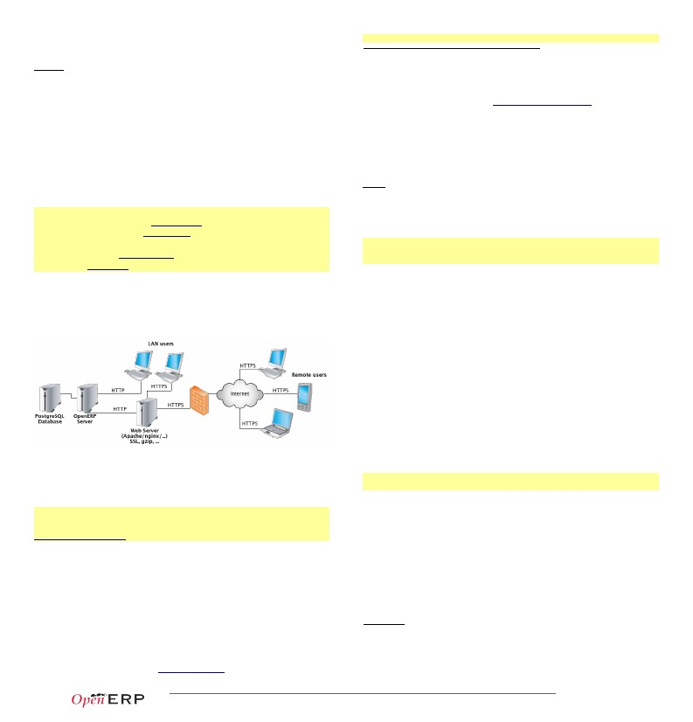
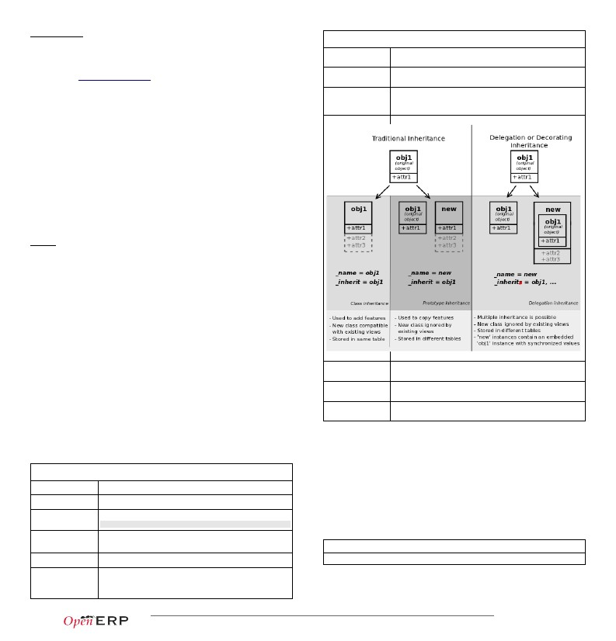
Open Source RAD with OpenERP 7.0
PREAMBLE OpenERP is a modern Suite of Business Applications, released under
Compilation tip: OpenERP being Python-based, no compilation step is needed
1
2
3
4
the AGPL license, and featuring CRM, HR, Sales, Accounting, Manufacturing,
Warehouse Management, Project Management, and more.
It is based on a modular, scalable, and intuitive Rapid Application Development
(RAD) framework written in Python.
OpenERP features a complete and modular toolbox for quickly building
applications: integrated Object-Relationship Mapping (ORM) support,
template-based Model-View-Controller (MVC) interfaces, a report generation
system, automated internationalization, and much more.
Python is a high-level dynamic programming language, ideal for RAD,
combining power with clear syntax, and a core kept small by design.
Tip: Useful links
• Main website, with OpenERP downloads: www.openerp.com
• Functional & technical documentation: doc.openerp.com
• Community resources: www.openerp.com/community
• Continous Integration server: runbot.openerp.com
• Learning Python: doc.python.org
Typical bazaar checkout procedure (on Debian-based Linux)
$ sudo apt-get install bzr# Install Bazaar (version control software)
$ bzr cat -d lp:~openerp-dev/openerp-tools/trunk setup.sh | sh # Get Installer
$ make init-v70# Install OpenERP 7.0
$ make server# Start OpenERP Server with embedded Web
Database creation
After starting the server, open http://localhost:8069 in your favorite
browser. You will see the Database Manager screen where you can create a
new database. Each database has its own modules and config, and can be
created in demo mode to test a pre-populated database (do not use demo
mode for a real database!)
Building an OpenERP module: idea
The code samples used in this memento are taken from a hypothetical
idea module. The purpose of this module would be to help creative minds, who
often come up with ideas that cannot be pursued immediately, and are too
easily forgotten if not logged somewhere. It could be used to record these
ideas, sort them and rate them.
CONTEXT
Note: Modular development
OpenERP uses modules as feature containers, to foster maintainable and robust development. Modules
provide feature isolation, an appropriate level of abstraction, and obvious MVC patterns.
Composition of a module
A module may contain any of the following elements:
• business objects: declared as Python classes extending the osv.Model
class, the persistence of these resources is completely managed by
OpenERP ;
• data: XML/CSV files with meta-data (views and workflows declaration),
configuration data (modules parametrization) and demo data (optional but
recommended for testing, e.g. sample ideas) ;
• wizards: stateful interactive forms used to assist users, often available as
contextual actions on resources ;
◦reports: RML (XML format), MAKO or OpenOffice report templates, to be
merged with any kind of business data, and generate HTML, ODT or PDF
reports.
Installing OpenERP
OpenERP is distributed as packages/installers for most platforms, but can also
be installed from the source on any platform.
OpenERP Architecture
Typical module structure
OpenERP uses the well-known client-server paradigm: the client is running as
a Javascript application in your browser, connecting to the server using the
JSON-RPC protocol over HTTP(S). Ad-hoc clients can also be easily written and
connect to the server using XML-RPC or JSON-RPC.
Tip: Installation procedure
The procedure for installing OpenERP is likely to evolve (dependencies and so on), so make sure to always
check the specific documentation (packaged & on website) for the latest procedures. See
http://doc.openerp.com/v7.0/install
Each module is contained in its own directory within the server/bin/addons
directory in the server installation.
Note: You can declare your own addons directory in the configuration file of OpenERP (passed to the server
with the -c option) using the addons_path option.
5 addons/
6 |- idea/
7|- demo/
8|- i18n/
9|- report/
10|- security/
11|- view/
12|- wizard/
13|- workflow/
14|- __init__.py
15|- __openerp__.py
16|- idea.py
Package installation
Windows all-in-one installer
Linux
Mac
all-in-one packages available for Debian-based (.deb) and RedHat-based
(.rpm) distributions
no all-in-one installer, needs to be installed from source
#
#
#
#
#
#
#
#
#
#
#
The module directory
Demo and unit test population data
Translation files
Report definitions
Declaration of groups and access rights
Views (forms,lists), menus and actions
Wizards definitions
Workflow definitions
Python package initialization (required)
module declaration (required)
Python classes, the module's objects
The __init__.py file is the Python module descriptor, because an OpenERP
module is also a regular Python module.
17 # Import all files & directories containing python code
18 import idea, wizard, report
Installing from source
There are two alternatives: using a tarball provided on the website, or directly
getting the source using Bazaar (distributed Source Version Control). You also
need to install the required dependencies (PostgreSQL and a few Python
libraries – see documentation on doc.openerp.com).
__init__.py:
The __openerp__.py is the OpenERP module manifest and contains a single
Python dictionary with the declaration of the module: its name, dependencies,
description, and composition.
p.1/12
Copyright © 2013 Open Object Press - All rights reserved – See license on page 12.
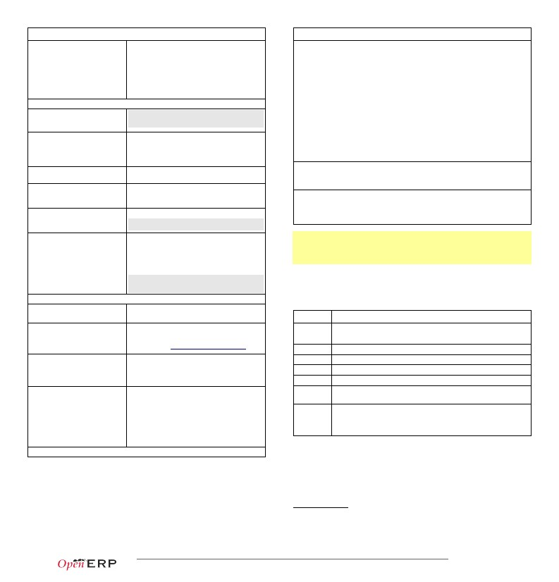
19 {
20'name' : 'Idea',
21'version' : '1.0',
22'author' : 'OpenERP',
23'description' : 'Ideas management module',
24'category': 'Enterprise Innovation',
25'website': 'http://www.openerp.com',
26'depends' : ['base'], # list of dependencies, conditioning startup order
27'data' : [# data files to load at module install
28'security/groups.xml',# always load groups first!
29'security/ir.model.access.csv', # load access rights after groups
30'workflow/workflow.xml',
31'view/views.xml',
32'wizard/wizard.xml',
33'report/report.xml',
34],
35'demo': ['demo/demo.xml'],# demo data (for unit tests)
36 }
__openerp__.py:
Predefined osv.osv attributes for business objects
_constraints
_sql_constraints
_log_access
list of tuples defining the Python constraints, in the form
(func_name, message, fields) (→70)
list of tuples defining the SQL constraints, in the form
(name, sql_def, message) (→69)
If True (default), 4 fields (create_uid, create_date, write_uid,
write_date) will be used to log record-level operations, made
accessible via the perm_read() function
Object-Relational Mapping Service – ORM
Key component of OpenERP, the ORM is a complete Object-Relational mapping
layer, freeing developers from having to write basic SQL plumbing. Business
objects are declared as Python classes inheriting from the osv.Model class,
which makes them magically persisted by the ORM layer.
Predefined attributes are used in the Python class to specify a business object's
characteristics for the ORM:
37 from osv import osv, fields
38 class idea(osv.Model):idea
39_name = 'idea.idea'
40_columns = {
41'name': fields.char('Title', size=64, required=True, translate=True),
42'state': fields.selection([('draft','Draft'),
43('confirmed','Confirmed')],'State',required=True,readonly=True),
44# Description is read-only when not draft!
45'description': fields.text('Description', readonly=True,
46states={'draft': [('readonly', False)]} ),
47'active': fields.boolean('Active'),
48'invent_date': fields.date('Invent date'),
49# by convention, many2one fields end with '_id'
50'inventor_id': fields.many2one('res.partner','Inventor'),
51'inventor_country_id': fields.related('inventor_id','country',
52readonly=True, type='many2one',
53relation='res.country', string='Country'),
54# by convention, *2many fields end with '_ids'
55'vote_ids': fields.one2many('idea.vote','idea_id','Votes'),
56'sponsor_ids': fields.many2many('res.partner','idea_sponsor_rel',
57'idea_id','sponsor_id','Sponsors'),
58'score': fields.float('Score',digits=(2,1)),
59'category_id' = many2one('idea.category', 'Category'),
60}
61_defaults = {
62'active': True,# ideas are active by default
63'state': 'draft',# ideas are in draft state by default
64}
65def _check_name(self,cr,uid,ids):
66for idea in self.browse(cr, uid, ids):
67if 'spam' in idea.name: return False # Can't create ideas with spam!
68return True
69_sql_constraints = [('name_uniq','unique(name)', 'Ideas must be unique!')]
70_constraints = [(_check_name, 'Please avoid spam in ideas !', ['name'])]
71
idea.py:
_order
_rec_name
_sql
_table
Name of the field used to sort the records in lists (default: 'id')
Alternative field to use as name, used by name_get() (default:
'name')
SQL code to create the table/view for this object (if _auto is
False) – can be replaced by SQL execution in the init() method
SQL table name to use (default: _name with dots '.' replaced by
underscores '_')
Inheritance mechanisms
Predefined osv.osv attributes for business objects
_name (required)
_columns (required)
_defaults
_auto
_inherit
_inherits
ORM field types
business object name, in dot-notation (in module namespace)
dictionary {field name→field declaration }
dictionary: {field name→literal or function providing default}
_defaults['name'] = lambda self,cr,uid,context: 'eggs'
Objects may contain 3 types of fields: simple, relational, and functional. Simple
types are integers, floats, booleans, strings, etc. Relational fields represent the
relationships between objects (one2many, many2one, many2many). Functional
fields are not stored in the database but calculated on-the-fly as Python
functions. Relevant examples in the idea class above are indicated with the
corresponding line numbers (→XX,XX)
if True (default) the ORM will create the database table – set
to False to create your own table/view within the init() method
_name of the parent business object (for inheritance)
ORM fields types
Common attributes supported by all fields (optional unless specified)
for decoration inheritance: dictionary mapping the _name of
the parent business object(s) to the names of the corresponding
foreign key fields to use
Copyright © 2013 Open Object Press - All rights reserved – See license on page 12.
p.2/12
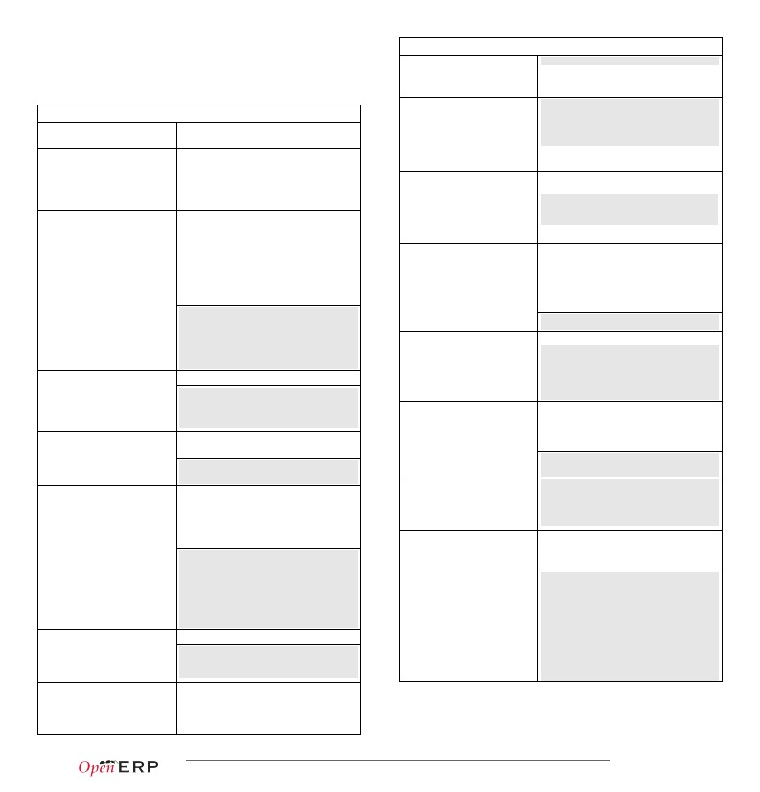
•
•
•
•
•
string: field label
required: True if mandatory
readonly: True if not editable
help: help tooltip
select: True to create a
ORM fields types
(required)• context: dictionary with contextual
ORM fields types
function(fnct, arg=None, fnct_inv=None, fnct_inv_arg=None, type='float',
fnct_search=None, obj=None, store=False, multi=False,…)
database index on this column
boolean(...) integer(...) date(...)
datetime(...) time(...)
char(string,size,translate=False,..)
text(string, translate=False, …)
parameters (for relational fields)
• change_default: True if field should be usable
as condition for default values in clients
• states: dynamic changes to this field's
common attributes based on the state field
(→42,46)
Functional field simulating a real field, computed rather than stored
•
•
•
•
•
•
Simple fields
'active': fields.boolean('Active'),
'priority': fields.integer('Priority'),
'start_date': fields.date('Start Date'),
•
Text-based fields
translate: True if field values can be
translated by users, for char/text fields
• size: optional max size for char fields
(→41,45)
fnct: function to compute the field value (required)
def fnct(self, cr, uid, ids, field_name, arg, context)
returns a dictionary { ids→values } with values of type type
fnct_inv: function used to write a value in the field instead
def fnct_inv(obj, cr, uid, id, name, value, fnct_inv_arg, context)
type: type of simulated field (can be any other type except 'function')
fnct_search: function used to search on this field
def fnct_search(obj, cr, uid, obj, name, args)
returns a list of tuples arguments for search(), e.g. [('id','in',[1,3,5])]
obj: model _name of simulated field if it is a relational field
store, multi: optimization mechanisms (see usage in Performance Section)
float(string, digits=None, ...)
Decimal value
selection(values, string, ...)
•
•
•
•
digits: tuple (precision, scale) (→58)
Field allowing selection among
a set of predefined values
values: list of values (key-label tuples) or
function returning such a list (required) (→42)
filters: optional filename filters for selection
related(f1, f2, …, type='float', …) Shortcut field equivalent to browsing chained fields
• f1,f2,...: chained fields to reach target (f1 required) (→51)
• type: type of target field
property(obj, type='float', view_load=None, group_name=None, …)
binary(string, filters=None, ...)
Field for storing a file or binary
content.
reference(string, selection, size,..)
'picture': fields.binary('Picture',
filters='*.png,*.gif')
Dynamic attribute with specific access rights
• obj: object (required)
• type: type of equivalent field
one2many ↔ many2one are symmetric
Field with dynamic relationship
to any other object, associated
with an assistant widget
selection: model _name of allowed objects
Tip: relational fields symmetry
types and corresponding label (same format as
values for selection fields) (required)
• size: size of text column used to store it
(storage format is 'model_name,object_id')
'contact': fields.reference('Contact',[
('res.partner','Partner'),
('res.partner.contact','Contact')])
•
•
•
many2many ↔ many2many are symmetric when inversed (swap field1 and field2 if explicit)
one2many ↔ many2one + many2one ↔ one2many = many2many
Special / Reserved field names
Relational fields
A few field names are reserved for pre-defined behavior in OpenERP. Some of them
are created automatically by the system, and in that case any field wih that name will
be ignored.
id
name
active
sequence
state
parent_id
Common attributes supported by
relational fields
many2one(obj, ondelete='set null', …)
(→50)
•
•
•
•
•
•
•
domain: optional filter in the form of
arguments for search (see search())
obj: _name of destination object (required)
ondelete: deletion handling, e.g. 'set null',
unique system identifier for the object
field whose value is used to display the record in lists, etc.
if missing, set _rec_name to specify another field to use
toggle visibility: records with active set to False are hidden by default
defines order and allows drag&drop reordering if visible in list views
lifecycle stages for the object, used by the states attribute
defines tree structure on records, and enables child_of operator
Relationship towards a parent
object (using a foreign key)
one2many(obj, field_id, …) (→55)
'cascade', see PostgreSQL documentation
obj: _name of destination object (required)
field_id: field name of inverse many2one, i.e.
Virtual relationship towards
multiple objects (inverse of
many2one)
corresponding foreign key (required)
obj: _name of destination object (required)
rel: optional name of relationship table to use
many2many(obj, rel, field1, field2, …)
(→56)
Bidirectional multiple
relationship between objects
parent_left, used in conjunction with _parent_store flag on object, allows faster
parent_right access to tree structures (see also Performance Optimization section)
create_date, used to log creator, last updater, date of creation and last update date of
create_uid, the record. disabled if _log_access flag is set to False
write_date, (created by ORM, do not add them)
write_uid
(default: auto-assigned based on model names)
• field1: name of field in rel table storing the id
of the current object (default: based on model)
• field2: name of field in rel table storing the id
of the target object (default: based on model)
Functional fields
Working with the ORM
Inheriting from the osv.Model class makes all the ORM methods available on
business objects. These methods may be invoked on the self object within the
Python class itself (see examples in the table below), or from outside the class
by first obtaining an instance via the ORM pool system.
72 class idea2(osv.Model):idea2
73_inherit = 'idea.idea'
74def _score_calc(self,cr,uid,ids,field,arg,context=None):
75res = {}
76# This loop generates only 2 queries thanks to browse()!
77for idea in self.browse(cr,uid,ids,context=context):
78sum_vote = sum([v.vote for v in idea.vote_ids])
ORM usage sample
Copyright © 2013 Open Object Press - All rights reserved – See license on page 12.
p.3/12
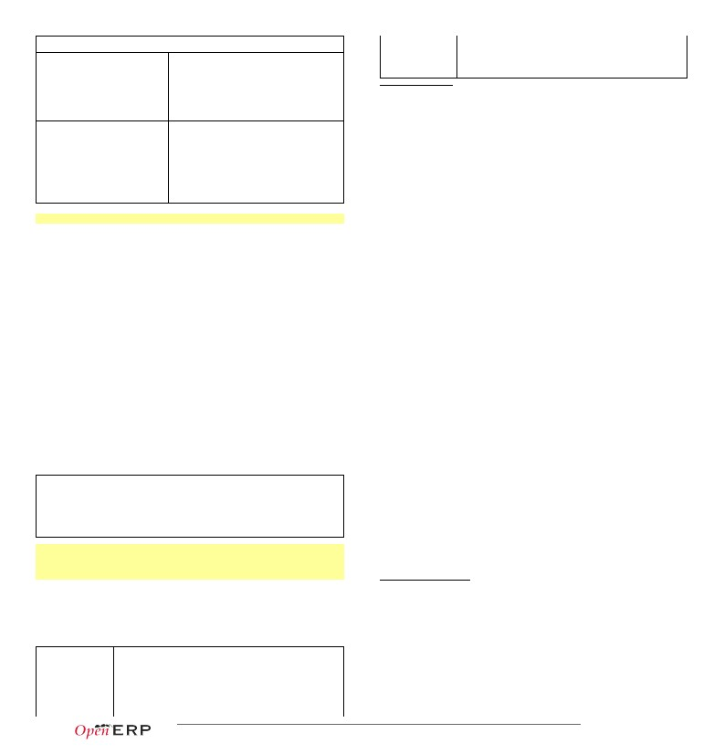
79
80
81
82
83
84
85
avg_vote = sum_vote/len(idea.vote_ids)
res[idea.id] = avg_vote
return res
_columns = {
# Replace static score with average of votes
'score':fields.function(_score_calc,type='float')
}
ORM Methods on osv.Model objects
unlink(cr, uid, ids, context=None)
self.unlink(cr, uid, [42,43])
Deletes records with the given ids
Returns: True
browse(cr, uid, ids, context=None)
ORM Methods on osv.Model objects
OSV generic accessor• self.pool.get('object_name') may be used to
obtain a model from any other
Common parameters, used by
multiple methods
•
•
•
•
•
•
•
•
cr: database connection (cursor)
uid: id of user performing the operation
ids: record ids to perform the operation on
context: optional dictionary of contextual
'lang': 'en_US', ... }
Fetches records as objects,
allowing to use dot-notation to
browse fields and relations
Returns: object or list of objects
requested
default_get(cr, uid, fields,
context=None)
idea = self.browse(cr, uid, 42)
print 'Idea description:', idea.description
print 'Inventor country code:',
idea.inventor_id.address[0].country_id.code
for vote in idea.vote_ids:
print 'Vote %2.2f' % vote.vote
•
fields: list of field names
parameters, e.g. {
search(cr, uid, domain, offset=0,
limit=None, order=None,
context=None, count=False)
domain: filter specifying search criteria
offset: optional number of records to skip
limit: optional max number of records to
Returns: a dictionary of the
default values for fields (set on
the object class, by the user
preferences, or via the context)
perm_read(cr, uid, ids, details=True)
defs = self.default_get(cr,uid,
['name','active'])
# active should be True by default
assert defs['active']
Returns: list of ids of records
matching the given criteria
return
order: optional columns to sort by (default:
self._order)
• count: if True, returns only the number of
•
records matching the criteria, not their ids
Returns: a list of ownership
dictionaries for each requested
record
#Operators: =, !=, >, >=, <, <=, like, ilike,
#in, not in, child_of, parent_left, parent_right
#Prefix operators: '&' (default), '|', '!'
#Fetch non-spam partner shops + partner 34
ids = self.search(cr, uid,
[ '|', ('partner_id', '!=', 34),
'!', ('name', 'ilike', 'spam'),],
order='partner_id' )
details: if True, *_uid fields values are
replaced with pairs (id, name_of_user)
• returned dictionaries contain: object id (id),
creator user id (create_uid), creation date
(create_date), updater user id (write_uid),
update date (write_date)
perms = self.perm_read(cr,uid,[42,43])
print 'creator:', perms[0].get('create_uid', 'n/a')
fields_get(cr, uid, fields=None,
context=None)
•
fields: list of field names
create(cr, uid, values,
context=None)
•
values: dictionary of field values
Creates a new record with the
specified value
Returns: id of the new record
read(cr, uid, ids, fields=None,
context=None)
idea_id = self.create(cr, uid,
{ 'name': 'Spam recipe',
'description' : 'spam & eggs',
'inventor_id': 45,
})
Returns a dictionary of field
dictionaries, each one describing
a field of the business object
fields_view_get(cr, uid,
view_id=None, view_type='form',
context=None, toolbar=False)
class idea(osv.osv):idea
(...)
_columns = {
'name' : fields.char('Name',size=64)
(...)
def test_fields_get(self,cr,uid):
assert(self.fields_get('name')['size'] == 64)
•
•
•
fields: optional list of field names to return
(default: all fields)
results = self.read(cr, uid, [42,43],
['name', 'inventor_id'])
print 'Inventor:', results[0]['inventor_id']
Returns: list of dictionaries with
requested field values
read_group(cr, uid, domain, fields,
groupby, offset=0, limit=None,
orderby=None, context=None)
Returns a dictionary describing
the composition of the requested
view (including inherited views)
name_get(cr, uid, ids,
context=None)
view_id: id of the view or None
view_type: type of view to return if view_id
is None ('form','tree', …)
• toolbar: True to also return context actions
def test_fields_view_get(self,cr,uid):
idea_obj = self.pool.get('idea.idea')
form_view = idea_obj.fields_view_get(cr,uid)
# Ideas should be shown with invention date
def name_get(self,cr,uid,ids):
res = []
for r in self.read(cr,uid,ids['name','create_date'])
res.append((r['id'], '%s (%s)' (r['name'],year))
return res
Returns: list of dictionaries with
requested field values, grouped
by given groupby field(s).
•
•
•
•
•
domain: search filter (see search())
fields: list of field names to read
groupby: field or list of fields to group by
offset, limit: see search()
orderby: optional ordering for the results
Returns tuples with the text
representation of requested
objects for to-many relationships
name_search(cr, uid, name='',
domain=None, operator='ilike',
context=None, limit=80)
> print self.read_group(cr,uid,[],
['score'], ['inventor_id'])
[{'inventor_id': (1, 'Administrator'),
'score': 23,# aggregated score
'inventor_id_count': 12, # group count
},
{'inventor_id': (3, 'Demo'),
'score': 13,
'inventor_id_count': 7,
}]
•
•
•
name: object name to search for
operator: operator for name criterion
domain, limit: same as for search())
Returns list of object names
matching the criteria, used to
provide completion for to-many
relationships. Equivalent of
search() on name + name_get()
write(cr, uid, ids, values, context=None)
•
values: dictionary of field values to update
Updates records with given ids
with the given values.
Returns: True
copy(cr, uid, id, defaults,context=None)
self.write(cr, uid, [42,43],
{ 'name': 'spam & eggs',
'partner_id': 24,
})
# Countries can be searched by code or name
def name_search(self,cr,uid,name='',
domain=[],operator='ilike',
context=None,limit=80):
ids = []
if name and len(name) == 2:
ids = self.search(cr, user,
[('code', '=', name)] + args,
limit=limit, context=context)
if not ids:
ids = self.search(cr, user,
[('name', operator, name)] + args,
limit=limit, context=context)
return self.name_get(cr,uid,ids)
•
Duplicates record with given id
updating it with defaults values.
Returns: True
defaults: dictionary of field values to modify
in the copied values when creating the
duplicated object
Copyright © 2013 Open Object Press - All rights reserved – See license on page 12.
p.4/12
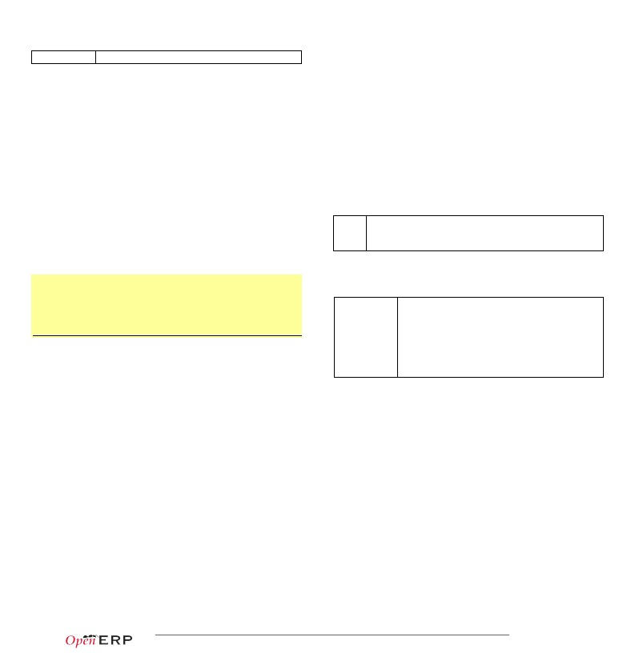
ORM Methods on osv.Model objects
export_data(cr, uid, ids, fields,• fields: list of field names
context=None)
• context may contain import_comp (default:
Exports fields for selected objects,
returning a dictionary with a
datas matrix. Used when
exporting data via client menu.
import_data(cr, uid, fields, data,
mode='init', current_module='',
noupdate=False, context=None,
filename=None)
many2many_field:id
many2many_field.id
reconnect w/ object's xml_id, multiple values w/ commas
reconnect w/ object's database id, multiple values w/ commas
False) to make exported data compatible with
import_data() (may prevent exporting some
fields)
101 "id","name","model_id:id","group_id:id","perm_read","perm_write","perm_create","perm_unlink"
102 "access_idea_idea","idea.idea","model_idea_idea","base.group_user",1,0,0,0
103 "access_idea_vote","idea.vote","model_idea_vote","base.group_user",1,0,0,0
one2many_field/field creates one2many destination record and sets field value
ir.model.access.csv
Imports given data in the given
module Used when exporting data
via client menu
•
•
•
•
•
•
fields: list of field names
data: data to import (see export_data())
mode: 'init' or 'update' for record creation
current_module: module name
noupdate: flag for record creation
filename: optional file to store partial import
Menus and actions
Actions are declared as regular records and can be triggered in 3 ways:
• by clicking on menu items linked to a specific action
• by clicking on buttons in views, if these are connected to actions
• as contextual actions on an object (visible in the side bar)
Action declaration
state for recovery
Tip: use read() through webservice calls, but prefer browse() internally
Building the module interface
To construct a module, the main mechanism is to insert data records declaring
the module interface components. Each module element is a regular data
record: menus, views, actions, roles, access rights, etc.
104 <record model="ir.actions.act_window" id="action_id">
105<field name="name">action.name</field>
106<field name="view_id" ref="view_id"/>
107<field name="domain">[list of 3-tuples (max 250 characters)]</field>
108<field name="context">{context dictionary (max 250 characters)}</field>
109<field name="res_model">object.model.name</field>
110<field name="view_type">form|tree</field>
111<field name="view_mode">form,tree,calendar,graph</field>
112<field name="target">new</field>
113<field name="search_view_id" ref="search_view_id"/>
114 </record>
Common XML structure
XML files declared in a module's data section contain record declarations in the
following form:
87 <?xml version="1.0" encoding="utf-8"?>
88 <openerp>
89<data>
90<record model="object_model_name" id="object_xml_id">
91<field name="field1">value1</field>
92<field name="field2">value2</field>
93</record>
94
95<record model="object_model_name2" id="object_xml_id2">
96<field name="field1" ref="module.object_xml_id"/>
97<field name="field2" eval="ref('module.object_xml_id')"/>
98</record>
99</data>
100 </openerp>
id
name
view_id
domain
context
res_model
view_type
view_mode
target
search_view_id
identifier of the action in table ir.actions.act_window, must be unique
action name (required)
specific view to open (if missing, highest priority view of given type is used)
tuple (see search() arguments) for filtering the content of the view
context dictionary to pass to the view
object model on which the view to open is defined
set to form to open records in edit mode, set to tree for a hierarchy view only
if view_type is form, list allowed modes for viewing records (form, tree, ...)
set to new to open the view in a new window/popup
identifier of the search view to replace default search form (new in version 6.0)
115 <menuitem id="menu_id" parent="parent_menu_id" name="label"
116action="action_id" groups="groupname1,groupname2" sequence="10"/>
Menu declaration
The menuitem element is a shortcut for declaring an ir.ui.menu record and
connect it with a corresponding action via an ir.model.data record.
id
parent
name
action
groups
sequence
identifier of the menuitem, must be unique
external ID (xml_id) of the parent menu in the hierarchy
optional menu label (default: action name)
identifier of action to execute, if any
list of groups that can see this menu item (if missing, all groups can see it)
integer index for ordering sibling menuitems (10,20,30..)
Each type of record (view, menu, action) supports a specific set of child entities
and attributes, but all share the following special attributes:
id
ref
the unique (per module) external identifier of this record (xml_id)
may be used instead of normal element content to reference another record
(works cross-module by prepending the module name)
eval used instead of element content to provide value as a Python expression, that
can use the ref() method to find the database id for a given xml_id
Tip: XML RelaxNG validation
OpenERP validates the syntax and structure of XML files, according to a RelaxNG grammar, found in
server/bin/import_xml.rng.
For manual check use xmllint: xmllint –relaxng /path/to/import_xml.rng <file>
Views and inheritance
Views form a hierarchy. Several views of the same type can be declared on the
same object, and will be used depending on their priorities. By declaring an
inherited view it is possible to add/remove features in a view.
117 <record model="ir.ui.view" id="view_id">
118<field name="name">view.name</field>
119<field name="model">object_name</field>
120<!-- types: tree,form,calendar,search,graph,gantt,kanban -->
121<field name="type">form</field>
122<field name="priority" eval="16"/>
123<field name="arch" type="xml">
124<!-- view content: <form>, <tree>, <graph>, … -->
125</field>
126 </record>
Generic view declaration
Common CSV syntax
CSV files can also be added in the data section and the records will be inserted
by the OSV's import_data() method, using the CSV filename to determine the
target object model. The ORM automatically reconnects relationships based on
the following special column names:
id (xml_id)
many2one_field
many2one_field:id
many2one_field.id
many2many_field
column containing identifiers for relationships
reconnect many2one using name_search()
reconnect many2one based on object's xml_id
reconnect many2one based on object's database id
reconnect via name_search(), multiple values w/ commas
id
name
model
type
priority
arch
unique view identifier
view name
object model on which the view is defined (same as res_model in actions)
view type: form, tree, graph, calendar, search, gantt, kanban
view priority, smaller is higher (default: 16)
architecture of the view, see various view types below
Copyright © 2013 Open Object Press - All rights reserved – See license on page 12.
p.5/12
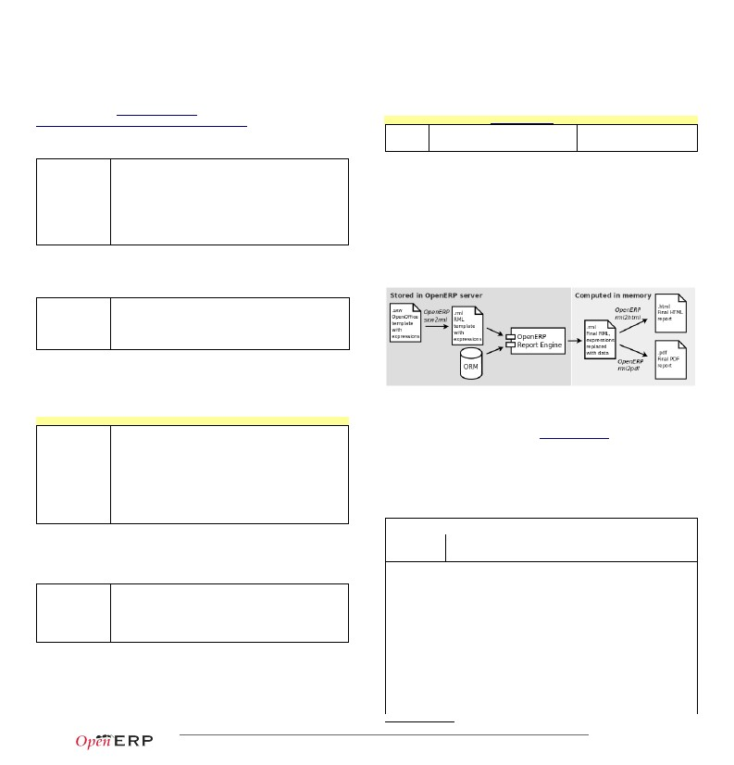
Forms
(to view/edit records)
Forms allow creation/edition or resources, and correspond to <form> elements.
button
Allowed elements
all (see form elements below)
127 <form string="Idea form">
128<group col="6" colspan="4">
129<group colspan="5" col="6">
130<field name="name" colspan="6"/>
131<field name="inventor_id"/>
132<field name="inventor_country_id" />
133<field name="score"/>
134</group>
135<group colspan="1" col="2">
136<field name="active"/><field name="invent_date"/>
137</group>
138</group>
139<notebook colspan="4">
140<page string="General">
141<separator string="Description"/>
142<field colspan="4" name="description" nolabel="1"/>
143</page>
144<page string="Votes">
145<field colspan="4" name="vote_ids" nolabel="1">
146<tree>
147<field name="partner_id"/>
148<field name="vote"/>
149</tree>
150</field>
151</page>
152<page string="Sponsors">
153<field colspan="4" name="sponsor_ids" nolabel="1"/>
154</page>
155</notebook>
156<field name="state"/>
157<button name="do_confirm" string="Confirm" type="object"/>
158 </form>
separator
newline
label
group
notebook,
page
clickable widget associated with actions. Specific attributes:
• type: type of button: workflow (default), object, or action
• name: workflow signal, function name (without parentheses) or
action to call (depending on type)
• confirm: text of confirmation message when clicked
• states: comma-separated list of states in which this button is shown
horizontal separator line for structuring views, with optional label
place-holder for completing the current line of the view
free-text caption or legend in the form
used to organise fields in groups with optional label (adds frame)
notebook elements are tab containers for page elements. Attributes:
• name: label for the tab/page
• position: tabs position in notebook (inside, top, bottom, left, right)
Dynamic views
In addition to what can be done with states and attrs attributes, functions may
be called by view elements (via buttons of type object, or on_change triggers on
fields) to obtain dynamic behavior. These functions may alter the view
interface by returning a Python map with the following entries:
value
domain
a dictionary of field names and their new values
a dictionary of field names and their updated domains of value
warning a dictionary with a title and message to show a warning dialog
Lists and Hierarchical Tree Lists
New: the v7.0 form API
As of OpenERP 7.0 a new form view API has been introduced. It can be turned on by adding
version=”7.0” to the <form> element. This new form API allows mixing arbitrary XHTML code with
regular OpenERP form elements. It also introduces a few specific elements to produce better-looking forms,
such as <sheet>, <header>, <footer>, and a set of general purpose CSS classes to customize the
appearance and behavior of form elements. Best practices and examples for the new form API are available in
the technical documentation:
http://doc.openerp.com/trunk/developers/server/form-view-guidelines
List views include field elements, are created with type tree, and have a <tree>
parent element. They are used to define flat lists (editable or not) and
hierarchical lists.
Attributes
•
Form Elements
colors: list of colors or HTML color codes mapped to Python
conditions
• editable: top or bottom to allow in-place edit
• toolbar: set to True to display the top level of object
hierarchies as a side toolbar (only for hierarchical lists, i.e.
opened with actions that set the view_type to “tree” instead of
“mode”)
Common attributes for all elements:
• string: label of the element
• nolabel: 1 to hide the field label
• colspan: number of column on which the field must span
• rowspan: number of rows on which the field must span
• col: number of column this element must allocate to its child elements
• invisible: 1 to hide this element completely
• eval: evaluate this Python code as element content (content is string by default)
• attrs: Python map defining dynamic conditions on these attributes: readonly,
invisible, required based on search tuples on other field values
fieldautomatic widgets depending on the corresponding field type. Attributes:
• string: label of the field for this particular view
• nolabel: 1 to hide the field label
• required: override required field attribute from Model for this view
• readonly: override readonly field attribute from Model for this view
• password: True to hide characters typed in this field
• context: Python code declaring a context dictionary
• domain: Python code declaring list of tuples for restricting values
• on_change: Python method to call when field value is changed
• groups: comma-separated list of group (id) allowed to see this field
• widget: select alternative field widget (url, email, image, float_time,
reference, html, progressbar, statusbar, handle, etc.)
properties dynamic widget showing all available properties (no attribute)
Allowed elements field, group, separator, tree, button, filter, newline
159 <tree string="Idea Categories" toolbar="1" colors="blue:state==draft">
160<field name="name"/>
161<field name="state"/>
162 </tree>
Copyright © 2013 Open Object Press - All rights reserved – See license on page 12.
p.6/12
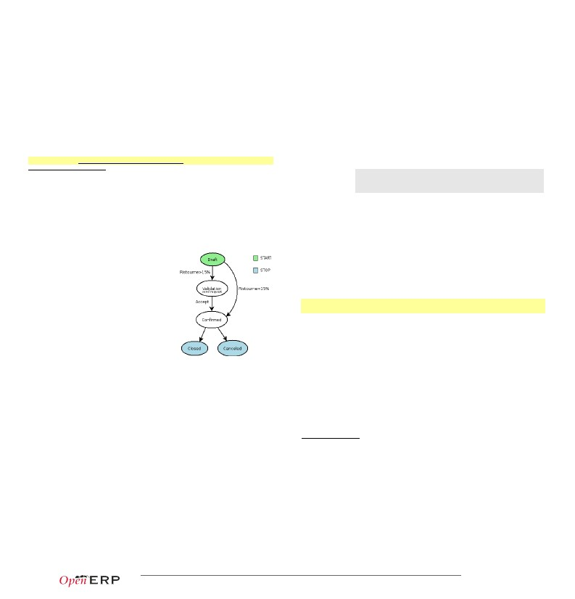
Kanban Boards
As of OpenERP 6.1 a new type versatile board view, in which each record is
rendered as a small “kanban card”. It supports drag&drop to manage the
lifecycle of the kanban cards based on configurable dimensions.
Kanban views are introduced in the OpenERP 6.1 release notes and defined
using the QWeb templating language, documented in the technical
documentation: see http://bit.ly/18usDXt and
http://doc.openerp.com/trunk/developers/web/qweb
186</group>
187 </search>
View Inheritance
Existing views should be modifying through inherited views, never directly. An
inherited view references its parent view using the inherit_id field, and may add
or modify existing elements in the view by referencing them through XPath
expressions, and specifying the appropriate position.
Tip: XPath reference can be found at www.w3.org/TR/xpath
position• inside: put inside match (default)
Calendars
Views used to display date fields as calendar events (<calendar> parent)
•
replace: replace match
•
•
before: put before match
after: put after match
Attributes
•
•
•
•
•
color: name of field for color segmentation
date_start: name of field containing event start date/time
day_length: length of a [working] day in hours (default: 8)
date_stop: name of field containing event stop date/time
or
date_delay: name of field containing event duration
Allowed elements
field (to define the label for each calendar event)
188 <!-- improved idea categories list -->
189 <record id="idea_category_list2" model="ir.ui.view">
190<field name="name">id.category.list2</field>
191<field name="model">ir.ui.view</field>
192<field name="inherit_id" ref="id_category_list"/>
193<field name="arch" type="xml">
194<xpath expr="/tree/field[@name='description']" position="after">
195<field name="idea_ids" string="Number of ideas"/>
196</xpath>
197</field>
198 </record>
163 <calendar string="Ideas" date_start="invent_date" color="inventor_id">
164<field name="name"/>
165 </calendar>
Reports
There are several report engines in OpenERP, to produce reports from
different sources and in many formats.
Gantt Charts
Bar chart typically used to show project schedule (<gantt> parent element)
Attributes
Allowed elements
same as <calendar>
field, level
•
level elements are used to define the Gantt chart levels, with
the enclosed field used as label for that drill-down level
166 <gantt string="Ideas" date_start="invent_date" color="inventor_id">
167<level object="idea.idea" link="id" domain="[]">
168<field name="inventor_id"/>
169</level>
170 </gantt>
Charts (Graphs)
Views used to display statistics charts (<graph> parent element)
Tip: charts are most useful with custom views extracting ready-to-use statistics
Special expressions used inside report templates produce dynamic data
and/or modify the report structure at rendering time.
Custom report parsers may be written to support additional expressions.
Attributes
•
•
type: type of chart: bar, pie (default)
orientation: horizontal, vertical
Alternative Report Formats (see doc.openerp.com)
sxw2rml
rml
xml,xsl:rml
odt2odt
OpenOffice 1.0 templates (.sxw) converted to RML with
sxw2rml tool, and the RML rendered in HTML or PDF
RML templates rendered directly as HTML or PDF
XML data + XSL:RML stylesheets to generate RML
OpenOffice templates (.odt)
OpenOffice documents (.odt)
used
to
produce
directly
Allowed elements field, with specific behavior:
• first field in view is X axis, 2nd one is Y, 3rd one is Z
• 2 fields required, 3rd one is optional
• group attribute defines the GROUP BY field (set to 1)
• operator attribute sets the aggregation operator to use for
other fields when one field is grouped (+,*,**,min,max)
171 <graph string="Total idea score by Inventor" type="bar">
172<field name="inventor_id" />
173<field name="score" operator="+"/>
174 </graph>
Expressions used in OpenERP report templates
[[ <content> ]]
double brackets content is evaluated as a Python expression
based on the following expressions
Search views
Search views customize the search panel on top of other views.
Predefined expressions:
• objects contains the list of records to print
Allowed elements
field, group, separator, label, search, filter, newline, properties
•
•
filter elements allow defining button for domain filters
adding a context attribute to fields makes widgets that alter the
search context (useful for context-sensitive fields, e.g.
pricelist-dependent prices)
175 <search string="Search Ideas">
176<group col="6" colspan="4">
177<filter string="My Ideas"
178domain="[('inventor_id','=',uid)]"
179help="My own ideas"/>
180<field name="name"/>
181<field name="description"/>
182<field name="inventor_id"/>
183<!-- following context field is for illustration only -->
184<field name="inventor_country_id" widget="selection"
185context="{'inventor_country': self}"/>
•
•
•
•
data comes from the wizard launching the report
user contains the current user (browse_record, as returned browse())
time gives access to Python time module
repeatIn(list,'var','tag') repeats the current parent element named tag for each
object in list, making the object available as var during each loop
• setTag('tag1','tag2') replaces the parent RML tag1 with tag2
• removeParentNode('tag') removes parent RML element tag
•
formatLang(value, digits=2, date=False, date_time=False, grouping=True,
monetary=False) can be used to format a date, time or amount according to
the locale
• setLang('lang_code') sets the current language and locale for translations
Report declaration
p.7/12
Copyright © 2013 Open Object Press - All rights reserved – See license on page 12.

199 <!-- The following creates records in ir.actions.report.xml model -->
200 <report id="idea_report" string="Print Ideas" model="idea.idea"
201name="idea.report" rml="idea/report/idea.rml" >
202 <!-- Use addons/base_report_designer/wizard/tiny_sxw2rml/tiny_sxw2rml.py
203to generate the RML template file from a .sxw template -->
join_mode
id
name
string
model
rml, sxw, xml, xsl
auto
header
groups
menu
keywords
unique report identifier
name for the report (required)
report title (required)
object model on which the report is defined (required)
path to report template sources (starting from addons), depending on report
set to False to use a custom parser, by subclassing report_sxw.rml_parse and
declaring the report as follows:
report_sxw.report_sxw(report_name, object_model,rml_path,parser=customClass)
split_mode
kind
set to False to suppress report header (default: True)
comma-separated list of groups allowed to view this report
set to True to display this report in the Print menu (default: True)
specify report type keyword (default: client_print_multi)
204 <story>
205<blockTable style="Table">
206<tr>
207<td><para style="Title">Idea name</para> </td>
208<td><para style="Title">Score</para> </td>
209</tr>
210<tr>
211<td><para>[[ repeatIn(objects,'o','tr') ]] [[ o.name ]]</para></td>
212<td><para>[[ o.score ]]</para></td>
213</tr>
214</blockTable>
215 </story>
Tip: RML User Guide: www.reportlab.com/docs/rml2pdf-userguide.pdf
Example RML report extract:
subflow_id
action
logical behavior of this node regarding incoming transitions:
• XOR: activate on the first incoming transition (default)
• AND: waits for all incoming transitions to become valid
logical behavior of this node regarding outgoing transitions:
• XOR: one valid transition necessary, send workitem on it (default)
• OR: send workitems on all valid transitions (0 or more), sequentially
• AND: send a workitem on all valid transitions at once (fork)
type of action to perform when node is activated by a transition:
• dummy to perform no operation when activated (default)
• function to invoke a function determined by action
• subflow to execute the subflow with subflow_id, invoking action to determine
the record id of the record for which the subflow should be instantiated. If action
returns no result, the workitem is deleted.
• stopall to terminate the workflow upon activation
if kind subflow, id of the subflow to execute (use ref attribute or search with a tuple)
object method call, used if kind is function or subflow. This function should also
update the state field of the object, e.g. for a function kind:
def action_confirmed(self, cr, uid, ids):
self.write(cr, uid, ids, { 'state' : 'confirmed' })
# … perform other tasks
return True
Workflow Transitions (edges)
227 <record id="trans_idea_draft_confirmed" model="workflow.transition">
228<field name="act_from" ref="act_draft"/>
229<field name="act_to" ref="act_confirmed"/>
230<field name="signal">button_confirm</field>
231<field name="role_id" ref="idea_manager"/>
232<field name="condition">1 == 1</field>
233 </record>
Conditions are evaluated in this order: role_id, signal, condition expression
Workflows
Workflows may be associated with any object in
OpenERP, and are entirely customizable.
Workflows are used to structure and manage
the life-cycles of business objects and
documents, and define transitions, triggers, etc.
with graphical tools.
Workflows, activities (nodes or actions) and
transitions (conditions) are declared as XML
records, as usual. The tokens that navigate in
workflows are called workitems.
act_from, act_to
signal
role_id
condition
identifiers of the source and destination activities
name of a button of type workflow that triggers this transition
reference to the role that user must have to trigger the transition (see Roles)
Python expression that must evaluate to True for transition to be triggered
Tip: OpenERP features a graphical workflow editor, available by switching to the Diagram view while viewing a
workflow in the Settings>Technical>Workflows
Security
Access control mechanisms must be combined to achieve a coherent security
policy.
Workflow declaration
216 <record id="wkf_idea" model="workflow">
217<field name="name">idea.basic</field>
218<field name="osv">idea.idea</field>
219<field name="on_create" eval="1"/>
220 </record>
Workflows are declared on objects that possess a state field (see the example
idea class in the ORM section)
Group-based access control mechanisms
Groups are created as normal records on the res.groups model, and granted
menu access via menu definitions. However even without a menu, objects may
still be accessible indirectly, so actual object-level permissions
(create,read,write,unlink) must be defined for groups. They are usually inserted
via CSV files inside modules. It is also possible to restrict access to specific
fields on a view or object using the field's groups attribute.
234 "id","name","model_id:id","group_id:id","perm_read","perm_write","perm_create","perm_unlink"
235 "access_idea_idea","idea.idea","model_idea_idea","base.group_user",1,1,1,0
236 "access_idea_vote","idea.vote","model_idea_vote","base.group_user",1,1,1,0
id
name
osv
on_create
unique workflow record identifier
name for the workflow (required)
object model on which the workflow is defined (required)
if True, a workitem is instantiated automatically for each new osv record
ir.model.access.csv
221 <record id="act_confirmed" model="workflow.activity">
222<field name="name">confirmed</field>
223<field name="wkf_id" ref="wkf_idea"/>
224<field name="kind">function</field>
225<field name="action">action_confirmed()</field>
226 </record>
Workflow Activities (nodes)
Roles
Roles are created as normal records on the res.roles model and used only to
condition workflow transitions through transitions' role_id attribute.
Wizards
Wizards describe stateful interactive sessions with the user through dynamic
forms. They are constructed based on the osv.TransientModel class and
automatically garbage-collected after use. They're defined using the same API
and views as regular osv.Model objects.
237 from osv import fields,osv
id
wkf_id
name
flow_start
flow_stop
unique activity identifier
parent workflow identifier
activity node label
True to make it a 'begin' node, receiving a workitem for each workflow instance
True to make it an 'end' node, terminating the workflow when all items reach it
Wizard models (TransientModel)
p.8/12
Copyright © 2013 Open Object Press - All rights reserved – See license on page 12.

238 import datetime
239 class cleanup_wizard(osv.TransientModel):cleanup_wizard
240_name = 'idea.cleanup.wizard'
241_columns = {
242'idea_age': fields.integer('Age (in days)'),
243}
244def cleanup(self,cr,uid,ids,context=None):
245idea_obj = self.pool.get('idea.idea')
246for wiz in self.browse(cr,uid,ids):
247if wiz.idea_age <= 3:
248raise osv.except_osv('UserError','Please select a larger age')
249limit = datetime.date.today()-datetime.timedelta(days=wiz.idea_age)
250ids_to_del = idea_obj.search(cr,uid, [('create_date', '<' ,
251limit.strftime('%Y-%m-%d 00:00:00'))],context=context)
252idea_obj.unlink(cr,uid,ids_to_del)
253return {}
309'inventor_id'=>new xmlrpcval($uid, "int"),
310 );
Wizard views
254 <record id="wizard_idea_cleanup" model="ir.ui.view">
255<field name="name">idea.cleanup.wizard.form</field>
256<field name="model">idea.cleanup.wizard</field>
257<field name="type">form</field>
258<field name="arch" type="xml">
259<form string="Idea Cleanup Wizard">
260<label colspan="4" string="Select the age of ideas to cleanup"/>
261<field name="idea_age" string="Age (days)"/>
262<group colspan="4">
263<button string="Cancel" special="cancel"/>
264<button string="Cleanup" name="cleanup" type="object"/>
265</group>
266</form>
267</field>
268 </record>
Wizards use regular views and their buttons may use a special cancel attribute
to close the wizard window when clicked.
Wizard execution
269 <record id="action_idea_cleanup_wizard" model="ir.actions.act_window">
270<field name="name">Cleanup</field>
271<field name="type">ir.actions.act_window</field>
272<field name="res_model">idea.cleanup.wizard</field>
273<field name="view_type">form</field>
274<field name="view_mode">form</field>
275<field name="target">new</field>
276 </record>
Such wizards are launched via regular action records, with a special target field
used to open the wizard view in a new window.
WebServices – XML-RPC
OpenERP is accessible through XML-RPC interfaces, for which libraries exist in
many languages.
277
278
279
280
281
282
284283
285
286
287
288
289
290
291
292
Python example
import xmlrpclib
# ... define HOST, PORT, DB, USER, PASS
url = 'http://%s:%d/xmlrpc/common' % (HOST,PORT)
sock = xmlrpclib.ServerProxy(url)
uid = sock.login(DB,USER,PASS)
print "Logged in as %s (uid:%d)" % (USER,uid)
# Create a new idea
url = 'http://%s:%d/xmlrpc/object' % (HOST,PORT)
sock = xmlrpclib.ServerProxy(url)
args = {
'name' : 'Another idea',
'description' : 'This is another idea of mine',
'inventor_id': uid,
}
idea_id = sock.execute(DB,uid,PASS,'idea.idea','create',args)
293
294
295
296
297
298
299
300
301
302
303
PHP example
<?
include('xmlrpc.inc'); // Use phpxmlrpc library, available on sourceforge
// ... define $HOST, $PORT, $DB, $USER, $PASS
$client = new xmlrpc_client("http://$HOST:$PORT/xmlrpc/common");
$msg = new xmlrpcmsg("login");
$msg->addParam(new xmlrpcval($DB, "string"));
$msg->addParam(new xmlrpcval($USER, "string"));
$msg->addParam(new xmlrpcval($PASS, "string"));
resp = $client->send($msg);
uid = $resp->value()->scalarval()
echo "Logged in as $USER (uid:$uid)"
305304 // Create a new idea
306 $arrayVal = array(
307'name'=>new xmlrpcval("Another Idea", "string") ,
308'description'=>new xmlrpcval("This is another idea of mine" , "string"),
Copyright © 2013 Open Object Press - All rights reserved – See license on page 12.
p.9/12
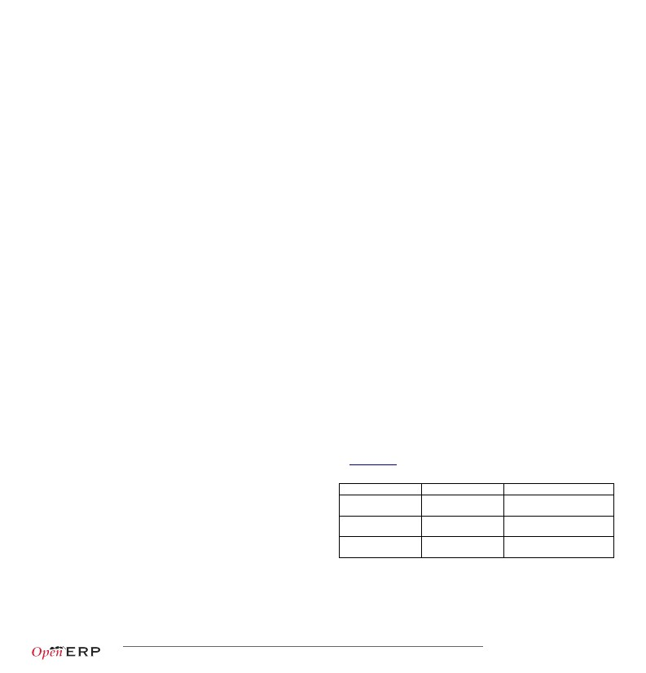
Copyright © 2013 Open Object Press - All rights reserved – See license on page 12.
p.10/12
Performance Optimization
As Enterprise Management Software typically has to deal with large amounts
of records, you may want to pay attention to the following anti-patterns, to
obtain consistent performance:
• Do not place browse() calls inside loops, put them before and access only
the browsed objects inside the loop. The ORM will optimize the number of
database queries based on the browsed attributes.
• Avoid recursion on object hierarchies (objects with a parent_id
relationship), by adding parent_left and parent_right integer fields on your
object, and setting _parent_store to True in your object class. The ORM will
use a modified preorder tree traversal to be able to perform recursive
operations (e.g. child_of) with database queries in O(1) instead of O(n)
• Do not use function fields lightly, especially if you include them in tree
views. To optimize function fields, two mechanisms are available:
◦ multi: all fields sharing the same multi attribute value will be computed
with one single call to the function, which should then return a
dictionary of values in its values map
◦ store: function fields with a store attribute will be stored in the
database, and recomputed on demand when the relevant trigger objects
are modified. The format for the trigger specification is as follows: store
= {'model': (_ref_fnct, fields, priority)} (see example below)
311
312
313
314
315
316
317
318
319
320
321
322
323
324
325
326
327
328
329
330
331
332
333
def _get_idea_from_vote(self,cr,uid,ids,context=None):
res = {}
vote_ids = self.pool.get('idea.vote').browse(cr,uid,ids,context=context)
for v in vote_ids:
res[v.idea_id.id] = True # Store the idea identifiers in a set
return res.keys()
def _compute(self,cr,uid,ids,field_name,arg,context=None):
res = {}
for idea in self.browse(cr,uid,ids,context=context):
vote_num = len(idea.vote_ids)
vote_sum = sum([v.vote for v in idea.vote_ids])
res[idea.id] = {
'vote_sum': vote_sum,
'vote_avg': (vote_sum/vote_num) if vote_num else 0.0,
}
return res
_columns = {
# These fields are recomputed whenever one of the votes changes
'vote_avg': fields.function(_compute, string='Votes Average',
store = {'idea.vote': (_get_idea_from_vote,['vote'],10)},multi='votes'),
'vote_sum': fields.function(_compute, string='Votes Sum',
store = {'idea.vote': (_get_idea_from_vote,['vote'],10)},multi='votes'),
}
Community / Contributing
OpenERP projects are hosted on Launchpad(LP), where all project resources may be
found: Bazaar branches, bug tracking, blueprints, FAQs, etc. Create a free account
on launchpad.net to be able to contribute.
Launchpad groups
Group*
OpenERP Quality
Team (~openerp)
OpenERP Drivers
(~openerp-drivers)
OpenERP Community
(~openerp-community)
Members
OpenERP Core Team
Selected active
community members
Open group, anyone
can join
Bazaar/LP restrictions
Can merge and commit on
official branches.
Can confirm bugs and set
milestones on bugs
Can create community branches
where everyone can contribute
*Members of upper groups are also members of lower groups
Copyright © 2013 Open Object Press - All rights reserved – See license on page 12.
p.11/12
License
Copyright © 2010-2013 Open Object Press. All rights reserved.
You may take electronic copy of this work and distribute it if you don't change the
content. You can also print a copy to be read by yourself only.
We have contracts with different publishers in different countries to sell and
distribute paper or electronic based versions of this work (translated or not)
in bookstores. This helps to distribute and promote the Open ERP product. It
also helps us to create incentives to pay contributors and authors with the
royalties.
Due to this, grants to translate, modify or sell this work are strictly forbidden, unless
OpenERP s.a. (representing Open Object Press) gives you a written authorization for
this.
While every precaution has been taken in the preparation of this work, the publisher
and the authors assume no responsibility for errors or omissions, or for damages
resulting from the use of the information contained herein.
Published by Open Object Press, Grand Rosière, Belgium
Copyright © 2013 Open Object Press - All rights reserved – See license on page 12.
p.12/12

