需求分析

|  |
| --- |
| 1物流信息查询LogisticsInfo |
| 2寄件单输入 SenderReceipt |
| 3收件信息输入ReceiverReceipt |
| 4车辆装车管理Load |
| 5收款单 CashRegister |
| 6 接收与派件 Receive&Send |
| 7车辆信息管理 VehicleInfo |
| 8司机信息管理 DriverInfo |
| 9货物到达管理 GoodsArrival |
| 10货物中转管理 GoodsTransition |
| 11货物装车管理 GoodsLoading |
| 12.1库存入库 StorageIn |
| 12.2库存出库 StorageOut |
| 13库存查看 StorageCheck |
| 14库存盘点 StorageInventory |
| 15库存调整 StorageChange |
| 16查询经营情况 Inquire |
| 17成本管理 Pay |
| 18期初建账 SetUpAccount |
| 19账户管理 Accountmanage |
| 20人员机构管理 clerk&organization |
| 21审批单据 Approval |
| 22制定常量 Constant |
| 23新建用户 CreateUser |
| 24用户管理 Usermanage |

需求分类

|  |  |
| --- | --- |
| 功能 | 对应的需求 |
| 物流 | 1 2 3 4 6 9 10 11 |
| 库存 | 12.1 12.2 13 14 15 |
| 财务 | 5 17 18 21 22 |
| 信息查询和管理 | 1 7 8 16 18 19 20 23 24 |

概要功能设计

|  |  |
| --- | --- |
| 功能 | 对应的逻辑包 |
| 物流 | logisticsui，logisticsbl，logisticsdata |
| 库存 | commodityui, commoditybl, commoditydata |
| 财务 | financeui, financebl, financedata |
| 信息查询和管理 | infomanageui,infomanagebl,infomanagedata |

开发包设计

|  |  |
| --- | --- |
| 开发包 | 依赖的其他开发包 |
| mainui | logisticsui, commodityui, financeui, infomanageui,vo |
| logisticsui | logisticsblservice, 界面类库包,vo |
| logisticsblservice |  |
| logisticsbl | logisticsblservice, logisticsdataservice, commodityblservice, financeblservice, infomanageblservice |
| logisticsdataservice | Java RMI,po |
| logisticsdata | Java RMI,po, databaseutility, |
| commodityui | 界面类库包 |
| commodityblservice |  |
| commoditybl | logisticsblservice, commoditydataservice, commodityblservice, financeblservice, infomanageblservice |
| commoditydataservice | Java RMI,po |
| commoditydata | Java RMI,po, databaseutility |
| financeui | 界面类库包 |
| financeblservice |  |
| financebl | logisticsblservice, financedataservice, commodityblservice, financeblservice, infomanageblservice |
| financedataservice | Java RMI,po |
| financedata | Java RMI,po, databaseutility |
| infomanageui | 界面类库包 |
| infomanageblservice |  |
| infomanagebl | logisticsblservice, infomanagedataservice, commodityblservice, financeblservice, infomanageblservice |
| infomanagedataservice | Java RMI,po |
| infomanagedata | Java RMI,po, databaseutility |
| vo |  |
| po |  |
| Java RMI | RMI |
| databaseutility | JDBC |
| 界面类库包 | swing |

Mainui是presentation层的主ui界面

presentation层和logic层之间通过businesslogicservice包接口实现互相调用

logic层和data层之间通过dataservice包接口实现互相调用

开发包图如下：

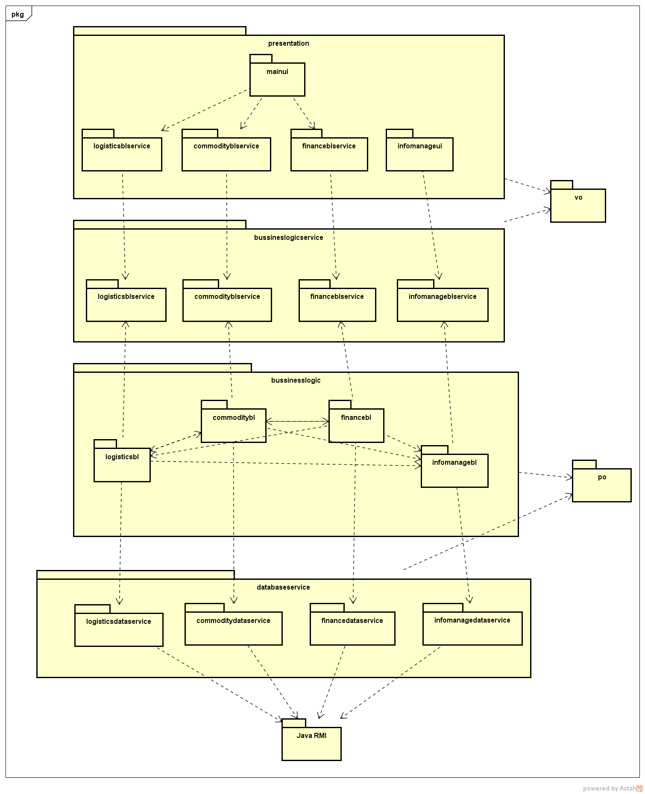客户端开发包图：

服务器端开发包图：

