# Overview of the Assignment:

This first assignment installs some of the tools that will be needed for the first weeks of this class.

# Part 1 – Install a database system

Choose either SQL Server or PostgreSQL database server. Feel free to use one that you’ve already installed for a previous course.

## SQL Server:

* Installing server: <http://www.sqlservertutorial.net/install-sql-server/>

## PostgreSQL:

* Installing PC: <https://www.postgresqltutorial.com/install-postgresql/>
* Installing Mac: <https://www.postgresqltutorial.com/postgresql-getting-started/install-postgresql-macos/>
* Connect to PostgreSQL: <https://www.postgresqltutorial.com/postgresql-getting-started/connect-to-postgresql-database/> (start with step 2)

**Connect to SQL Server:** <https://www.sqlservertutorial.net/connect-to-the-sql-server/>

**Connect to PostgreSQL:** <https://www.postgresqltutorial.com/postgresql-getting-started/connect-to-postgresql-database/> (start with step 2)

**Take a screenshot showing that you have a working database system on your machine by getting the version information. (you will need to google how to get the version for either SQL server or PostgreSQL)**

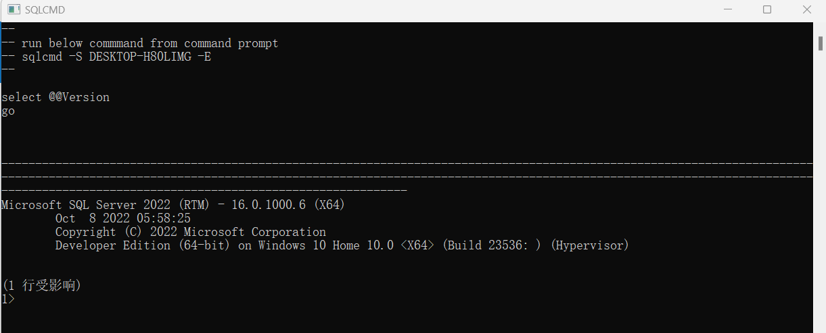

# Part 2 – Restore US National Statistics Database

## SQL Server:

* Download and save the us\_national\_statistics.bak file, make sure to keep note of the location where you saved it. SQL Server might not be able to find it on your desktop, place it in C drive root so that you can find it more easily.
* How to restore a database on SQL Server using SQL Server Management Studio: [https://sqlbackupandftp.com/blog/restore-database-backup#ssms](https://sqlbackupandftp.com/blog/restore-database-backup" \l "ssms)
  + Make sure the destination database is called us\_national\_statistics

## 微信截图_20230907111657微信截图_20230907111722

## PostgreSQL:

* Download and save the us\_national\_statistics.backup file , make sure to keep note of the location where you saved it.
* Create a database named us\_national\_statistics
* How to restore a PostgreSQLdatabase in pgAdmin (you might find an alternative web site): [https://o7planning.org/11913/backup-and-restore-postgres-database-with-pgadmin#a33893371](https://o7planning.org/11913/backup-and-restore-postgres-database-with-pgadmin" \l "a33893371)
  + Make sure the destination database is called us\_national\_statistics
  + Note, you may first get an error when starting the backup: “Please configure the PostgreSQL Binary Path” if so, perform the next steps before performing the backup. Note to use the correct DB version, in the case below, it is version 14
  + Click Files -> preferences -> Binary path
  + ProgresSQL Binary path: c:\Program Files\PosgresSQL\14\bin

## Alter and run the following SQL commands and take a screenshot showing the results of each:

Look to add two additional columns to the code below (both select statements), these two columns will repeat for each record:

* **MyName**
* **CurrentDateAndTime**

**The following will show you how to get current date and time:**

**SQL Server:** https://www.sqlservertutorial.net/sql-server-date-functions/sql-server-getdate-function/

**PostgreSQL:** https://www.postgresqltutorial.com/postgresql-date-functions/postgresql-now/

**SQL Commands to alter and run:**

1. SELECT education\_codes.\* FROM education\_codes;
2. SELECT COUNT(\*) as CountOfRecords FROM household\_income

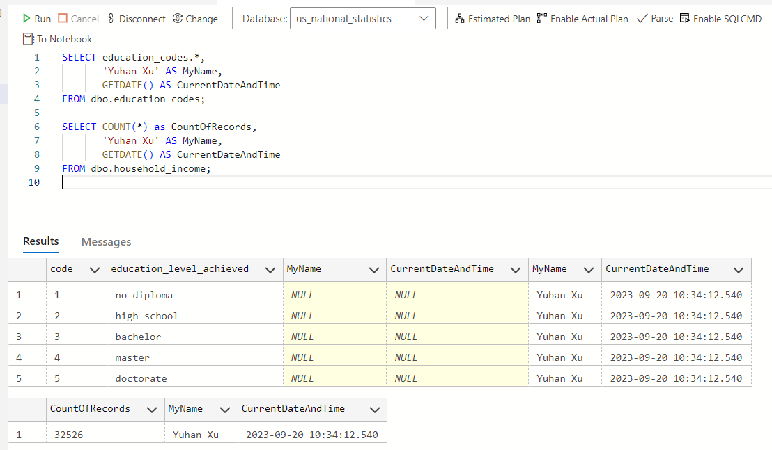

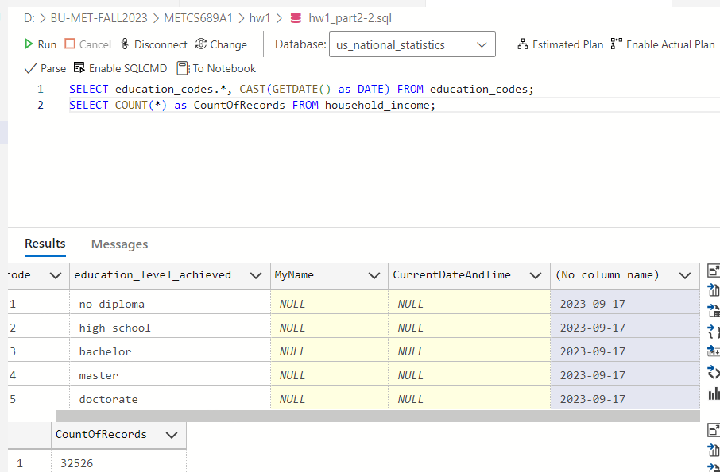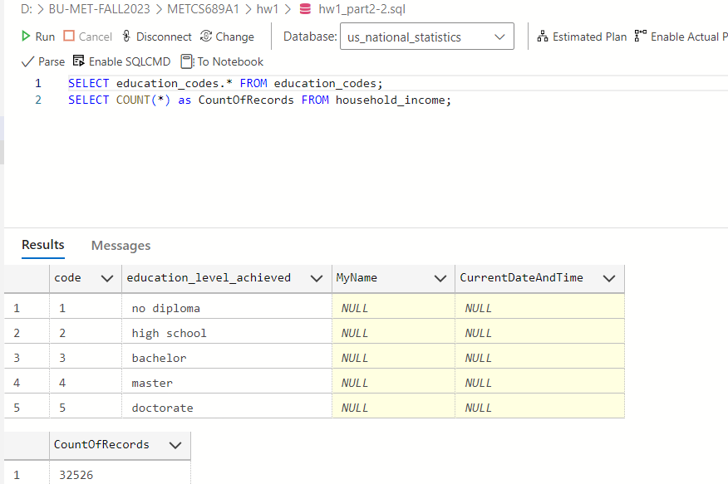

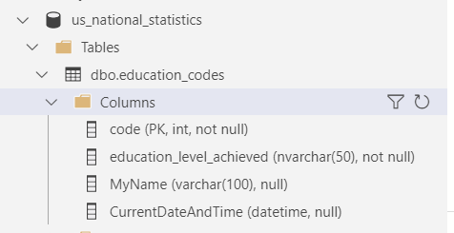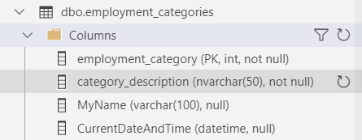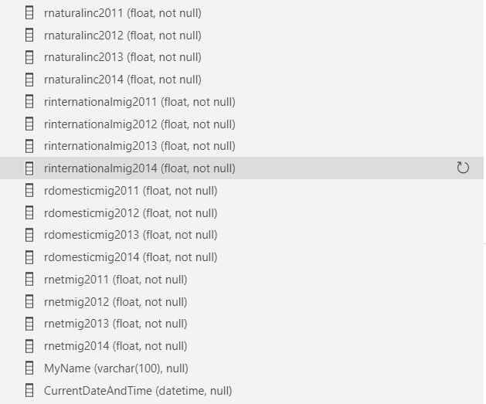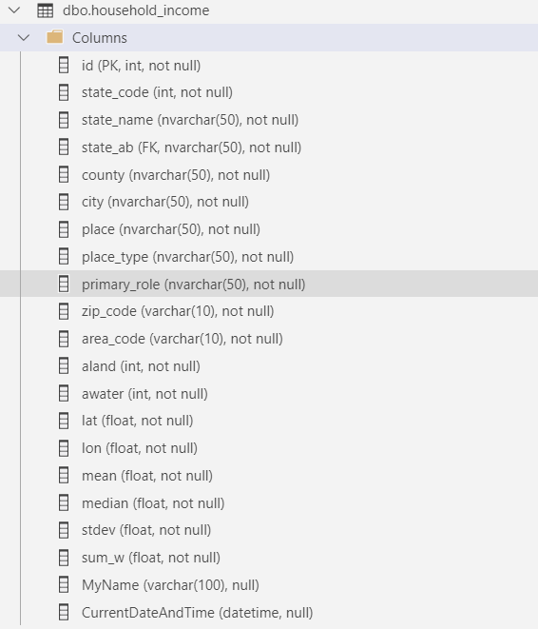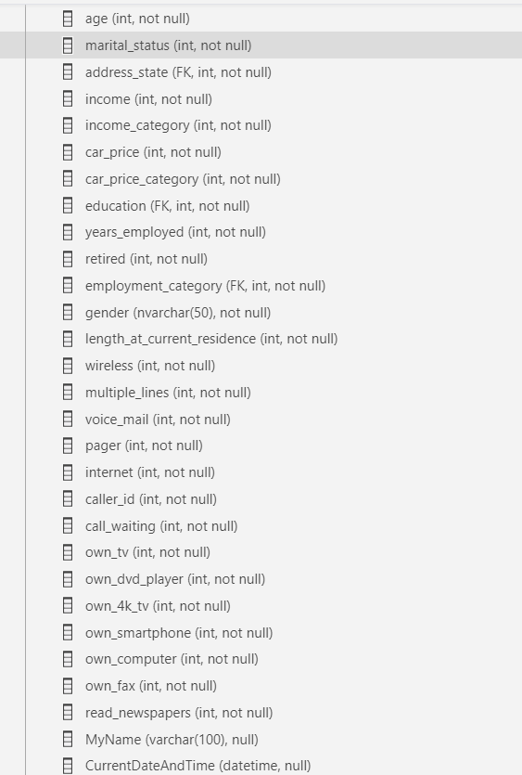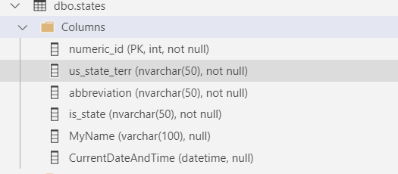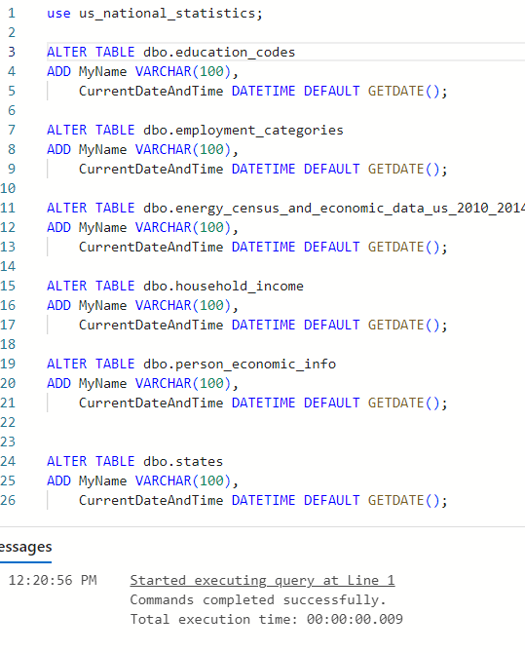

# Part 3 – Install Anaconda / Jupyter notebook

* Download and save Python Intro.ipynb somewhere you will be able to navigate to later.
* Use the following link to download and install Anaconda. [https://www.anaconda.com](https://www.anaconda.com" \t "_blank).
* Open up Anaconda Navigator and Launch jupyter notebook.
* Navigate to the folder where you saved Python Intro.ipynb and open the file.

**Take a screen shot of the opened file.**

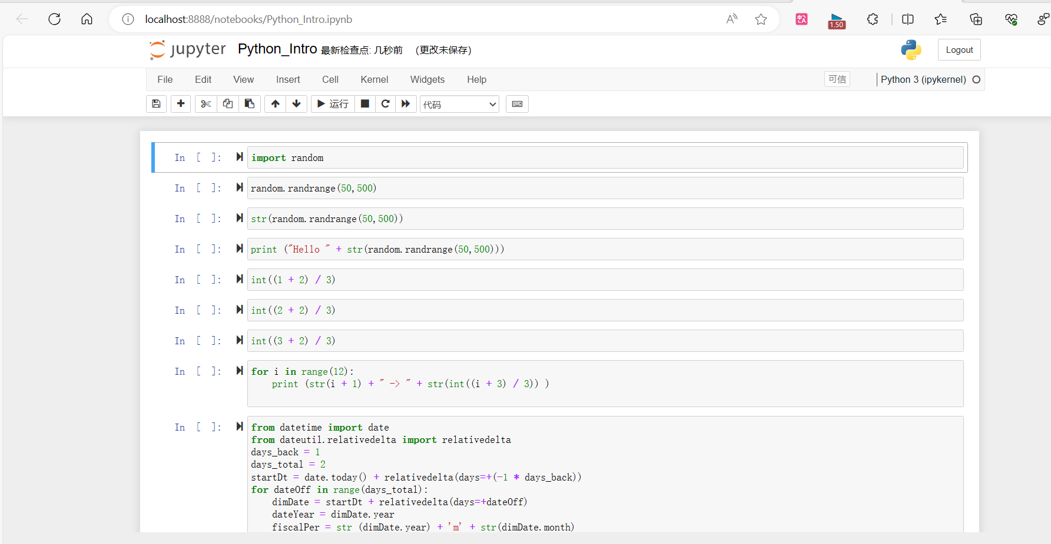

# Grading Criteria

Use the **Ask the Teaching Team Discussion Forum** if you have any questions regarding the how to approach this assignment.

Save your assignment as ***lastnameFirstname\_assign1\_A.docx*** and submit it in the *Assignments* section of the course.

For help uploading files please refer to the *Technical Support* page in the syllabus.

|  |  |  |  |  |  |  |
| --- | --- | --- | --- | --- | --- | --- |
| **Criterion** | **A** | **B** | **C** | **D** | **F** | **Letter Grade** |
| **Correctness and Completeness of Results (70%)** | All steps' results are entirely complete and correct | About ¾ of the steps' results are correct and complete | About half of the steps' results are correct and complete | About ¼ of the steps' results are correct and complete | Virtually none of the step's results are correct and complete |  |
| **Constitution of SQL/Python and Explanations (30%)** | Excellent use and integration of appropriate SQL/Python constructs and supporting explanations | Good use and integration of appropriate SQL/Python constructs and supporting explanations | Mediocre use and integration of appropriate SQL/Python constructs and supporting explanations | Substandard use and integration of appropriate SQL/Python constructs and supporting explanations | Virtually all SQL/Python constructs and supporting explanations are unsuitable or improperly integrated |  |
|  |  |  |  |  | Assignment Grade: |  |