# CS544 Homework 2

**Part 1**

|  |  |  |  |  |
| --- | --- | --- | --- | --- |
| Age | Number of People | Rate of people in Surveyed | Number of BMI above 30 | Probability of BMI above 30 |
| 18-34 | 4250 | 0.425 | 1062 | 0.24988 |
| 35-49 | 2850 | 0.285 | 1710 | 0.6 |
| 50-64 | 1640 | 0.164 | 656 | 0.4 |
| >= 65 | 1260 | 0.126 | 189 | 0.15 |

a:

P(selected person in survey have BMI above 30)

= $0.425×0.24988+0.285×0.6+0.164×0.4+0.126×0.15$

= $0.106199+0.171+0.0656+0.0189$

= $0.3617(rounded)$

Beyes Rule: $P(B|A) = \frac{P(A|B)×P(B)}{P(A)}$

b:

P(person who is in age 18-34 have BMI above 30)

= $\frac{(0.24988 × 0.425)}{0.3617}$

=0.2936(rounded)

c:

P(person who is in age 35-49 have BMI above 30)

= $\frac{(0.6× 0.285)}{0.3617}$

=0.4728(rounded)

d:

P(person who is in age 50-64 have BMI above 30)

= $\frac{(0.4× 0.164)}{0.3617}$

=0.1814(rounded)

e:

P(person who is in age >=65 have BMI above 30)

= $\frac{(0.15× 0.126)}{0.3617}$

=0.0523(rounded)

**Part 2**

code

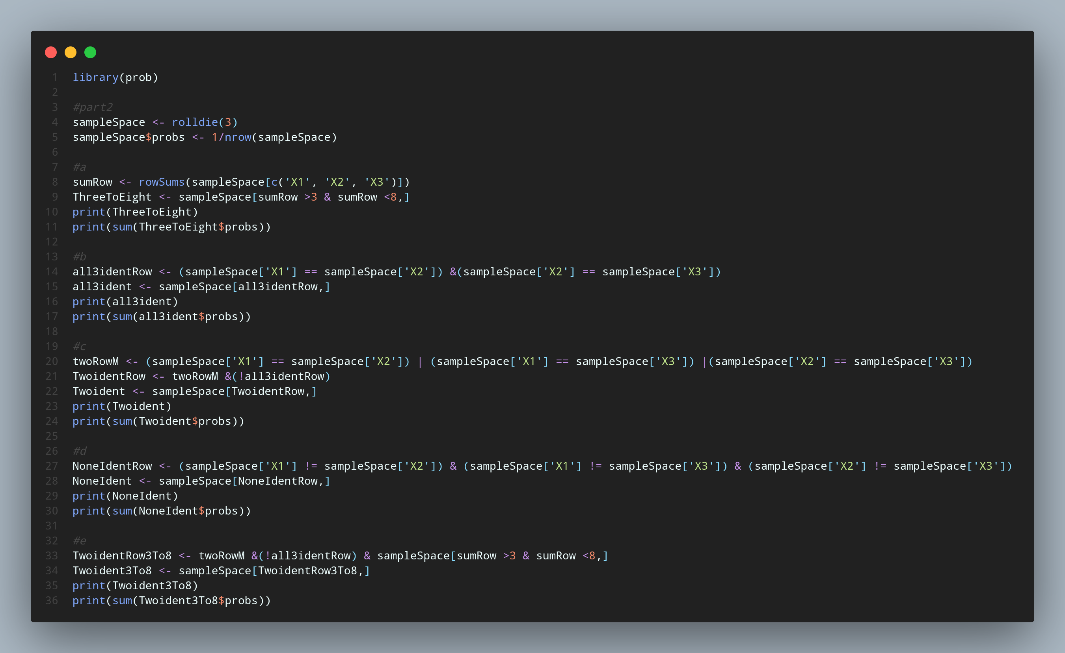

a:output

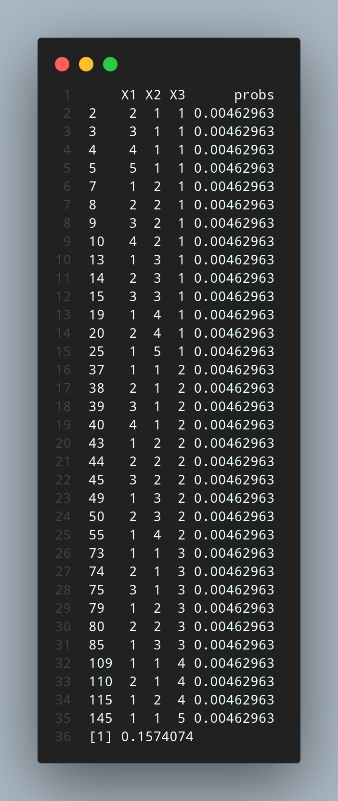

b:output

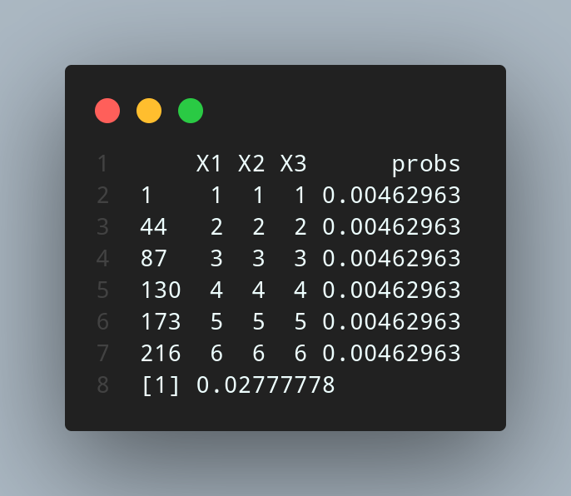

c:output

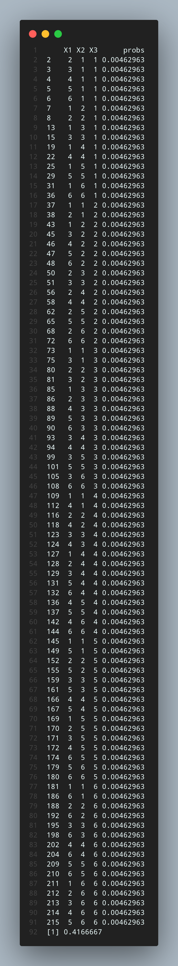

d:output

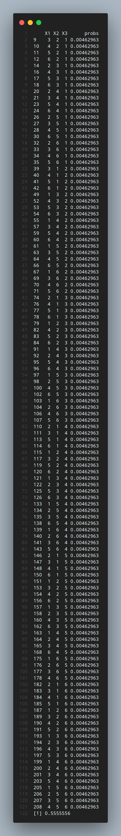

e:output

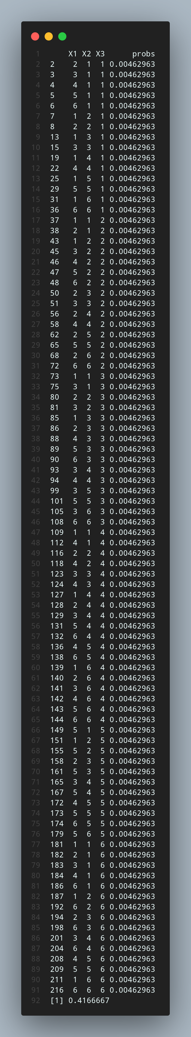

**Part 3**

code

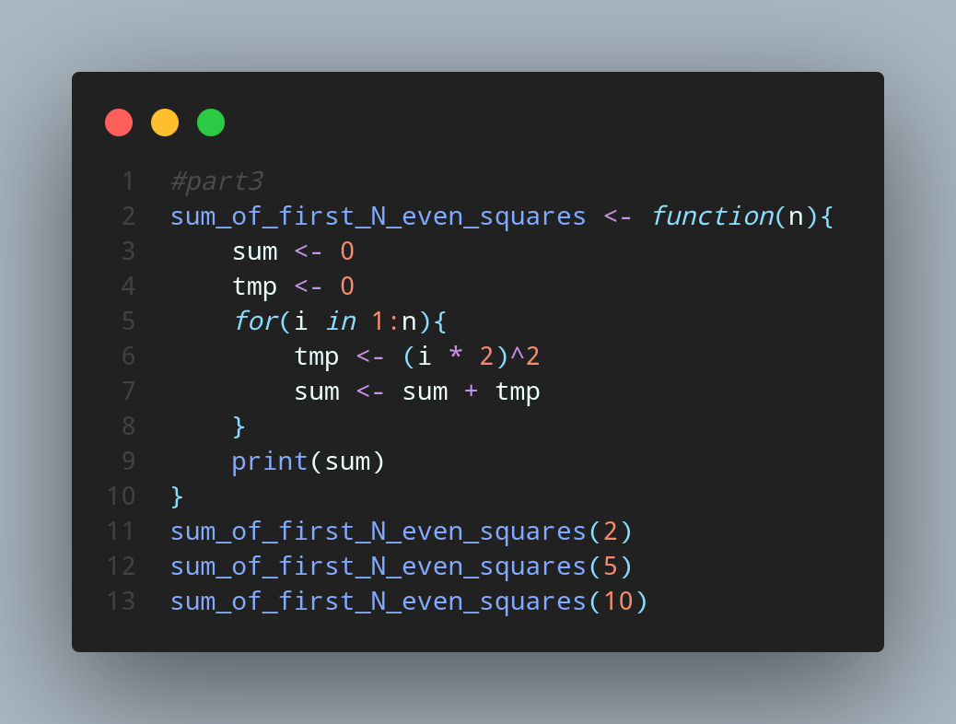

output

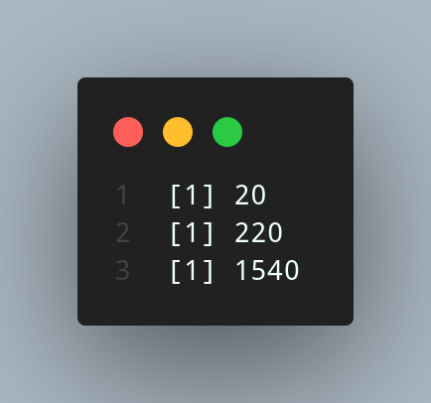

**Part 4**

code

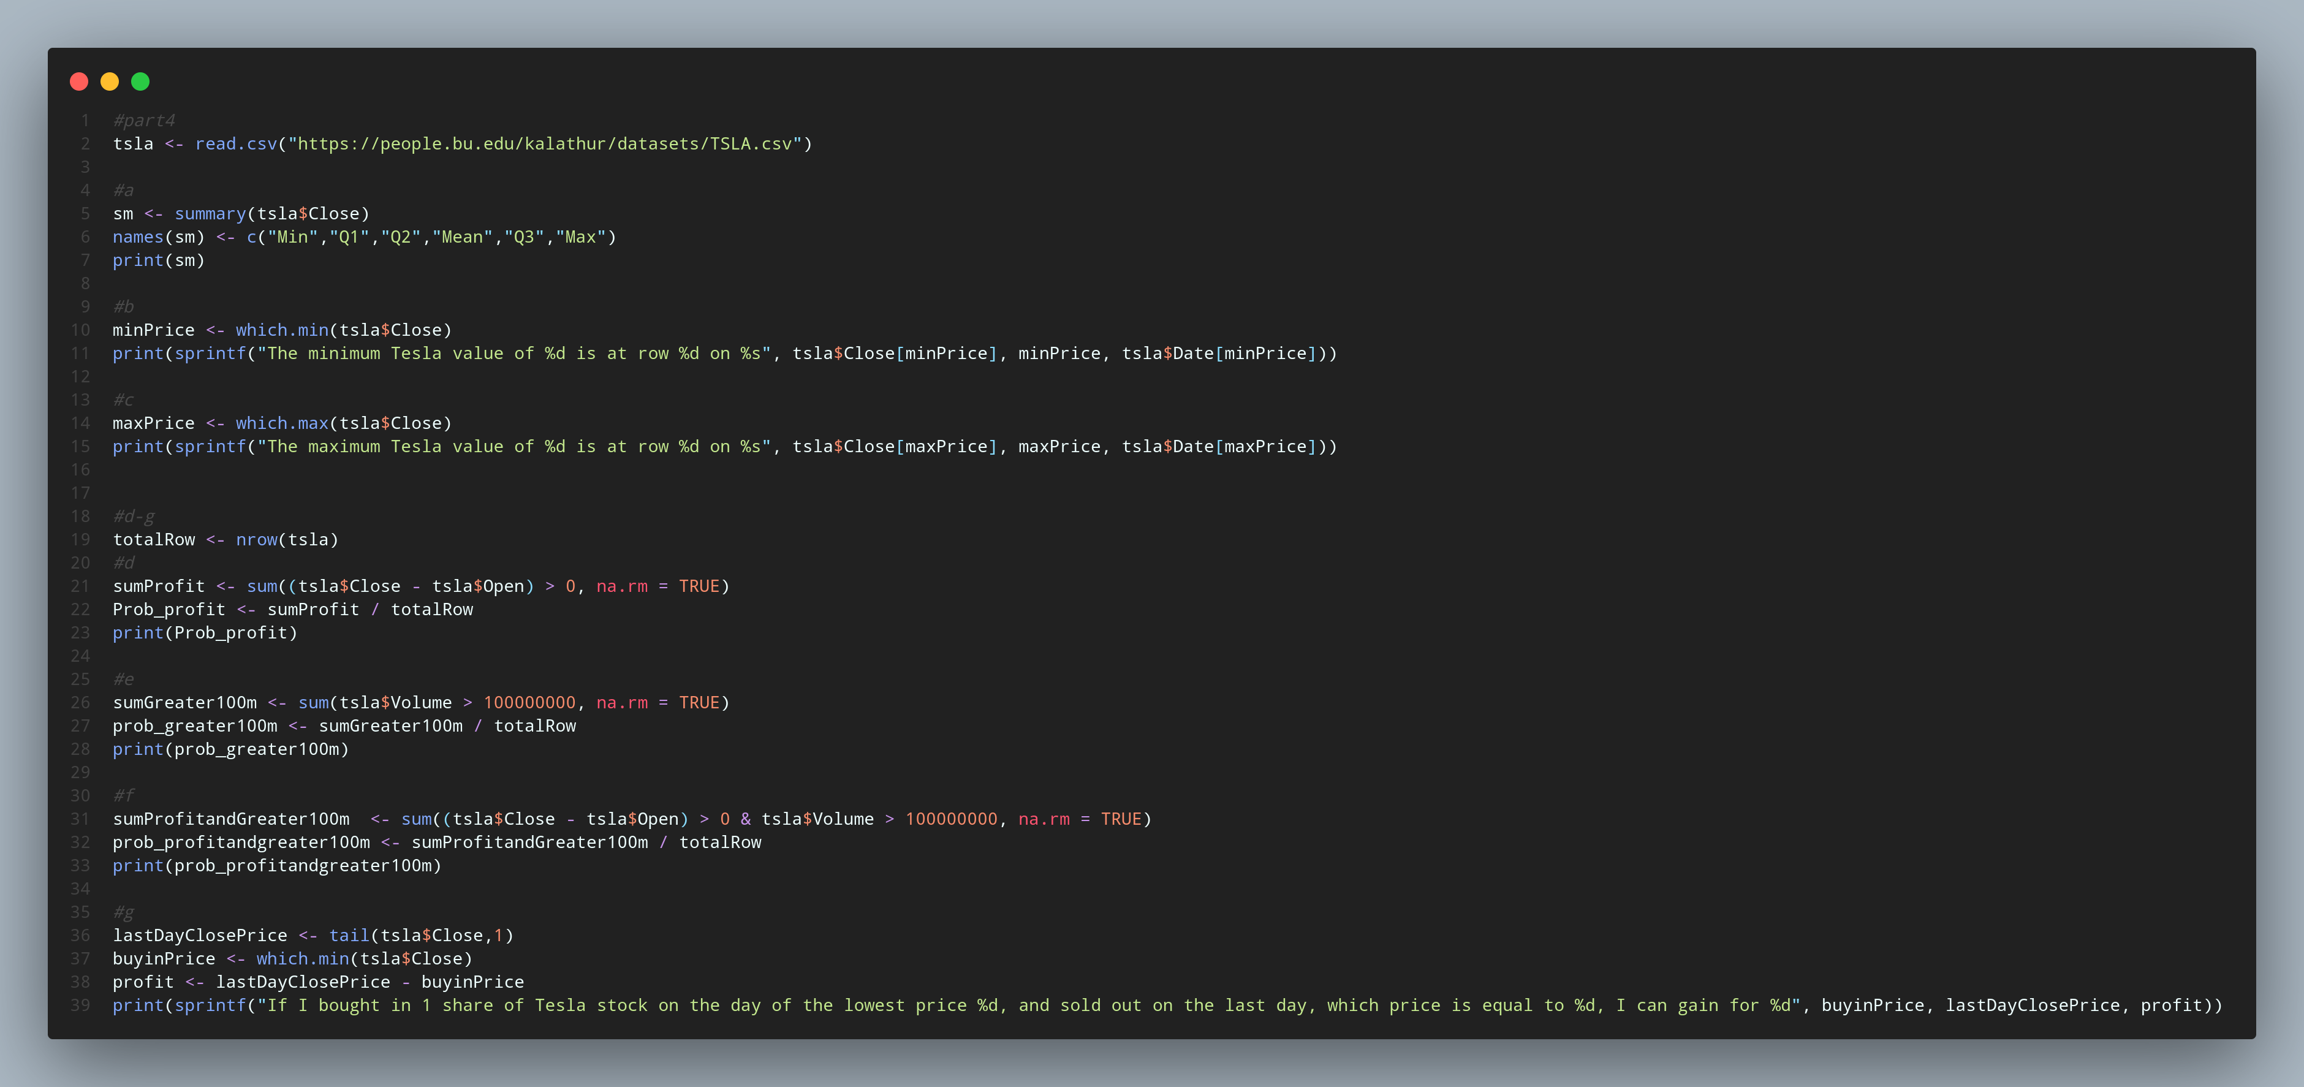

output

a:

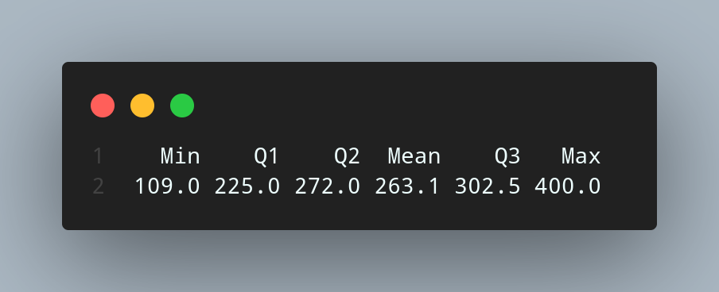

b:

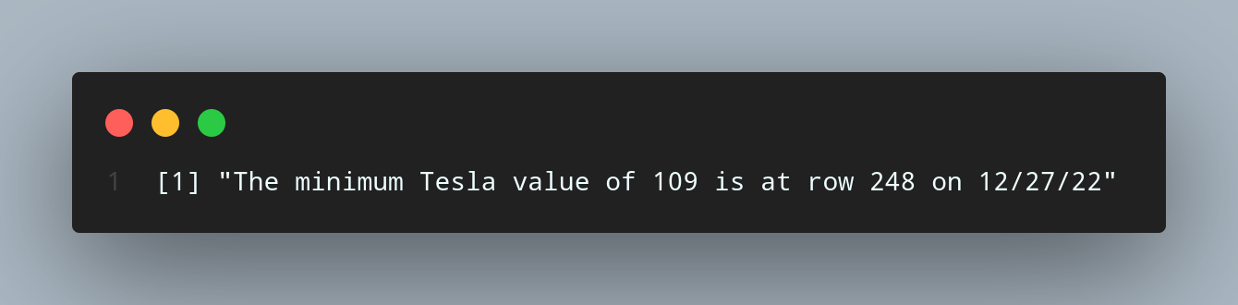

c:

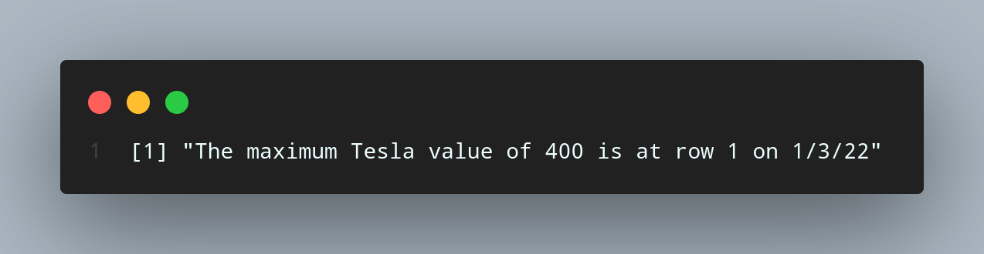

d:e:f:g:

output:(d-g, from up to down)

