Part1



a

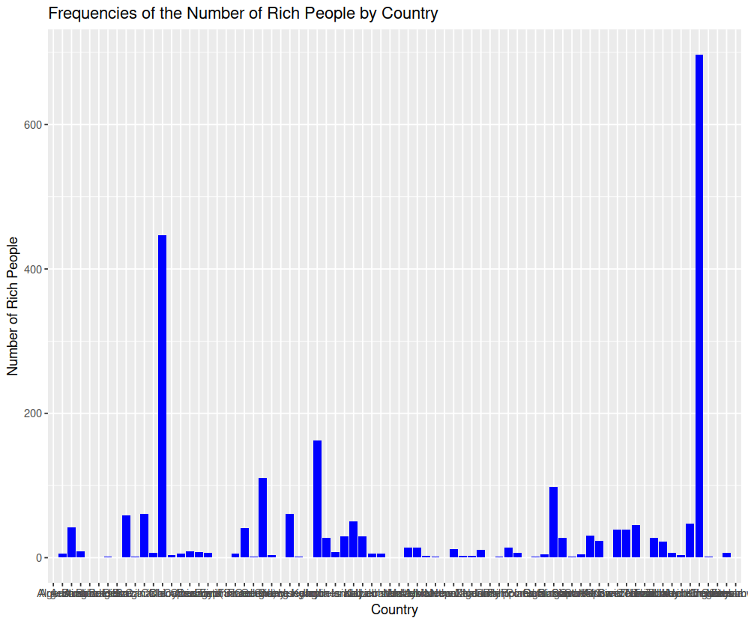

b

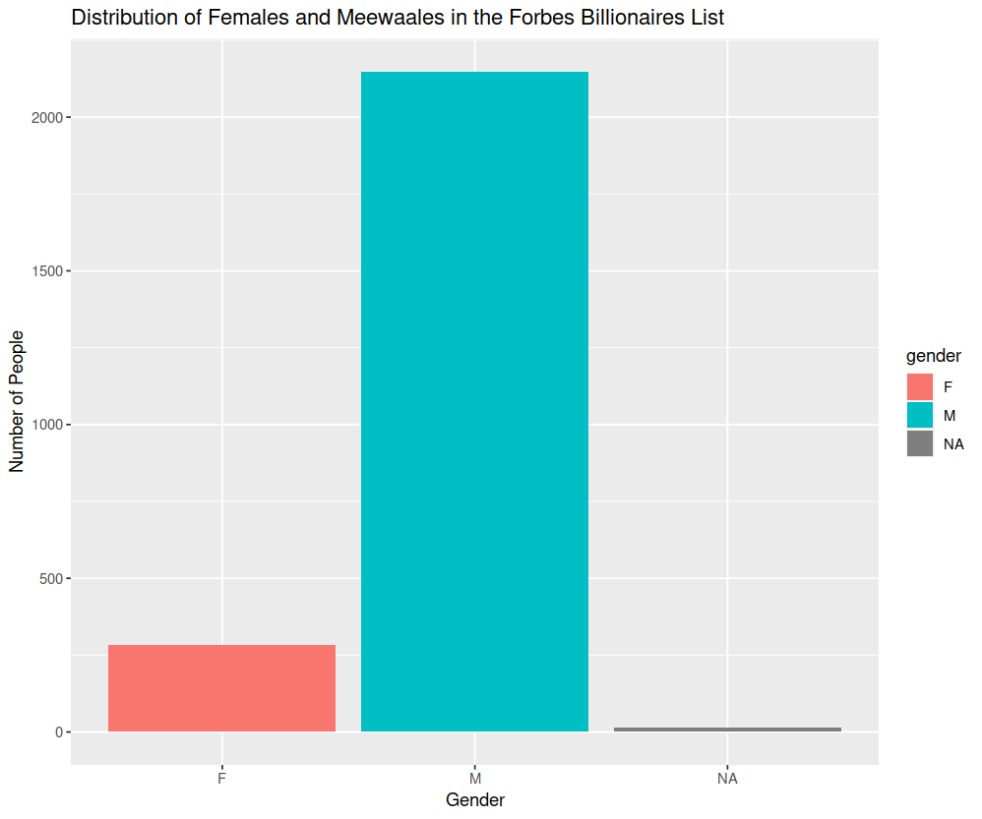

c

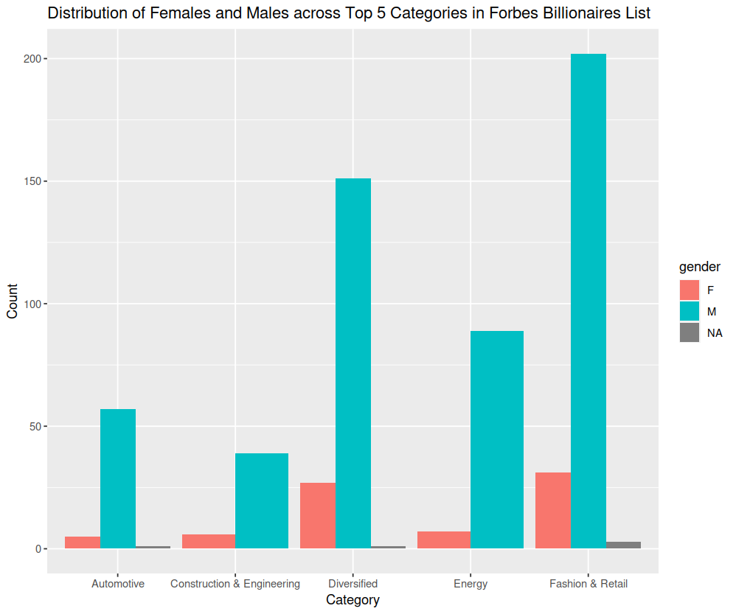

d

1.in first plot, we can know that United States have the highest number of rich people.

2.In second one, we can find that the number of males in Forbes is higher that the number of females

3.In the last one, in all the field, the number of males are all higher than the number of females.

Part2

a

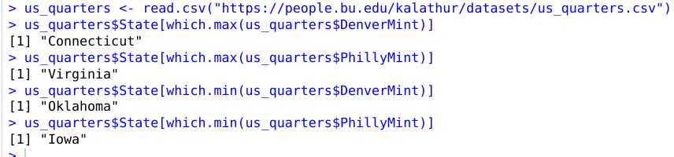

b

2b

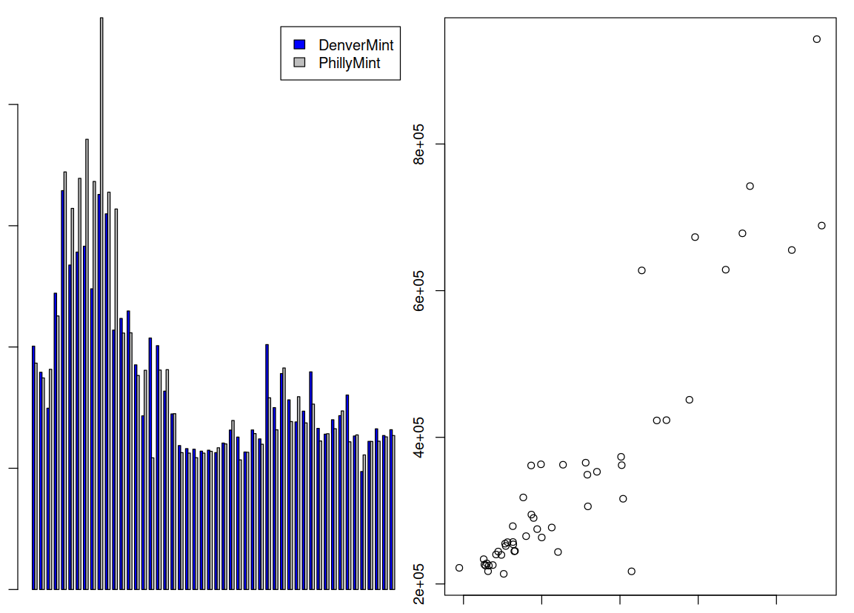

1.From barplot, I find that the two mint productions are positivelt correlated.

2.From scatterplot, I find that there are many outliner states in the dataset.

c



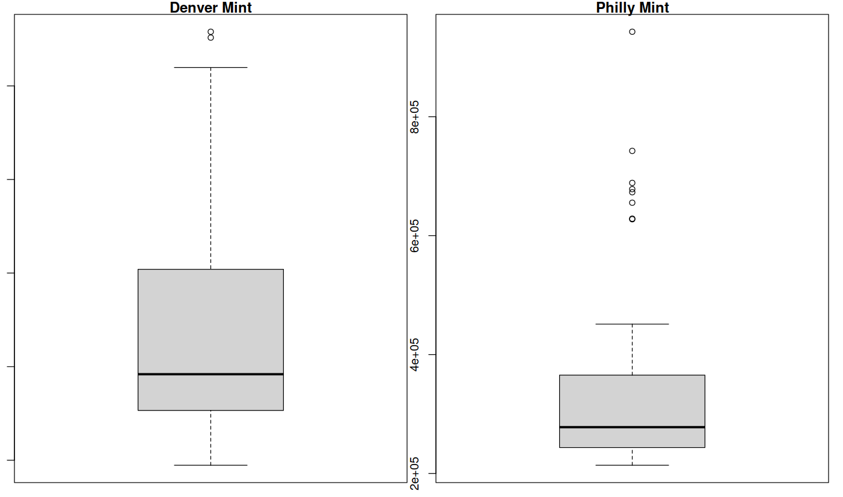

1.In Denver Mint, its max value is much higher than the min value, but in Philly Mint, its max value is little higher than its min value.

2.For Philly Mint, it has many outliers.

d



Part3

a

3a

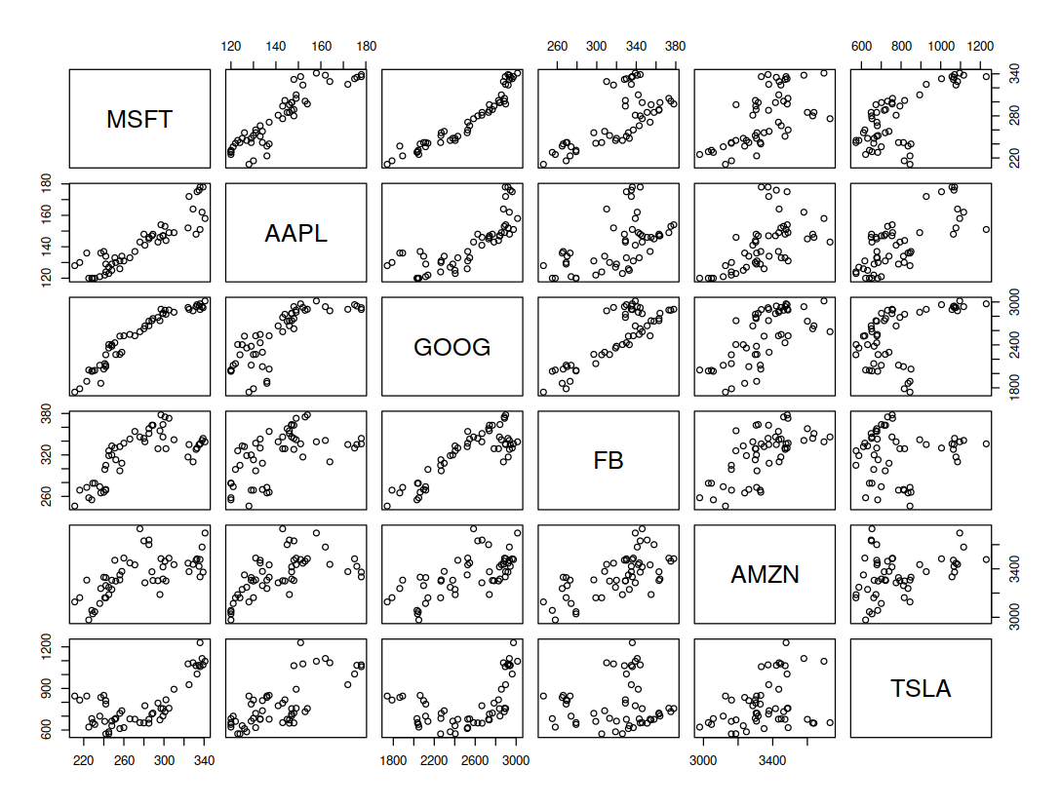

b

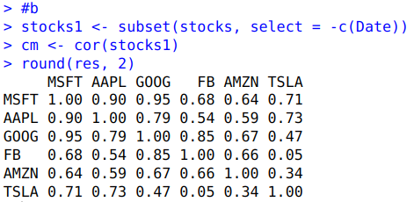

c

1.Positive correlations indicate that two stocks tend to move in the same direction, while negative correlations indicate that two stocks tend to move in opposite directions.

2.A correlation value close to 1 indicates strong positive correlation, while a value close to -1 indicates strong negative correlation. A value close to 0 indicates weak or no correlation.

3.The diagonal elements of the correlation matrix are all 1, which indicates that each stock is perfectly positively correlated with itself.

4.The correlation matrix provides a summary of the linear relationships between each pair of stocks, but it does not capture non-linear relationships or other types of dependencies between stocks.

d



Part4

a



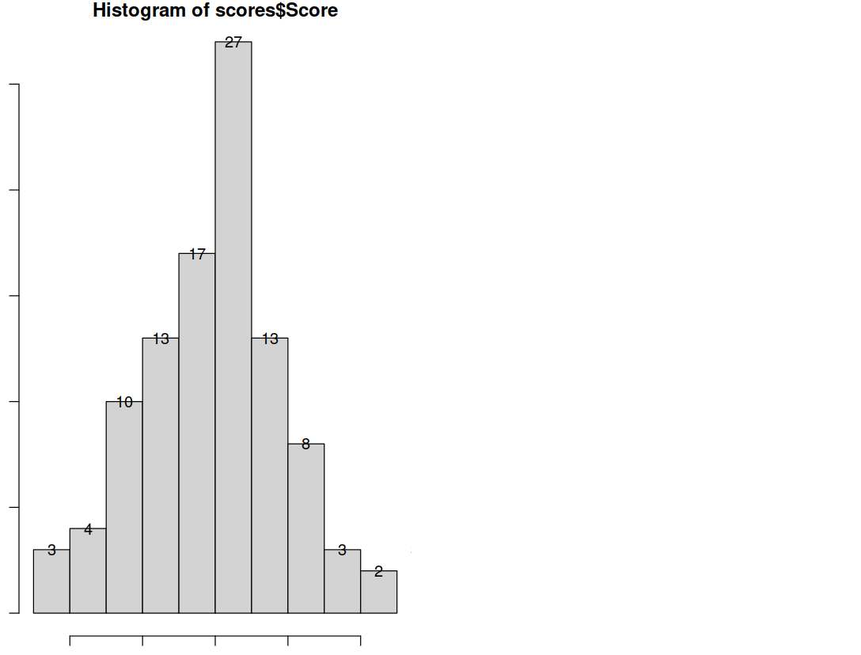

b



