1/12/23

CS 566 Draft Assignment 1

Hand in a draft of Assignment 1, using the Word template supplied, with only the following parts drafted: 1.1, 2.2, 2.4

1.1:

Given conditions: (Preconditions)

1.The Bluebeards and Zombis are peace when they have the same number.

2. The goat is safe when it stays with the ferryman

3. The boat can load for four, and can only be operated by ferryman

What we want to do: (Postconditions)

1. Transport all the units to the right bank
2. To make the goat safe

According to the preconditions and the postconditions above, we can let the goat move with the ferryman. And because of the volume of the boat, and to make the Bluebeards and Zombies, which are on the each side of bank, to be peaceful,we can make 1 Bluebeard and 1 Zombies to move with the ferryman and the goat.

How to move: (outcome)

1. To make 1 Bluebeard and 1 Zombies to move with the ferryman and the goat, and when they reached at the right bank
2. To leave this pair of Bluebeards and Zombies, the ferryman and the goat move back to the left.
3. To repeat this process for many times util all the Bluebeards and Zombies are on the right bank. At that time, the ferryman and the goat can reached at the right bank.

2.2

By finding gcd(s,t)

iteration 1:

Substract $s^{k}$ from t where $s^{k} ≤ t$ and $s^{k+1}> t$, then we can get the new t, and then continue to measure and substract $s^{x} ≤ new t$ from new t.

At this time, n is the number for the iterations we need to do, and the number of iteration is depend on the complexity of gcd(s,t), like the given example, we go from gcd(4, 250) to gcd(4, 186) to gcd(4, 122) to gcd(4, 58) to gcd(4, 42) to gcd(4, 26) to gcd(4, 10) to gcd(4, 6) to gcd(4, 2) to gcd(2, 2) = 2, the number of iteration n at this example is 9.

2.4

For the algorithm in part 2, according to the code, we can get the big-oh time complexity is O(n^2)

For classical Euclidean algorithm, gcd(2,n) where n is odd, we can know its big-oh is O(log(n))

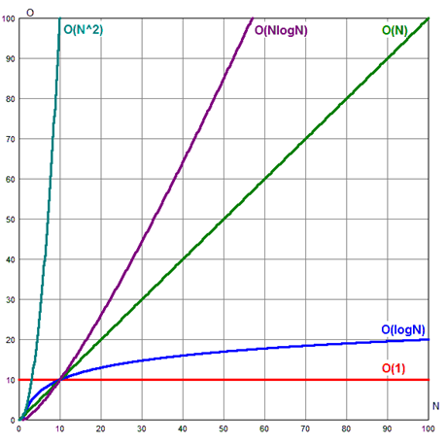

The graph is for the time complexity, in this graph, the smaller slope represents faster.

Compared to the two algorithm, we can know that the classical Euclidean algorithm is faster than the algorithm in part2