# Passengers Classification (Airport)

# Yuhan Xu

1/18/2023

# Assignment 2: Divide and Conquer

## 1.1 SUMMARY DESCRIPTION

I plan to design an airport passenger destination survey system. This system can store the destination of passengers and the airline they carry when they go to the destination. We can use Divide and Conquer to solve this problem. For example, we can use it to divide passengers into domestic flight and cross flight. Each flight is divided by airline (e.g. American Airlines AAL, Cathay Pacific CPA...)

## 1.2 PROJECTED I/O SPECIFIC EXAMPLE FROM PROJECTED COMPLETED PROJECT

INPUT:

Passenger A: To: KLAX(Los Angeles, CA), AAL

Passenger B: To: KORD(Chicago, IL), DAL

Passenger C: To: KJFK(New York, NY), AAL

Passenger D: To: VHHH(Hong Kong, China), CPA

Passenger E: To: EGLL(London, UK), BAW

Passenger F: YSSY(Sydney, Australia), AAL

OUTPUT:

The destination of passenger A B C are in the same country

The destination of passenger D E F are different with passenger A B C.

The passenger D E F have the different destination with each other.

The airliners passenger A C F taken are the same,

The airliners passenger B D E taken are different with the passenger A C F taken

Passenger B D E take the different airliners with each other

## 1.3 REQUIREMENTS IMPLEMENTED IN THIS RELEASE

### 1.3.1 Your requirement title replaces this

The package should include the destination(TO) ,detailed city, states, contries,and the Airliners they want to take

### 1.3.2 Your requirement title replaces this

The output should point out the similarity and the difference from the Destination(TO) and Airliners

## 1.4 ILLUSTRATIVE OUTPUT

Passenger A,B,C are the national travel

Passenger D,E,F are the international travel

The destination of passenger D,E,F are different with passenger A,B,C

The passenger D,E,F have the different destination with each other.

The airliners passenger A,B,C taken are different

The airliners passenger D,E,F taken are different

These output produced by the conquer() function

## 1.5 YOUR DIRECTORY AND README

Directory

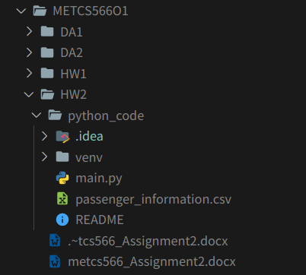

Readme

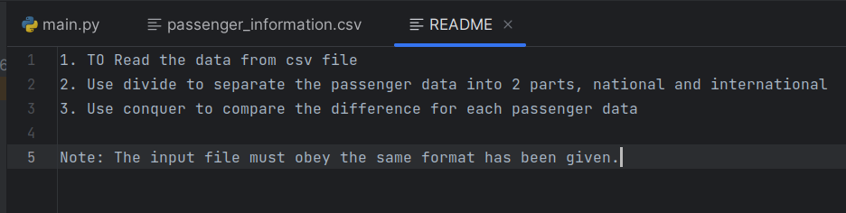

All the functions defined are in the main.py, the program will read the file passenger_information.csv, and use divide and conquer to do the analysis.

## 1.6 DIVIDE AND CONQUER IMPLEMENTED

### 1.6.1 Class model and Sequence Diagram

Class models:

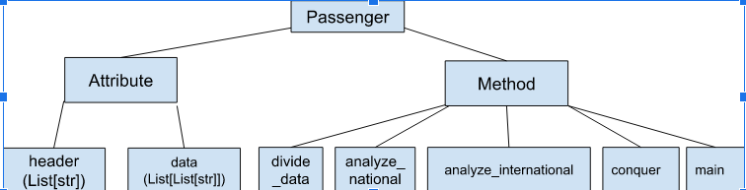

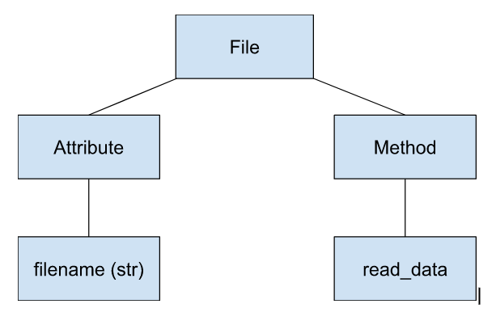

Sequence Diagram:

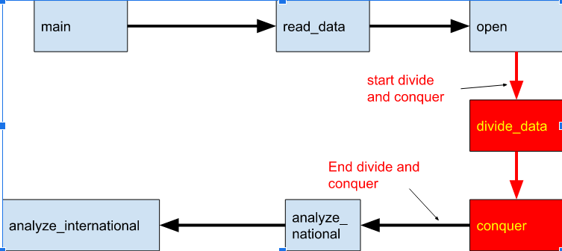

### 1.6.2 Divide & Conquer Algorithm Outline

The code performs the divide and conquer algorithm on a passenger data file in CSV format.

1. read_data : to read the data from the CSV file and returns the data as a list of rows.
2. divide_data : to take the data and divides it into two groups: national and international. National refers to passengers whose destination country is the US, while international refers to passengers with a destination country other than the US.
3. analyze_national : to take the national data and generates three sets of information: destination city, destination state, and airline.
4. analyze_international : to take the international data and generates three sets of information: destination city, destination country, and airline.
5. conquer : to take the output of analyze_national and analyze_international and prints the result. It prints the list of passengers for national and international travel, the difference in destination between the two groups, and whether the passengers took the same or different airlines.
6. main : to run the algorithm by calling read_data, divide_data, and conquer.

### 1.6.3 Code showing divide and conquer.

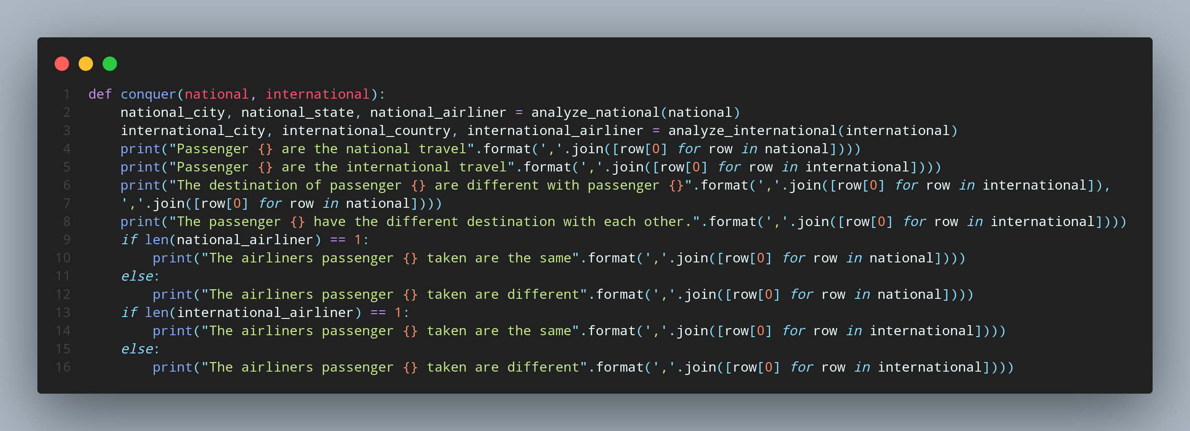

|  |  |
| --- | --- |
|  |  |

In my code, I first use divide to separate the passengers into national travel and international travel, and then use conquer to find the similarities and difference of each passenger.

### 1.6.4 Efficiency

The time complexity of this code is O(n), where n is the number of rows in the CSV file, because each row of data will be processed in the divide_data, analyze_national, and analyze_international functions. The divide_data function takes O(n) time, as it loops over each row in the data and appends it to either the national or international list. The analyze_national and analyze_international functions each take O(n) time, as they extract and store information from each row in their respective lists. Finally, the conquer function takes O(1) time as it simply performs set operations and print statements.

In terms of space complexity, the code has a space complexity of O(n), as it stores the entire CSV data in memory in the data list. Additionally, it creates separate lists for national and international data, each with a maximum size of n.

## 1.7 YOUR CODE

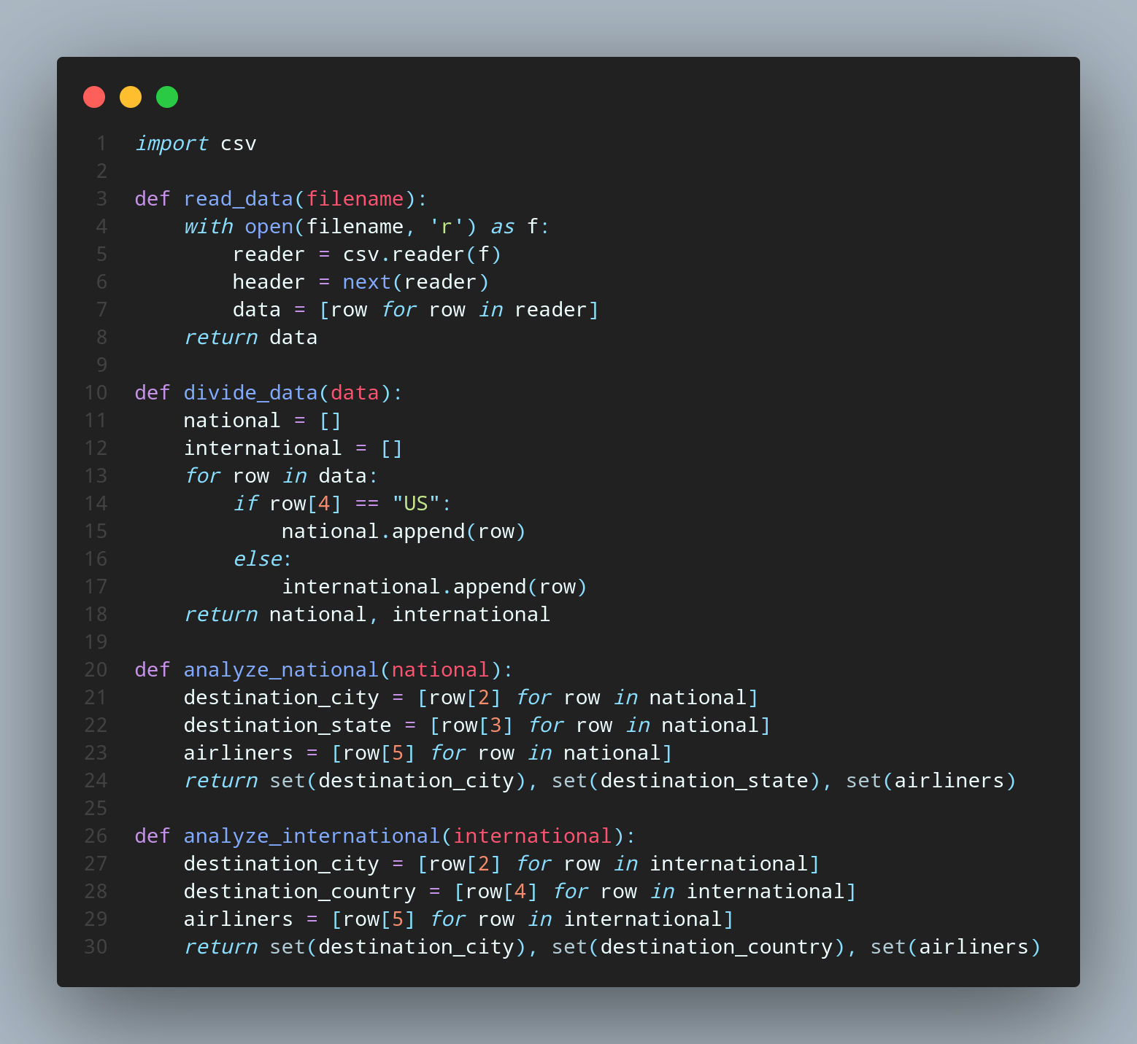

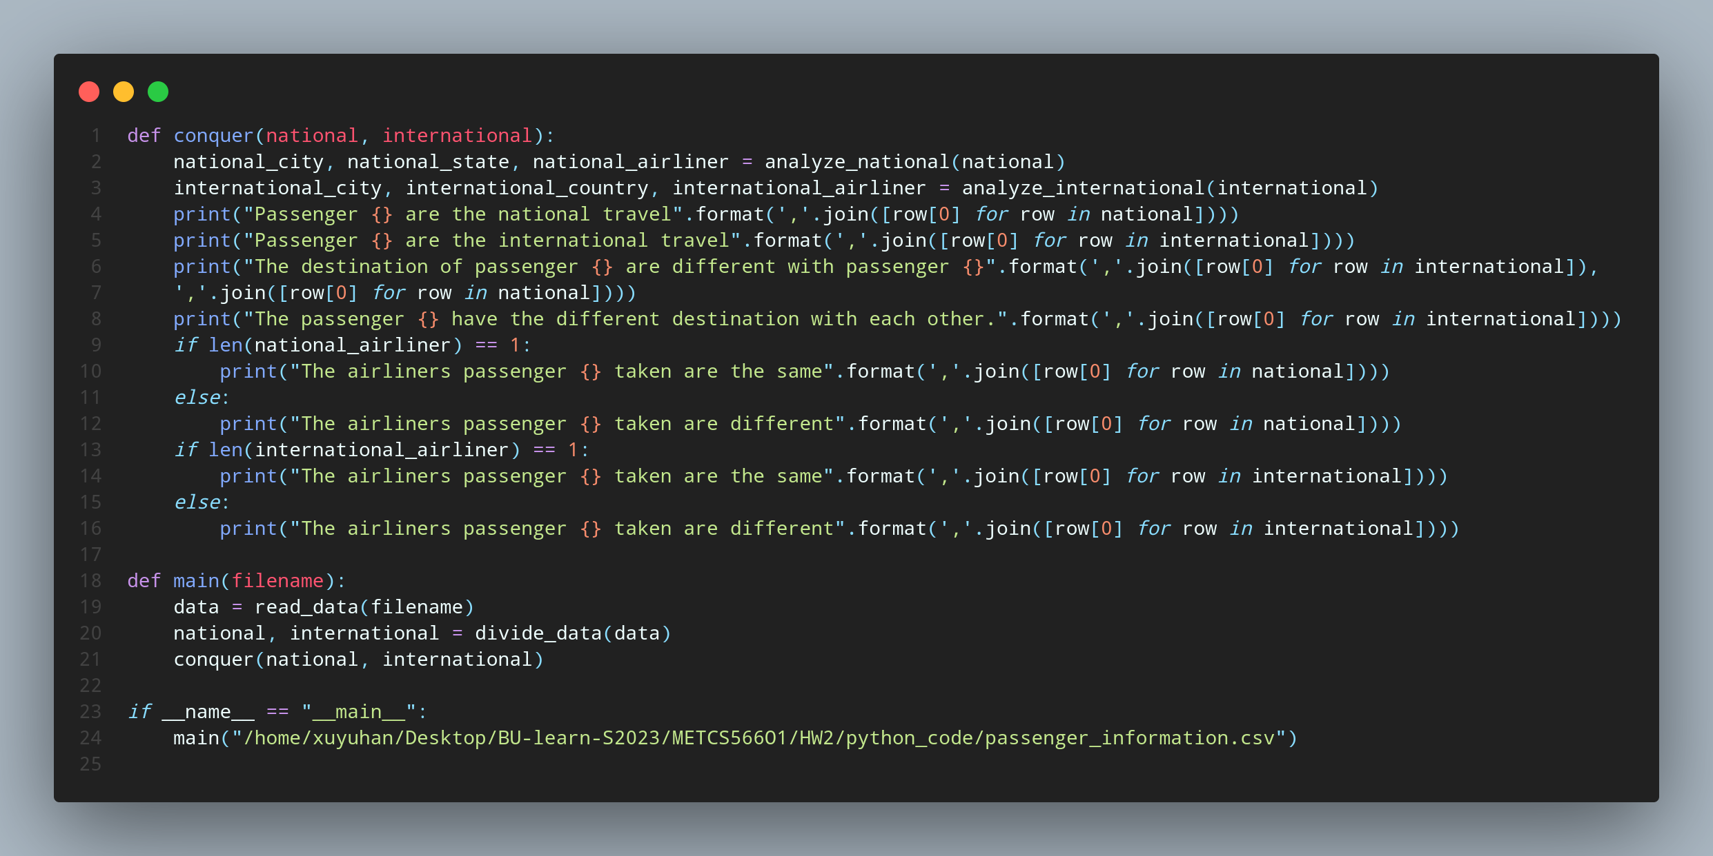

## 1.8 Evaluation



## References (if used. Each of [1], [2], etc. should occur within the paper above.)

[1]

[2]

## Appendix 1 (if needed; should be referenced above, and will be read as-needed only)

## Appendix 2 (if needed; should be referenced above, and will be read as-needed only)