**JMP Pro Installation (for homework 1)**

JMP Pro is available from the following BU’s website:

<http://www.bu.edu/tech/services/cccs/desktop/distribution/statistics/>

Go to the above web site and scroll down to the “Getting Started” section, shown below:

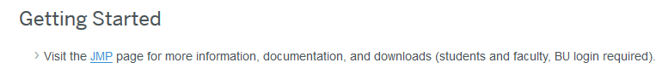

Click the “JMP” link and log in with your BU credential. You will see the following screen (only a part of the screen is shown):

Download JMP Pro 17 for your OS and install it.

You may also want to download JMP Pro documentation from this website:

<https://www.jmp.com/en_us/support/jmp-documentation.html>

Then, start JMP Pro 17 by double clicking the shortcut.

For your assignment, please complete the 5 steps (starting on the next page) and submit the image requested in step 5.

1. Access JMP Preferences (File > Preferences on Windows or JMP > Preferences on Mac). Go to the Reports Preference Group on the left side, and set a check box in the field “Date Title on Output”.

2. Select Help > Sample Data Library and open Big Class.jmp. You should see the following data:

3. Select Analyze > Distribution. The following screen will pop up.

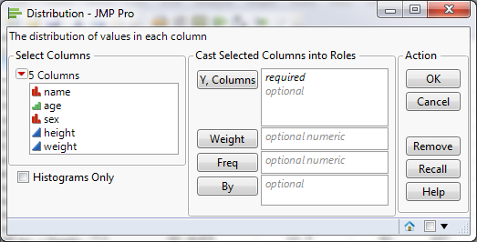

4. Select age and height and click Y, Columns, as shown below:

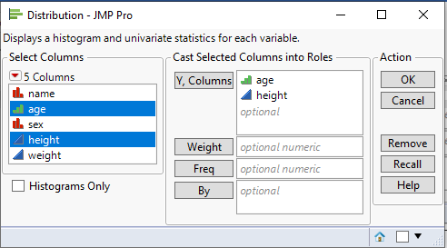

5. Click OK. You will see something like the screen shown below (note we are looking for the graphs and the timestamp which will help us know you had a successful install of JMP on your own machine and are not just copy and pasting the image below):

Capture this screen and include it in your submission file.