**Weka Installation (for homework 1)**

Weka Installation

Note that the screenshots shown here may not be exactly the same as those you will see on your computer screen.

1. Go to <http://www.cs.waikato.ac.nz/ml/weka/>

2. Read general description (you may want to browse various links on this page to learn more about Weka).

3. Click Download link.

4. There are a couple of different versions. You may want to download the latest stable version. Choose and download the executable that is appropriate for your computer.

5. Run the downloaded executable file.

6. Installation is straightforward. Step by step instruction is given below FYR (the screenshots in this file may not be exactly the same as those you will see).

7. This is the first window you see when you run the executable. Click *Next*.

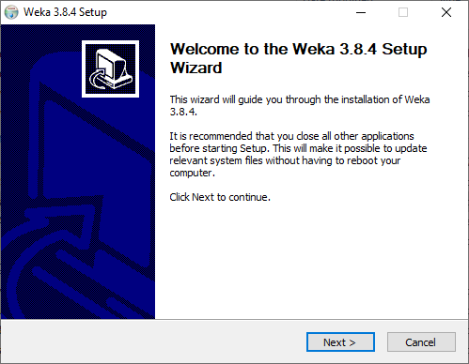

8. Click *I Agree* on the License Agreement window.

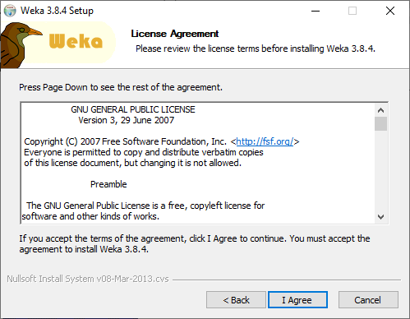

9. In the Choose Components window, make sure *Full* is selected and *Associate Files* is checked, and click *Next*.

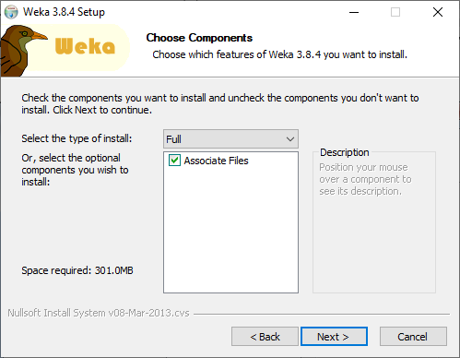

10. You can change the installation location if you want. Otherwise, accept the default location and click *Next*.

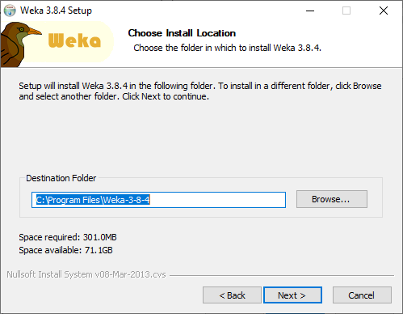

11. Click *Install*.

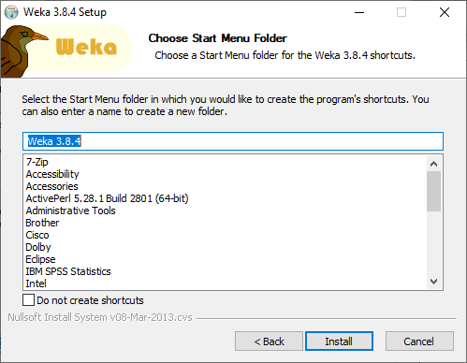

12. Installation is being done.

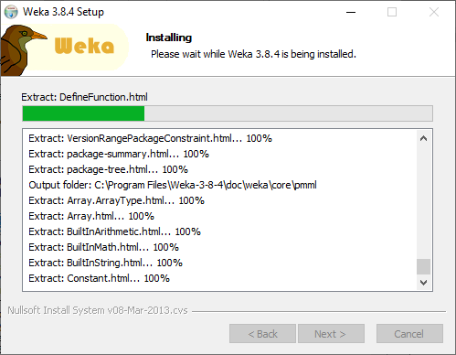

13. Installation is completed. Click *Next*.

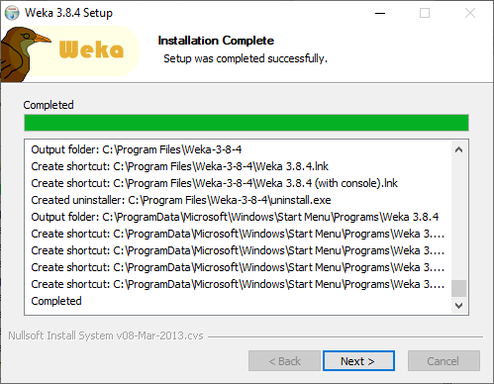

14. Click *Finish*.

