**Related file: XU_YUHAN_Assign_10_naive_bay.py**

**Assignment 10 Naive Bayesian**

## **1. implement a Gaussian naive bayesian classifier and compute its accuracy for year 2**



## **2. compute the confusion matrix for year 2**

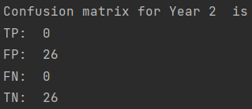

## **3. what is true positive rate and true negative rate for year 2**

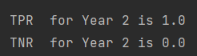

## **4. implement a trading strategy based on your labels for year 2 and compare the performance with the ”buy-and-hold” strategy. Which strategy results in a larger amount at the end of the year?**

Because the second year is a big drop compared to the first year,it is impossible to hold for a long time.

Therefore, the strategies we can take are simple, all short-term actions.Buy when it falls compared to the previous day,

and sell when it rises compared to the previous day,so as to maximize the benefits.

Compared to buy-and-hold, my strategy will result in a larger amount at the end of the year.