**Assignment 11 Tips**

**Related file: XU_YUHAN_Assign_11_tips.py**

## **1. what is the average tip (as a percentage of meal cost) for for lunch and for dinner?**

## 

## **2. what is average tip for each day of the week (as a percentage of meal cost)?**

## 

## **3. when are tips highest (which day and time)?**

## 

## 

## 

## 

## **4. compute the correlation between meal prices and tips**

## 

## **5. is there any relationship between tips and size of the group?**

Yes

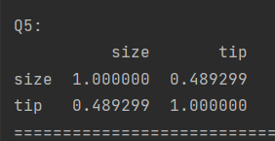

## **6. what percentage of people are smoking?**

## 

## **7. assume that rows in the tips.csv file are arranged in time. Are tips increasing with time in each day?**

## 

## 

## 

## **8. is there any difference in correlation between tip amounts from smokers and non-smokers?**