**Assignment 6**

# **Questions:**

## **1. take year 1 and examine the plot of your labels. Construct a reduced dataset by removing some green and red points so that you can draw a line separating the points. Compute the equation of such a line (many solutiuons are possible)**

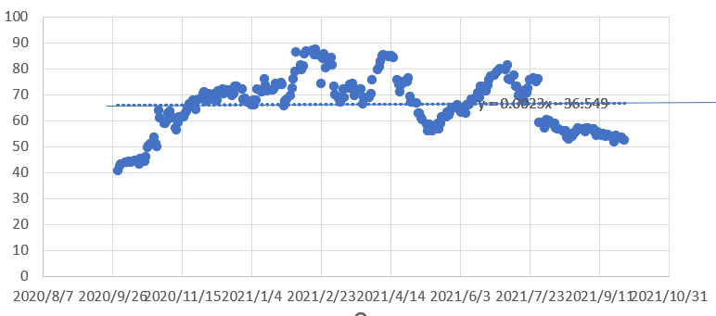

This is the first-year graph of the stock PINS, I chose. The line I used to separate the point is also in the graph. The equation of this line is

$y = 0.023x - 36.549$

## **2. take this line and use it to assign labels for year 2**

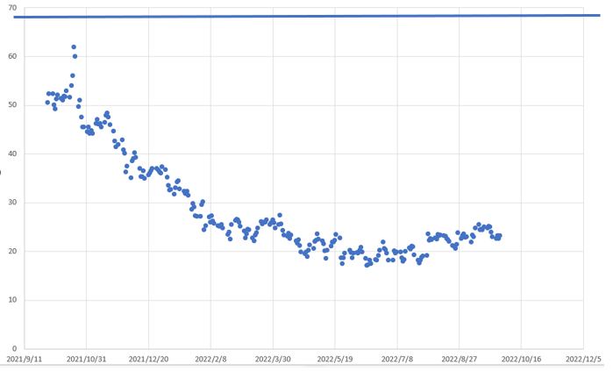

If I take this line to assign the labels for year 2, I think all the labels are “**Red**”.

## **3. implement a trading strategy based on your labels for year 2**

**Answer:**

Because the second year is a big drop compared to the first year, it is impossible to hold for a long time. Therefore, the strategies we can take are simple, all short-term actions. Buy when it falls compared to the previous day, and sell when it rises compared to the previous day, so as to maximize the benefits.