**Assignment 7 Logistic Regression**

## **1. what is the equation for logistic regression that your classifier found from year 1 data?**

Answer:

The equation for logistic regression is

$y = \frac{e^{0.17423484+0.015211045147071875x}}{1+e^{0.17423484+0.015211045147071875 x}}$

$ln(\frac{1}{y}-y)=0.17423484+ 0.015211045147071875x$

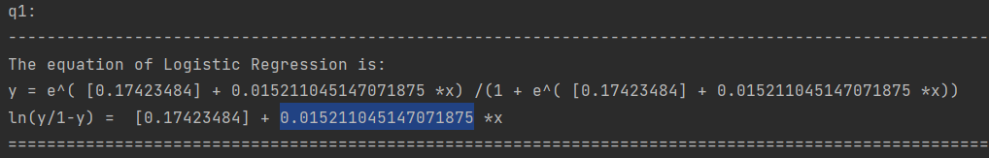

## **2. what is the accuracy for year 2?**

Answer:

54%

## **3. compute the confusion matrix for year 2**

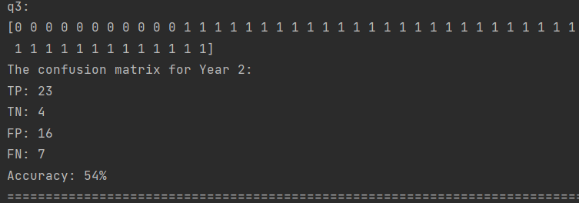

## **4. what is true positive rate (sensitivity or recall) and true negative rate (specificity) for year 2?**

Answer:

## Year 2:

## true positive rate (sensitivity or recall) = 0.766667

## true negative rate (specificity) = 0.200000

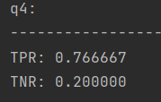

## **5. implement a trading strategy based on your labels for year 2 and compare the performance with the ”buy-and-hold” strategy. Which strategy results in a larger amount at the end of the year?**

Answer:

Because the second year is a big drop compared to the first year, it is impossible to hold for a long time. Therefore, the strategies we can take are simple, all short-term actions. Buy when it falls compared to the previous day, and sell when it rises compared to the previous day, so as to maximize the benefits.

Compared to “buy-and-hold”, I think my strategy will result in a larger amount at the end of the year.