**Assignment 8 Bakery**

# **Questions**:

## **1. what is the busiest (in terms of number of transactions)?**

### 

### **(a) hour**

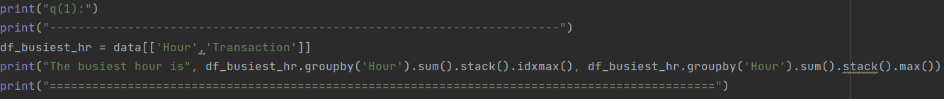

The busiest hour is 11.

### **(b) day of the week**

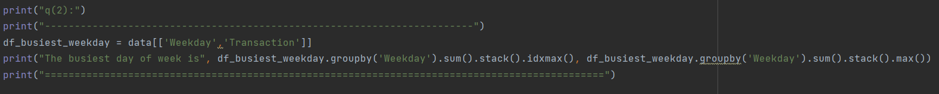

The busiest day of week is Saturday.

### **(c) period**

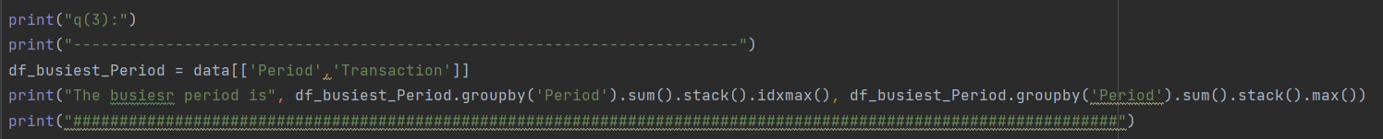

The busiest period is afternoon

## **2. what is the most profitable time (in terms of revenue)?**

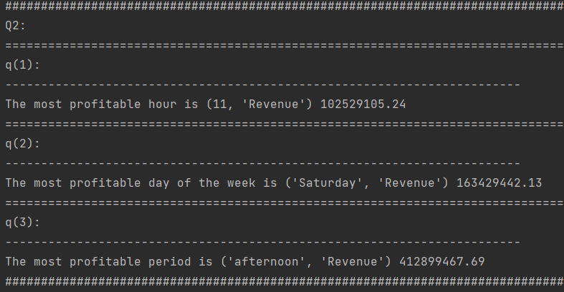

### **(a) hour**

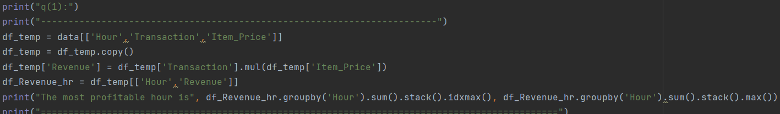

The most profitable hour is 11

### **(b) day of the week Page**

### 

The most profitable day of week is Saturday

### **(c) period**

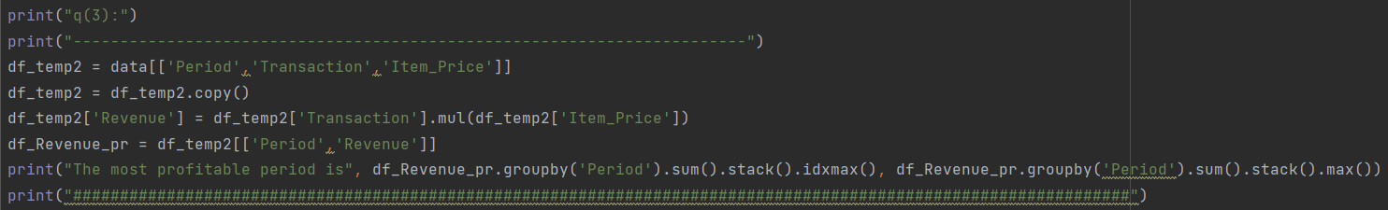

The most profitable period is afternoon

## **3. what is the most and least popular item?**

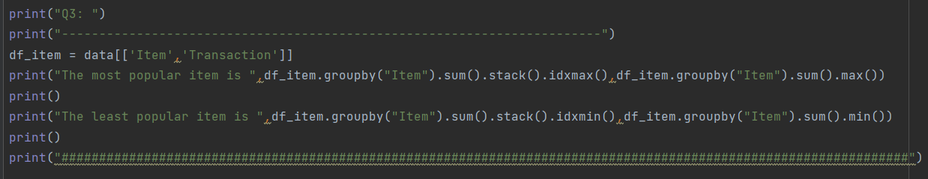

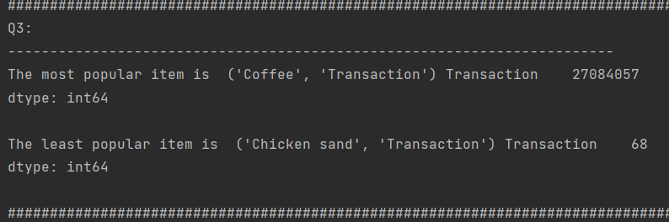

The most popular item is Coffee

The least popular item is Chicken sand

## **4. assume one barrista can handle 50 transactions per day. How many barristas do you need for each day of the week?**

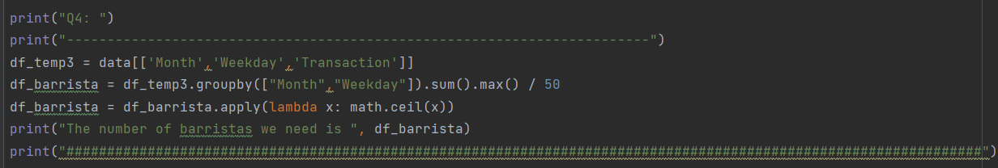

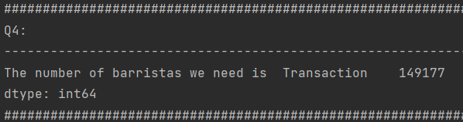

The baristas we need is 149177 for each day of the week

## **For the questions below, because they need to divide all of them into 3 groups, so I use csv to divide it, and generate a new csv to analyze, the new csv I will attached with all the homework file. The name of the new csv is end of withGroup**

## **5. divide all items in 3 groups (drinks, food, unknown). What is the average price of a drink and a food item?**

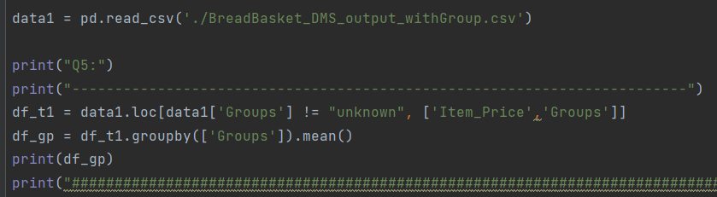

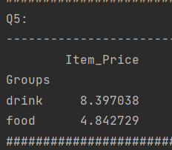

The average price of drinks is 8.397038

The average price of food is 4.842729

## **6. does this coffee shop make more money from selling drinks or from selling food?**

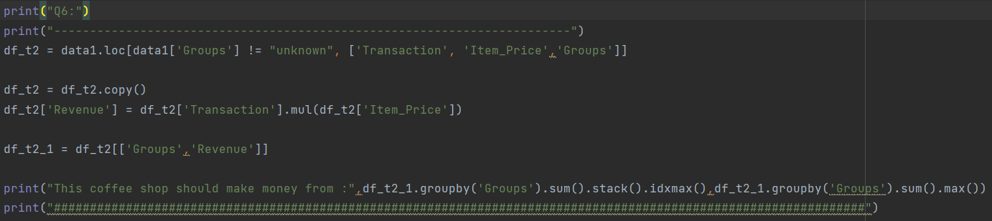

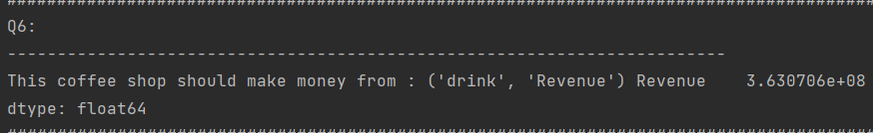

The coffee shop should make money from selling drinks.

## **7. what are the top 5 most popular items for each day of the week? does this list stays the same from day to day?**

## 

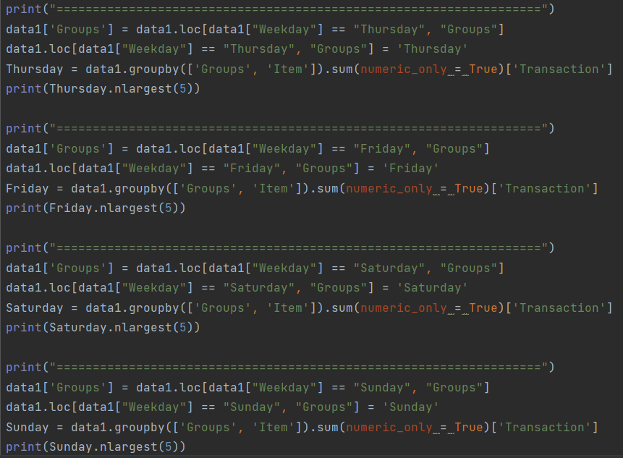

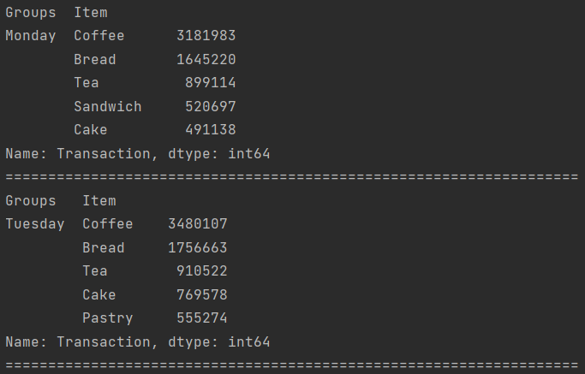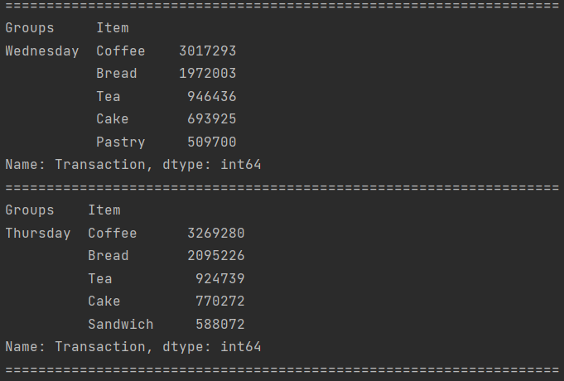

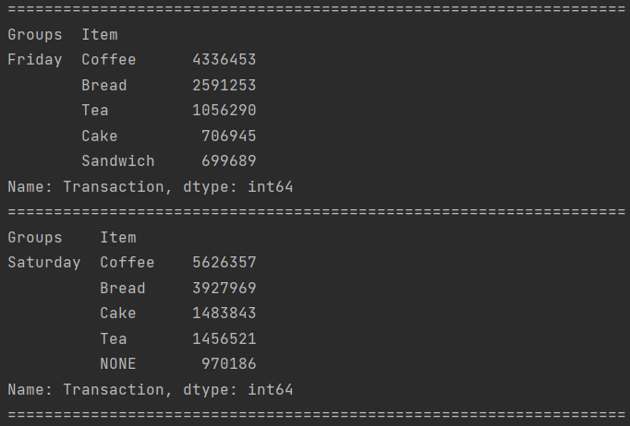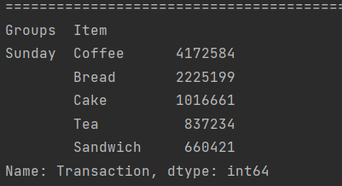

## **8. what are the bottom 5 least popular items for each day of the week? does this list stays the same from day to day?**

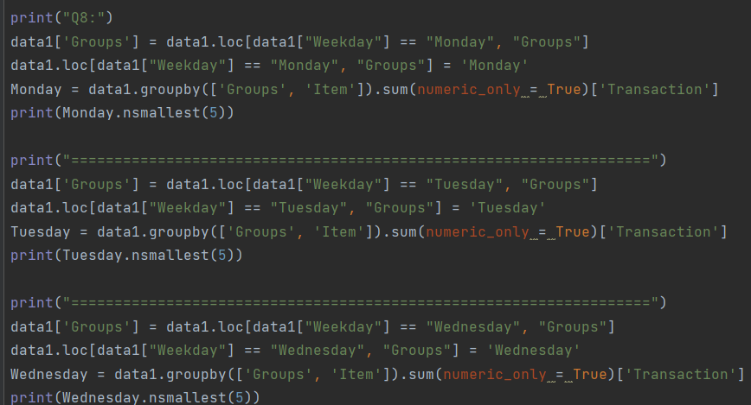

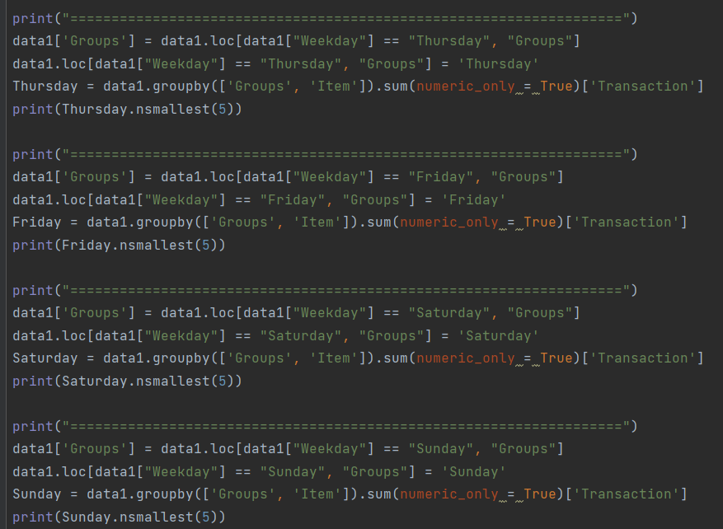

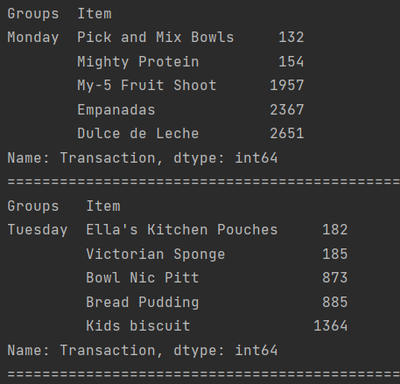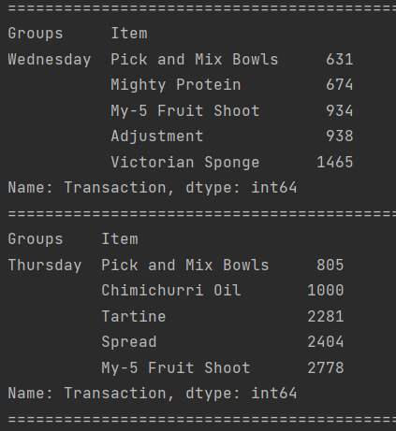

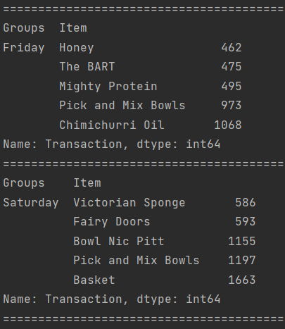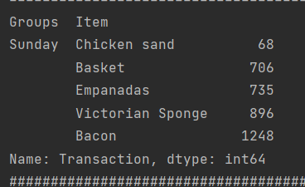

## **9. how many drinks are there per transaction?**

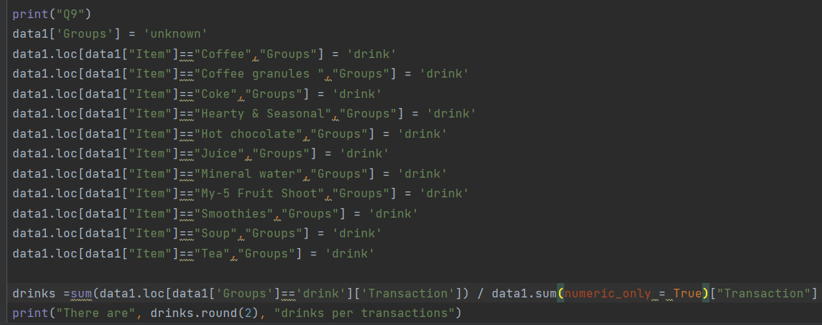

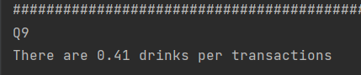

There are 0.41 drinks per transaction.