**Assignment 9 Linear Model**

**Related File: XU_YUHAN_Assign_9.xlsx**

**Sheet: (lin_mod_y1&lin_mod_y2)**

**The Results here are all calculated out in Excel, related files are in the zip.**

## **1. take weekly data for year 1. For each W = 5, 6, . . . , 12 and for each d = 1, 2, 3 construct the corresponding polynomials Use these polynomials to predict weekly labels. Plot the accuracy - on x axis you have W and you plot three curves for accuracy (separate curve for each d)**

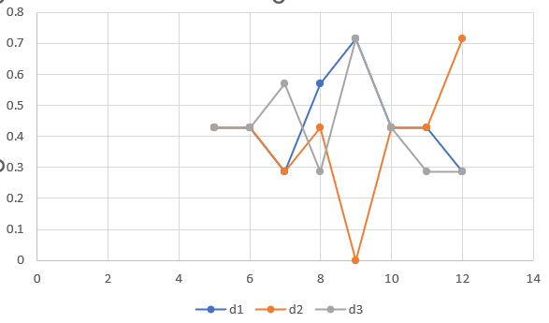

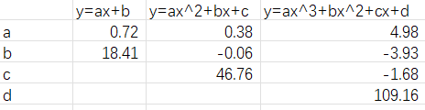

X: Open Price Y: Close Price

## **2. for each d take the best W that gives you the highest accuracy. Use this W to predict labels for year 2. What is your accuracy?**

Year 1 Accuracy

| numWeek | d1 | d2 | d3 |
| --- | --- | --- | --- |
| 5 | 0.428571 | 0.428571 | 0.428571 |
| 6 | 0.428571 | 0.428571 | 0.428571 |
| 7 | 0.285714 | 0.285714 | 0.571429 |
| 8 | 0.571429 | 0.428571 | 0.285714 |
| 9 | 0.714286 | 0 | 0.714286 |
| 10 | 0.428571 | 0.428571 | 0.428571 |
| 11 | 0.428571 | 0.428571 | 0.285714 |
| 12 | 0.285714 | 0.714286 | 0.285714 |

In Year 1:

d1: Choose Week 9

d2: Choose Week 12

d3: Choose Week 9

Year 2 Accuracy

| Week | d1 | d2 | d3 |
| --- | --- | --- | --- |
| 9 | 0.571429 | 0.428571 | 0.428571 |
| 12 | 0.428571 | 0.571429 | 0.428571 |

## 

## 

## **3. compute confusion matrices (for each d) for year 2**

|  | TP | TN | FP | FN | Accuracy |
| --- | --- | --- | --- | --- | --- |
| d1 | 3 | 4 | 3 | 4 | 0.5 |
| d2 | 3 | 4 | 4 | 3 | 0.5 |
| d3 | 5 | 7 | 1 | 1 | 0.86 |

## **4. implement three trading strategies for year 2 (for each d using the ”best” values for W from year 1 that you have computed)**

For d1, we can take the short position transaction

For d2, we can take the short position transaction

For d3, we can take the long position transaction