**Assignment 9 Linear Regression**

## **1.take W = 5, 6, . . . , 30 and consider your data for year 1. For each W in the specified range, compute your average P/L per trade and plot it: on x-axis you plot the values of W and on the y axis you plot profit and loss per trade. What is the optimal value W∗ of W?**

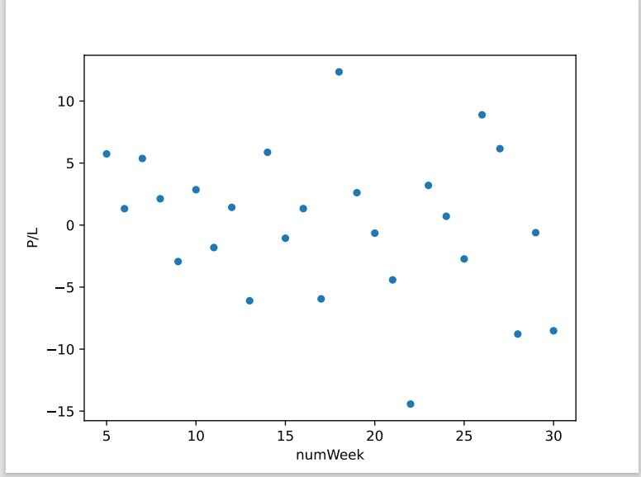

W* = 18

## **2. use the value of W∗ from year 1 and consider year 2. For every day in year 2, take the previous W∗ days, compute linear regression and compute the value of r^2 for that day. Plot the graph of r^2 for year 2. What is the average r^2 . How well does it explain price movements?**

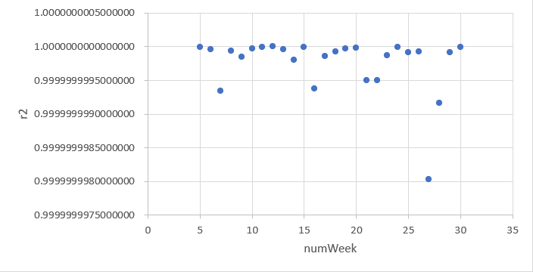

| The average r^2 = 0.9999999997612100 |
| --- |

According to r^2, we can say that the price change for Year 2 is similar to that for Year 1.

## **3. take the optimal value of W∗ from year 1 and use it to implement the above trading strategy for year 2. How many ”long position” and ’short position” transactions did you have in year 2?**

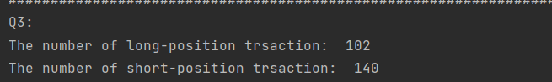

The number of ”long position” transactions I did is 102 in Year 2

The number of ”short position” transactions I did is 140 in Year 2

**The strategy I implemented:**

Because the second year is a big drop compared to the first year,it is impossible to hold for a long time.

Therefore, the strategies we can take are simple, all short-term actions.Buy when it falls compared to the previous day,

and sell when it rises compared to the previous day,so as to maximize the benefits.

## **4. what is the average profit/loss per ”long position” trade and per ”short position” trades in year 2?**

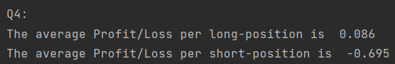

The Average profit/loss per ”long position” trade is 0.086 in Year 2

The average profit/loss per ”short position” trade is -0.695 in Year 2

## **5. what is the average number of days for long position and short position transactions in year 2?**

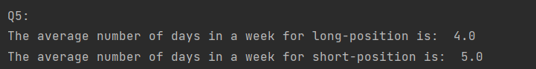

The average number of days for long position in Year 2 is 4

The average number of days for short position in Year 2 is 5

## **6. are these results very different from those in year 1 for this value of W∗ ?**

No, in my result, Year 2 is different from those in Year 1, but there is only little difference from those in Year 1 for this value of W*, not very different.