Changes in color, antioxidant, and free radical scavenging enzyme activity of

Mushrooms under high oxygen modified atmospheres

高氧气调环境下蘑菇颜色、抗氧化剂和自由基清除酶活性的变化

Keywords:Mushroom、High oxygen、Antioxidant、ROS

1. Introduction

The commercial value of mushroom decreases within 2–3 d Mainly because they have no cuticle to protect them from physical damage or microbial attack and water loss (Burton and Noble,1993;Nerya et al., 2006). Browning is the major factor limiting shelf

Life of mushroom.（蘑菇的商业价值在2-3天内下降，主要是因为它们没有角质层保护它们免受物理伤害或微生物攻击和水分流失（Burton and Noble，1993；Nerya等人，2006）。褐变是限制蘑菇货架期的主要因素。）

In previous work, high oxygen concentration was effective at maintaining the quality of mushrooms (Liu et al., 2010). Mushroom slices packaged under 80%O2/20% N2 and stored at 8◦C had more than 12-d shelf life(Day,2001).But elevated O2 concentrations can cause the production of reactive oxygen species (ROS)。（在之前的研究中，高氧浓度对蘑菇的质量是有效的（Liu等人，2010）。蘑菇片在80%O2/20%N2下包装，储存在8℃下，保质期超过12天（2001年第二天）。但是，高浓度的O2会导致活性氧物种（ROS）的产生。）Defense against oxidative stress in plants by preventing or reducing the damage from ROS includes enzymatic ROS scavenging systems and non-enzymatic antioxidant compounds. Enzymatic ROS scavenging systems include superoxide dismutase (SOD), peroxidase (POD) and catalase (CAT) (Asada, 1992; Scandalios, 1993).（通过防止或减少ROS的损伤，植物中的氧化应激包括酶ROS清除系统和非酶抗氧化化合物。酶促ROS清除系统包括超氧化物歧化酶（SOD）、过氧化物酶（POD）和过氧化氢酶（CAT）（ASADA，1992；StavaloS，1993）。）It is still not clear whether high oxygen ameliorates or aggravates the production of ROS and reactive oxygen scavenging enzymes activities. Meanwhile, little information is available on the effect of high oxygen modified atmosphere on browning of mushrooms in relation to ROS metabolism.（目前尚不清楚高氧是否会改善或加重活性氧的产生和活性氧清除酶的活性。同时，高氧气氛对蘑菇褐变的影响与ROS代谢的关系尚不清楚。）

The objective of our research was to determine the effects of the application of a high oxygen atmosphere of 80% O2, balance N2 on color,antioxidant enzyme and free radical scavenging activity of mushrooms that might be involved in browning control.（本研究的目的是确定应用80% O2的高氧气氛，平衡N2对可能参与褐变控制的蘑菇的颜色、抗氧化酶和自由基清除活性的影响）

2.Materials and methods

2.1.High oxygen modified atmosphere chambers

The dynamic control system maintains the concentration of oxygen and carbon dioxide, and determines nitrogen flow, temperature and humidity of each chamber

in real-time.（动态控制系统保持氧和二氧化碳的浓度，以及实时测定各室氮气流量、温度和湿度。）

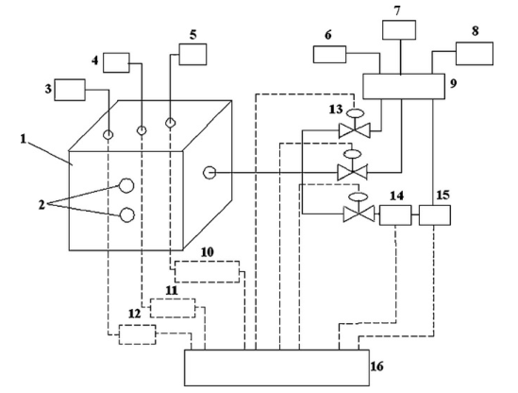

图1。高氧改性气氛室结构图（1）实验室；（2）取样孔；（3）二氧化碳传感器；（4）二氧化碳传感器；（5）温湿度传感器；（6）氧气瓶；（7）二氧化碳瓶；（8）氮气发生器；（9）分离器配件；（10）温湿度变送器；（11）二氧化碳变送器；（12）二氧化碳变送器；（13）微计量阀；（14）电磁阀；（15）流量计；（16）无纸记录仪。

2.2.Sample preparation（样品制备）

Mushrooms with cap size of 40–50 mm were selected。选择菌盖大小为40-50 mm的蘑菇。There were three chambers at high oxygen and three at standard air conditions as controls. The chambers were held at 2◦C and linked by separate lines to continuous

flow(1.67mLs−1) of humidified air (control), 80% O2(balanced with N2). The relative humidity of the chambers remained at approximately 95%. Samples were taken initially

And at 3-d intervals during storage.有三个高氧室和三个标准空气条件作为对照。燃烧室保持在2°C，并通过单独的管路连接至持续流动（1.67 mL s-1）的加湿空气（控制）、80%的氧气（用氮气平衡）。各房间的相对湿度保持在95%左右。在储存期间，最初和每隔3天采集一次样品。

2.3.Color measurement（颜色测定）

Colorimeter（色度计）Surface and flesh color（表面和肉色）L\*、a\*、b\*

Color changes were described using a whiteness index



2.4.Measurement of membrane permeability （膜透性测量）

Membrane permeability was expressed by tissue electrolyte

leakage.膜通透性通过组织电解质渗漏来表达。

2.5.Determination of lipid peroxidation（脂质过氧化的测定）

Lipid peroxidation was evaluated by measuring malondialdehyde (MDA) content. 通过测量丙二醛（MDA）含量来评价脂质过氧化。

2.6.Determination of superoxide radical (O2•−)（超氧阴离子自由基的测定（O2））

2.7.Measurement of hydrogen peroxide (H2O2) content（过氧化氢（H2O2）含量的测定）

2.8.Enzyme assays（酶分析）

POD（过氧化物酶），SOD（超氧化物气化酶），CAT（氧化氢酶）

2.9.Determination of total phenolic（总酚的测定）

2.10. Analysis of DPPH radical scavenging activity（DPPH自由基清除活性分析）

2.11.Superoxide radical scavenging activity（超氧阴离子自由基清除活性）

3.Results and discussion

3.1.Color

Mushroom has a very short shelf-life, as it turns brown and loses its quality within only a few days. The browning of flesh and surface is a major postharvest problem for mushroom. As shown in Fig. 2, the whiteness index of mushroom flesh and surface decreased rapidly with storage time. Browning of mushrooms appeared after 3 d of storage and became serious after 9 d under air treatment. However, browning was found in mushrooms under high 80% O2on day 9. The mushrooms kept in air had a lower whiteness index, while high oxygen significantly delayed the decrease of the whiteness index. After 12 d of storage, the whiteness index for the control mushroom flesh and surface was respectively 69.67 and 69.65, while high oxygen treated mushroom flesh and surface had a whiteness index of 80.41and 71.94.The results showed that high oxygen concentration was effective at inhibiting discoloration of mushrooms.（蘑菇的保质期很短，因为它会变成棕色，几天内就会失去品质。蘑菇采后果肉和果皮褐变是蘑菇采后的主要问题。如图2所示，蘑菇果肉和表面的白度指数随贮藏时间的延长而迅速下降。蘑菇贮藏3d后出现褐变，空气处理9d后褐变严重。然而，在第9天，蘑菇在80%氧气浓度下出现褐变。空气中蘑菇的白度指数较低，而高氧显著延缓了白度指数的下降。贮藏12d后，对照蘑菇果肉和表面的白度指数分别为69.67和69.65，高氧处理蘑菇果肉和表面的白度指数分别为80.41和71.94。结果表明，高氧浓度对蘑菇的变色有抑制作用。）

Enzymatic browning is related to a loss of membrane integrity,which resulted in the decompartmentalization of enzymes and substrates(Jiang et al., 2004; Liu et al., 1991). The flesh and surface of mushrooms treated with high oxygen showed higher whiteness

index(Fig. 2).（酶促褐变与膜完整性的丧失有关，导致酶和底物的分解（Jiang等人，2004；Liu等人，1991）。高氧处理的蘑菇果肉和表面白度指数较高（图2）。）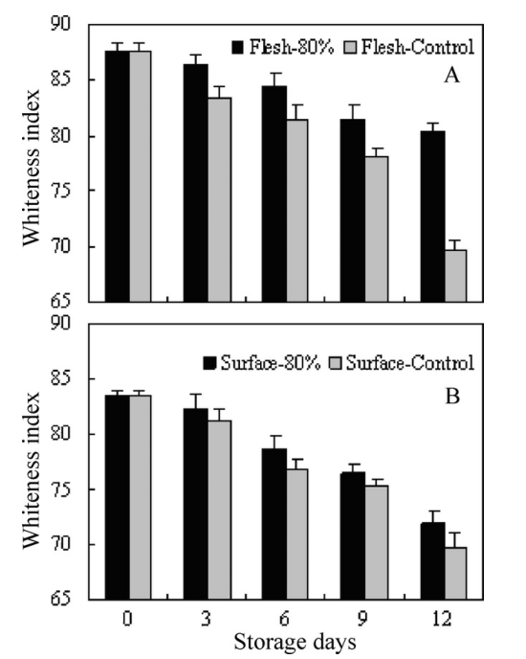

图二 蘑菇肉（A）和表面（B）在80%氧气和空气中2℃贮藏时的白度指数。每个值均表示为平均值±标准误差（n=3）。

3.2.Membrane permeability and lipid peroxidation（膜通透性与脂质过氧化）

Relative leakage rate is generally considered an indirect measure of cell membrane damage. Changes in relative leakage rate of mushrooms were presented in Fig. 3A. In general, relative leakage rate in mushrooms increased with the storage, which was consistent with the decline in whiteness index. The initial relative leakage rate was 21.4%, while it increased respectively to 27.5% and 34.3% under 80% O2and air。（相对渗漏率通常被认为是细胞膜损伤的间接测量指标。蘑菇相对渗漏率的变化如图3A所示。一般来说，蘑菇的相对渗漏率随着贮藏时间的延长而增加，这与白度指数的下降是一致的。初始相对泄漏率为21.4%，分别提高到27.5%和34.3%在80%氧气和空气。）Cantos et al.

1. Also found that membrane stability is potentially a major factor of controlling the

browning. Our results showed that the loss of membrane integrity was associated with the browning of mushrooms (Fig. 2).（Cantos等人。（2002）还发现膜稳定性可能是控制褐变的主要因素。我们的结果表明，膜完整性的丧失与蘑菇的褐变有关（图2）。）

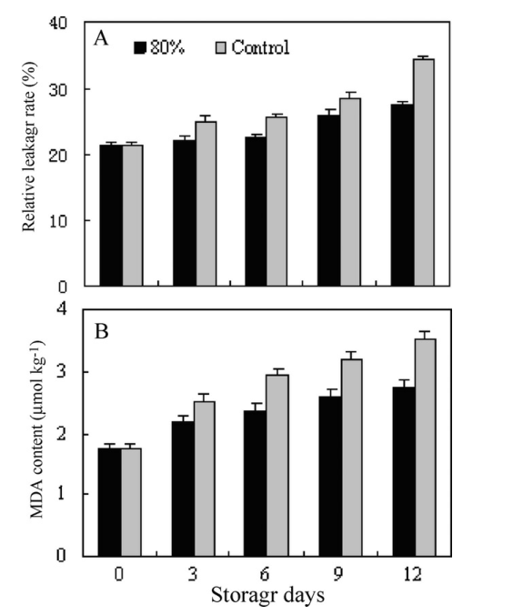图3。在2℃贮藏期间，在80%氧气和空气条件下的相对泄漏率（A）和丙二醛含量（B）。每个值均表示为平均值±标准误差（n=3）。

The level of lipid peroxidation was measured in terms of MDA content (Fig. 3B).During the storage of 12 d, MDA content increased from the initial value(1.75umol

kg−1) to 3.52 umol kg−1 under control treatment, while 1.75–2.75 ?mol kg−1under 80% O2. Marked increase in MDA content of mushrooms stored in air was found. The difference was significant (P < 0.05). The results indicated that high oxygen treatment could prevent the existence of mushroom oxidative injury to some degree. Our results are in agreement with those of Duan et al. (2011) who found that pure oxygen could significantly inhibit the accumulation of MDA in litchi fruit. Zheng et al. (2008) had also reported that there were higher levels of MDA content in Chinese bayberry under high oxygen. In the study, the decrease of relative leakage rate was correlated with the loss

Of membrane integrity,which could be partly due to lipid peroxidation.（用MDA含量测量脂质过氧化水平（图3B）。贮藏12d，丙二醛含量较初始值（1.75？摩尔千克-1）至3.52？对照组为1.75-2.75？摩尔千克-1在80%氧气下。贮藏在空气中的蘑菇丙二醛含量显著增加。差异有显著性（P<0.05）。结果表明，高氧处理能在一定程度上防止蘑菇氧化损伤的发生。我们的结果与Duan等人的一致。（2011）世卫组织发现，纯氧能显著抑制荔枝果实中丙二醛的积累。郑等人。（2008）也报道了在高氧条件下杨梅的丙二醛含量较高。在研究中，相对渗漏率的降低与膜完整性的丧失有关，这可能部分是由于脂质过氧化。）

3.3.Superoxide production rate and H2O2content（超氧化物生产率与H2O2含量）

Reactive oxygen species (ROS) such as O2•−and H2O2have a role in lipid peroxidation, membrane damage and consequently in senescence. The effect of high oxygen concentration on O2•− production rate and H2O2content was shown in Fig. 4. The O2•− production rate had marked increase during the first 3 d of storage,and was kept at high level at the end of storage (Fig. 4A). A higher level of O2•−production rate was noticed in mushrooms under the control treatment (P < 0.05). The results showed that high oxygen treatment had a significant inhibition on O2•−production.（活性氧（如氧）和H2O2在脂质过氧化、膜损伤和衰老中起重要作用。图4显示了高氧浓度对氧气生成速率和过氧化氢含量的影响。在储存的前3天，氧气的产生率显著增加，并在储存结束时保持在高水平（图4A）。在对照处理下，蘑菇的O2•－产生率较高（P<0.05）。结果表明，高氧处理对O2•－产生有明显的抑制作用。）

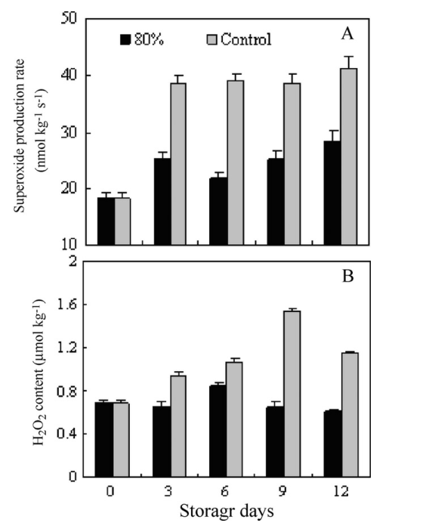图4。在2℃下储存期间，在80%氧气和空气条件下，O2•—产生率（A）和H2O2含量（B）均以平均值±标准误差（n=3）表示。

The H2O2content in mushrooms under the control and high oxygen treatments continually increased then decreased during storage (Fig. 4B). The contents of H2O2in control mushrooms were 23.7%higher than those in high oxygen treated mushrooms on day 9. Application of high oxygen resulted in significantly lower H2O2 content compared

With the control (P < 0.05).（在对照和高氧处理下，蘑菇中的过氧化氢含量在贮藏期间不断增加，然后减少（图4B）。对照蘑菇第9天过氧化氢含量比高氧处理蘑菇高23.7%。高氧处理与对照组相比，过氧化氢含量显著降低（P<0.05）。）

The overproduction of ROS is an intrinsic feature of senescence and fruit ripening (Buchanan-Wollaston et al., 2003; Jiménezet al., 2002). The accumulation of ROS is one of the processes that contribute to loss of membrane integrity and membrane-bound enzyme activities (Bartoli et al., 1996).（活性氧的过量生产是衰老和果实成熟的内在特征（Buchanan-Wollaston等人，2003年；Jiménez等人，2002年）。ROS的积累是导致膜完整性和膜结合酶活性丧失的过程之一（Bartoli等人，1996）。）

3.4.Oxygen radical scavenging enzyme activities（氧自由基清除酶活性）

SOD,CAT and POD are important active free-radical scavenging enzymes 。The

Changes of these enzyme activities were shown in Fig. 5. （SOD、CAT和POD是重要的活性自由基清除酶。这些酶活性的变化如图5所示。）

图5。POD（A）、SOD（B）和CAT（C）在80%氧气和空气中的活性在2℃下储存。每一个数值均为平均值±标准误差（n=3）。

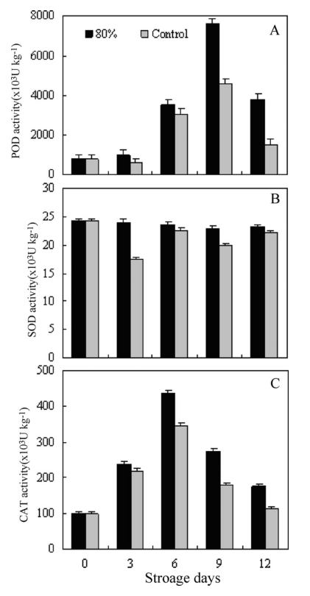

POD activity showed a marked increase during 9 d of storage (Fig.5A).The significant increase of POD activity was found in high oxygen treated mushrooms (P < 0.05).The highest enzyme activity was detected in the mushrooms on day 9. At the end of storage, POD activity decreased. POD is ubiquitous enzymes that have diverse biochemical functions in higher plants. The activity of POD has been found to be higher in pure oxygen treated Chinese Bayberry fruit than air treated fruit (Yang et al., 2005). POD activity increased in high oxygen treated squash and peaked at around day 3–6 before it decreased, while POD activity increased substantially at day 6 in control samples (Zheng et al., 2008). （在储存的9天中，POD活性显着增加（图5A）。在高氧处理的蘑菇中发现POD活性显着增加（P <0.05）。在第9天，蘑菇中的酶活性最高。 存储结束时，POD活性下降。 POD是在高等植物中具有多种生化功能的普遍存在的酶。 已发现纯氧处理的杨梅果实中的POD活性高于空气处理的果实（Yang等，2005）。 在经过高氧处理的南瓜中，POD活性增加，并在第3-6天达到峰值，然后才下降，而在对照样品中，POD活性在第6天显着增加（Zheng等，2008）。）

SOD was mainly responsible for catalyzing the reduction of superoxide radical to O2and H2O2, and CAT was responsible for eliminating H2O2. The mushrooms stored under high oxygen maintained remarkably higher SOD activity during storage (Fig. 5B).CAT activity in both treatments increased to a peak on day 6, and then decreased during the rest of the days (Fig. 5C). CAT activity showed significantly higher levels in the high oxygen treatments compared with the control (P < 0.05). A similar change pattern has been reported for litchi fruit stored under pure oxygen, where the activities of SOD and CAT were maintained at higher levels (Duanet al., 2011).（SOD主要催化超氧化物自由基向O2和H2O2的还原，CAT有助于消除H2O2。在高氧条件下贮藏的蘑菇在贮藏期间保持了显著的高SOD活性（图5B）。两种处理的CAT活性在第6天都达到高峰，然后在其余时间内下降（图5C）。高氧处理的CAT活性显著高于对照（P<0.05）。据报道，在纯氧条件下贮藏的荔枝果实也有类似的变化模式，其中SOD和CAT的活性保持在较高水平（Duan等人，2011）。）

High levels of antioxidant enzymes are involved in alleviating oxidative damage and delaying the senescence process (Lacan and Baccou, 1998). In this work, the increase of POD, SOD and CAT activity has been found in mushrooms under high oxygen. Thus, the decrease of SOD, CAT and POD may contribute to the development of browning in mushrooms. The effectiveness of high oxygen in delaying the occurrence of browning may result from delaying the reduction of antioxidant enzymes during the storage. Some reports have shown that high oxygen induced the activities of SOD and CAT and maintained membrane integrity in peach (Wang et al., 2005) and loquat (Ding et al., 2006). The application of high oxygen concentration maintained higher activities of CAT and POD,and delayed the decay of Chinese bayberry (Yang et al., 2009).（高水平的抗氧化酶参与减轻氧化损伤并延缓衰老过程（Lacan and Baccou，1998）。 在这项工作中，发现在高氧下的蘑菇中POD，SOD和CAT活性增加。 因此，SOD，CAT和POD的减少可能会导致蘑菇褐变。 高氧气延迟褐变的发生可能是由于在储存过程中延迟了抗氧化酶的还原。 一些报告表明，高氧诱导桃（Wang等，2005）和枇杷（Ding等，2006）中SOD和CAT的活性并维持膜的完整性。 高浓度氧气的施用保持了CAT和POD的较高活性，并延缓了杨梅的腐烂（Yang等，2009）。）

3.5. Antioxidant activity（抗氧化活性）

The initial phenolic content was about 1.00 g/kg in mushrooms (Table 1). The total phenolic content in high oxygen treated mushrooms exhibited an increase during the first 9 d, reaching a maximum accumulation about 1.59 g/kg. Thereafter, it decreased gradually. The phenolic content in mushrooms under air was 1.20g/kg on day 9. There were significantly higher levels of total phenolic content in mushroom tissues under 80% O2(P < 0.05).Cocci et al. (2006) demonstrated that the oxygen availability in the package headspace of fresh-cut apples stored under air could lead to a stronger degradation of the functional compounds such as phenolics. It has been proved that the activity of phenylpropanoid pathway increases under stressful conditions and phenolic compounds are synthesized and accumulated (Kang and Saltveit, 2002).（蘑菇中的初始酚含量约为1.00 g / kg（表1）。 高氧处理蘑菇中的总酚含量在前9天显示出增加，达到最大值累积约1.59 g / kg。 此后，它逐渐减少。在第9天，空气中蘑菇中的酚含量为1.20g / kg。在80％O2下，蘑菇组织中的总酚含量显着更高（P <0.05）。 （2006年）证明了在空气中储存的鲜切苹果包装顶部空间的氧气供应可能导致功能性化合物（如酚类）的降解。 已经证明，在压力条件下，苯丙酸途径的活性增加，并且酚类化合物得以合成和积累（Kang and Saltveit，2002）。）

DPPH-radical scavenging activity has been extensively used for screening antioxidant activity in plant extracts (Benjakul et al.,2005). As shown in Table 1, mushrooms exposed to 80% O2 exhibited higher DPPH-radical scavenging activity after 6 d of storage (P < 0.05). The increase of phenolic content resulted in higher DPPH-radical scavenging activity, which, in turn, possibly accelerated the browning of mushrooms. Cheng et al. (2009) reported that lower DPPH-radical scavenging activity in Longan fruit stored at 60% O2 might be due to oxidation of phenolic compounds.（DPPH自由基清除活性已被广泛用于筛选植物提取物中的抗氧化活性（Bejakal等人，2005）。如表1所示，蘑菇在贮藏6d后，暴露于80%o2中表现出较高的DPPH自由基清除活性（P<0.05）。随着酚类物质含量的增加，蘑菇对dpph的清除活性提高，进而可能加速蘑菇的褐变。Cheng等人。（2009）报道在60% O2贮藏的隆安水果中DPPH自由基清除活性降低可能是由于酚类化合物的氧化所致。）

Superoxide anion is an important radical that is involved in the formation of other cell-damaging free radicals. The superoxide radical scavenging activity of mushrooms at harvest was around 8%(Table1). No significant differences were observed between high oxygen and the control in the first 3 d. After 3 d, comparable superoxide radical scavenging activity was found, and 80% O2was more efficient in increasing superoxide radical scavenging activity. At the end of storage, superoxide radical scavenging activity decreased in both treatments.（超氧阴离子是参与其他细胞损伤自由基形成的一个重要自由基。采后蘑菇的超氧自由基清除活性约为8%（表1）。高氧和对照在第一3 d之间没有显著差异。3 d后，发现了类似的超氧阴离子自由基清除活性，80%的O2在提高超氧阴离子自由基清除活性方面更有效。在贮藏结束时，两种处理的超氧化物自由基清除活性均降低。）

High oxygen induced a higher production of total phenolic and non-enzymatic antioxidant activity compared to the control.Antioxidant activity of fruits and vegetables is known to depend on a wide number of compounds.In our study, the increase in antioxidant activity was probably due to the synthesis of phenolic compounds, which may be related to induced stress metabolism.These results were consistent with those reported by Zheng et al.(2008), who found that significantly higher total phenolic content and DPPH-radical scavenging activity were obtained in high oxygen treated Chinese bayberry from day 6 to the end of storage. Duan et al.(2011) found that pure oxygen delayed the decrease of phenol compounds content and DPPH scavenging activity. According to Martínez-Sánchez et al. (2006), air treatment induced a particularly marked decrease in antioxidant capacity in leaves of wild rocket, which could be due to losses in some antioxidant constituents and total phenolic compounds.

（高氧诱导的总酚类和非酶的抗氧化活性与对照相比更高。众所周知，水果和蔬菜的抗氧化活性取决于大量的化合物。在我们的研究中，抗氧化活性的增加可能是由于酚类化合物的合成，这可能与诱导的应激代谢有关。这些结果与郑等报道的结果一致。2008年，世界卫生组织发现，从第6天到贮藏结束，高氧处理的杨梅中总酚含量和DPPH自由基清除活性显著提高。Duan等人。（2011）发现纯氧延缓了酚类化合物含量和DPPH清除活性的下降。根据马丁内斯-桑切斯等人的说法。（2006）空气处理导致野生火箭叶片抗氧化能力的显著降低，这可能是由于某些抗氧化成分和总酚类化合物的损失所致。）

表一2℃条件下80% O2和空气条件下香菇总酚含量、DPPH自由基清除活性和超氧阴离子自由基清除活性

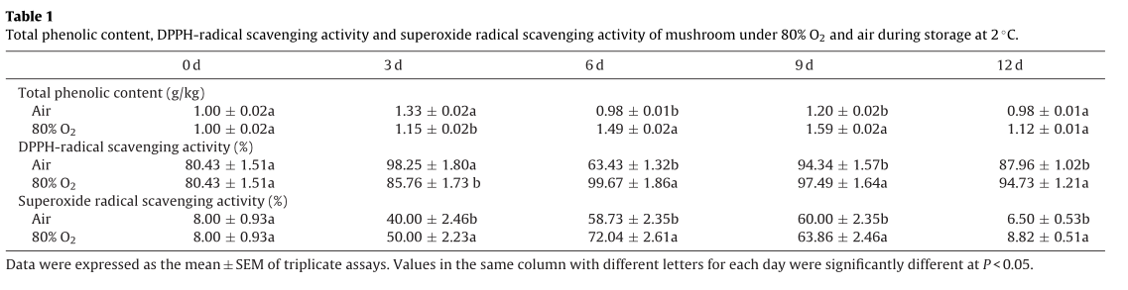

1. Conclusion

Postharvest metabolism of mushrooms was deeply modified by the application of high oxygen, which inhibited browning and delayed ripening. Mushrooms exposed to high oxygen concentration (80% O2) were shown to have a higher whiteness index, and a lower increase in relative electrolyte leakage rate, lipid peroxidation, and ROS (O2•−and H2O2) production indicating lower membrane damage. Higher activities of SOD, POD and CAT and higher non-enzymatic antioxidant activities in mushrooms under high oxygen corresponded to low levels of ROS (H2O2and O2•−) accumulation, lipid peroxidation and relative electrolyte leakage rate. These effects were evidently responsible for reduced browning in mushroom flesh and surface during storage.（利用高氧处理对蘑菇采后代谢进行了深度调控，抑制了蘑菇采后褐变和延迟成熟。暴露于高氧浓度（80% O2）的蘑菇具有更高的白度指数，相对电解质渗漏率、脂质过氧化和ROS（O2 -OH和H2O2）的生成较低，表明膜损伤较低。高氧条件下蘑菇SOD、POD、CAT活性较高，非酶促抗氧化活性较高，与低活性氧自由基积累、脂质过氧化和电解质外渗率有关。这些效应对蘑菇贮藏过程中果肉和表面褐变的减少有明显的作用。）