描述统计
Study 4 Stroop 被试层级描述统计
condition | congruency | N_subj | Mean_RT | SD_RT | Mean_Acc | SD_Acc
control | congruent | 121 | 0.619 | 0.104 | 0.988 | 0.014
control | incongruent | 121 | 0.739 | 0.147 | 0.923 | 0.106
deplete | congruent | 121 | 0.608 | 0.096 | 0.985 | 0.019
deplete | incongruent | 121 | 0.719 | 0.137 | 0.916 | 0.118

Study 4 DDM 参数描述统计
condition | N_subj | Mean_a | SD_a | Mean_v | SD_v
control | 121 | 0.143 | 0.048 | 0.272 | 0.094
deplete | 121 | 0.139 | 0.049 | 0.274 | 0.098

Study 4 主观评定描述统计
condition | N_obs | Mean_Fatigue | SD_Fatigue | Mean_Effort | SD_Effort | Mean_Frustrate | SD_Frustrate | Mean_Bored | SD_Bored | Mean_MentalDemand | SD_MentalDemand
control | 121 | 1.81 | 1.09 | 2.11 | 1.33 | 2.05 | 1.38 | 3.10 | 1.83 | 2.17 | 1.28
deplete | 121 | 5.34 | 1.62 | 5.98 | 1.14 | 4.37 | 1.92 | 4.01 | 2.06 | 6.16 | 1.04

推断性统计

操纵检验汇总：主观评定 ～Condition
评定 | b (95% HPD) | Byes Factor | Cohen’s d (95% HPD)
Fatigue | b = 1.87, 95% HPD [1.55, 2.20] | BF > 500 | d = 1.18, 95% HPD [0.90, 1.50]
Effort | b = 1.79, 95% HPD [1.48, 2.11] | BF > 500 | d = 1.12, 95% HPD [0.83, 1.39]
Frustrate | b = 1.56, 95% HPD [1.25, 1.87] | BF > 500 | d = 1.04, 95% HPD [0.74, 1.33]
Bored | b = 0.75, 95% HPD [0.39, 1.10] | BF > 500 | d = 0.42, 95% HPD [0.21, 0.63]
MentalDemand | b = 1.71, 95% HPD [1.40, 2.03] | BF > 500 | d = 1.06, 95% HPD [0.79, 1.35]
注：高负荷（deplete）条件下主观疲惫、努力、挫折感、心理需求均显著高于低负荷（control），操纵成功。
Stroop 反应时贝叶斯模型结果
效应 | b和d 估计
Condition (deplete vs control) | b = −0.01, 95% HPD [−0.02, −0.005], d = −0.25
Congruency (incongruent vs congruent) | b = 0.12, 95% HPD [0.11, 0.13], d = 2.05
Condition × Congruency | b = −0.007, 95% HPD [−0.02, 0.01], d = −0.12
Stroop 正确率贝叶斯模型结果
效应 | b和d 估计
Condition (deplete vs control) | b = −0.004, 95% HPD [−0.02, 0.007], d = −0.06
Congruency (incongruent vs congruent) | b = −0.07, 95% HPD [−0.08, −0.05], d = −0.95
Condition × Congruency | b = −0.001, 95% HPD [−0.02, 0.01], d = −0.02
DDM 决策边界 a 贝叶斯模型结果
效应 | b和d 估计
Condition (deplete vs control) | b = −0.006, 95% HPD [−0.01, 7e−04], d = −0.13
Congruency (incongruent vs congruent) | b = −0.01, 95% HPD [−0.02, −0.004], d = −0.27
DDM 漂移率 v 贝叶斯模型结果
效应 | b和d 估计
Condition (deplete vs control) | b = −0.003, 95% HPD [−0.01, 0.007], d = −0.05
Congruency (incongruent vs congruent) | b = −0.10, 95% HPD [−0.11, −0.09], d = −1.56

DDM 决策边界 a～主观评定
评定 | b(95% HPD) | Byes Factor | Cohen’s d (95% HPD)
挫折感 | −0.001, 95% HPD [−0.005, 0.002] | 0.05 | −0.04, 95% HPD [−0.12, 0.04] |
无聊感 | 8e−04, 95% HPD [−0.003, 0.004] | 0.05 | 0.02, 95% HPD [−0.07, 0.11] |
疲惫感 | −0.001, 95% HPD [−0.004, 0.001] | 0.05 | −0.03, 95% HPD [−0.09, 0.03] |
努力感 | −0.002, 95% HPD [−0.004, 0.00] | 0.14 | −0.05, 95% HPD [−0.11, 0.008] |
心理需求 | −0.002, 95% HPD [−0.004, 0.00] | 0.08 | −0.05, 95% HPD [−0.10, 0.01] |
DDM 漂移率 v ～主观评定
评定 | b(95% HPD | Byes Factor | Cohen’s d (95% HPD) |
挫折感 | −0.002, 95% HPD [−0.006, 0.003] | = 0.05 | −0.03, 95% HPD [−0.11, 0.05] |
无聊感 | −0.005, 95% HPD [−0.009, 0.00] | = 0.21 | −0.09, 95% HPD [−0.17, 0.00] |
疲惫感 | 0.00, 95% HPD [−0.004, 0.003] | = 0.03 | −0.006, 95% HPD [−0.07, 0.06] |
努力感 | 0.00, 95% HPD [−0.003, 0.003] | = 0.02 | 0.002, 95% HPD [−0.06, 0.06] |
心理需求 | 0.00, 95% HPD [−0.003, 0.003] | =0.02 | −0.002, 95% HPD [−0.06, 0.06] |

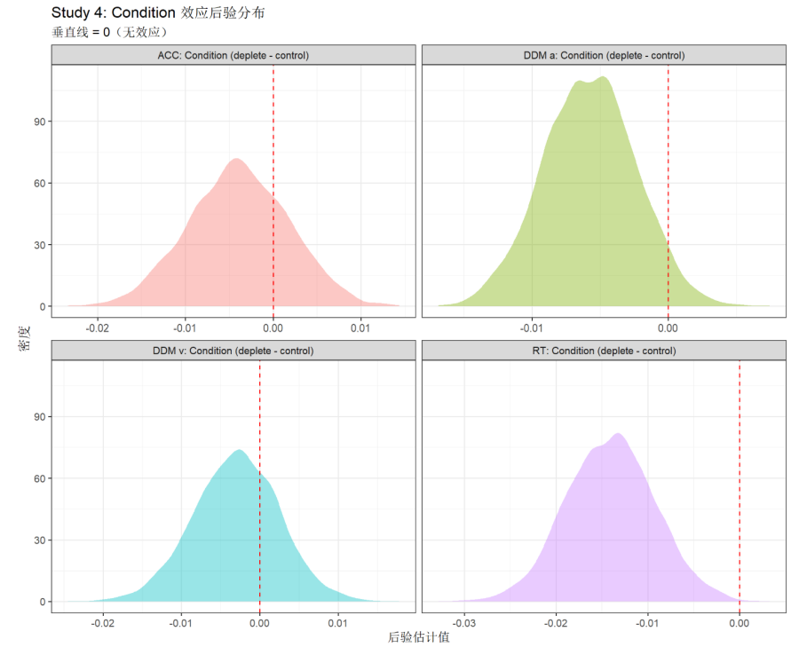

使用与原文献不同方法的推断性统计
增设一套lme4+lmerTest 频率派多层线性模型作为替代分析方案，基于传统显著性检验框架完成推断统计，两种模型均匹配完全一致的数据分层结构、固定效应与随机截距设定。
