1. **Code:**

<https://github.com/shuzhen1/CIDeploy.git>

1. **Start Jenkins as administor**
2. **Common settings for each job**

Add setting below in each job

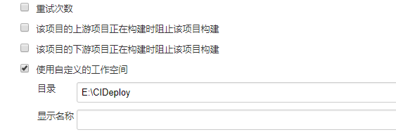

1. [DeployTACForPatch](http://localhost:8080/view/DeployTestingEnv/job/DeployTACForPatch/)
2. Download build from server
3. Configure TAC and start it
4. Create new project on TAC and give *authorization to user
5. Start nexus, config nexus on tac

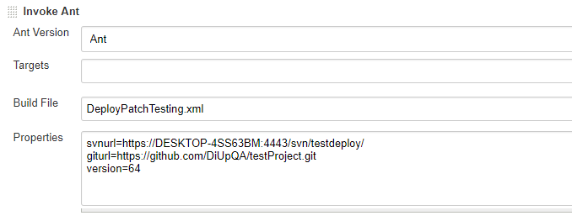

1. CleanTAC

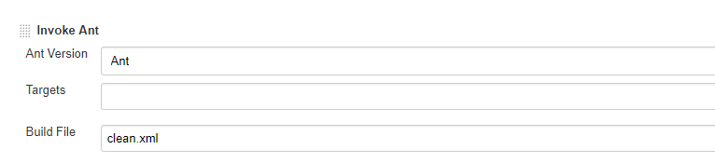

1. [GeneratePatchComment](http://localhost:8080/view/DeployTestingEnv/job/GeneratePatchComment/)

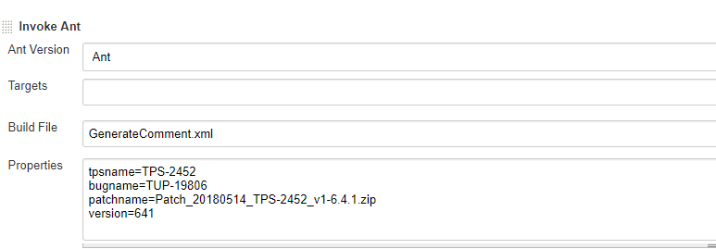

1. [Studio_Commandline](http://localhost:8080/view/DeployTestingEnv/job/Studio_Commandline/)

