Ascending thoracic aortic aneurysm and acute type A aortic dissection are governed by largely distinct molecular programmes: an integrative meta-analysis of human aortic transcriptomes with single-cell validation
Journal of Translational Medicine – Research article (draft for submission)
Authors: [First Author]¹, [Co-authors]^{1,2}, [Corresponding Author]^{1*}
¹ [Department, Institution, City, Country]; ² [Department, Institution, City, Country]
\* Correspondence: [name, e-mail]

Abstract
Background. Ascending thoracic aortic aneurysm (ATAA) and acute Stanford type A aortic dissection (TAAD) are often viewed as stages of one degenerative process, yet most dissections occur below surgical diameter thresholds and their molecular relationship has never been defined systematically.
Methods. All GEO transcriptomes of human ascending/thoracic aortic tissue comparing disease with non-diseased aorta were harmonised (ATAA: four cohorts, n = 115; TAAD: six cohorts, n = 76). Differential expression was combined by random-effects meta-analysis, genes were classified with a between-disease difference statistic, and pathways were compared by GSEA of meta-rankings. Cell composition was inferred by ssGSEA with markers from an integrated ascending-aorta single-cell atlas (73,755 cells). Findings were validated in an independent micro-regional RNA-seq cohort directly contrasting dissected and dilated media and by a leave-one-cohort-out (LOCO) classifier.
Results. The TAAD signature was highly reproducible (2,198 consensus genes; inter-cohort ρ = 0.50), whereas the ATAA signature was weak and cohort-dependent (499 genes; ρ = 0.12). Effect sizes of the two diseases were weakly correlated genome-wide (ρ = 0.11) and only 137 genes were shared. TAAD-specific changes (1,780 genes) comprised loss of the smooth-muscle contractile programme (MYOCD, ACTA2, CNN1) and of endothelial/adventitial transcripts, with gain of hypoxia/oxidative-stress (HMOX1, MT2A, VEGFA), MYC/mTORC1/E2F, p53, unfolded-protein and innate inflammatory programmes (IL6, CXCL8, S100A8/A9); AKT1, STAT3 and MYC were network hubs. ATAA-enriched changes (230 genes) centred on type I interferon signalling (OAS1-3, IFIT1-3, CXCL10), MHC class II antigen presentation (CD74, HLA-DR/DP) and collagen genes. Composition inference indicated loss of smooth-muscle, fibroblast and endothelial signatures with S100A8/A9⁺ myeloid infiltration in TAAD versus lymphoid infiltration without smooth-muscle loss in ATAA. Pathway differences replicated in the direct-contrast cohort (ρ = 0.42) and the LOCO classifier discriminated TAAD from ATAA (AUC 0.92).
Conclusions. ATAA and TAAD share a limited NF-κB/IL-6/hypoxia core but are otherwise governed by distinct programmes: interferon/adaptive immune activation with matrix remodelling in aneurysm versus acute cellular stress, smooth-muscle loss and innate inflammation in dissection, arguing against a simple continuum model and providing disease-specific targets and biomarker candidates.
Keywords: ascending thoracic aortic aneurysm; type A aortic dissection; transcriptomics; meta-analysis; single-cell RNA sequencing; smooth muscle cell; interferon; inflammation

Background
Diseases of the ascending thoracic aorta span a clinical spectrum from asymptomatic dilatation to acute Stanford type A aortic dissection (TAAD), a surgical emergency with a mortality of 1–2 % per hour in the untreated state [1,2]. Current guidelines treat ascending thoracic aortic aneurysm (ATAA) as the principal modifiable precursor of dissection and recommend prophylactic replacement once the diameter exceeds 5.0–5.5 cm [1]. Yet data from the International Registry of Acute Aortic Dissection show that around 60 % of type A dissections occur in aortas smaller than 5.5 cm and many arise in aortas that would not have met any aneurysm definition [2,3]. Conversely, many aneurysms remain stable for decades. These observations suggest that aneurysmal dilatation and dissection may be driven, at least in part, by different biological processes rather than by a single degenerative continuum [4–6].
Histopathologically, both conditions feature medial degeneration with elastic-fibre fragmentation, proteoglycan accumulation and smooth muscle cell (SMC) loss [5,7]. Dissection tissue additionally shows intimal tearing, intramural haemorrhage and an intense inflammatory infiltrate rich in neutrophils and macrophages [8–11], whereas aneurysmal tissue shows a lymphocyte-dominant infiltrate and hyperplastic remodelling of the media [12,13]. Genetic studies have identified shared susceptibility genes that encode components of the SMC contractile apparatus, the extracellular matrix (ECM) and TGF-β signalling [14–16], supporting a common vulnerability of the aortic wall, but they do not explain why a given aorta dilates rather than dissects.
Transcriptomic profiling of surgical specimens has been performed repeatedly for both diseases, and a large number of bioinformatic re-analyses have been published. Almost all of them, however, examined a single cohort, and none has formally compared aneurysm and dissection signatures across cohorts or tested whether such differences hold in a direct within-cohort contrast. The reproducibility of published aortic signatures is also unknown, which matters because many candidate biomarkers and "hub genes" are derived from small single datasets [17,18].
Here we assembled all publicly available human ascending/thoracic aortic tissue transcriptomes that compare disease with non-diseased aorta, re-processed them under a single pipeline, and performed a random-effects meta-analysis for each disease. We then compared the two diseases at the gene, pathway and inferred cell-composition levels, and validated the differences in an independent micro-regional RNA-seq cohort that directly contrasts dissected with dilated aortic media, in an integrated single-cell atlas of the human ascending aorta, and by leave-one-cohort-out machine learning. The results show that ATAA and TAAD are transcriptionally distinct diseases with a small shared core.

Methods

Data sources and eligibility
GEO DataSets was searched on 29 September 2026 for human expression profiling series (array or high-throughput sequencing) using the terms "aortic dissection", "ascending aortic aneurysm", "thoracic aortic aneurysm" and "ascending aorta AND aneurysm" (Additional file 1). Series were eligible if they profiled bulk ascending or thoracic aortic tissue from patients with sporadic ATAA or acute TAAD together with non-diseased aortic tissue (organ donors, heart-transplant donors, or non-dilated aorta from cardiac surgery), and provided processed expression data or raw data amenable to re-processing. Cell-culture experiments, peripheral blood, abdominal aortic aneurysm, animal models, and series that pooled aneurysm and dissection without separable labels (GSE314998) were excluded. Ten disease-versus-control bulk cohorts met these criteria (Table 1). One additional micro-regional RNA-seq series that directly compares dissected and dilated aortic media (GSE318877) and two single-cell RNA-seq (scRNA-seq) series of ascending aorta (GSE155468, ATAA; GSE213740, TAAD) were used for validation. Cell-culture microarrays of SMCs from aneurysm and dissection (GSE219204) were not analysed because gene-level data were unavailable.

Pre-processing
All cohorts were processed with a single Python pipeline (Additional file 2). Gene symbols were harmonised to current NCBI Gene nomenclature using the NCBI gene_info alias table; multiple probes per gene were collapsed to the probe with the highest mean intensity (arrays) or summed (counts/FPKM). Platform-specific steps were: GSE26155, Affymetrix Human Exon 1.0 ST RMA transcript-cluster values annotated through GPL5175 gene assignments, restricted to intima-media biopsies of tricuspid-valve patients classified as dilated (> 45 mm) or non-dilated (< 40 mm; "borderline" samples excluded); GSE52093, Illumina HumanHT-12 v4 raw (non-normalised) intensities re-processed by log2 transformation and quantile normalisation, probes retained when detected (P < 0.05) in ≥ 3 arrays, with sample identity confirmed by rank correlation against the GEO matrix; GSE98770, Agilent Feature Extraction files re-processed from raw gProcessedSignal (log2, quantile normalisation, probes well above background in ≥ 3 arrays) because the deposited GeneSpring matrix contained no group-related signal; GSE190635, MAS5 log2 values (GPL570 annotation); GSE140947, gene counts with the two regional samples per subject (aneurysm belly + neck; donor mid + distal ascending aorta) summed to obtain subject-level libraries (6 vs 6); GSE153434, GSE202267 and GSE294606, gene counts; GSE235161, FPKM from a total-RNA library, restricted to protein-coding genes, rescaled to transcripts-per-million and quantile-normalised because rRNA and 7SL transcripts dominated the original values; GSE267434, transcript-level FPKM summed to genes using Ensembl release 110; GSE147026, deposited normalised expression values. For GSE318877 the 70 punch-level count files (four medial micro-regions in duplicate/triplicate per patient) were summed per subject for the primary subject-level contrast (3 dissection vs 4 dilatation), and analysed at punch level for signature scoring.

Differential expression and quality control
For count data, differential expression was estimated with DESeq2 (PyDESeq2 v0.5.4 implementation; Wald test, design ~ group; genes with ≥ 10 counts in at least the smaller group size) [19,20]. For arrays and normalised expression data the limma linear model with empirical-Bayes moderation and the mean-variance trend option (limma-trend, inmoose implementation) was used [21]. False discovery rates (FDR) were controlled by the Benjamini–Hochberg procedure [22]. Principal component analysis and volcano plots were inspected per cohort (Additional file 3). Concordance between cohorts was quantified as the Spearman correlation of moderated statistics over genes significant (FDR < 0.05) in either cohort of a pair. GSE190635 was excluded because its profile was anti-correlated with every other TAAD cohort (ρ = −0.37 to −0.68), a pattern indicative of a group-label inconsistency in the deposit; it is retained in the concordance matrix for transparency.

Meta-analysis and gene classification
For each disease, cohort statistics were combined by Stouffer's weighted-Z method (weights = √n) and effect sizes by DerSimonian–Laird random-effects models of log2 fold changes, with I² as heterogeneity measure [23,24]. Genes present in ≥ 75 % of cohorts were considered. A consensus differentially expressed gene (DEG) required meta-FDR < 0.05, the same direction in ≥ 75 % of cohorts and nominal P < 0.05 with the same direction in ≥ 50 % of cohorts. Robustness was assessed by leave-one-cohort-out (LOCO) re-analysis. Genes were classified as shared (consensus DEG in both diseases, same direction), discordant (both, opposite direction), TAAD-specific (consensus DEG in TAAD; in ATAA either meta-FDR > 0.10 or opposite direction), ATAA-specific (mirror definition), or stronger in one disease (DEG in one disease with a concordant meta-FDR ≤ 0.10 trend in the other). The between-disease difference was tested formally with z_diff = (LFC_TAAD − LFC_ATAA)/√(SE_TAAD² + SE_ATAA²); "strict" specific genes additionally required FDR_diff < 0.05. Overlap of consensus DEG sets was tested with the hypergeometric distribution.

Pathway analysis
Pre-ranked GSEA (gseapy v1.3.1; 1,000 permutations; gene sets of 15–500 genes) [25,26] was run on each cohort's moderated statistic and on three meta-rankings: the ATAA meta-z, the TAAD meta-z and the difference statistic z_diff. MSigDB v2024.1 Hallmark, KEGG (legacy) and Reactome collections were used [27]. A pathway was classified as shared, TAAD-specific, ATAA-specific or opposite using FDR < 0.05 on the disease rankings and FDR_diff < 0.05 on the difference ranking. Over-representation analysis of gene classes (hypergeometric test with all meta-analysed genes as background) used GO Biological Process 2023, KEGG 2021, Reactome 2022, MSigDB Hallmark 2020 and TRRUST 2019 libraries from Enrichr [28].

Single-cell atlas and cell-composition inference
Cells from GSE155468 (8 ATAA, 3 control) and GSE213740 (6 TAAD, 3 donor) were quality-filtered (200–6,000 genes, < 20 % mitochondrial reads), down-sampled to ≤ 4,000 cells per sample, normalised, log-transformed and integrated with Harmony on 40 principal components of 2,000 highly variable genes (Scanpy v1.11) [29,30]. Leiden clusters (resolution 0.8) were annotated with canonical markers and cluster-level marker discovery; a cluster co-expressing myeloid and mural genes (906 cells) was removed as doublet-like, leaving 73,755 cells in 12 cell types. Cell-type marker sets (≤ 50 genes; one-versus-rest Wilcoxon, log2FC > 1.5, adjusted P < 0.01, expressed in > 30 % of the type and < 25 % of other cells) were used as gene sets for single-sample GSEA (ssGSEA) [31,32] in every bulk cohort. ssGSEA scores were z-scored within cohort, disease-versus-control effects were expressed as Hedges' g and pooled per disease by random-effects meta-analysis. Marker-based scores recovered true proportions in sample-level pseudo-bulk profiles of the scRNA-seq data (Spearman ρ = 0.94–0.96 for SMC, fibroblast, endothelial, macrophage and T-cell scores; Additional file 4). Cell-type-resolved pseudo-bulk profiles (summed counts per sample and cell type, ≥ 10 cells) were tested with limma-trend for the cellular source and cell-type-specific reproduction of bulk gene classes.

Protein–protein interaction networks
TAAD-specific (top 1,200 by |z|) and ATAA-specific genes were submitted to STRING v12 (Homo sapiens, combined score ≥ 700) [33]; degree, maximal clique centrality and betweenness were computed with NetworkX.

Control-referenced signature scores and machine learning
To compare samples across platforms, every disease sample was expressed relative to the non-diseased controls of its own cohort (per-gene z-score using control mean and SD, clipped at ±10). Signature scores were mean z of up-regulated minus mean z of down-regulated genes of a class. A LOCO elastic-net logistic regression (scikit-learn; L1 ratio 0.5, C = 0.05, class-balanced) [34,35] was trained on control-referenced profiles of consensus DEGs to discriminate TAAD from ATAA samples, each cohort being held out in turn; the pooled out-of-cohort AUC was computed from held-out probabilities. In GSE318877 (no controls) within-cohort z-scores were used and dissection versus dilatation punches were compared by Mann–Whitney tests at punch and subject level.

Software and code
Analyses used Python 3.11 with pandas, SciPy, statsmodels, scikit-learn, PyDESeq2, inmoose, gseapy, Scanpy, harmonypy and NetworkX. All code, processed matrices and result tables are provided (see Availability of data and materials).

Results

Twelve human aortic transcriptomic datasets and an asymmetry in reproducibility
Ten bulk cohorts with disease-versus-non-diseased ascending/thoracic aortic tissue were eligible (Table 1; Fig. 1). The ATAA set comprised four cohorts (n = 115; two exon/RNA-seq discovery-scale cohorts and two smaller RNA-seq cohorts); the TAAD set comprised six cohorts (n = 76). Per-cohort differential expression yielded 1,966, 1,186, 7 and 81 genes at FDR < 0.05 in the ATAA cohorts and 1,928, 3,097, 1,323, 1,408, 1,051 and 1,161 in the TAAD cohorts (Table 1; Additional file 3). Re-processing GSE98770 from raw Agilent files was necessary: the deposited GeneSpring matrix yielded no significant gene and a uniform P-value distribution, whereas re-processing recovered 1,323 DEGs headed by loss of MYOCD, CXCL14 and PI16.
Cross-cohort concordance revealed a striking asymmetry (Fig. 1b). TAAD cohorts were mutually concordant despite four different platforms (median Spearman ρ of moderated statistics 0.50, range 0.23–0.71), whereas ATAA cohorts were only weakly concordant (median ρ = 0.12, range −0.09 to 0.22; Mann–Whitney P = 3.7 × 10⁻⁵ versus TAAD pairs). Concordance between ATAA and TAAD cohorts was also low (median ρ = 0.10). One TAAD cohort (GSE190635) was anti-correlated with all other TAAD cohorts (ρ −0.37 to −0.68), which cannot be explained by biology and is most consistent with swapped group labels; it was excluded from further analysis.

Consensus signatures: a robust dissection programme and a fragile aneurysm programme
Random-effects meta-analysis identified 2,198 TAAD consensus DEGs (1,253 up, 945 down; median I² among DEGs 62 %) and 499 ATAA consensus DEGs (274 up, 225 down; median I² 48 %). LOCO analysis showed that the TAAD signature was robust to the omission of any single cohort (73–85 % of consensus genes retained, direction retained for 100 %, ρ of effect sizes ≥ 0.99), whereas the ATAA signature depended heavily on the largest cohort (omission of GSE26155 retained 9 % of consensus genes, of GSE140947 25 %, of GSE235161 34 %; Additional file 5). The ATAA signature should therefore be regarded as an aneurysm-enriched tendency rather than a fixed programme, and all ATAA-specific findings below were interpreted with this caveat.
The top TAAD consensus genes were dominated by stress and injury transcripts (up: DEPP1, FAM20C, MTHFD2, MT1X, MT2A, VEGFA, GLRX, ANGPTL4, HK2, SOX4, SERPINA1, HMOX1, NNMT; down: PTPRB, ITGB4, APOD, ACKR1, NOSTRIN, TEK, VWF, PODXL, PI16, DCN, CXCL14, MYOCD). The top ATAA consensus genes were dominated by immune transcripts (up: LGALS3BP, HLA-DPA1, SAMD9L, CD83, OAS2/3, HLA-DRA, HLA-DPB1, CD74, CXCR4, VCAM1, IL1B, IL32; down: TIMP4, CASQ1, BMAL1, ADRA2C, HIF3A, ATP1A2, NPAS2).

Gene-level comparison: the two diseases share little
Meta-analytic log2 fold changes of the 11,235 genes quantified in both diseases were only weakly correlated (Spearman ρ = 0.11; ρ = 0.18 within the union of DEGs; Fig. 2a). Of 474 ATAA and 2,090 TAAD consensus DEGs with data in both diseases, 137 overlapped (expected 88; hypergeometric P = 1.7 × 10⁻⁸; Jaccard index 0.056): 107 were concordant and 30 discordant. Applying the between-disease difference test classified 1,780 genes as TAAD-specific (737 with FDR_diff < 0.05), 230 as ATAA-specific (44 with FDR_diff < 0.05), 173 as stronger in TAAD, 107 as stronger in ATAA, 107 as shared-concordant and 30 as discordant (Fig. 2c; Additional file 6).
The shared-concordant core comprised up-regulated VEGFA, APLN, TNFRSF1A, ANGPTL2, TFPI, HSPA5, HSPA8, RUNX1, SERPINH1, P4HA1, PLOD1, LOXL3 and VCAN (angiogenic, unfolded-protein-response and collagen-modifying genes) and down-regulated SMC calcium-handling and contractile-support genes (RYR2, CASQ1, DES, ACTN2, FILIP1, TRPC1, ATP8A1, SPARCL1). Thus both diseases share evidence of functional SMC de-differentiation and matrix-synthetic activation even where the SMC contractile machinery itself differs (below). Discordant genes included TNC (down in ATAA, up in TAAD), C3 (up in ATAA, strongly down in TAAD), HMGA1, F3, MEDAG, SPOCK1 and the circadian gene PER3.
Canonical aortopathy genes illustrated the separation (Additional file 6). The SMC contractile programme was lost only in TAAD (MYOCD log2FC −1.60, FDR 1 × 10⁻²⁰; ACTA2 −1.17; CNN1 −1.62; LMOD1 −0.86; MYH11 −0.65), with no change in ATAA (MYOCD +0.11; ACTA2 +0.11). Endothelial (VWF −3.17, PECAM1 −1.41, PTPRB −2.65) and adventitial fibroblast (PI16, DCN, APOD, CXCL14) transcripts were likewise lost only in TAAD. Innate inflammatory mediators were strongly and specifically induced in TAAD (IL6 +3.20, CXCL8 +2.52, CCL2 +2.15, S100A9 +1.57, SPP1 +2.47, SERPINE1 +1.73, TIMP1 +1.18, MMP14 +0.99), together with hypoxia and stress genes (HIF1A +1.03, HMOX1 +2.44, MT2A +2.42, CDKN1A +1.33) and the transcription factors MYC (+1.77), STAT3 (+0.66) and SOX4 (+1.71). In contrast, MHC class II (CD74 +0.76, HLA-DRA +0.87, HLA-DPA1, HLA-DPB1) and interferon-stimulated genes (CXCL10 +1.59, OAS1 +0.61, MX1 +0.69, IFIT1 +0.62) were induced only in ATAA and were unchanged or reduced in TAAD (CXCL10 −0.50; IFIT1 −0.51). TGF-β pathway genes (TGFB1, SMAD3, FBN1) were modestly increased in both diseases but more strongly in TAAD, and MMP2/MMP9 were not consistently altered in either.

Pathway-level comparison
GSEA of the disease meta-rankings placed the differences into a coherent framework (Fig. 3; Additional file 7). Fifteen Hallmark gene sets were shared, including TNF-α signalling via NF-κB (NES 2.35 in ATAA, 2.63 in TAAD), inflammatory response, IL-6/JAK/STAT3, hypoxia, epithelial–mesenchymal transition, TGF-β signalling, complement, angiogenesis, apoptosis, allograft rejection, interferon-γ response, unfolded protein response, glycolysis and G2M checkpoint. Twelve Hallmark sets were TAAD-specific: MYC targets V1/V2 (NES 3.02 and 2.75 in TAAD versus 0.66 and 0.77 in ATAA), mTORC1 signalling, E2F targets, DNA repair, reactive-oxygen-species pathway, p53 pathway, PI3K/AKT/mTOR, UV-response-up and xenobiotic metabolism were positively enriched, while myogenesis (NES −2.31) and KRAS-signalling-down were negatively enriched. In KEGG and Reactome, TAAD-specific negative enrichment was headed by vascular smooth muscle contraction (NES −2.54), smooth-muscle contraction, calcium signalling and the cardiomyopathy gene sets, and positive enrichment by ribosome, spliceosome, proteasome, DNA replication, pyrimidine/purine metabolism, glycolysis, pentose-phosphate pathway, glutathione metabolism, translation, rRNA processing and NFE2L2-mediated events—an integrated picture of acute cellular stress with activation of biosynthetic, proliferative and antioxidant machinery.
ATAA-specific or ATAA-only enrichment was concentrated on interferon-α response (NES 2.74 in ATAA versus 0.97 in TAAD; FDR_diff < 0.001), coagulation, mitotic spindle, Notch and Hedgehog signalling and, in KEGG, the antigen-presentation-driven sets allograft rejection, graft-versus-host disease, autoimmune thyroid disease and type I diabetes (all NES ≥ 2.3 in ATAA and ≤ −1.1 in TAAD), leukocyte transendothelial migration, and cell adhesion molecules (NES +2.33 in ATAA versus −1.84 in TAAD). Reactome sets enriched in ATAA but not TAAD included integrin cell-surface interactions, collagen chain trimerisation, collagen formation, ECM proteoglycans, interferon α/β signalling and immunoregulatory interactions between lymphoid and non-lymphoid cells. Two Hallmark sets were oppositely regulated: UV-response-down and apical junction were positively enriched in ATAA but negatively in TAAD.
Over-representation analysis of the gene classes gave the same picture (Additional file 8): ATAA-specific up-regulated genes were enriched for interferon-γ/α responses (adjusted P = 4 × 10⁻⁸), antiviral defence and the RFX5 regulon (MHC class II transcription); TAAD-specific up-regulated genes for MYC targets (adjusted P = 2 × 10⁻²²), mTORC1, TNF-α/NF-κB, ribosome biogenesis, hypoxia and inflammatory response; and TAAD-specific down-regulated genes for vascular smooth muscle contraction (adjusted P = 7 × 10⁻⁸), focal adhesion, myogenesis and cGMP-PKG signalling. Genes stronger in ATAA were enriched for NF-κB (NFKB1/RELA) targets, genes stronger in TAAD for NF-κB and SP1 targets and EMT.

Inferred cell composition diverges between the diseases
Integration of the two scRNA-seq datasets produced an atlas of 73,755 cells in 12 populations, including contractile and modulated SMC states, a fibromyocyte population (LTBP2, EFEMP1, COL1A1, DKK3), fibroblasts, endothelial cells, macrophages, S100A8/A9⁺ inflammatory myeloid cells, T, NK, B, plasma and mast cells (Fig. 7a; Additional file 4). Marker sets derived from this atlas were used to infer composition in every bulk cohort (Fig. 4).
In TAAD, scores of contractile SMC (pooled Hedges' g = −1.48, P = 2 × 10⁻⁸), modulated SMC (g = −1.93), fibromyocytes (g = −0.84), fibroblasts (g = −1.55) and endothelial cells (g = −2.25, P = 4 × 10⁻⁴) were all reduced, whereas the inflammatory myeloid score was increased (g = +1.31, P = 0.005), with macrophage and lymphoid scores unchanged. In ATAA, by contrast, no mural, fibroblast or endothelial score was reduced (contractile SMC g = −0.15; fibromyocyte g = +0.58), whereas T-cell (g = +0.78, P = 1 × 10⁻⁴), NK (g = +0.76, P = 2 × 10⁻⁴), plasma cell (g = +0.49, P = 0.015) and B-cell (g = +0.68) scores were increased. The between-disease difference was significant for SMC, fibromyocyte, fibroblast, endothelial and T-cell scores (P_diff ≤ 0.027). Single-cell proportions were directionally consistent: in GSE155468 the T-cell fraction rose from 7.9 % to 46.4 % of captured cells in ATAA (Mann–Whitney P = 0.024), and in GSE213740 the S100A8/A9⁺ myeloid fraction rose from 4.2 % to 18.6 % in TAAD (Fig. 7b, c), although dissociation-dependent capture bias (marked under-representation of SMC in the aneurysm dataset) precludes quantitative comparison of mural fractions between scRNA-seq datasets.

Cellular source and single-cell reproduction of the gene classes
Mapping the gene classes onto control-aorta cell types showed that TAAD-specific down-regulated genes were predominantly expressed by contractile SMC (35 % of genes) and endothelial cells (23 %), whereas TAAD-specific up-regulated genes were most often expressed by inflammatory myeloid cells (19 %), endothelial cells (14 %) and fibroblasts (12 %). ATAA-specific up-regulated genes were most often expressed by macrophages (19 %), fibroblasts (16 %) and fibromyocytes (13 %), and the shared down-regulated genes were overwhelmingly contractile-SMC transcripts (61 %; Fig. 8c). Thus, part of the TAAD signature is explained by changes in cellular composition, but a substantial part reflects transcriptional reprogramming within resident cells.
Cell-type-resolved pseudo-bulk comparisons confirmed this and showed that the divergence between the diseases holds within individual cell types (Fig. 8a, b; Additional file 4). In the TAAD dataset, TAAD-specific genes changed in the predicted direction within contractile SMC (69 % concordance), modulated SMC (80 %), fibromyocytes (74 %), fibroblasts (76 %) and endothelial cells (76 %; all Wilcoxon P < 10⁻¹⁰), whereas in the ATAA dataset the same genes showed only marginal concordance within the corresponding cell types (51–60 %; median signed log2FC ≤ 0.14). Conversely, ATAA-specific genes were modestly reproduced within aneurysm mural and stromal cells (contractile SMC 64 %, modulated SMC 60 %, fibromyocytes 56 %, fibroblasts 56 %; P ≤ 0.013) but were actively reversed within dissection cells (contractile SMC 24 %, fibroblasts 27 %, endothelial cells 32 %, myeloid cells 32–34 %; median signed log2FC −0.25 to −0.33; all P < 10⁻⁵). Shared-concordant genes were reproduced within mural cells of both datasets (contractile SMC 91 % and fibromyocytes 88 % in ATAA; modulated SMC 81 % and endothelial cells 77 % in TAAD). At the level of individual genes, the metallothionein/stress cluster (MT1X, MT2A, GLRX, HK2, SERPINA1, NNMT, SLC38A5) was induced across SMC, fibromyocyte and fibroblast populations only in dissection, whereas MHC class II genes (HLA-DRA, HLA-DPA1, HLA-DPB1, CD74), OAS2 and SFRP4 were induced in aneurysm stromal cells and reduced in dissection cells (Fig. 8a, b). The disease-specific programmes therefore represent cell-intrinsic reprogramming of the resident aortic wall cells rather than solely differences in infiltrating cell content.

Protein–protein interaction hubs
STRING networks of TAAD-specific genes (818 nodes, 2,983 interactions) were centred on AKT1 (degree 53), STAT3 (49), MYC (49), GAPDH, HIF1A, HSP90AB1 and a dense module of ribosome-biogenesis factors (MRTO4, RPF2, NOP56, FBL, NAT10, DKC1, PES1), with PKM, GAPDH, LAMB1, ITGA5, FURIN, ANPEP and TLR2 forming the highest-scoring cliques (Fig. 6a). The ATAA-specific network (69 nodes, 116 interactions) was a single interferon module (OAS1/2/3, IFIT1/2/3, MX1/2, IFI44L, IFI6, DHX58, TRIM22, SAMD9L) connected through CXCL10 to an antigen-presentation module (CD74, HLA-DRA, HLA-DPA1, HLA-DPB1) and to COL1A2/ITGA4, with a small circadian node (BMAL1, NPAS2, CRY2, BHLHE41; Fig. 6b; Additional file 9).

Independent validation in a direct dissection-versus-dilatation cohort
GSE318877 profiled 70 micro-dissected medial punches from three dissected and four dilated ascending aortas on one platform, allowing a direct contrast that is free of the control-tissue differences inherent to the meta-analysis. At the pathway level, NES values from the meta-derived difference ranking (TAAD − ATAA) correlated with NES values of the direct dissection-versus-dilatation contrast across 1,116 gene sets (Spearman ρ = 0.42, P = 5 × 10⁻⁴⁸; Fig. 3b). MYC targets (NES 3.19), oxidative phosphorylation, translation, rRNA processing, proteasome, p53 stabilisation, NFE2L2 events, ROS pathway, mTORC1, DNA repair and E2F targets were higher, and smooth-muscle contraction, calcium signalling and the cardiomyopathy sets lower, in dissected than in dilated media, reproducing the TAAD-specific programme. At the gene level, TAAD-specific genes changed in the predicted direction in 60.4 % of cases with a positive median signed effect (Wilcoxon P = 1.2 × 10⁻²⁸), and the TAAD-specific signature score was higher in dissected than dilated punches in all four medial micro-regions (median 0.06 versus −0.16; punch-level Mann–Whitney P = 5 × 10⁻⁶; AUC 0.82; subject-level P = 0.11 with n = 3 versus 4; Fig. 5d). The ATAA-enriched programme was not reproduced as aneurysm-restricted in this cohort: ATAA-specific genes showed no consistent direction (42 % agreement) and interferon-α response was, if anything, higher in dissected media (NES 1.94). Inferred cell-composition differences were also not reproduced in medial punches (ρ = −0.23), as expected for samples that exclude intima and adventitia.

Machine learning across cohorts
On control-referenced profiles, the TAAD-specific score was elevated in every TAAD cohort (median 3.2–6.2) and close to zero in every ATAA cohort (−0.6 to 0.3), whereas the ATAA-specific score was positive in all ATAA cohorts (0.6–3.2) and negative in four of six TAAD cohorts (Fig. 5a, b). Because these scores are partly circular, a LOCO elastic-net classifier was trained to discriminate dissection from aneurysm samples with each cohort held out in turn: the pooled out-of-cohort AUC was 0.92 (accuracy 88.5 %). Every TAAD cohort was classified with ≥ 75 % accuracy and GSE26155 and GSE140947 (ATAA) with 95 % and 100 %, whereas the heterogeneous ATAA cohorts GSE235161 and GSE202267 were classified with 77 % and 50 % accuracy, mirroring their weak disease signal (Additional file 10). The 23-gene consensus panel was led by TRAF3IP2, HMGA1, SOX4, SLC25A22, UTP4, AKR1C3 and SHMT2 (dissection-favouring) and LGALS3BP, REEP1, NOSTRIN, TPM1, NHS and SDHD (aneurysm-favouring). Applied to sample-level pseudo-bulk profiles of the scRNA-seq datasets, the ATAA-specific score separated aneurysm from dissection samples completely (AUC 1.00), whereas the TAAD-specific score and the classifier did not (AUC 0.42 and 0.60), because dissociated aneurysm samples were dominated by immune cells and therefore carried an inflammatory pseudo-bulk profile.

Discussion
By re-analysing every available human ascending-aortic tissue transcriptome under one pipeline, we show that acute type A dissection and ascending aneurysm are governed by largely distinct molecular programmes with a small shared core. Three findings stand out. First, the dissection signature is highly reproducible across six cohorts and four platforms, whereas the aneurysm signature is weak and cohort-dependent. Second, the two diseases differ qualitatively: TAAD is characterised by loss of the SMC contractile programme and of endothelial/adventitial transcripts, activation of hypoxia, oxidative-stress, MYC/mTORC1 biosynthetic, p53 and unfolded-protein programmes, and innate (neutrophil/monocyte, IL-6/STAT3) inflammation, whereas ATAA is characterised by type I interferon signalling, MHC class II antigen presentation, lymphoid infiltration and collagen/ECM remodelling without loss of SMC content. Third, the dissection-specific programme is reproduced in an independent within-cohort contrast of dissected versus dilated media and supports out-of-cohort classification with an AUC of 0.92.

An asymmetry of reproducibility
The reproducibility of the dissection signature is remarkable given the heterogeneity of platforms, control tissues and centres, and it implies that acute dissection imposes a dominant, stereotyped transcriptional response on the aortic wall. The ATAA signature, in contrast, was fragile: omission of the largest cohort removed 91 % of consensus genes, and individual aneurysm cohorts correlated with each other no better than with dissection cohorts. Several factors contribute. Aneurysm is an indolent, heterogeneous state that includes bicuspid-valve, degenerative and syndromic aetiologies with different biology [12,36]; control tissues ranged from non-dilated aortas of valve-surgery patients (GSE26155) to organ donors (GSE140947), and the sampled wall layer differed. The practical implication is that biomarker or "hub-gene" claims for ATAA derived from single small cohorts—of which many have been published—should be regarded as provisional until replicated, whereas single-cohort dissection studies are more likely to generalise. Our LOCO framework provides a template for such replication.

Dissection: acute injury with smooth-muscle loss and innate inflammation
The dissection programme integrates several mechanisms previously described in isolation. Loss of MYOCD, ACTA2, CNN1, LMOD1 and MYH11, together with negative enrichment of smooth-muscle contraction and calcium-signalling gene sets and a depletion of SMC marker scores, documents both SMC loss and de-differentiation, consistent with histological SMC depletion and with the genetic evidence that impaired SMC force generation predisposes to dissection [14,15,37,38]. The concomitant loss of endothelial (VWF, PECAM1, TEK, ACKR1) and adventitial-fibroblast (PI16, DCN, APOD, CXCL14) transcripts most likely reflects medial delamination and false-lumen formation, which physically separate the sampled media from the intima and adventitia. Superimposed on this structural loss is a cellular stress response—hypoxia (HIF1A, VEGFA, ANGPTL4, HK2), haem/metal stress (HMOX1, MT1X, MT2A), the unfolded-protein response, NFE2L2 antioxidant targets, p53/CDKN1A and DNA-damage checkpoints—and a striking activation of MYC, mTORC1, ribosome biogenesis, translation and nucleotide metabolism. This biosynthetic programme, reproduced in the direct-contrast cohort (MYC targets NES 3.19) and anchored by AKT1, STAT3 and MYC in the interaction network, has received little attention in aortic disease; it is compatible with a wound-healing response of surviving mural cells and infiltrating leukocytes and suggests that mTOR inhibition, which protects against dissection in experimental models [39], may act partly through this axis. Finally, the innate inflammatory component (IL6, CXCL8, CCL2, S100A8/A9, SPP1, SERPINE1, TIMP1, MMP14; S100A8/A9⁺ myeloid infiltration) agrees with the established roles of neutrophils, GM-CSF-driven myeloid cells and IL-6/STAT3 signalling in experimental and human dissection [8–11,40]. Because dissection specimens are obtained hours to days after the event, part of this programme is necessarily reactive rather than causal; the direct-contrast cohort and the single-cell data support its presence within the media itself, but its temporal relationship to the intimal tear cannot be resolved from tissue collected at surgery.

Aneurysm: interferon, antigen presentation and matrix remodelling without smooth-muscle loss
The aneurysm-enriched programme was dominated by interferon-stimulated genes, MHC class II molecules, the RFX5 regulon, CXCL10, VCAM1, ITGA4 and CXCR4, and by collagen-assembly and ECM gene sets, accompanied by inferred T, NK, plasma and B-cell infiltration but preserved SMC, fibroblast and endothelial content. This profile matches the lymphocyte-rich, macrophage-poor infiltrate and the hyperplastic medial remodelling described histologically in ATAA [12,13], and the immune activation reported in tricuspid-valve aneurysms in the ASAP study [36]. Interferon and antigen-presentation signatures have been linked to adaptive immune activation in abdominal aneurysm [41] and to SMC modulation, and CXCL10 is a T-cell chemoattractant; our data extend these observations to the ascending aorta and show that the programme is not shared by acute dissection tissue, in which interferon-stimulated genes were unchanged or reduced relative to controls. The absence of contractile-gene loss in ATAA, despite modest down-regulation of calcium-handling genes shared with TAAD, argues that aneurysmal dilatation in the sporadic setting is driven more by matrix remodelling and chronic immune activity than by frank SMC depletion, in line with the hyperplastic rather than hypocellular media described by Tang et al. [13]. Two caveats apply. The ATAA programme was cohort-dependent, and in the direct micro-regional contrast, dissected media showed higher rather than lower interferon activity than dilated media; the interferon programme is therefore best described as enriched in aneurysm relative to non-diseased aorta rather than as absent from dissection. A novel and unexplained observation is the coordinated down-regulation of circadian clock genes (BMAL1/ARNTL, NPAS2, PER3, CRY2) in aneurysm, which is consistent with reports that clock disruption promotes aortic aneurysm in mice [42] and merits dedicated study.

A shared core
The 107 shared genes and 15 shared Hallmark sets define a common vulnerability programme: NF-κB, IL-6/JAK/STAT3 and hypoxia signalling, angiogenesis (VEGFA, APLN), unfolded-protein and collagen-modifying enzymes (SERPINH1, P4HA1, PLOD1, LOXL3), TGF-β signalling, and loss of SMC calcium-handling genes (RYR2, CASQ1, DES, ACTN2). These processes are the ones most frequently reported from single-cohort studies of either disease and are the most plausible targets for treatments intended to benefit both. Notably, TGF-β pathway genes were increased in both diseases and more strongly in TAAD, consistent with the concept of compensatory or maladaptive TGF-β activation in advanced aortopathy [4,16], whereas MMP2 and MMP9 were not consistently altered in either disease at the transcript level, cautioning against the use of these transcripts as tissue biomarkers.

Translational implications
The disease-specific programmes suggest different therapeutic logic: in dissection, limiting acute stress signalling (IL-6/STAT3, mTORC1, oxidative stress) and myeloid recruitment, and in aneurysm, modulating adaptive/interferon-driven inflammation and matrix remodelling. The reproducible dissection signature also supports circulating biomarker development: several of its most specific members (IL6, CXCL8, SPP1, S100A8/A9, SERPINE1, TIMP1, HMOX1) encode secreted or shed proteins, and the LOCO classifier shows that a compact panel can distinguish dissection from aneurysm tissue across platforms. Whether this distinction can be captured in blood, and whether an aneurysm that begins to acquire the dissection programme is at imminent risk, are testable hypotheses.

Limitations
This study is retrospective and rests on public data with incomplete clinical annotation; age, sex, valve morphology, medication, aortic diameter and time from dissection could not be modelled. Control tissues differed between cohorts, and dissection specimens inherently include haemorrhage, necrosis and reactive changes. Composition inference from marker scores is relative rather than absolute, and single-cell proportions are affected by dissociation bias. The direct-contrast cohort is small and restricted to the media, which limits gene-level and composition-level validation, and the sample-level pseudo-bulk validation was confounded by immune-cell enrichment in dissociated aneurysm tissue; cell-type-resolved comparisons partly overcome this. The aneurysm signature is heterogeneous and its specific components require replication in larger, aetiologically stratified cohorts. Finally, no experimental validation was performed; the analyses generate hypotheses for mechanistic work.

Conclusions
Across all available human aortic transcriptomes, acute type A dissection and ascending aneurysm show a limited shared NF-κB/IL-6/hypoxia/TGF-β core but otherwise distinct molecular programmes: dissection is defined by a reproducible signature of SMC loss, acute hypoxic and biosynthetic stress with MYC/mTORC1 activation, and innate inflammation, whereas aneurysm is defined by an interferon/antigen-presentation programme with lymphoid infiltration and matrix remodelling without SMC loss. These findings argue against a simple aneurysm-to-dissection continuum at the molecular level and provide a validated framework and gene sets for disease-specific biomarker and target discovery.

Abbreviations
ATAA: ascending thoracic aortic aneurysm; TAAD: Stanford type A aortic dissection; SMC: smooth muscle cell; ECM: extracellular matrix; GEO: Gene Expression Omnibus; DEG: differentially expressed gene; FDR: false discovery rate; GSEA: gene set enrichment analysis; ssGSEA: single-sample GSEA; NES: normalised enrichment score; LOCO: leave-one-cohort-out; AUC: area under the receiver-operating-characteristic curve; PPI: protein–protein interaction; scRNA-seq: single-cell RNA sequencing; MHC: major histocompatibility complex.

Declarations
Ethics approval and consent to participate. Not applicable; all data are publicly available and de-identified.
Consent for publication. Not applicable.
Availability of data and materials. All datasets are available from GEO under accessions GSE26155, GSE140947, GSE235161, GSE202267, GSE52093, GSE153434, GSE98770, GSE294606, GSE267434, GSE147026, GSE190635, GSE318877, GSE155468 and GSE213740. The analysis code, processed expression matrices, cohort-level and meta-analytic result tables, pathway, cell-composition, network and classifier outputs are provided in the accompanying repository (scripts/, results/, figures/ directories) and as Additional files.
Competing interests. The authors declare that they have no competing interests.
Funding. [To be completed.]
Authors' contributions. [To be completed: conception and design; data acquisition and analysis; interpretation; drafting; critical revision. All authors read and approved the final manuscript.]
Acknowledgements. We thank the investigators who deposited the primary datasets in GEO.

References
1. Isselbacher EM, Preventza O, Hamilton Black J, et al. 2022 ACC/AHA guideline for the diagnosis and management of aortic disease. Circulation. 2022;146:e334–e482.
2. Evangelista A, Isselbacher EM, Bossone E, et al. Insights from the International Registry of Acute Aortic Dissection: a 20-year experience of collaborative clinical research. Circulation. 2018;137:1846–60.
3. Pape LA, Tsai TT, Isselbacher EM, et al. Aortic diameter ≥ 5.5 cm is not a good predictor of type A aortic dissection: observations from the International Registry of Acute Aortic Dissection (IRAD). Circulation. 2007;116:1120–7.
4. Michel JB, Jondeau G, Milewicz DM. From genetics to response to injury: vascular smooth muscle cells in aneurysms and dissections of the ascending aorta. Cardiovasc Res. 2018;114:578–89.
5. Nienaber CA, Clough RE, Sakalihasan N, et al. Aortic dissection. Nat Rev Dis Primers. 2016;2:16053.
6. Elefteriades JA, Farkas EA. Thoracic aortic aneurysm: clinically pertinent controversies and uncertainties. J Am Coll Cardiol. 2010;55:841–57.
7. Rombouts KB, van Merrienboer TAR, Ket JCF, Bogunovic N, van der Velden J, Yeung KK. The role of vascular smooth muscle cells in the development of aortic aneurysms and dissections. Eur J Clin Invest. 2022;52:e13697.
8. Kurihara T, Shimizu-Hirota R, Shimoda M, et al. Neutrophil-derived matrix metalloproteinase 9 triggers acute aortic dissection. Circulation. 2012;126:3070–80.
9. Anzai A, Shimoda M, Endo J, et al. Adventitial CXCL1/G-CSF expression in response to acute aortic dissection triggers local neutrophil recruitment and activation leading to aortic rupture. Circ Res. 2015;116:612–23.
10. Son BK, Sawaki D, Tomida S, et al. Granulocyte macrophage colony-stimulating factor is required for aortic dissection/intramural haematoma. Nat Commun. 2015;6:6994.
11. del Porto F, Proietta M, Tritapepe L, et al. Inflammation and immune response in acute aortic dissection. Ann Med. 2010;42:622–9.
12. He R, Guo DC, Estrera AL, et al. Characterization of the inflammatory and apoptotic cells in the aortas of patients with ascending thoracic aortic aneurysms and dissections. J Thorac Cardiovasc Surg. 2006;131:671–8.
13. Tang PC, Coady MA, Lovoulos C, et al. Hyperplastic cellular remodeling of the media in ascending thoracic aortic aneurysms. Circulation. 2005;112:1098–105.
14. Guo DC, Pannu H, Tran-Fadulu V, et al. Mutations in smooth muscle alpha-actin (ACTA2) lead to thoracic aortic aneurysms and dissections. Nat Genet. 2007;39:1488–93.
15. Milewicz DM, Trybus KM, Guo DC, et al. Altered smooth muscle cell force generation as a driver of thoracic aortic aneurysms and dissections. Arterioscler Thromb Vasc Biol. 2017;37:26–34.
16. Pinard A, Jones GT, Milewicz DM. Genetics of thoracic and abdominal aortic diseases. Circ Res. 2019;124:588–606.
17. Ramasamy A, Mondry A, Holmes CC, Altman DG. Key issues in conducting a meta-analysis of gene expression microarray datasets. PLoS Med. 2008;5:e184.
18. Leek JT, Scharpf RB, Bravo HC, et al. Tackling the widespread and critical impact of batch effects in high-throughput data. Nat Rev Genet. 2010;11:733–9.
19. Love MI, Huber W, Anders S. Moderated estimation of fold change and dispersion for RNA-seq data with DESeq2. Genome Biol. 2014;15:550.
20. Muzellec B, Teleńczuk M, Cabeli V, Andreux M. PyDESeq2: a python package for bulk RNA-seq differential expression analysis. Bioinformatics. 2023;39:btad547.
21. Ritchie ME, Phipson B, Wu D, et al. limma powers differential expression analyses for RNA-sequencing and microarray studies. Nucleic Acids Res. 2015;43:e47.
22. Benjamini Y, Hochberg Y. Controlling the false discovery rate: a practical and powerful approach to multiple testing. J R Stat Soc Ser B. 1995;57:289–300.
23. DerSimonian R, Laird N. Meta-analysis in clinical trials. Control Clin Trials. 1986;7:177–88.
24. Higgins JPT, Thompson SG. Quantifying heterogeneity in a meta-analysis. Stat Med. 2002;21:1539–58.
25. Subramanian A, Tamayo P, Mootha VK, et al. Gene set enrichment analysis: a knowledge-based approach for interpreting genome-wide expression profiles. Proc Natl Acad Sci U S A. 2005;102:15545–50.
26. Fang Z, Liu X, Peltz G. GSEApy: a comprehensive package for performing gene set enrichment analysis in Python. Bioinformatics. 2023;39:btac757.
27. Liberzon A, Birger C, Thorvaldsdóttir H, Ghandi M, Mesirov JP, Tamayo P. The Molecular Signatures Database (MSigDB) hallmark gene set collection. Cell Syst. 2015;1:417–25.
28. Kuleshov MV, Jones MR, Rouillard AD, et al. Enrichr: a comprehensive gene set enrichment analysis web server 2016 update. Nucleic Acids Res. 2016;44:W90–7.
29. Wolf FA, Angerer P, Theis FJ. SCANPY: large-scale single-cell gene expression data analysis. Genome Biol. 2018;19:15.
30. Korsunsky I, Millard N, Fan J, et al. Fast, sensitive and accurate integration of single-cell data with Harmony. Nat Methods. 2019;16:1289–96.
31. Barbie DA, Tamayo P, Boehm JS, et al. Systematic RNA interference reveals that oncogenic KRAS-driven cancers require TBK1. Nature. 2009;462:108–12.
32. Hänzelmann S, Castelo R, Guinney J. GSVA: gene set variation analysis for microarray and RNA-seq data. BMC Bioinformatics. 2013;14:7.
33. Szklarczyk D, Kirsch R, Koutrouli M, et al. The STRING database in 2023: protein–protein association networks and functional enrichment analyses for any sequenced genome of interest. Nucleic Acids Res. 2023;51:D638–46.
34. Zou H, Hastie T. Regularization and variable selection via the elastic net. J R Stat Soc Ser B. 2005;67:301–20.
35. Pedregosa F, Varoquaux G, Gramfort A, et al. Scikit-learn: machine learning in Python. J Mach Learn Res. 2011;12:2825–30.
36. Folkersen L, Wågsäter D, Paloschi V, et al. Unraveling divergent gene expression profiles in bicuspid and tricuspid aortic valve patients with thoracic aortic dilatation: the ASAP study. Mol Med. 2011;17:1365–73.
37. Humphrey JD, Schwartz MA, Tellides G, Milewicz DM. Role of mechanotransduction in vascular biology: focus on thoracic aortic aneurysms and dissections. Circ Res. 2015;116:1448–61.
38. Clément M, Chappell J, Raffort J, et al. Vascular smooth muscle cell plasticity and autophagy in dissecting aortic aneurysms. Arterioscler Thromb Vasc Biol. 2019;39:1149–59.
39. Li G, Wang M, Caulk AW, et al. Chronic mTOR activation induces a degradative smooth muscle cell phenotype. J Clin Invest. 2020;130:1233–51.
40. Cifani N, Proietta M, Tritapepe L, et al. Stanford-A acute aortic dissection, inflammation, and metalloproteinases: a review. Ann Med. 2015;47:441–6.
41. Zhao G, Lu H, Chang Z, et al. Single-cell RNA sequencing reveals the cellular heterogeneity of aneurysmal infrarenal abdominal aorta. Cardiovasc Res. 2021;117:1402–16.
42. Lutshumba J, Liu S, Zhong Y, et al. Deletion of BMAL1 in smooth muscle cells protects mice from abdominal aortic aneurysms. Arterioscler Thromb Vasc Biol. 2018;38:1063–75.
43. Li Y, Ren P, Dawson A, et al. Single-cell transcriptome analysis reveals dynamic cell populations and differential gene expression patterns in control and aneurysmal human aortic tissue. Circulation. 2020;142:1374–88.
44. Chen PY, Qin L, Li G, et al. Smooth muscle cell reprogramming in aortic aneurysms. Cell Stem Cell. 2020;26:542–57.
45. Pan S, Wu D, Teschendorff AE, et al. JAK2-centered interactome hotspot identified by an integrative network algorithm in acute Stanford type A aortic dissection. PLoS One. 2014;9:e89406.
46. Kimura N, Futamura K, Arakawa M, et al. Gene expression profiling of acute type A aortic dissection combined with in vitro assessment. Eur J Cardiothorac Surg. 2017;52:810–7.
47. Zhou Z, Liu Y, Zhu X, et al. Exaggerated autophagy in Stanford type A aortic dissection: a transcriptome pilot analysis of human ascending aortic tissues. Genes (Basel). 2020;11:1187.
48. Barrett T, Wilhite SE, Ledoux P, et al. NCBI GEO: archive for functional genomics data sets—update. Nucleic Acids Res. 2013;41:D991–5.
Datasets without a linked primary publication at the time of analysis (GSE235161, GSE202267, GSE294606, GSE267434, GSE147026, GSE190635, GSE213740, GSE318877 [PMID 42045332]) are cited by GEO accession [48].

Figure legends
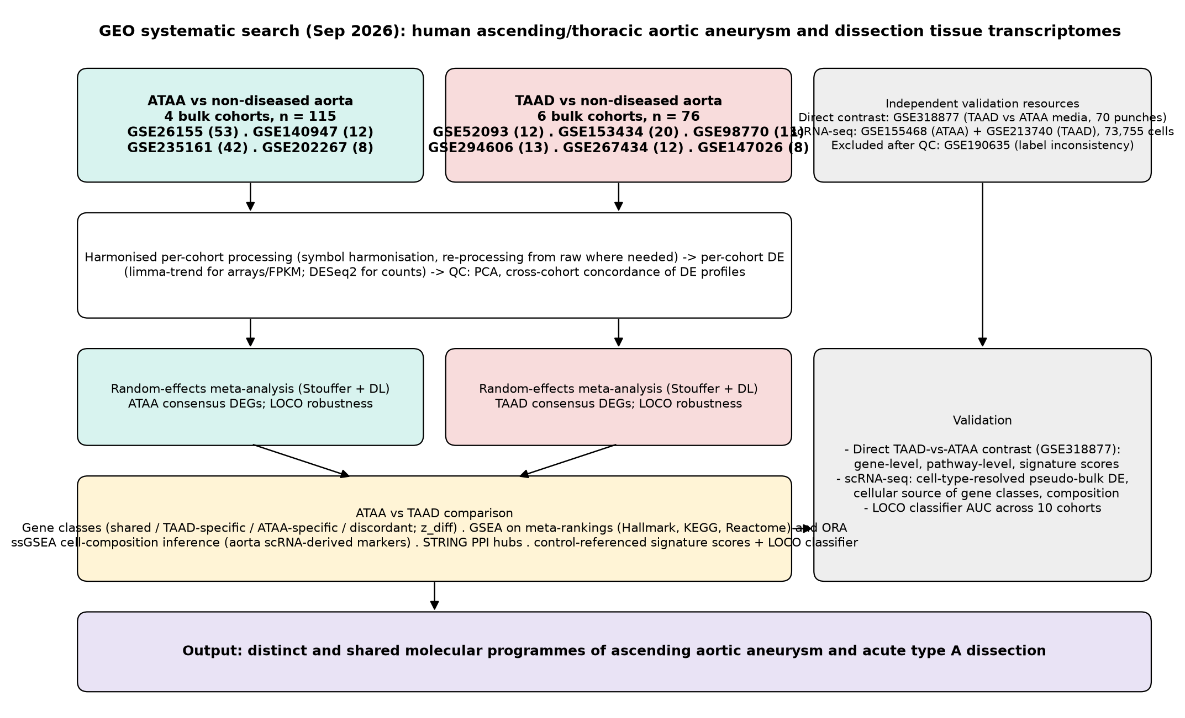
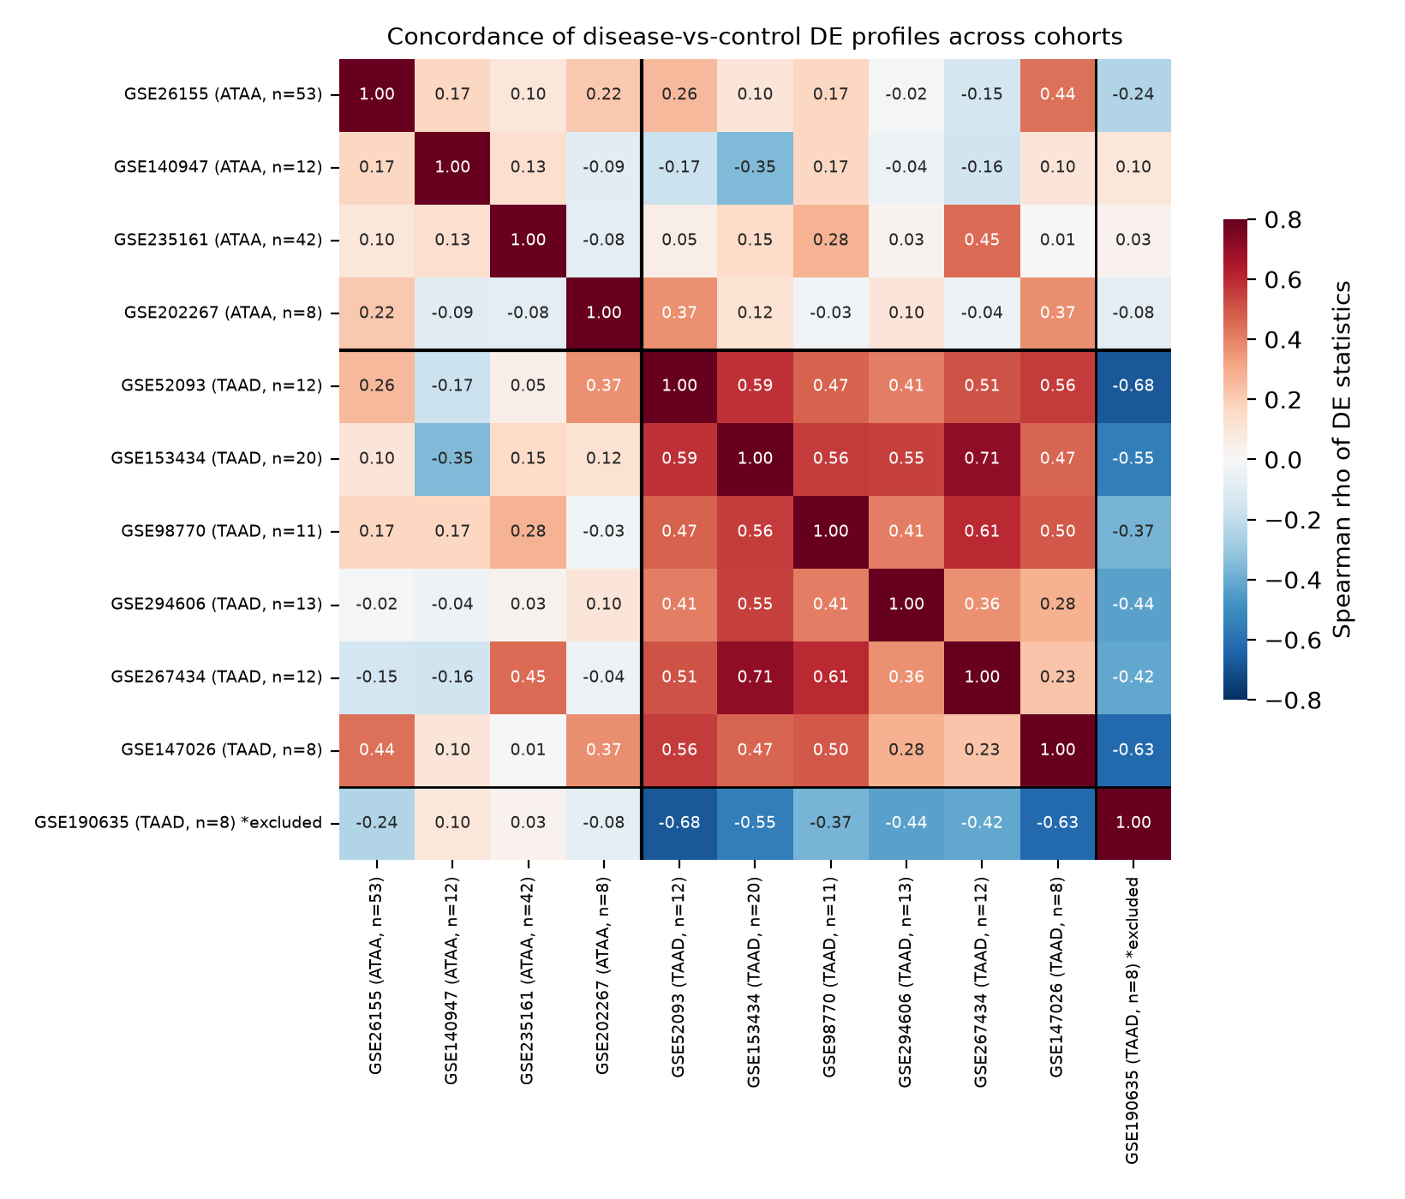
Fig. 1 Study design and cohort concordance. a Overview of data sources, processing, meta-analysis, comparison and validation steps. b Pairwise Spearman correlation of moderated differential-expression statistics between cohorts over genes significant (FDR < 0.05) in either cohort; TAAD cohorts are mutually concordant whereas ATAA cohorts are not, and GSE190635 is anti-correlated with all other TAAD cohorts (excluded).
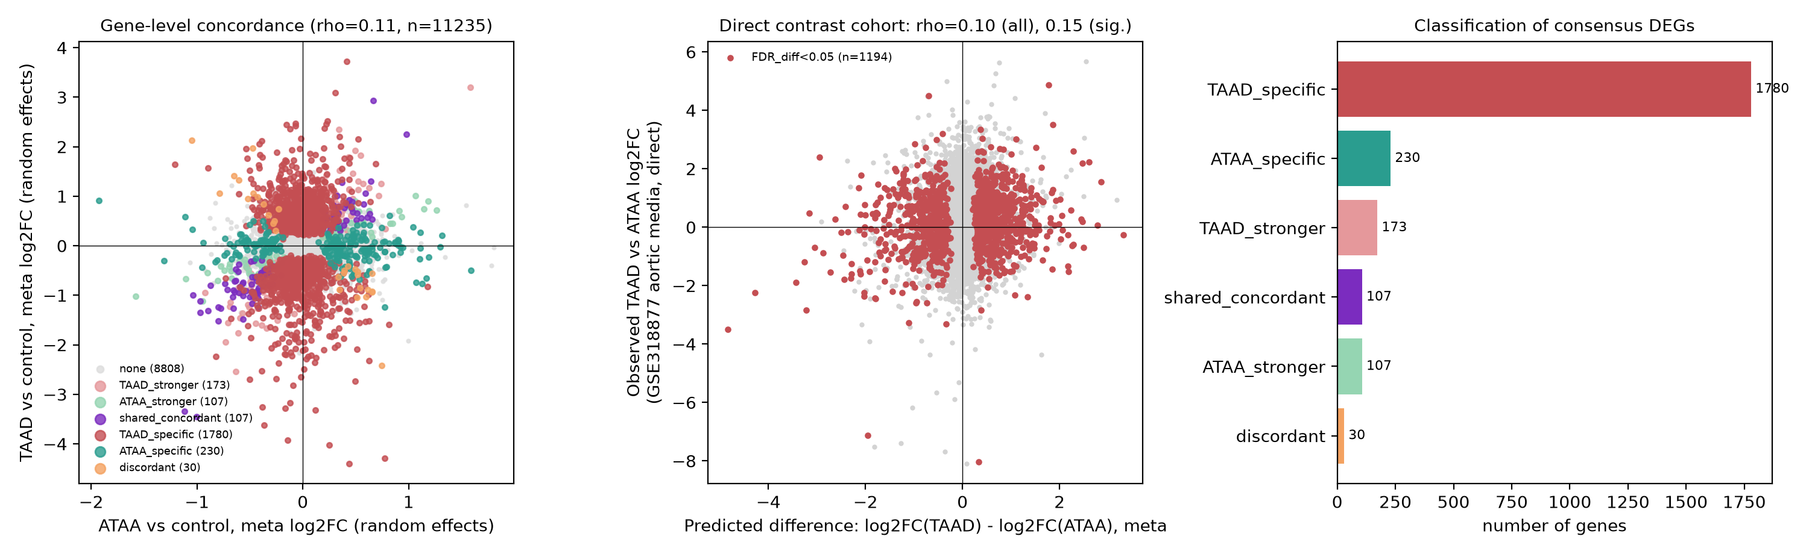
Fig. 2 Gene-level comparison of ATAA and TAAD. a Random-effects meta-analytic log2 fold changes (disease versus non-diseased aorta) for 11,235 genes quantified in both diseases, coloured by gene class. b Predicted between-disease difference (log2FC_TAAD − log2FC_ATAA) versus the observed log2 fold change of dissected versus dilated media in the independent direct-contrast cohort GSE318877; red, genes with FDR_diff < 0.05. c Number of consensus DEGs in each class.
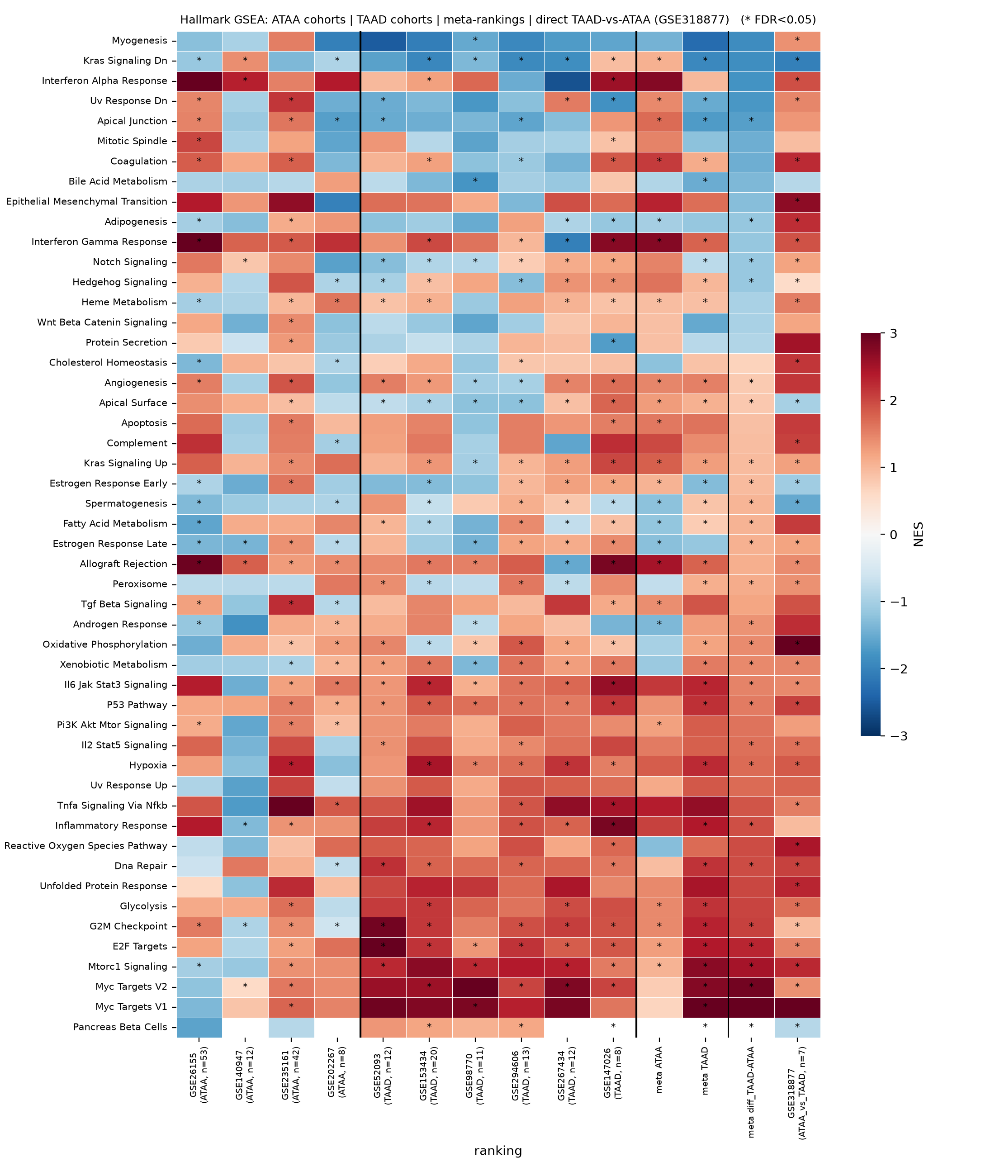
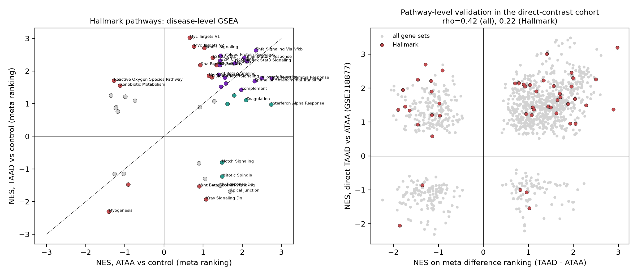
Fig. 3 Pathway-level comparison. a Hallmark GSEA normalised enrichment scores (NES) for each cohort, for the ATAA and TAAD meta-rankings, for the difference ranking (TAAD − ATAA) and for the direct contrast (GSE318877); asterisks, FDR < 0.05; rows ordered by the difference NES. b Left: disease-level Hallmark NES for ATAA versus TAAD; right: NES of the meta-derived difference ranking versus NES of the direct dissection-versus-dilatation contrast across all Hallmark, KEGG and Reactome sets (ρ = 0.42).
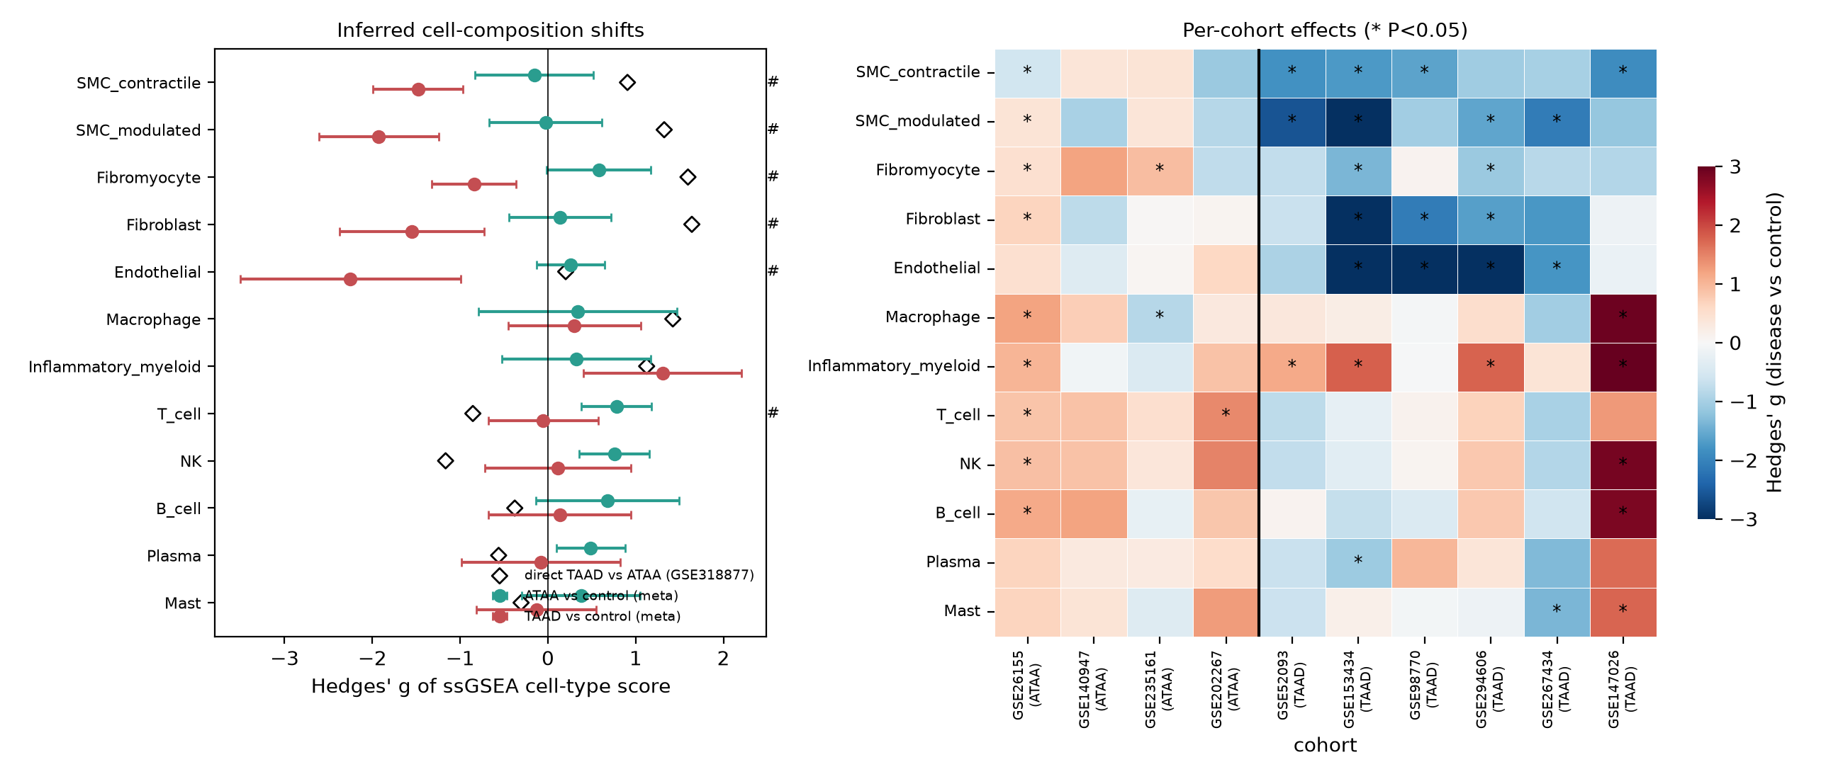
Fig. 4 Inferred cell composition. a Pooled Hedges' g (± 95 % CI) of ssGSEA cell-type scores for ATAA (green) and TAAD (red) versus controls, with the direct dissection-versus-dilatation effect (diamonds); #, P_diff < 0.05. b Per-cohort effects; asterisks, Mann–Whitney P < 0.05.
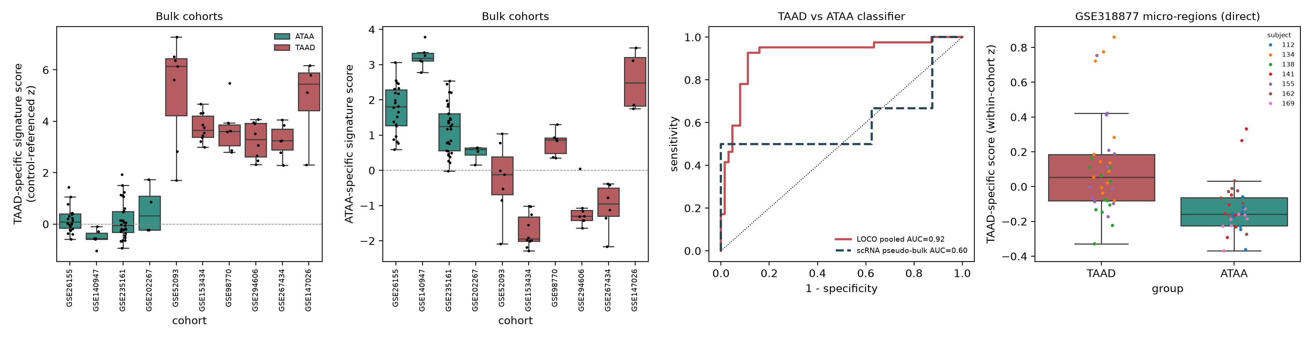
Fig. 5 Control-referenced signature scores and leave-one-cohort-out classification. a, b TAAD-specific and ATAA-specific scores of disease samples expressed relative to each cohort's controls. c Receiver-operating-characteristic curves of the LOCO elastic-net classifier (pooled held-out predictions) and of its application to scRNA-seq pseudo-bulk profiles. d TAAD-specific score in medial micro-regions of dissected and dilated aortas (GSE318877), coloured by subject.
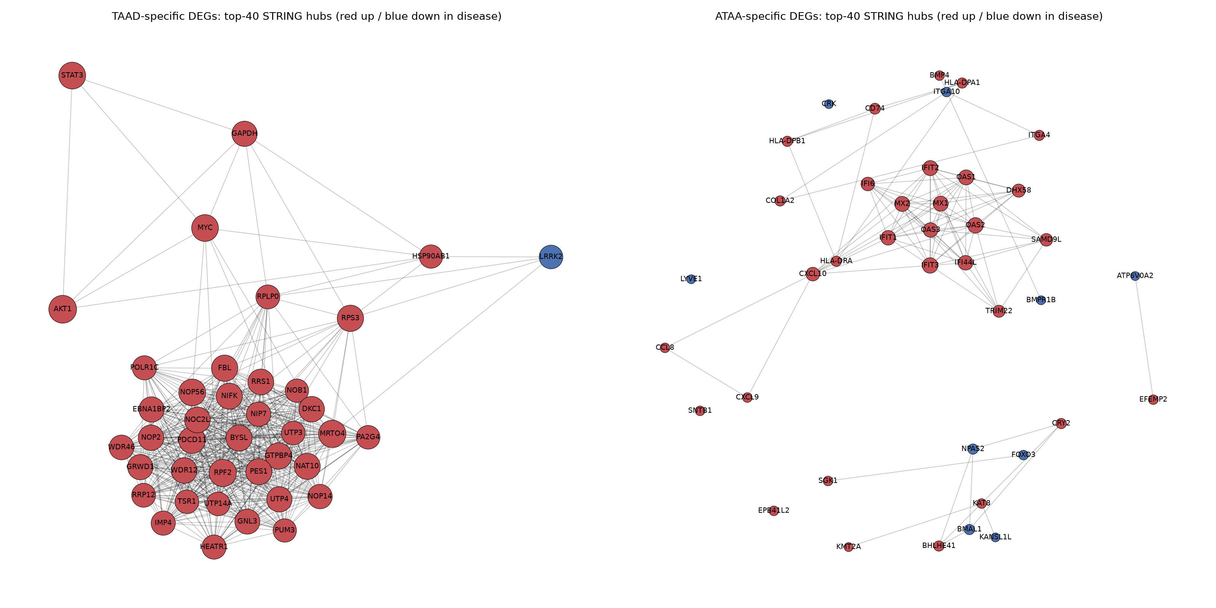
Fig. 6 STRING interaction networks of the top-40 hubs among a TAAD-specific and b ATAA-specific genes (red, up-regulated; blue, down-regulated in the respective disease; node size proportional to degree).
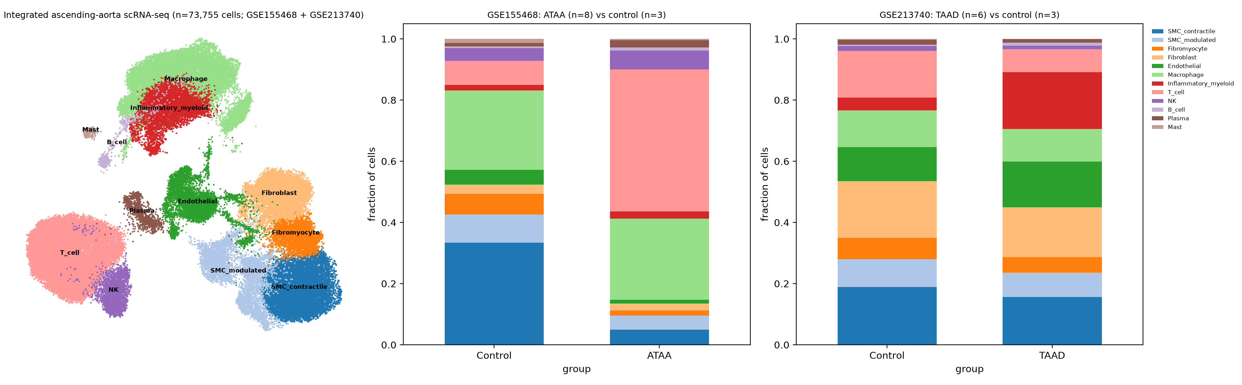
Fig. 7 Integrated single-cell atlas of the human ascending aorta. a UMAP of 73,755 cells from GSE155468 and GSE213740 after Harmony integration. b, c Mean cell-type proportions per group in each dataset.
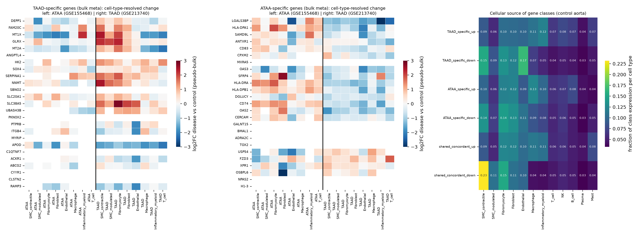
Fig. 8 Cell-type-resolved validation. a, b Pseudo-bulk log2 fold changes (disease versus control) per cell type in GSE155468 (ATAA) and GSE213740 (TAAD) for the top TAAD-specific and ATAA-specific genes. c Fraction of each gene class's expression attributable to each cell type in control aorta.

Tables
Table 1 Cohorts included in the study (see manuscript/Table1_cohorts.csv).
Accession | Disease | Design | Platform | Cases | Controls | DE method | DEGs FDR05 | Role
GSE26155 | ATAA | Ascending aorta intima-media; dilated (>45 mm) vs non-dilated (<40 mm) TAV patients | Affymetrix Human Exon 1.0 ST | ATAA=22 | 31 | limma-trend | 1966 | ATAA meta-analysis
GSE140947 | ATAA | Ascending aortic media (aneurysm neck + belly per patient) vs organ-donor media | RNA-seq (NextSeq 500) | ATAA=6 | 6 | DESeq2 | 1186 | ATAA meta-analysis
GSE235161 | ATAA | Thoracic aortic aneurysm tissue (surgical) vs non-aneurysmal aorta (CABG/donor) | RNA-seq (FPKM) | ATAA=31 | 11 | limma-trend | 7 | ATAA meta-analysis
GSE202267 | ATAA | Thoracic aortic aneurysm vs non-aneurysmal aorta (surgical controls) | RNA-seq (counts) | ATAA=4 | 4 | DESeq2 | 81 | ATAA meta-analysis
GSE52093 | TAAD | Acute Stanford type A dissection, ascending aorta vs normal ascending aorta | Illumina HumanHT-12 V4 | TAAD=7 | 5 | limma-trend | 1928 | TAAD meta-analysis
GSE153434 | TAAD | Acute type A dissection ascending aorta vs normal (heart-transplant donors) | RNA-seq (HiSeq X Ten) | TAAD=10 | 10 | DESeq2 | 3097 | TAAD meta-analysis
GSE98770 | TAAD | Acute type A dissection intima-media vs transplant-donor ascending aorta | Agilent SurePrint G3 8x60K | TAAD=6 | 5 | limma-trend | 1323 | TAAD meta-analysis
GSE294606 | TAAD | Aortic dissection tissue vs control aorta | RNA-seq (counts) | TAAD=8 | 5 | DESeq2 | 1408 | TAAD meta-analysis
GSE267434 | TAAD | Dissected ascending aorta vs normal ascending aorta | RNA-seq (FPKM) | TAAD=6 | 6 | limma-trend | 1051 | TAAD meta-analysis
GSE147026 | TAAD | Acute dissection aortic media vs control media | RNA-seq | TAAD=4 | 4 | limma-trend | 1161 | TAAD meta-analysis
GSE190635 | TAAD | Aortic dissection vs healthy control aorta (excluded: label inconsistency) | Affymetrix HG-U133 Plus 2.0 | TAAD=4 | 4 | limma-trend | 0 | excluded (QC)
GSE318877 | ATAA_vs_TAAD | Micro-regional (100 um) punches of ascending aortic media; dissection (3 pts) vs dilatation (4 pts); 70 punches | Micro-regional RNA-seq | TAAD=3 subjects (34 punches) | ATAA=4 subjects (36 punches) | DESeq2 | 486 | direct TAAD-vs-ATAA contrast
GSE155468 | ATAA | scRNA-seq of ascending aorta: 8 ATAA vs 3 controls | 10x Genomics | ATAA=8 | 3 | pseudo-bulk limma | - | single-cell validation
GSE213740 | TAAD | scRNA-seq of ascending aortic wall: 6 sporadic type A dissection vs 3 donors | 10x Genomics | TAAD=6 | 3 | pseudo-bulk limma | - | single-cell validation

Additional files
Additional file 1: GEO search strategy and screening. Additional file 2: Analysis code (scripts/). Additional file 3: Per-cohort QC (PCA, volcano plots) and differential-expression tables. Additional file 4: Single-cell atlas annotation, marker sets and ssGSEA validation. Additional file 5: Meta-analysis tables and LOCO robustness. Additional file 6: ATAA-versus-TAAD gene classification with direct-contrast validation. Additional file 7: GSEA results (per cohort and meta-rankings) and pathway classification. Additional file 8: Over-representation analysis of gene classes. Additional file 9: STRING networks and hub statistics. Additional file 10: Signature scores and LOCO classifier results.

