Problem 13)

a)
P(D | S1, S2, S3) = P(D) * P(S1|D) * P(S2|D) * P(S3|D) / (P(S1) * P(S2) * P(S3))

b)
P(D | S1, S2, S3) = P(D) * P(S1, S2) * P(S3 | S1, S2) / P(S1, S2, S3)

c)
The probabilities in part b, specifically the one that defines S3 based on S1 and S2,
are different because the Symptoms are not reliant on each other to some extent. By
this I mean the symptoms are no longer conditionally independent.

Naive Bayes assumes that the variables are not at all related, this is generally not
true in real life.

d)
Is A|D,B d-separable from C|D,B? Give reasons for your answer!

d is d-seperable

the path from A to C with respect to D and B is blocked at the verticie D because
A->D->E is a head to tail relationship and D is in the set of nodes we are
separating with respect to

the path from C to A is blocked with respect to B and D because C->E->D is a
head to head and E is not in our set of nodes we are seperating with repect to.

Is A,E| d-separable from C|? Give reasons for your answer! :=”no evidence”

A,E -> C will not be d-seperable if there is any head to head relationship
between vertexes along the way, since there is no evidence for nodes of us to
take the d separation with respect to.

A,E and C are indeed d-seperable
Problem 14)

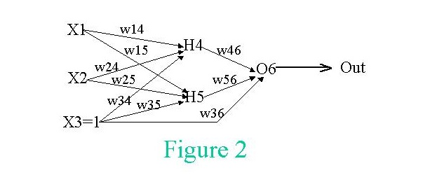

Proof showing that g’(x) = g(x) * (1 – g(x))

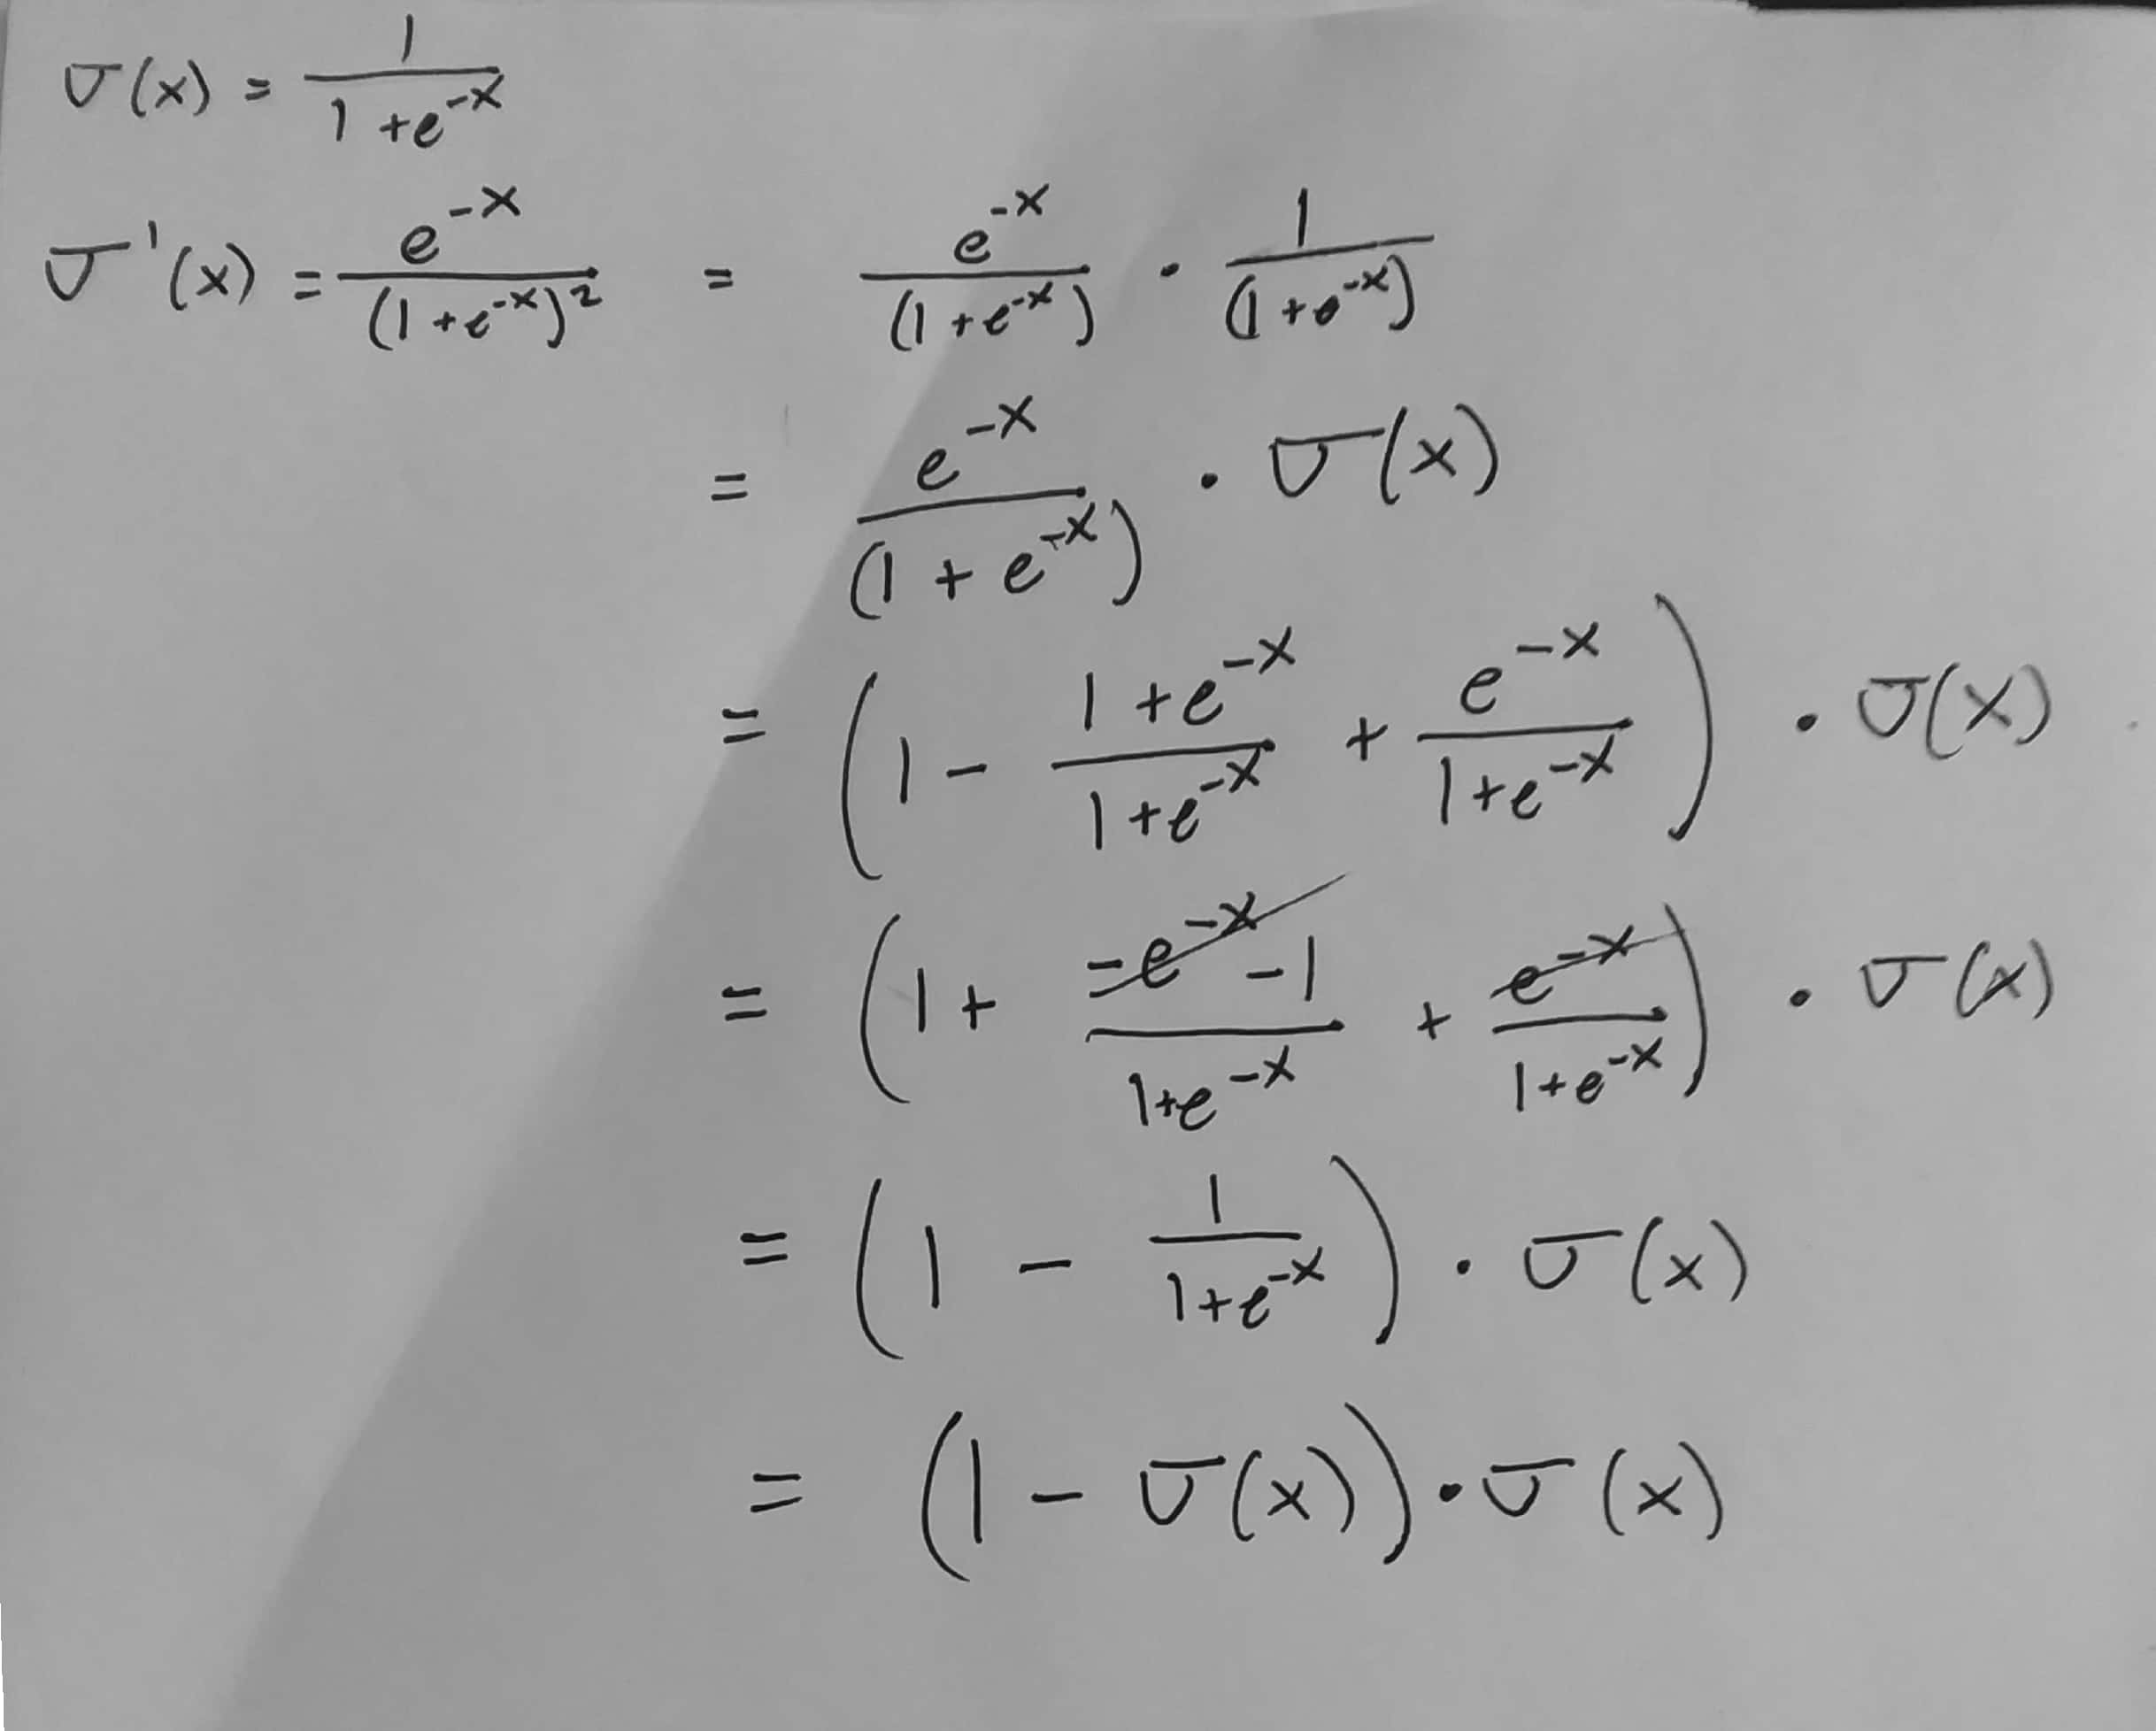
Variables that Will Be Used

Weights, activation values of X, Weights applied to activation values of X, Activation Levels of H, weights applied to activation levels of H, final answer O6.
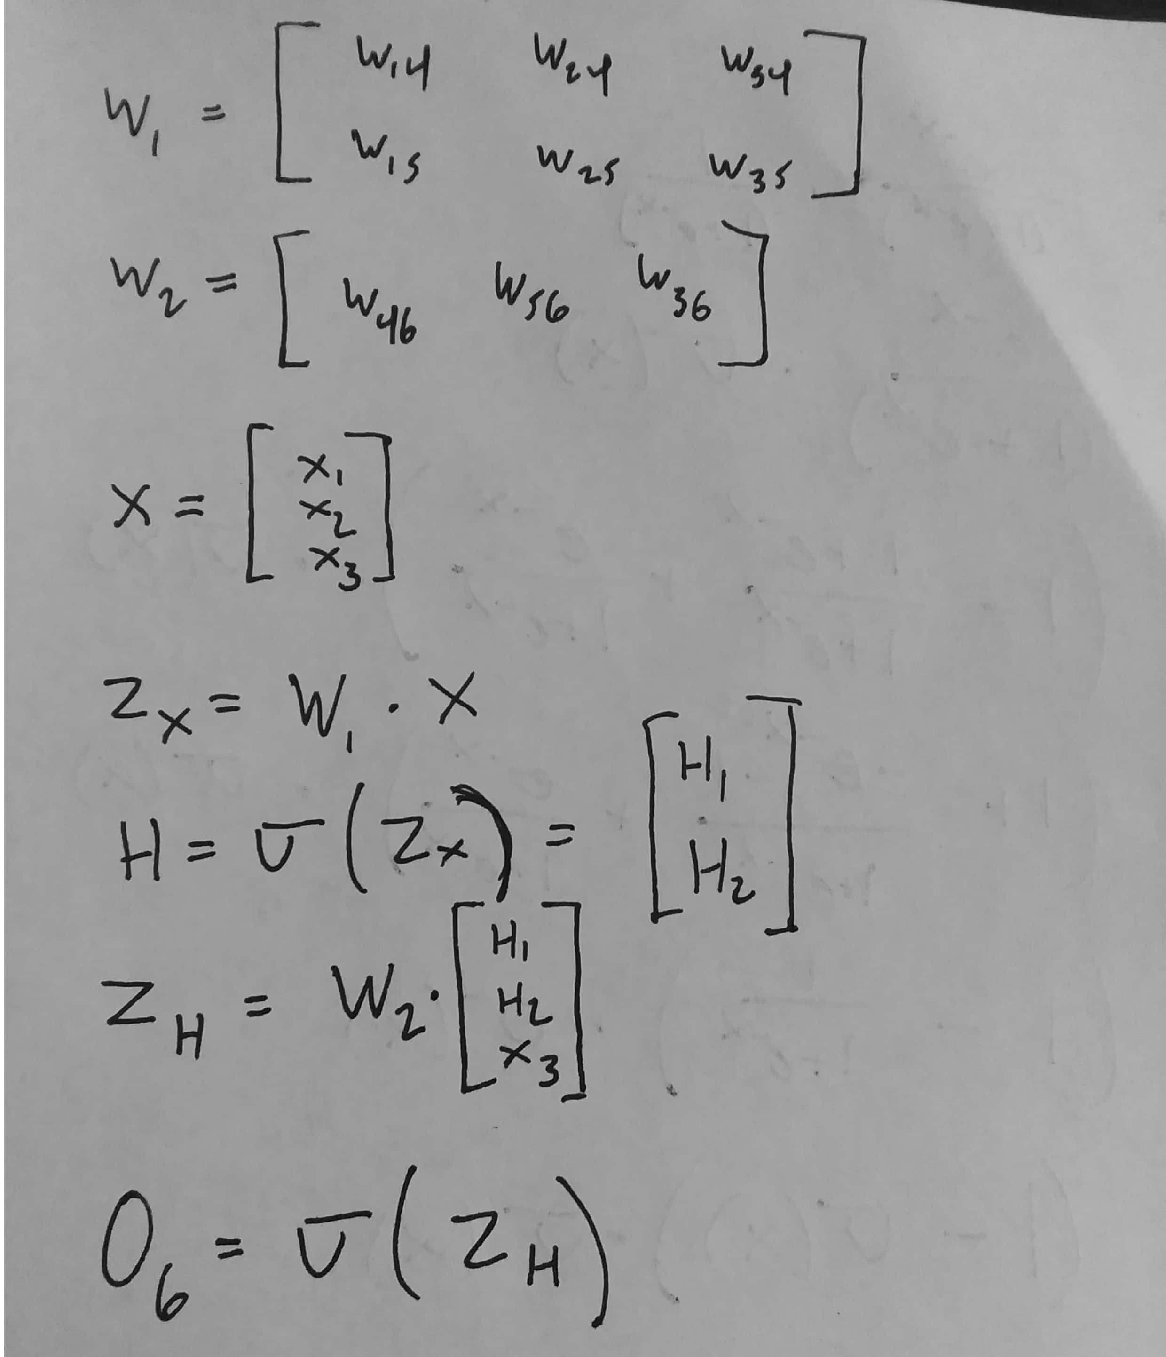

Derivation of the values that the weights of the outer nodes (those weights connecting H to O6) should be shifted by.

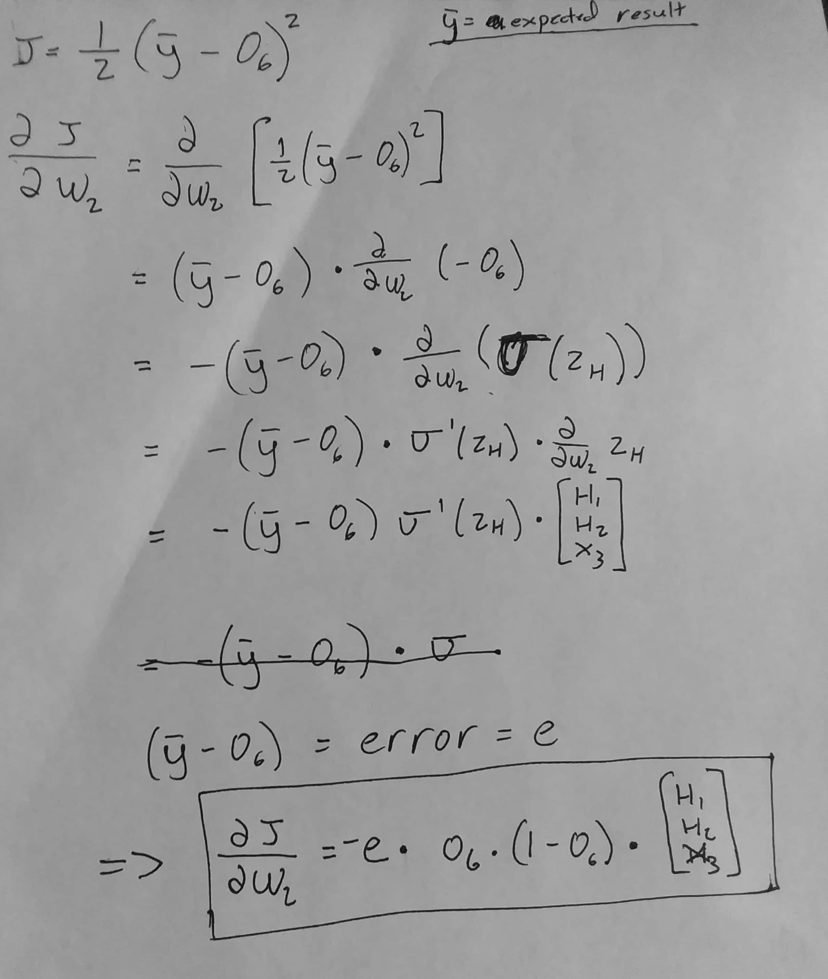

Derivation of the values that the inner weights, those connecting X to H should be shifted by.
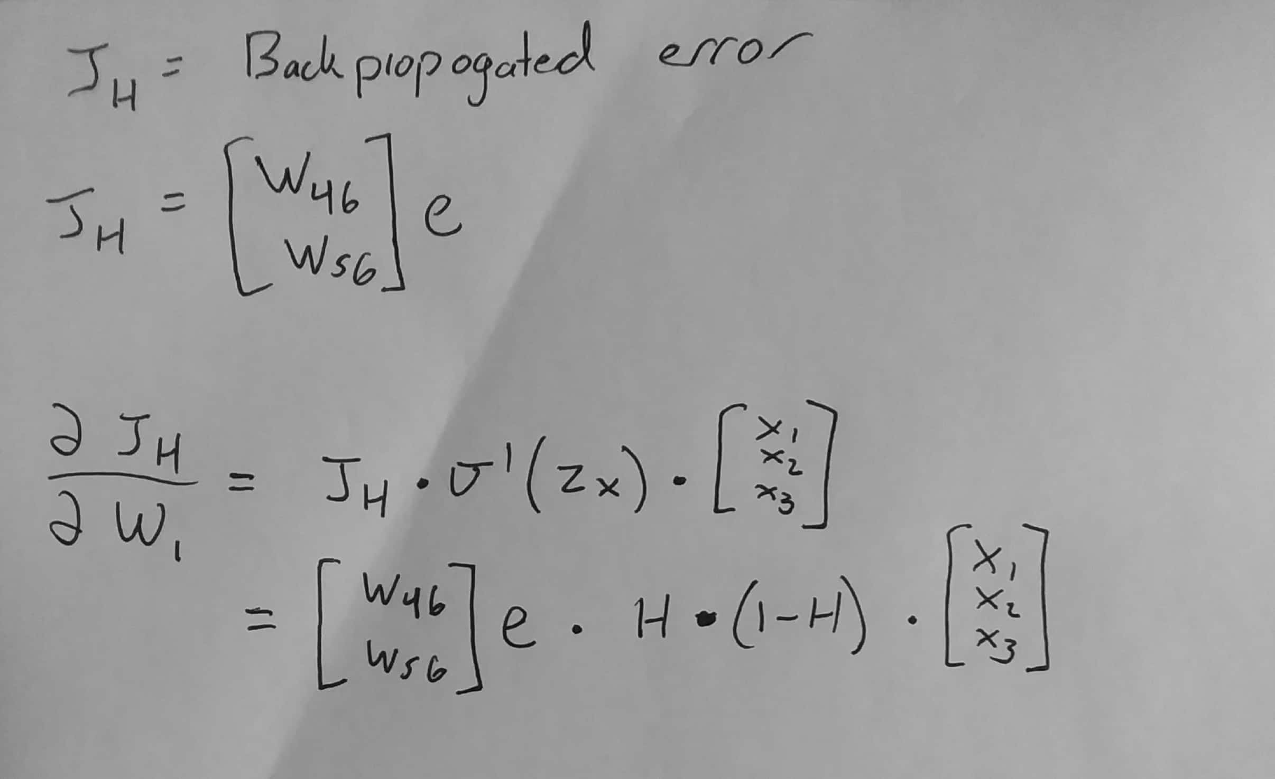

Calculations:
ROUND 1
((1, 1, 1), 1)
H4:
g(w14 * x1 + w24 * x2 + w34 * x3) = 0.6456563062257954
H5:
g(w15 * x1 + w25 * x2 + w35 * x3) = 0.6456563062257954
O6:
g(w46 * h4 + w56 * h5 + w36 * x3) = 0.7587166294411014
Error: 0.2412833705588986

w46 = OldWeight - LEARN_RATE * error * (O6 * (1 - O6) * H4
= 0.5 - 0.5 * 0.2412833705588986 * (0.7587166294411014 * (1 - 0.7587166294411014)) * 0.6456563062257954
= 0.4857404511098188
w56 = OldWeight - LEARN_RATE * error * (O6 * (1 - O6) * H5
= 0.5 - 0.5 * 0.2412833705588986 * (0.7587166294411014 * (1 - 0.7587166294411014)) * 0.6456563062257954
= 0.4857404511098188
w36 = OldWeight - LEARN_RATE * error * (O6 * (1 - O6) * X3
= 0.5 - 0.5 * 0.2412833705588986 * (0.7587166294411014 * (1 - 0.7587166294411014)) * 1
= 0.4779146447534357

w14 = OldWeight - LEARN_RATE * error * (H4 * (1 - H4) * X1
= 0.2 - 0.5 * 0.048256674111779724 * (0.6456563062257954 * (1 - 0.6456563062257954)) * 1
= 0.19447981673318604
w24 = OldWeight - LEARN_RATE * error * (H4 * (1 - H4) * X2
= 0.2 - 0.5 * 0.048256674111779724 * (0.6456563062257954 * (1 - 0.6456563062257954)) * 1
= 0.19447981673318604
w34 = OldWeight - LEARN_RATE * error * (H4 * (1 - H4) * X3
= 0.2 - 0.5 * 0.048256674111779724 * (0.6456563062257954 * (1 - 0.6456563062257954)) * 1
= 0.19447981673318604

w15 = OldWeight - LEARN_RATE * error * (H5 * (1 - H5) * X1
= 0.2 - 0.5 * 0.048256674111779724 * (0.6456563062257954 * (1 - 0.6456563062257954)) * 1
= 0.19447981673318604
w25 = OldWeight - LEARN_RATE * error * (H5 * (1 - H5) * X2
= 0.2 - 0.5 * 0.048256674111779724 * (0.6456563062257954 * (1 - 0.6456563062257954)) * 1
= 0.19447981673318604
w35 = OldWeight - LEARN_RATE * error * (H5 * (1 - H5) * X3
= 0.2 - 0.5 * 0.048256674111779724 * (0.6456563062257954 * (1 - 0.6456563062257954)) * 1
= 0.19447981673318604

weights:
w14 = 0.19447981673318604, w24 = 0.19447981673318604, w34 = 0.19447981673318604, w15 = 0.19447981673318604, w25 = 0.19447981673318604, w35 = 0.19447981673318604, w46 = 0.4779146447534357, w56 = 0.4857404511098188, w36 = 0.4857404511098188

ROUND 2
((0, 0, 1), 0)
H4:
g(w14 * x1 + w24 * x2 + w34 * x3) = 0.5484672879682142
H5:
g(w15 * x1 + w25 * x2 + w35 * x3) = 0.5484672879682142
O6:
g(w46 * h4 + w56 * h5 + w36 * x3) = 0.7338556952515334
Error: -0.7338556952515334

w46 = OldWeight - LEARN_RATE * error * (O6 * (1 - O6) * H4
= 0.4779146447534357 - 0.5 * -0.7338556952515334 * (0.7338556952515334 * (1 - 0.7338556952515334)) * 0.5484672879682142
= 0.5172206809440036
w56 = OldWeight - LEARN_RATE * error * (O6 * (1 - O6) * H5
= 0.4857404511098188 - 0.5 * -0.7338556952515334 * (0.7338556952515334 * (1 - 0.7338556952515334)) * 0.5484672879682142
= 0.5250464873003867
w36 = OldWeight - LEARN_RATE * error * (O6 * (1 - O6) * X3
= 0.4857404511098188 - 0.5 * -0.7338556952515334 * (0.7338556952515334 * (1 - 0.7338556952515334)) * 1
= 0.557405684484404

w14 = OldWeight - LEARN_RATE * error * (H4 * (1 - H4) * X1
= 0.19447981673318604 - 0.5 * -0.14272012112112303 * (0.5484672879682142 * (1 - 0.5484672879682142)) * 0
= 0.19447981673318604
w24 = OldWeight - LEARN_RATE * error * (H4 * (1 - H4) * X2
= 0.19447981673318604 - 0.5 * -0.14272012112112303 * (0.5484672879682142 * (1 - 0.5484672879682142)) * 0
= 0.19447981673318604
w34 = OldWeight - LEARN_RATE * error * (H4 * (1 - H4) * X3
= 0.19447981673318604 - 0.5 * -0.14272012112112303 * (0.5484672879682142 * (1 - 0.5484672879682142)) * 1
= 0.2121522015247713

w15 = OldWeight - LEARN_RATE * error * (H5 * (1 - H5) * X1
= 0.19447981673318604 - 0.5 * -0.14272012112112303 * (0.5484672879682142 * (1 - 0.5484672879682142)) * 0
= 0.19447981673318604
w25 = OldWeight - LEARN_RATE * error * (H5 * (1 - H5) * X2
= 0.19447981673318604 - 0.5 * -0.14272012112112303 * (0.5484672879682142 * (1 - 0.5484672879682142)) * 0
= 0.19447981673318604
w35 = OldWeight - LEARN_RATE * error * (H5 * (1 - H5) * X3
= 0.19447981673318604 - 0.5 * -0.14272012112112303 * (0.5484672879682142 * (1 - 0.5484672879682142)) * 1
= 0.2121522015247713

weights:
w14 = 0.19447981673318604, w24 = 0.19447981673318604, w34 = 0.19447981673318604, w15 = 0.19447981673318604, w25 = 0.2121522015247713, w35 = 0.2121522015247713, w46 = 0.557405684484404, w56 = 0.5172206809440036, w36 = 0.5250464873003867

S# | X1 | X2 | X3 | O6 | Des-O6 | Error | w14 | w15 | w24 | w25 | w34 | w35 | w36 | w46 | w56
0 |  |  |  |  |  |  | 0.2 | 0.2 | 0.2 | 0.2 | 0.2 | 0.2 | 0.5 | 0.5 | 0.5
1 | 1 | 1 | 1 | 0.758 | 1 | 0.24 | 0.194 | 0.194 | 0.194 | 0.194 | 0.194 | 0.194 | 0.486 | 0.486 | 0.486
2 | 0 | 0 | 1 | 0.733 | 0 | -0.73 | 0.194 | 0.194 | 0.194 | 0.212 | 0.194 | 0.212 | 0.525 | 0.557 | 0.517

