1. List all the nine control signal from the control unit with description having a six bit opcode i.e. six input signals to the control unit.

* Instruction Type
  + R-Format
    - 000000
  + lw
    - 100011
  + sw
    - 101011
  + beq
    - 000100
* Outputs
  + Reg Dst
  + ALU Src
  + Mem To Reg
  + Reg Write
  + Mem Read
  + Mem Write
  + Branch
  + ALU Op 1
  + ALU Op 2

1. 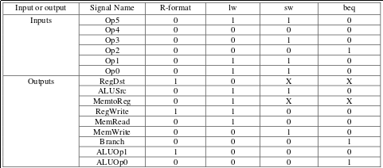Draw the truth table of control unit.
2. How are the control lines extended in the control unit to include the jump/branch instructions.

There is an additional mux that allows selection between an address given in the instruction and the ouput of the PC+4 or PC+4+ALUOUTPUT

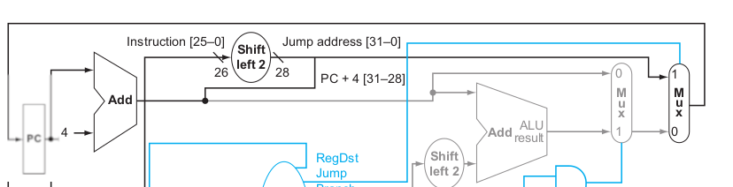

1. How is the program counter incremented for jump/branch as well as other instructions?

There is a mux that selects between just incrementing the PC by 4 or by incrementing it by 4 and adding in the output from the ALU.

