- Compare VHDL and Verilog in terms of design reusability.
  - VHDL
    - Procedures and functions that are created can be put into a ‘package’ that can be used in future designs
  - Verilog
    - There is no concept of packages in verilog. To include functions anf procedures from another place they must be put into another file and included using the ‘include’ compiler directive.

- Write a VHDL code to implement a basic 4:1Multiplexer. 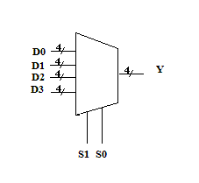

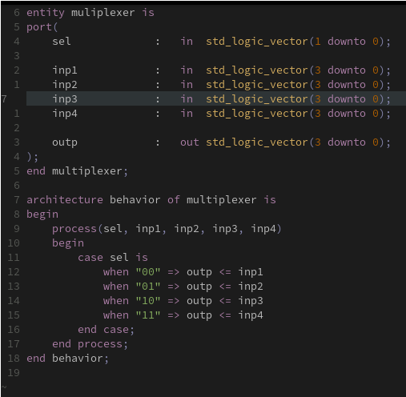
- Write the entity of full adder, diagram shown below 