

University of Houston
College of Technology
Computer Engineering Technology and Electrical Power Technology

Sophomore Laboratory
ELET 2103
Digital Circuits and Systems Laboratory

Experiment 4
Flip-Flops and Related Devices

© 2016– University of Houston, College of Technology ELET Labs
Table of contents
1 Purpose 4
2 Objectives 4
3 Equipment, Components and Simulation Software 4
4 Pre-Lab 5
4.1 Flip Flops and Related Devices 5
4.1.1 Primitive Flip-Flop: NAND Gate Latch 5
4.1.2 Clock Signals and Clocked Flip-Flops 6
4.1.3 Schmitt Trigger 13
4.2 Sequential Circuits 17
4.2.1 Examples 18
4.3 Simulation 25
4.3.1 Simulation 1: Generating Non-Overlapping Clock Pulses 25
4.3.2 Simulation 2: Astable Multivibrator using 555 Timer IC 26
4.3.3 Simulation 3: Triggering One-Shot using 555 Timer IC 28
5 Procedures 31
5.1 Procedure 1: Generating Non-Overlapping Clock Pulses 31
5.2 Procedure 2 – Astable Multivibrator using 555 Timer IC 32
5.3 Procedure 3 – Triggering One-Shot using 555 Timer IC 32
6 Application 33
6.1 Logic Sequencer 33
7 Knowledge Evaluation 34
8 References 35
9 Datasheets 36
9.1 LM 555 Timer IC 36
9.2 74LS112 Dual Negative Edge Triggered JK FF 40
9.3 74LS75 Quad Latch 43
9.4 SN74121N Monostable Multivibrators 46

Purpose
This experiment is on various flip-flops, special devices such as one-shot and clock generators and their simple applications. The basic flip-flops are used in the design of sequential circuits and this experiment provides you with some introductory concepts. The future experiments will explore sequential circuits in detail.

Objectives
At the end of this experiment you will know:
- How to construct and analyze the operation of latches and various types of flip-flops.
- The difference between synchronous and asynchronous systems.
- How to draw the output timing waveforms of several types of flip-flops in response to a set of input signals.
- How to convert analog signals into logic-compatible signals using Schmitt trigger devices.
- How flip-flops and related devices are used in simple applications.

Equipment, Components and Simulation Software
For this experiment, the student will need the following:
- Analog/Digital Trainer Board
- Cathode Ray Oscilloscope
- IC’s: NE555, 74LS08, 74LS75, 74LS112 and SN74121N.
- Resistors: 10 KΩ, 4.7 KΩ and 27 KΩ.
- Capacitors: 0.01 µF, 10 µF, 100µF.
- Multisim

Pre-Lab

Flip Flops and Related Devices

Primitive Flip-Flop: NAND Gate Latch
NAND gate latch has two NAND gates that are cross-coupled so that the output of NAND-1 is connected to one of the inputs of NAND-2, and vice-versa. The gate outputs labeled Q and Q are the latch outputs. Under normal operating conditions, the outputs will always be the inverse of each other. There are two latch inputs: the SET input is the input that sets Q to the logic 1 state; the clear input clears Q to the logic 0 state. The operation of the NAND latch is summarized in the truth table given in Figure 1.
Inputs | Output
Set Clear | Q
1 1  0 1  1 0  0 0 | No change  Q = 1  Q = 0  Invalid

Figure 1. Truth table and logic circuit for a NAND latch.
The simple latch is rarely used in logic circuit design but understanding of its operation is very important. A more complicated version, the clocked flip-flop, is much easier to work with. Note that a single flip-flop has a capability to store 1-bit of logical state. In other words, it has 1-bit of memory. Some early RAM (Random Access Memory) devices used flip-flops in their constructions.

Clock Signals and Clocked Flip-Flops

Clock Signals
Digital systems can operate either synchronously or asynchronously. In synchronous systems, the outputs can change state only when a clock (CLK) makes a transition. When the clock changes from 0 to 1, it is known as positive-going transition (PGT); when the clock goes from 1 to 0, it is known as negative-going transition (NGT). In asynchronous systems, the outputs of logic circuits can change state every time one or more of the inputs changes, independent of the clock signals.
Most digital systems are synchronous in principle, since synchronous circuits are easier to design and troubleshoot. Figure 2 shows the two general configurations of clocked flip-flops. Note the difference between the clock inputs and designated symbols. The number of control inputs varies depending on the type of the FF.

Figure 2. Clocked flip-flops

Clocked D Flip-Flop
The D flip-flop, shown in Figure 3, has only one synchronous control input D, which stands for data, the other inputs (i.e. clock, preset and clear) are generally asynchronous. The operation of the D flip-flop is very simple; Q will go to the same state as D input upon the application of the clock pulse.
A positive-edge triggered D flip-flop’s Q output will follow the value of D when a PGT occurs at the CLK. Note that the output Q can only change when a PGT occurs. The D input can change between clock pulses but only affects the state of the FF upon the PGT of the clock. A negative-edge triggered D flip-flop operates in the same way; however, Q will follow the value of D when a NGT clock occurs. D-type FF is normally used for temporary data storage.
The symbol and characteristic table, also referred to as truth table, for a positive-edge-triggered D flip-flop are shown in Figure 4. The up-arrow in the table indicates PGT. Typical IC for D-type flip-flop includes 74LS74 and 74LS75. Each IC manufacturer uses different convention and provides the full description of the FF operation. Make sure to study specific data sheets when selecting any IC devices.

Inputs | Output
D CLK | Q
0  1  0 inactive  1 inactive | 0  1  unchanged  unchanged
Figure 3. D flip flop that triggers only on a PGT and its truth table.
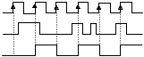
1
0
D
Q
1
0
1
0
CLK
Figure 4. Timing waveforms of a D-Flip flop that responds only to positive-going edge of the clock pulse.

Clocked S-C Flip-Flop
The S-C flip-flop has two synchronous control inputs S (Set) and C (Clear). Figure 5 shows a positive-edge-triggered S-C flip-flop and its characteristic table. The table in Figure 5 defines how the flip-flop output will respond to the PGT at the CLK input for the various combinations of S and C inputs. This truth table uses some new parameters: The up-arrow (↑) indicates that a PGT is required at CLK; the label Q₀ indicates the state prior to the PGT.

Inputs | Output
S C CLK | Q
0 0  0 1  1 0  1 1 | Q₀  0  1  Ambiguous
Figure 5. Clocked S-C flip flop that triggers only on a Positive edge of clock and its truth table.
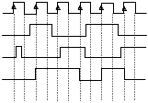
0
1
0
1
0
1
0
CLK
S
C
Q
1
Figure 6. Timing waveforms of clocked S-C flip-flop that responds to PGT of the clock.

Clocked J-K Flip-Flop
The J-K flip-flop has two synchronous control inputs J and K. Figure 7 shows a negative-edge-triggered J-K flip-flop and its characteristic table. The J and K inputs control the state of the flip-flop in the same way as S and C inputs do for the clocked S-C flip-flop except for one major difference: the J = K = 1 condition does not result in an ambiguous output. For this condition, the output Q will always go to its opposite state (frequently called toggling mode) upon the negative transition of the clock. J-K flip-flops are more popular than other types of flip-flops because of the absent of the ambiguous state and its ability to be wired as a D-type flip-flop. The toggling effect (when J=K=1) is very important in applications such as: for all kinds of counter circuits, sequencing control circuits, etc. Typical ICs used for J-K flip-flop are 74LS76, 74LS78, 74LS107, 74LS109 and 74LS112.

Inputs | Output | Description
J K CLK | Q
0 0  0 1  1 0  1 1 | Q₀  0  1  Q₀ | No change in state of Q  Q forced to 0 state  Q forced to 1 state  Toggle mode
Figure 7. Clocked J-K flip flop and its truth table.
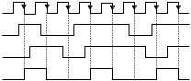
0
1
0
1
0
1
0
CLK
J
K
Q
1
Figure 8. Timing waveforms of clocked J-K flip flop.

Flip-Flops with Asynchronous Inputs
For all the FF’s we have been studying earlier, the S, C, J, K and D inputs have been referred to as control inputs. These inputs are also called synchronous inputs since their effect on the FF output is synchronized with the clock. Most clocked FF’s also have one or more asynchronous inputs which operate independently of the synchronous inputs and clock input. These asynchronous inputs can be used to set or clear the FF at any time, regardless of the conditions at the other inputs. Figure 9 shows a clocked J-K FF with asynchronous inputs and the truth table that summarizes how the asynchronous inputs affect the FF output for all possible cases.

 |  | FF Response
1  0  1  0 | 1  1  0  0 | Clocked operation  Q = 1  Q = 0  Not used
Figure 9. Clocked J-K FF with asynchronous inputs and its FF response truth table
Figure 10 shows an edge-triggered J-K FF with active-low asynchronous inputs. The J and K inputs are permanently held HIGH. The timing waveforms are shown below in Figure 10 for the Q output response to the input waveforms at CLK, PRESET, and CLEAR. Assume that Q is initially high. For example, the 74LS76 J-K FF provides both asynchronous inputs. Again, different nomenclature is used by different manufacturers.
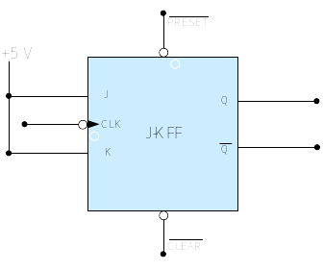

Figure 10. Output waveforms of the clocked FF with asynchronous inputs.

Schmitt Trigger
If a slow changing signal is applied to the input of a logic device, the device will often produce an output signal that oscillates as the input slowly transitions between high and low logic levels. A device that has Schmitt-trigger type input is designed to accept slow-changing signals and produce an output that has oscillation-free transitions. A Schmitt trigger is a wave shaping device used to convert signals in which the voltage is slowly changing (and, therefore, incompatible with logic devices) to a signal that is compatible with the signal transition times of logic devices (such as 0V and 5V).

Figure 11. The waveform produced at the output of the Schmitt trigger inverter
The output will generally have very rapid transition times that are independent of the input signal characteristics. The Schmitt trigger’s output will switch between the two possible logic levels once the input exceeds the positive-going threshold voltage or drops below the negative-going threshold voltage as shown in Figure 11. The 74LS14 IC is a hex inverter chip with Schmitt trigger inputs.

One-Shots or Monostable Multivibrators
A multivibrator is a pulse generator circuit which produces a rectangular-wave output. Multivibrators are classified as astable (also called free-running multivibrator), bistable (also called a flip-flop), or monostable (also called one-shot multivibrator).
A one-shot (OS) is a timing device in which the output is triggering into a quasi-stable state and then returns to its stable state. It remains in this quasi-stable state for a fixed period of time, T_{p}, which is usually controlled by an external resistor and capacitor. OSs are typically used to produce delays in control signals for digital systems. There are two types of OSs available in IC form: retriggerable and non-retriggerable. 74LS121, 74LS122 and 74LS123 are examples of single non-retriggerable, single retriggerable and dual retriggerable OS ICs, respectively.
Figure 12 shows the logic symbol for an OS, and also the typical waveforms for non-retriggerable and retriggerable OSs.
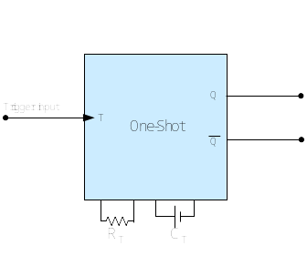

Figure 12. Logic symbol of OS and typical timing waveforms of retriggerable and non-retriggerable operation
For a Non-retriggerable OS, the PGT at points a and c shown in Figure 12 will trigger the OS to its quasi-stable state for a time T_{p}, after which it automatically returns to the stable state. The PGT at points b and d has no effect on the OS because it has already been triggered to the quasi-stable state. The OS must return to the stable state before it can be triggered in the case of non-retriggerable one-shots.
In the case of retriggerable one-shots, the OS can be triggered while it is still in the quasi-stable state by a trigger pulse, and it will begin a new T_{p} interval each time a trigger pulse is applied, regardless of the current state of its Q output. Therefore, the retriggerable OS is first triggered by the PGT at points a and c and is retriggered by the PGT at points b and d respectively to begin a new T_{p} interval.

555 Timer ICs
The 555 Timer is a TTL(Transistor-Transistor-Logic) digital logic circuit that is used in the digital circuits that can operate in several different modes. The 555 IC timer can be used to implement an astable, bistable or monostable multivibrator.
The 555 timer IC is a popular circuit for generating asymmetric rectangular waves. Figure 13 shows how external components can be connected to a 555 timer IC so that it operates as a free running oscillator.

Figure 13. 555 Timer IC used as an astable multivibrator
The output waveform switches between two logic levels. The duty cycle is the proportion of the complete cycle for which the output is high. It is usually given as a percent. The period and duty cycle of the output waveform are determined by the resistors and capacitors connected to the timer. The formulas for the time intervals t₁ and t_{2,} and the overall period of oscillation, T, are given below.
t₁ = 0.693 R_{B}C (Eq. 1)
t₂ = 0.693 (R_{A +} R_{B}) C (Eq. 2)
T = t₁ + t₂ (Eq. 3)
Frequency = 1/T (Eq. 4)
Duty cycle = t₂ /T (Eq. 5)
It is impossible to produce a perfect 50% duty-cycle square wave output. However, it is possible to get very close to a 50% duty cycle by making R_{B} >> R_{A} (while keeping R_{A} greater than 1 KΩ), so that t₁ ≈ t₂.

Sequential Circuits
A sequential circuit is an interconnection of memory elements and combinational circuits. The external outputs of a sequential circuit are functions of both the external inputs and the present state of the memory elements.
Memory elements are devices that can store information. The most important memory element is the flip flop (FF), which is made up of assembly of logic gates. A FF can store one bit of information.
Block diagram of a sequential network is shown in Figure 14.
Memory
Elements
Combinational
Circuit
Next State
Outputs
Present State
External Inputs
Figure 14. Block diagram of sequential circuits
A synchronous sequential circuit employs storage elements called flip-flops (FF) that may change their binary value only at discrete instants of time. Synchronization is achieved by a timing device called a clock pulse generator. The clock pulses from the generator are distributed throughout the system in such a way that flip-flops are affected only by the arrival of the synchronization pulse.

Examples

Example 1: Frequency Divider/ Divide-by-Two Counter
Frequently, the source clock frequency may not match the desired application. One way to accomplish that is through the D-type flip-flop shown in Figure 15.

Figure 15. Frequency divider circuit using D FF.
This circuit generates the clock signal with exactly the same shape and a frequency which is half of that of the input clock frequency. If the input clock frequency is f = 200KHz, the frequency at the output Q is f/2 or 100KHz. This circuit is also known as a frequency divider or sometimes called a divide-by-two counter. The waveforms at the clock input and output Q is shown in Figure 16.
Figure 16. Timing waveforms of the frequency divider circuit.
Calculation of the time period (T_{Q}) for output signal Q where f_{CLK} and f_{Q} are the frequencies for the clock signal and the output signal Q.
f_{CLK} = 200 KHz
T_{CLK =} 1/ f_{CLK} = 1/200 KHz = 0.5 * 10⁻⁵ = 50 µs
f_{Q} = f_{CLK}/2 = 200 KHz/2 = 100 KHz
T_{Q} = 1/ f_{Q} = 1/100 KHz = 1 * 10⁻⁵ = 10 µs
The simulation of the frequency divider circuit in Multisim:
- After constructing the circuit shown in Figure 15, use a function generator from the instrument toolbar to generate a clock signal at 200 KHz.
- You can change the settings of the function generator by double-clicking with the left-mouse-button on the function generator 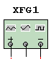 placed in the circuit window.
- Similarly, the settings of any instrument available in Multisim can be changed by double-clicking on that particular instrument and changing the settings manually.
- A dialog box as shown in Figure 17 allows you to change the clock to 200 KHz.
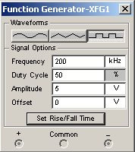
Figure 17. Snapshot of function generator settings
- Use an Agilent Oscilloscope or any other oscilloscope from the instrument toolbar, for display of the timing waveforms.
- For display of the waveforms CLK, Q and D (or Q) signals, connect these to the pins D0, D1 and D2 on the oscilloscope, respectively. The pins D0 to D15 of the Agilent scope are arranged as in Figure 18.
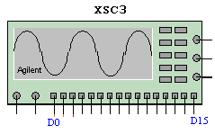
Figure 18. Agilent oscilloscope pin assignments.
- Run the simulation of the circuit in Multisim as shown in Figure 19.
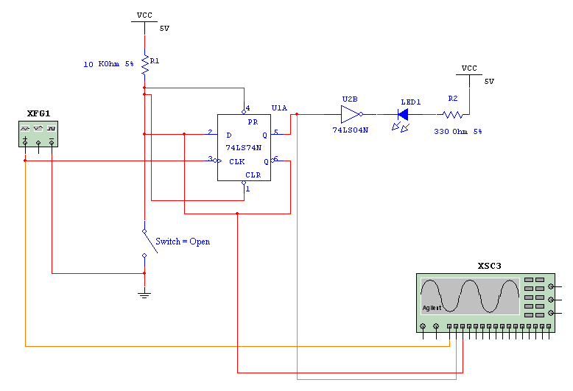
Figure 19. Simulation of frequency divider in Multisim.
- The results of the simulation are shown below in Figure 20 where D0, D1 and D2 correspond to the CLK, Q and D signal waveforms, respectively.
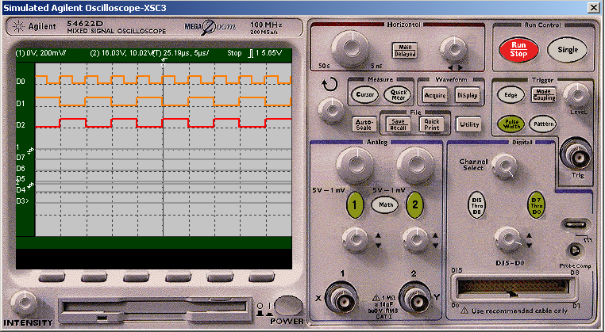
Figure 20. Results of simulation observed on the Agilent oscilloscope.

Example 2: Application of Flip-Flop Asynchronous Inputs
One application of the FF asynchronous inputs is that one can position the state of the flip-flop to a desired state upon power-up. External circuit components are needed to accomplish this. A simple RC circuit is connected to one of the asynchronous input as shown in Figure 21.

Figure 21. RC external circuit for (a) set and (b) clear of the FF on power-up.
The proper selection of R and C values is needed to do this in a fraction of the time. Theoretically, any combination of R and C will suffice. The practical considerations and FF electrical characteristics such as setup time (i.e., time required prior to the application of the clock signal), maximum clock frequency that can be applied and the component availabilities limit the choice of R and C values. The setup time is specified by the IC manufacturer for the flip-flop inputs., Please note that these values are usually specified differently. For example, to place 74LS112A in a 0 state, the data sheet specifies a typical time (t_{PLH} = 15ns at room temperature). The RC combination must provide a rise time that exceeds this value. Let us assume 1ms for simplicity.
Now if we select a capacitor value of 0.1 µF then
T = R C ≥ 1 ms
R ≥ 1ms / C = 1 * 10⁻³ / 0.1 * 10⁻⁶
= 1 * 10⁻³ * 10⁺⁷
= 10 KΩ
In T duration, the voltage at node A reaches 0.632V_{cc} or 3.8 V. This is higher than logic 1 state, specified as 2.4V for a typical TTL. Run the simulation of the circuit using Multisim and use the dual channel oscilloscope to display the timing waveform of the output of the FF as shown in Figure 22.
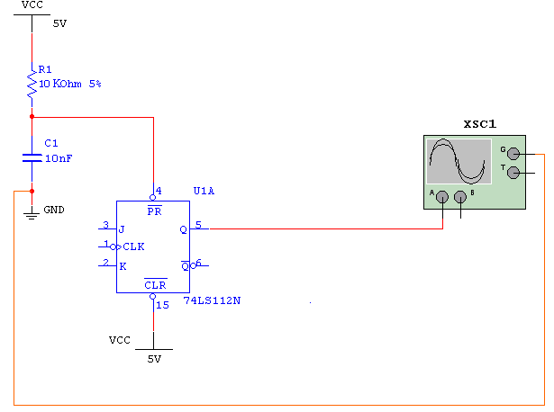
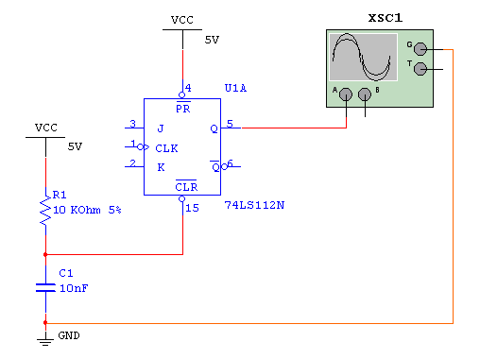
Figure 22. Simulation of the circuits in Multisim.

Simulation

Simulation 1: Generating Non-Overlapping Clock Pulses
One application of the J-K flip-flop is to generate non-overlapping clock pulses. The configuration shown in Figure 23 sets the J-K flip-flop in the toggling mode and feeds the outputs of the FF to two 2-input AND gates in synchronism with the clock.

Figure 23. Diagram of the non-overlapping clock pulse generator circuit
The signal at X is synchronous with the clock whereas the signal at Y is the delayed version of the clock. This type of non-overlapping clock is used for generating strobe signals (short pulsed signal) and various waveforms for digital devices.
- Calculate expected output frequencies at X and Y for the selected clock frequency.
- Draw the expected output waveforms in reference to the clock. Comment on the waveforms observed at Q, X, and the clock. How do they compare to the outputs at Q and Y? Verify your calculations using the oscilloscope.
- Construct the circuit as shown in Figure 23 in Multisim using 7408 AND gate IC and 74LS112 dual J-K negative-edged triggered FFs with preset and clear.
- Use a function generator from the instrument toolbar to generate a clock signal.
- Set the clock frequency to less than 10 Hz (between 2 Hz to 3.5 Hz is ideal for observation).
- Use an Agilent oscilloscope from the instrument toolbar, for the display of the timing waveforms.
- To display CLK, Q, Q, X and Y signals, connect these to the pins D0 to D4, respectively on the oscilloscope.
- Run the simulation using Multisim and verify if the timing waveforms are similar to the expected waveforms.

Simulation 2: Astable Multivibrator using 555 Timer IC
In this application, the 555 timer IC is configured as an astable multivibrator. Construct the circuit shown in Figure 24 and verify its operation. The values of the resistors and capacitors are given below.
R_{A} = R_{B} = 4.7 KΩ
C₁ = 100 µF
C₂ = 0.01 µF

Figure 24. 555 Timer IC used as an astable multivibrator
- Draw the waveform observed at pin number 3, the output. You will use this signal in the next experiment to trigger another IC.
- Calculate the output frequency and record its value.
- Measure the output frequency using the oscilloscope and compare it to the calculated value and note any difference. Use the computer clock or your hand watch. Is the value on computer clock or your hand watch the same as the calculated and measured values? If they are different, how do you explain the difference?

- Calculate the theoretical value of frequency and the duty cycle of the waveform generated at the output of pin 3.
- Construct the circuit as shown in Figure 24 in Multisim using 555 timer IC.
- Use the dual channel oscilloscope from the instrument toolbar, for displaying the results of the timing waveforms.
- This circuit is really slow; you should reduce the sample rate to make
the simulation speed up. This is done by selecting simulate-->default
instrument setting, change TMAX from 1e-005 to 1e-003 as shown below in Figure 25.
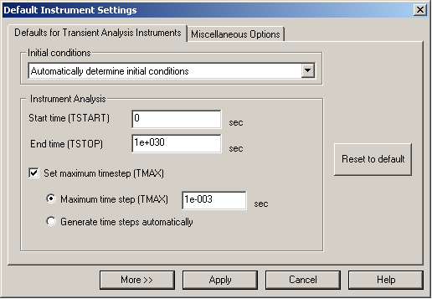
Figure 25. screenshot for changing the speed of simulation
- Run the simulation of the circuit in Multisim.
- Measure the output frequency using the oscilloscope and compare it to the calculated value and note any difference.

Simulation 3: Triggering One-Shot using 555 Timer IC
The 74LS121 one-shot has many applications. Simple applications of this IC include generating a wide pulse from a narrow pulse, generating a narrow pulse from a wide pulse, or a series of pulses may be converted into a single pulse. Other applications of one-shots are eliminating a switch contact bounce and time delay circuits.
In this experiment you will use the clock generator constructed in procedure 2 as a triggering signal for a 74LS121 shown in Figure 26. Assume C_{EXT} = 10 µF.

Figure 26. Block Diagram of the OS triggering circuit.
Consult the data sheet for the range of acceptable values for the R_{ext} and C_{ext} for the 74LS121.
Note: The values may be different for different logic families of 74121, therefore consult the datasheet for exact component ranges.
Design a pulse at the Q output of the 74LS121 that is 0.2 seconds long (i.e. T = 0.2 sec).
- Based on the selected C_{EXT,} calculate the value of R_{EXT} from the equation below. Use the closest value of resistor available in your component kit for R_{EXT}.
T ≈ 0.7 R_{EXT} C_{EXT}
- Construct the circuit shown in Figure 27 in Multisim using 555 timer IC and 74121 OS.

Figure 27. Circuit for triggering an OS with the 555 Timer IC
Use the virtual monostable component from the component toolbar for the 74LS121 IC chip. The screenshot of the position of the virtual monostable component in the component toolbar list is shown in Figure 28.
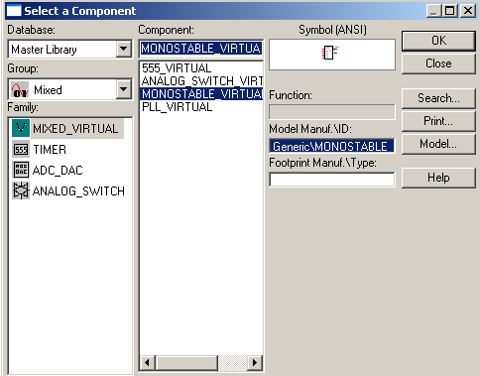
Figure 28. screenshot of monostable multivibrator component selection

- Use the dual channel Oscilloscope from the instrument toolbar for the display of the timing waveforms at pin 6 of the OS. Change the speed of simulation setting to perform the simulation faster. Follow the same steps given in simulation 2 for increasing the simulation speed.
- Run the simulation of the circuit in Multisim.
- Measure the duration of the pulse and frequency at pin 6 of OS and compare the pulse duration with the calculated values.

Procedures

Procedure 1: Generating Non-Overlapping Clock Pulses
Construct the circuit shown in Figure 23 as follows:
- Place the 74LS08 AND gate IC and 74LS112 dual J-K negative-edged triggered FFs with preset and clear on the breadboard.
- Connect the V_{cc} and Ground pins of the IC’s to the V_{cc} (+5 V) and GND on the trainer board, respectively. Refer to the datasheets for the pin assignments.
- Wire the logic circuit and connect the J, K, Preset and Clear pins to V_{cc,} and the output X and Y to LED’s.
- Connect the clock to Cathode Ray Oscilloscope (CRO) and set it to any frequency between 2 Hz to 3.5 Hz.
- After setting the frequency, connect the CLK pin on the 74LS112 to the Clock on the trainer board. Turn on the trainer board.
- Connect the CLK, Q and X to the CRO and measure the frequency of each and record the readings in your Worksheet.
- Connect the CLK, Q, and Y to the CRO and record the readings in your Worksheet.
- Compare the results obtained to that of the simulation 1 and record your observations in the Worksheet.
- Turn off the equipment and dismantle the circuit when completed.

Procedure 2 – Astable Multivibrator using 555 Timer IC
- Construct the circuit as shown in Figure 24 on the trainer board.
- Connect the output (pin 3) to an LED.
- Measure the output frequency using the oscilloscope and compare it to the calculated value and note any difference.
Record the timing for T using a hand watch or computer clock.
- Compare the results obtained to that of the simulation 2 and record your observations in the Worksheet.
- Turn off the equipment when completed and do not dismantle the circuit as you will be using it in procedure 3.

Procedure 3 – Triggering One-Shot using 555 Timer IC
- Wire the circuit as shown in Figure 27 on the trainer board.
- Connect the output (pin 3) of 555 timer and the output pin 6 of the 74LS121 to LED’s.
- Measure the output frequency and pulse duration using the oscilloscope.
- Compare the results obtained to that of the simulation 3 and record your observations in the Worksheet.
- Turn off the equipment when completed and do not remove the wiring as the same circuit is going to be used in the next section.

Application

Logic Sequencer
A logic sequencer is a device that changes its state in a predetermined order with a control signal. In this experiment, the output of the one-shot from the previous procedure 3 is used as a control signal to sequence a 3-bit register through the repeated states of 100-010-001. The individual output of the register can be used to initiate other control signals to start a series of fans or lights. The initial state is set upon power-up using the external RC combination discussed before and then continues according to the stated system sequence. Similar sequencer will be used in future experiments for other tasks.

Figure 29: Logic Sequencer
Construct the circuit shown in Figure 29 and determine the output waveforms of Q1, Q2 and Q3, also measure the frequency at each output of J-K FF’s. Check if the sequence is 100-010-001 and it is repeated.

Knowledge Evaluation
- Design and construct a waveform generator that will produce the waveforms given in the timing diagram shown in Figure 28. Use the 555 timer to generate one of the waveforms, and then use that waveform to trigger the 74LS121 one-shot to produce other waveforms shown in Figure 30. Each division in Figure 30 is 0.1ms.

Figure 30

- How would you change the output frequency of the circuit shown in Figure 24? Construct an astable multivibrator using 555 timer IC that will produce an output waveform of frequency 218.63 KHz. Assume R_{A} = R_{B} = 2.2 KΩ and C₂ = 0.01 µF to calculate the value of duty cycle.
- A sequencing system is required to repeat the sequence 101, 110, 011, and 101 as shown in Figure 29. Show a detailed logic diagram that will accomplish this sequence. How many clock pulses to this system are required before the sequence is repeated?

References
If you want to learn more about the topics related to this lab, see the following references:
- Ronald J Tossi, Digital Systems Principles and Applications. Prentice Hall, 9th Edition, 2004.
- Ronal J Tossi, Neal S Widmer and Gregory L Moss, Lab Manual: A Design Approach to Accompany Digital Systems. Prentice Hall, 9th Edition, 2004.
- Thomas L. Floyd, Digital Fundamentals, Prentice Hall,8th Edition, 2002.
- Albert Y. Teng and William A. Malmgren, Experiments in Logic and Computer Design, Prentice Hall, 1984.
- David Buchla, Digital experiments: emphasizing systems and design: to accompany Floyd, Digital fundamentals, Merrill Publishing Company, 1994.
- Experimenting with Real Circuits. available [online]
http://www.play-hookey.com/digital/experiments/
- CLAB resources. [Online] available:
http://cot-vyger.cougarnet.uh.edu

Datasheets

LM 555 Timer IC
Pin Configuration
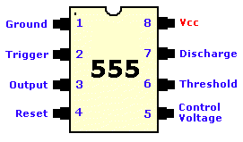
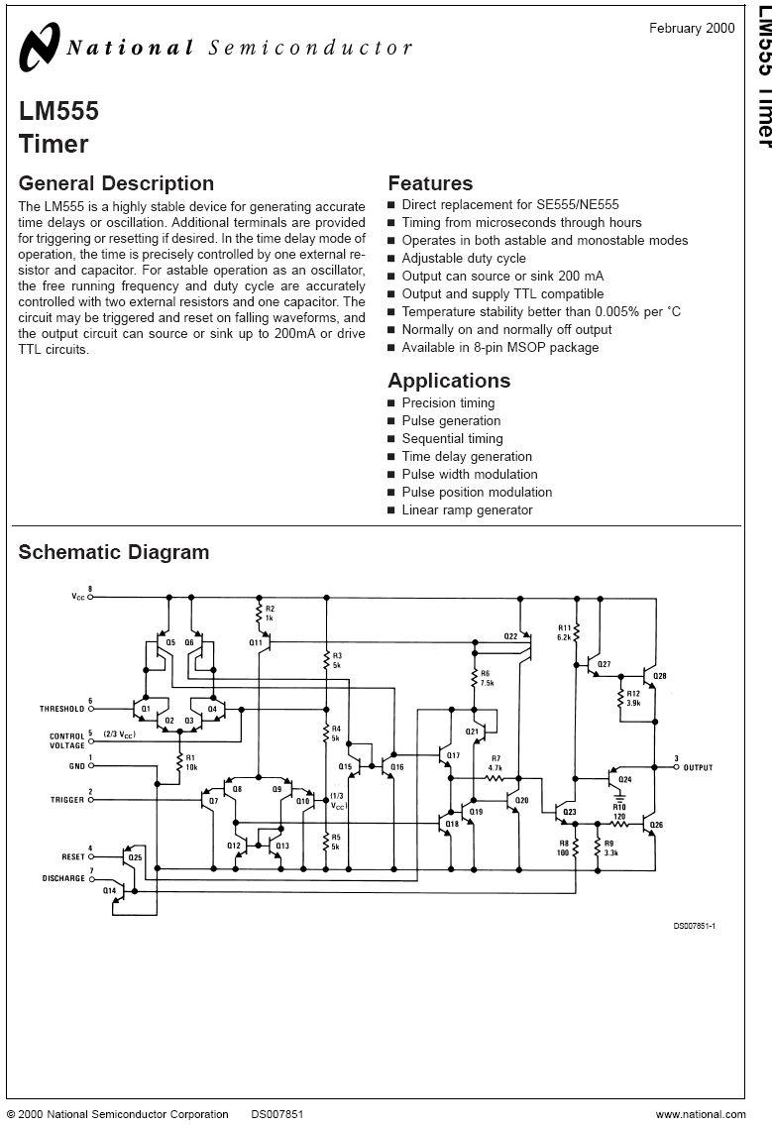
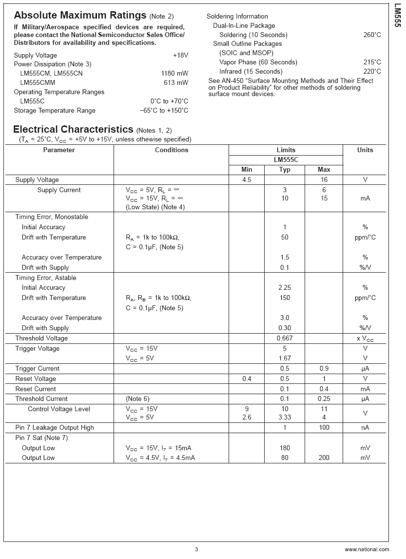
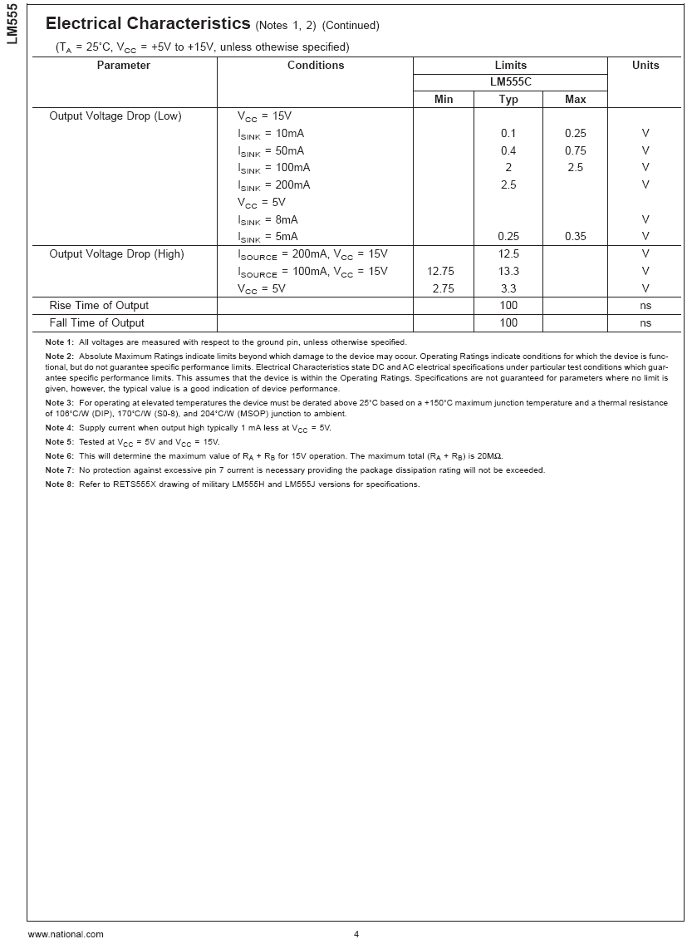

74LS112 Dual Negative Edge Triggered JK FF
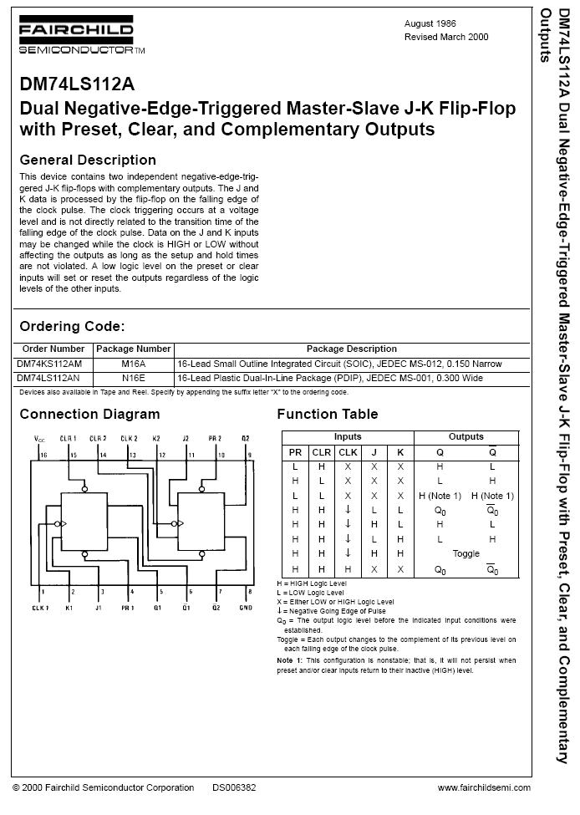
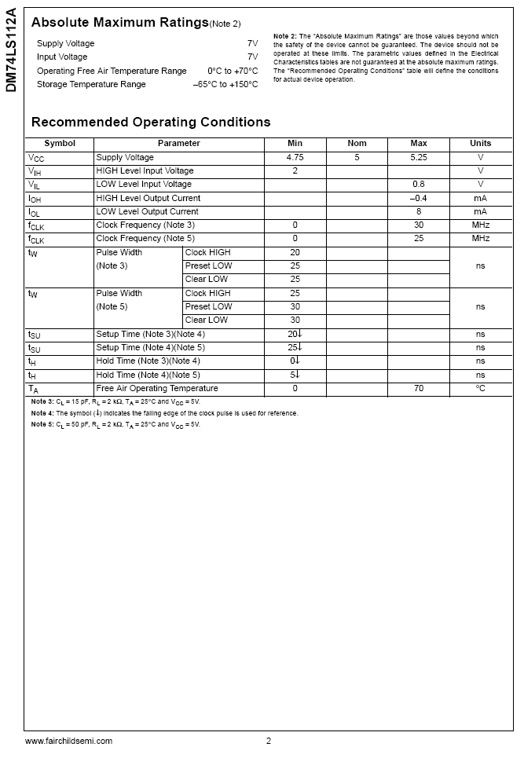
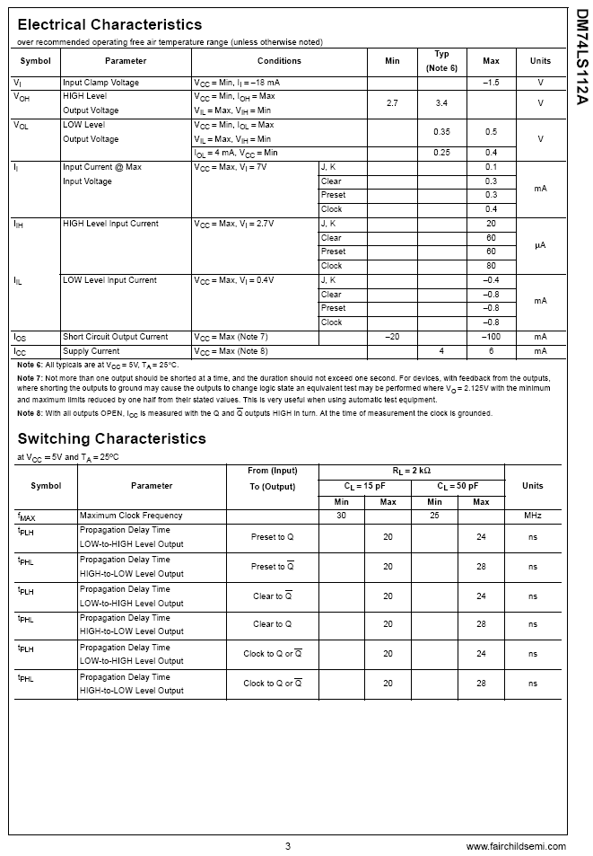

74LS75 Quad Latch
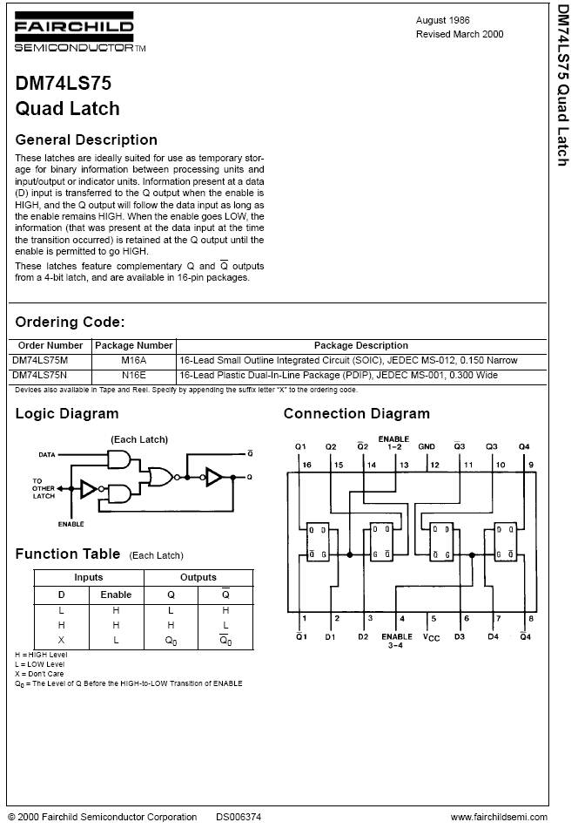
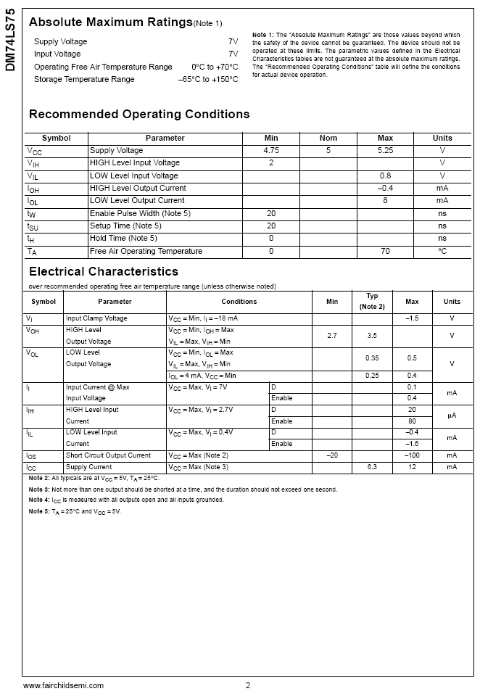
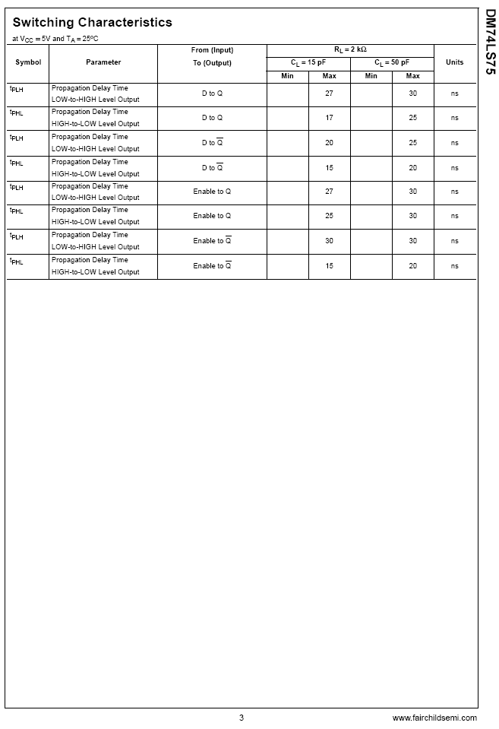

SN74121N Monostable Multivibrators
