Verilog allows the developer a certain level of abstraction; it allows them to ignore the specific implementation of a circuit and focus on the functionality. After the functionality is detailed the actual implementation can be selected from a variety of different options. The different implementations exist as libraries that can be selected via EDA tools

Introduction to Verilog
Simulations are performed by EDA (electronic design automation) tools and the Verilog design RTL is placed inside a testbench.
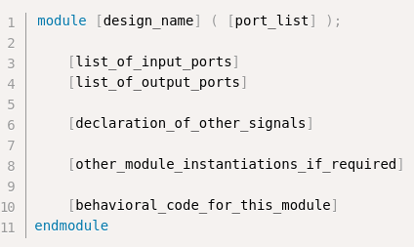
Verilog sections
- Module definition and also the port list declarations
- A list of the input ports and a list of the output ports
- Declarations of other signals
- instantiations of other verilog modules
- The module design, details the behavior

ASIC Design Flow
In digital design, you do not often build things from scratch. Rather you use IP provided by someone that does something you need (such as I2C or CAN or SPI). This behavioral description is written in something like verilog or vhdl and included in a project.

Logic Synthesis is the conversion of a RTL design into HDL on a gate level – this is called a netlist. A netlist is a description of the circuit in terms of gates and the connections between them
Logic synthesis tools ensure that the netlist meets timing, area and power specifications. These criteria come from libraries provided by semiconductor fabricators (etc). Encoded in the netlist is things like the rise and fall times for flip flops and the input-output time for computational gates

Logical equivalence is when “gate level verification” is performed, making sure that the produced netlist is logically the same as the RTL that was written

Placement and Routing is where the netlist is inputted into a physical design flow. Automatic place and route is done with the help of EDA tools. Cadence Encounter and Synopsys IC Compiler are examples of EDA tools that help with place and route. For ASICs, this will create a ball pin output, put the cells into rows, create different metal layers and place buffers to meet timing. There is generally a “physical design team” who is well versed in the technology.

Validation of the chip is done by another team of engineers who run different patterns on a tester

Chip Abstraction Layers
The top layer is the system level architecture. Defines various sub blocks and groups them based on functionality

Verilog Syntax

Number types

Sized Numbers.
[size]’[base_format][number]

3’b010 // size is 3 bits, represented here in binary
3’d2 // size is 3 bits, represented here in decimal
32’hFACE_47B2

Unsized Numbers
Numbers without a base format are decimal by default. Numbers without size have a default number of bits, which depends on the type of machine or simulator

integer a = 5423;
integer b = ‘h1AD7; // since int is a 32 bit and size is not specified, this is represented as 0000_1AD7

Verilog Data Types
There are four values that nearly all data types can take. `real` and `event` data types are the only ones which do not take these values
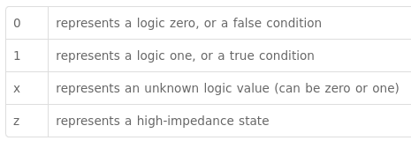
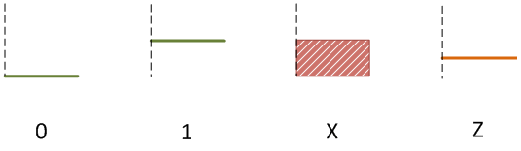

Unconnected wires in verilog will result in high impedance state.

Nets and variables
The two main groups of data types which represent different hardware structures, they differ in the way they are assigned and hold values.
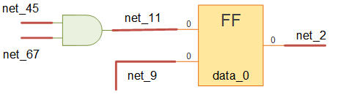
Nets connect hardware entities like logic gates, they do not store any values of their own

The most popular used net is the wire type. It is similar to an electrical wire.

Wires of more than length one are called vectors

variables are an abstraction of data storage and can hold values. Flip flops are a good example of a storage element. In verilog, the reg type can be used to model hardware registers.

Registers are driven within procedural blocks, whereas wires are actively driven by something (such as the output of a module). Remember that registers are clocked, so this means they have to be assigned inside of a block (rhyme).

Other data types
integer is a general purpose variable that is 32 bits wide
time is an unsigned 64 bit wide type used to store simulation time p
real floating point value

Verilog Strings
Strings are stored in reg type

Scalar and Vector types
You can access any individual bit of a register.

The most significant bit of a vector is the left hand value, while the least significant is the right hand.

wire [msb:lsb] my_wire;

Accessing a single bit from a vector is known as a bit select

Accessing a range of contiguous bits from a vector is known as a part-select. There are two types of part-select: index part-select and constant part-select.

Constant part-select
addr [23:16] = 8’h23; // bits 23 through 16 are replaced by ‘h23

Indexed part select:
[<start_bit> +: <width>]
[<start_bit> -: <width>]

data[8*ii +: 8]

Verilog Arrays
An array of net or variable can be either scalar or vector. Arrays are allowed for reg, wire, integer and real types.

Y2[0] = 8’ha2; // Assign 0xa2 to index 0
Y2[2] = 8’h1c; // assign to index 2
Y3[1][2] = 8’hdd; // assign to rows=1 cols=2

Memories
Digital storage elements that help store data and info in digital circults, such as RAM and ROMs.
Memories can be modeled using one dimensional arrays of type reg

Register Vectors are declared using a size range on the left side of the variable name. These become a set of flip flops that match the size of the variable
reg [15:0] register;
This can be used as internal storage for a module

Array
You can use an array to have a set of registers that could potentially be selected from.

Verilog Modules
A module is a block of verilog code that implements certain functionality. Modules can contain other modules; modules communicate with one eachother via input and output ports.
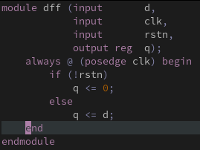
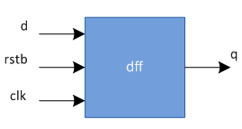
You cannot have any code that is written outside of a module!
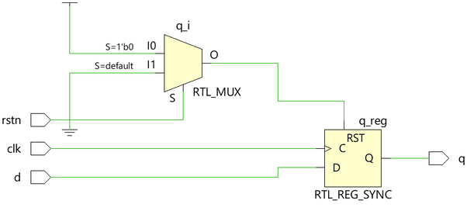
Our previous example of dff could be used to create a shift register.
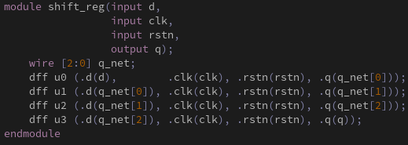

This is simply a set of dff modules connected together in series, where the output of one is the input of the next.

A top level module is a module that contains all of the other modules. A top module is not instantiated within any other modules.
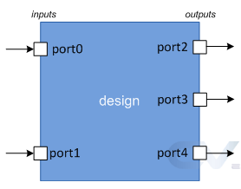

Verilog Ports
Ports are a set of signals that act as inputs and outputs to a particular module; this is the primary way of communicating with a module. Ports are like the pins on some IC.

Ports can either be inputs, outputs or inout. Ports are considered nets of type wire by default.

Output ports that are in a procedural block must be implemented as a register, not a wire. If the output will be given outside of a block, then a wire can be used.

Verilog Module Instantiations
You can hook modules together in a few ways. When you instantiate a module inside of another module, you can either link the ports in order (like you would arguments to a function) or specifically by name.

Generally passing in the ports in order like arguments to a function is discouraged, because if a new port is added the order might change.

Port connections by name are encouraged more. The dot indicates that the port name following the dot belongs to the design – the signal name that the port is connected to is given inside the parenthesis
.submodule_port(super_module_signal)
When using named port connections, the order does not matter. Ports can not be connected multiple times.

Unconnected and Floating ports. Ports that are not connected to any wire will have a high impedance value.

All port declarations default to wire, and so port direction is the only additional info required. Output ports that need to store values should be declared as reg type – these output ports can only be used in always and initial procedural blocks.

Both input and inout cannot be of type reg because they are being driven from outside continuously and should not store values.

Beware: it is valid to connect two vectors of different sizes, the most significant bits will just be chopped off.

Verilog assign statement
Signals of type wire require continuous assignment of a value. The assign statement can be used to accomplish this – assign used on a wire will drive it continuously with a value.

Assign Syntax
assign <net_expression> = [drive_strength] [delay] <expression of different signals or constant values>
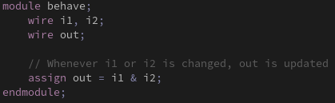
Both the [drive_strength] and [delay] values are useful for simulation.

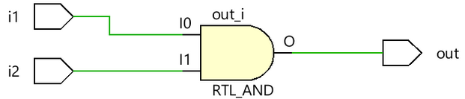
The left hand side should never be register. The right hand side can contain register values and function calls. Whenever any operand on the right hand side changes value, the left hand side is updated. Assign statements are also called continuous assignments and they are always active.

It seems that register variables are clocked, and because of this they cannot be driven by a assign statement – they need to be driven inside of an initial or an always block.

There are both implicit and explicit continuous assignments. When we use the assign keyword, this is an explicit assignment. However we can assign a wire with some values when it is declared, which is an example of an implicit assignment.

Wire [1:0] a = x & y;

Assign examples
The assign statement is generally used to continuously drive a wire datatype.
Some use cases include half adders, full adders, multiplexers, demultiplexers, decoders and encoders.

Verilog Operators
a === b : a is equal to b, including x and z
a !== b : a is not equal to b, including x and z
a == b : a is equal to b, result can be unknown
a != b : a is not equal to b, result can be unknown

<< is logical shift whereas <<< is arithmetic shift

<= is generally used for sequential logic
= is generally used for combinational logic

Concatenation
Multi bit verilog wires and variables can be clubbed together using the concatenation operators { }.
The size of each operand must be known

wire a, b;
wire [1:0] res;
assign res = {a, b};

The replication operator allows the same expression to be repeated a number of times. For example
assign res = {7{a}};

This replication operator is allows to be nested inside of concatenation expressions.

Verilog always
this is one of the procedural blocks in verilog, statements inside of the block are executed sequentially.
Always blocks are triggered by some sensitivity list. This ia an expression that defines when the always block should be executed, specified with the @ operator within parenthesis. The list can contain either on or a group of signals.

This will execute whenever a or b changes

always @ (a or b) begin
[statements]
end

Even if the sensitivity list is empty in a simulation, there should always be some sort of time delay. These explicit delays are not synthesizable to logic gates though. Real verilog design code always requires a sensitivity list.

All output signals used in a procedural block (such as always) need to be of type reg.

The always blocks are almost always used to implement sequential logic; sequential logical is simply logic that has memory elements such as flip flops.

A JK Flip Flop has two inputs, J and K. The truth table is
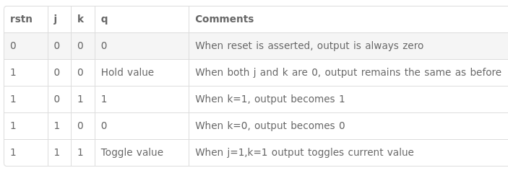
The output register is a storage device, so you can access it and use it for calculation or part of the next output in the procedural block.

Verilog initial block
In a simulation, the statements inside of a procedural block are executed sequentially.
The initial block is not synthesizable and cannot be converted into a hardware schematic. These blocks are used to initialize variables and drive design ports with specific values.

An initial block is started at the beginning of a simulation at time unit 0. The block is only executed once. The block finishes once all of the statements in the block are executed.

There are no limits to the number of initial blocks inside of a module.

The $finish statement is a Verilog System Task that tells the simulator to terminate.

System Verilog
SystemVerilog is an extension of Verilog with many additional verification features.

SystemVerilog is preferred to Verilog because it can: perform constrained random stimuli, use OOP features in testbench construction, functional coverage, assertions and much more.
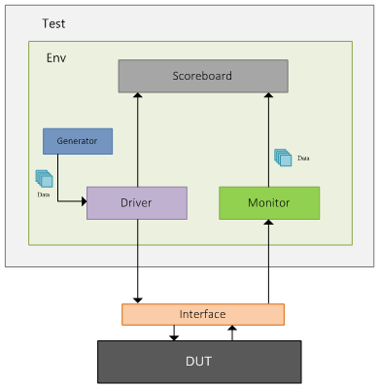
Components of a testbench
Generator: Generates different input stimulus
Interface: Contains signals that can be driven or monitored
driver: drives the generated stimulus to the design
monitor: monitors the design’s IO ports to capture activity
scoreboard: checks the output of the design with expected behavioral
environment: Contains all of the components mentioned
test: contains the environment that can be tweaked with different configuration settings.

DUT stands for Design Under Test; hardware design written in some HDL.

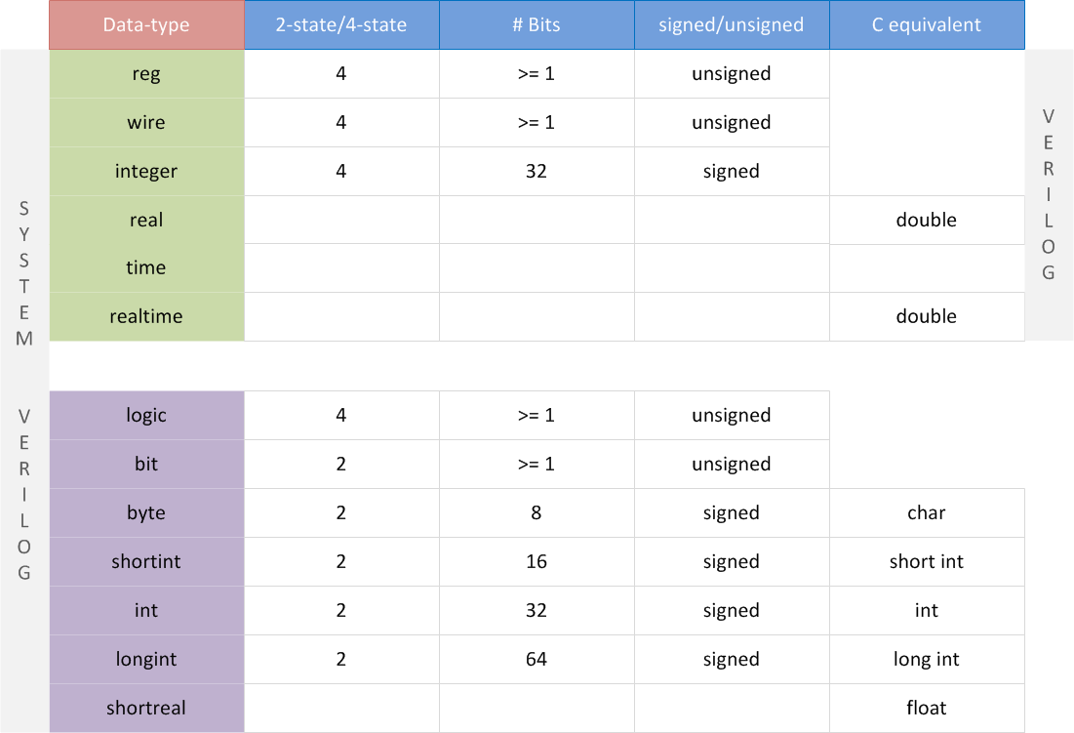
System verilog data types
Verilog data types are not sufficient for test benches and test cases; system verilog adds more C like data types to the verilog arsenal.

Logic type can be driven both in procedural blocks as well as in assign statements;

In SystemVerilog, there are two types of arrays: Packed and unpacked. Packed arrays are when the dimensions are declared before the variable name; a packed array is guaranteed to be contiguous and must be made out of only single bit types such as bit and logic. A one dimensional packed array is the same thing as a vector.

System verilog also has associative arrays.

