1. Explain Binary to Decimal Conversions and Decimal to Binary Conversions with an example.

Binary is a number system of base 2, meaning the highest single digit possible is 1. When a digit would go past 1, it caries over into the next place. Decimal is our normal number system, one that has a base of 10 (the highest number is 9 and then you carry).

2. Explain sum of products (SOP) form and product of sums (POS) form with an example.

Sum of product form is where we take all of the valid conditions that lead to a high output for a given logic expression (rows in a truth table that result in an output of 1) and AND all of those expressions together.

Product of Sums is the opposite, we and together a series of sums.

A | B | Y
0 | 0 | 1
0 | 1 | 0
1 | 0 | 0
1 | 1 | 1

SOP: Y = AB + ^A^B

3. Explain why Karnaugh Mapping is used with an example.

Kernaugh Mapping gives us a way to ‘mechanically’ reduce a circuit. If we try to use Boolean algebra we need to use intuition and that at times can even lead us in the wrong direction (by not simplifying the expression or by even making it more complicated).

Here is a truth table
A | B | Y
0 | 0 | 1
0 | 1 | 0
1 | 0 | 1
1 | 1 | 0

And here is the Karnaugh map for it

\ A  B | 0 | 1
0 | 1 | 1
1 | 0 | 0

Since there is a row of 1’s, and for that row, B doesn’t change but A does change (and iterates through all of its states), we know that we can remove A.

Y = ^AB + AB = B(^A + A) = B
4. Draw the truth table and gate symbol for NOR, NAND, XOR and XNOR gates.

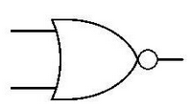
NOR

A | B | Y
0 | 0 | 1
0 | 1 | 0
1 | 0 | 0
1 | 1 | 0

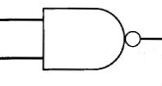
NAND

A | B | Y
0 | 0 | 1
0 | 1 | 1
1 | 0 | 1
1 | 1 | 0

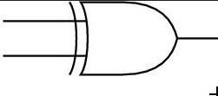
XOR
A | B | Y
0 | 0 | 0
0 | 1 | 1
1 | 0 | 1
1 | 1 | 0

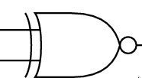
XNOR
A | B | Y
0 | 0 | 1
0 | 1 | 0
1 | 0 | 0
1 | 1 | 1

