CHAPTER 12: EARTH'S INTERIOR
Terms to Know and Define:
Asthenosphere  Upper mantle  Below Lithosphere | Conduction | Convection | Core
Crust | Geothermal gradient  rate of increasing temperature with respect to increasing depth in earth’s interior | Inner core | Lithosphere  Crust and solid upper portion of mantle  cool, rigid layer, about 100km thick
Lower mantle | Mantle | Magnetic field | Mesosphere  third layer of atmosphere, directly above stratosphere
Moho  boundary between earth’s crust and the mantly | Outer core | Shadow zones | Seismic reflection
Seismic refraction | Geoid | Seismic rays | D" layer  Core / Mantle boundary
Concepts to know:
1. How do the velocities of P- and S-waves change with depth in passing through the following layers: crust, asthenosphere, transition zones, lower mantle, outer core, and inner core (see Figure 12.6 in the text book)?
P Waves
Velocity Decreases in Outer Core, waves bend downward
Velocity Increases in mantle and waves bend back upward
Outer Core (liquid)
Slows down P waves
Stops S waves
Asthenosphere
wave velocities decrease because peridotite contains few percent partial melt, not enough to stop S waves though
2. What is seismic refraction? Why do seismic rays bend outward with depth in the mantle?
Depends on properties of the material it is trveling through. If the solid that the wave go into are more dense then the waves will move faster in the new material. When a wave moves faster, it moves towards the line between the two materials.
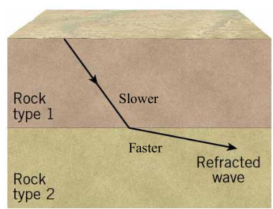
3. What is seismic reflection?
There can be both reflection and refraction when a wave passes into a new material
Can happen when waves meet the boundary between two different materials

4. What causes P-wave and S-wave shadow zones? Which is wider and why?
P Wave Shadow Zone
bending of P waves in the outer core
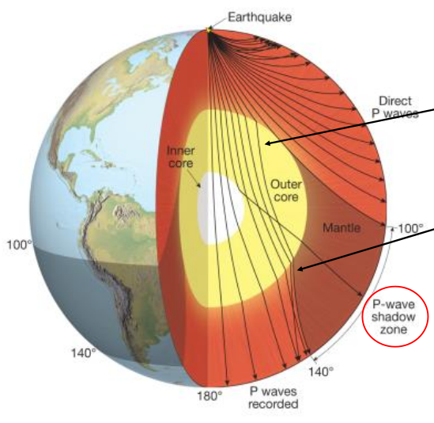
S Wave Shadow Zone
Much larger than P wave shadow zone
This is because S waves cannot travel through the outer core
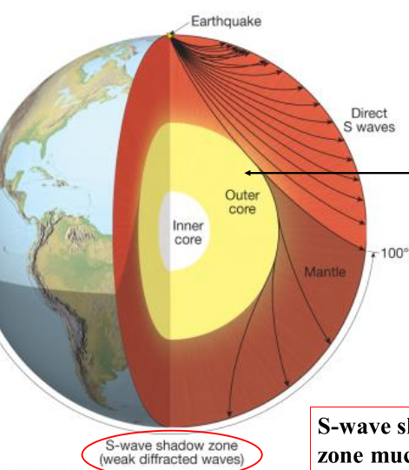
5. How does continental crust differ from oceanic crust in terms of composition and thickness?
Both types of crust vary in thickness, but continential crust is much thicker
Oceanic: 3-15km thick, Basalt and Gabbro
Continental: 40-65 km thick, Granite, more buoyant than oceanic crust

6. What is the Moho and where does it occur?
Mohorovicic discontinuity
50 km depth, change in physical properties which marks the base of the crust
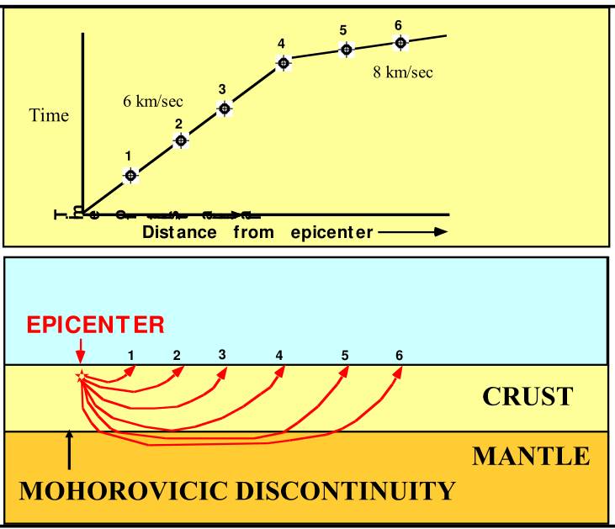
7. Where is the asthenosphere? How do S-waves behave when passing through the asthenosphere? What does the behavior of S-waves tell us about the asthenosphere?
Athenosphere (weak sphere)
located in the upper mantle beneath the lithosphere
known as low velocity zone because it slows down waves
partially melted
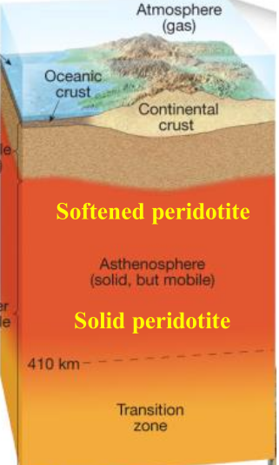
8. What is the composition of the mantle? How do P- and S-waves generally behave when traveling deeper into the mantle?
9. Why do seismic waves speed up within the 400km and 670km transition zones?
400 km: Olivine Changes to Spinel Crystal structure which has higher density
660 km: Spinel Changes to Perovskite
10. Where is the D" layer? What are its characteristics?
Bottom few hundred km of lower mantle
large variations in composition and temperature
11. What is the composition of the outer core? How does the velocity of P-waves change when entering the outer core? What happens to S-waves in the outer core?
Made of Liquid Iron
S waves can’t pass
P Waves slow down

12. What is the composition of the inner core?
Soild Iron
S waves travel through
13. What produces the earth's magnetic field? Do the geographic poles coincide with the magnetic poles?
Conductive Flow of nickel-iron outer core
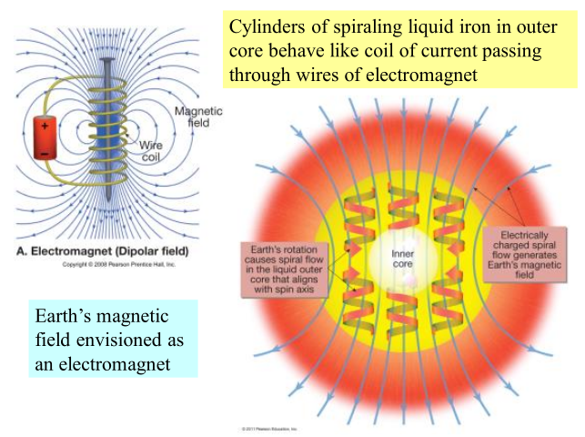
The poles do not coecide with eachother

14. What is the geothermal gradient? List three processes that have contributed to Earth's internal heat.
Geothermal gradient is the rate at which earth’s temp gradually increases with depth
- Heat released by colliding particles during formation of earth
- heat released as iron is crystalized to form solid inner core
- heat emitted by radioactive decay
- moon forming impact
15. Describe the process of conduction. Which of Earth’s layers transfers heat mainly by conduction?
16. Describe mantle convection and how this process transports heat through the mantle.
17. Is gravity on earth everywhere uniform? What are the various factors that affect Earth’s gravity? What is the geoid?
No. Gravity is stronger at the equator because of centrifugal force and because the poles are farther from the earth’s center of gravity

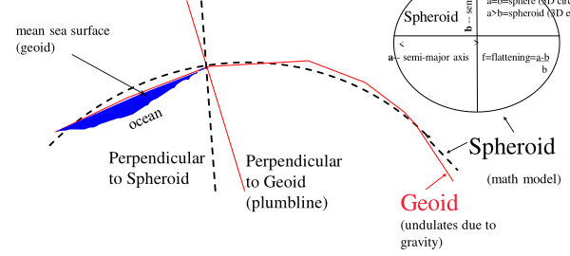
CHAPTER 16: RUNNING WATER
Terms to Remember and Define:
Alluvial fan | Alluvium  stream sediments | Antecedent stream | Bar
Base level  lowest point to which a stream can erode | Bed load | Braided stream | Capacity
Competence | Cut bank | Delta  forms when a sediment charged stream enters the relatively still waters of a lake | Dendritic pattern
Discharge | Dissolved load | Distributary | Divide
Drainage basin | Flood  most common and destructibe geologic hazard | Floodplain | Graded stream  correct slope to maintain velocity required to transport material supplied to it  neither eroding or depositing generally
Gradient  (h1 – h2)/ 1  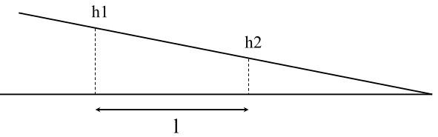 | Headward erosion  A way in which a stream can lengthen its course by: building a delta at the mouth, or headward erosion  headward erosion can result in stream piracy | Hydrologic cycle | Incised meander
Infiltration  how groundwate is recharged from surface water; either from heavy rain or snow or something | Laminar flow | Local base level  type of base level, resistany rock layers, lakes and dams  (waterfall) | Meander
Mouth  where stream empties into large body of water | Natural levee | Oxbow lake | Point bar
Radial pattern | Rectangular pattern | Rills | Runoff
Saltation | Sheet flow | Stream piracy  Diversion of the drainage of one stream into another | Superposed stream
Suspended load | Terrace | Trellis pattern | Turbulent flow
Ultimate base level  Sea Level | Water gap | Waterfall
Concepts to know:
1. What is the hydrologic cycle? Describe the different ways (e.g. infiltration, evaporation, runoff, and precipitation) by which water is transferred from one reservoir (e.g. oceans, glaciers, groundwater, etc.) to another.
Traces the cyclical movement of water through variaous resivours
Rain / melting snow → Runoff → sheetflow → rills (tiny channels) → gullies → streams
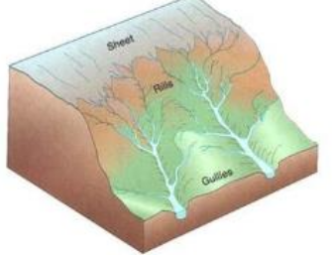
2. Streams are vital geologic agents that perform four special functions. What are those functions?
- Carry most of the water that goes from land to sea
- transport billions of tons of sediment to the ocean’s each year
- carry small amounts of soluble salts to the sea
- shape the surface of the earth
3. How does laminar stream flow differ from turbulent flow? What may cause laminar flow in a stream to change to turbulent flow?
Laminar Flow
Slow moving Streams
Streamlines in parrallel paths
Turbulent Flow
faster moving streams
erratic and swirling motion
whirlpools and eddies

4. Describe how a stream’s discharge, channel cross sectional area, velocity, channel roughness, and gradient changes when going from the stream’s head to its mouth.
Stream originates at the head
empties into larger body of water at mouth
Discharge: Q = A * V, Q = discharge, A = cross sectional area of channel, V = average velocity
The velocity can increase if the stream channel is narrowed or if there is a lot more rain because of a heavy rainfall

5. What is the base level of a stream and what does it represent? How does ultimate base level differ from local base level? Give some examples of local base levels.
Base level is the lowest point that a stream can dissolve to
Ultimate is sea level but local is determined by surrounding rock and such
waterfall is an example of a local base level

6. How does a stream respond to uplift of the land (erosion or deposition)? How does a stream respond to global sea-level rise (erosion or deposition)?
7. What are the three principal ways by which a stream transports material? What is saltation?
- Bed Load: Coarser particles are moved by rolling and sliding along stream bed
- Suspended Load: Finer particles carries in suspension
- Dissolved Load: Disolved chemical substances
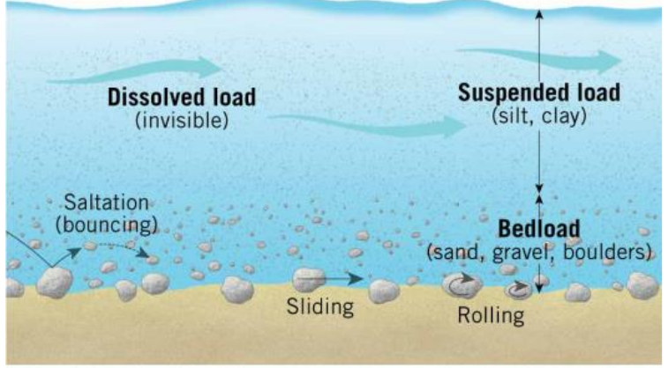
8. How does the stream capacity differ from its competence? What major factor affects the capacity and competence of a stream?
Capacity
Maximum load a stream can transport
Increasing discharge increases the capacity of the stream
Competence
Maximum particle size a stream can transport
greater velocities can carry larger particles in suspension
9. What causes a stream to deposit its sediment load?
Velocity Decreases and stream no longer can carry particular sediment
10. Sketch a meandering stream channel with several bends. Include a dashed line in the channel showing the trace of maximum water velocity. At each bend, indicate where the channel wall is undergoing erosion and where sediment deposition occurs. Show the locations of point bars.
11. Sketch and describe how an oxbow lake forms.
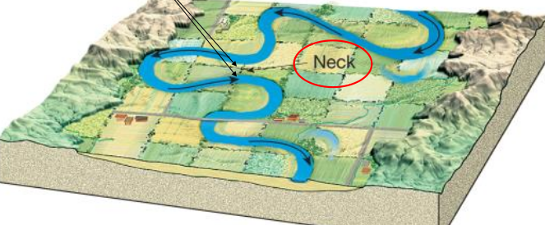
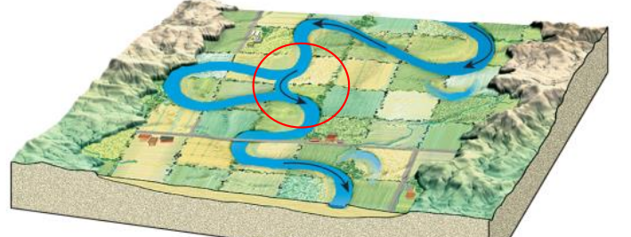
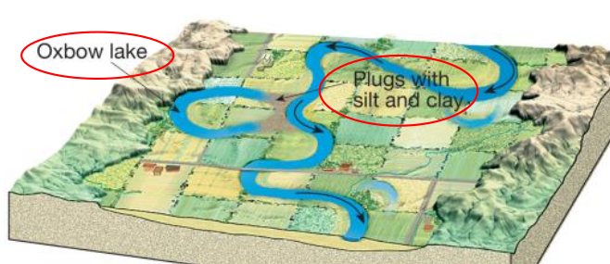
12. How does a meandering stream channel differ from a braided channel?
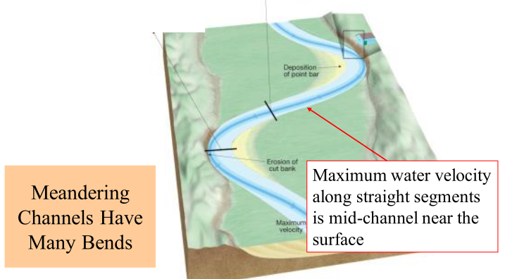
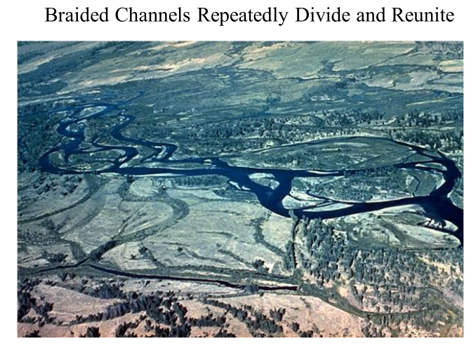
13. Describe the two general types of stream valleys.
Narrow Valleys
V Shaped, Stream downcutting towards base level, rapids and waterfalls
Wide Valleys
Stream near base lavel, downward erosion, stream energy is directed side to side
14. Sketch a typical stream valley and label the main stream channel, natural levees, flood plain, and terraces. Indicate where you would expect to find the coarser sediment versus finer sediment.
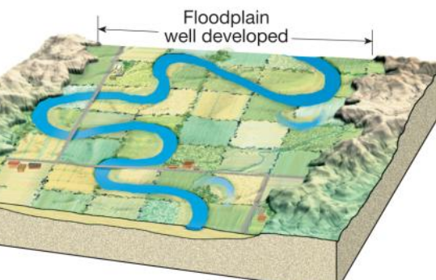
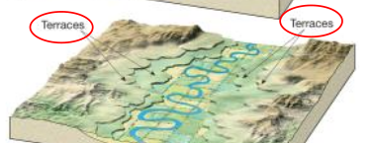

15. How do natural levees form?
16. How do stream terraces form?
Flood plain that erodes rock and goes down lower over time, see above picture
17. Sketch and describe a drainage basin showing tributaries, the main stream(s) and divides. How large or small are drainage basins?
18. Sketch and describe four types of drainage patterns. Match each type of drainage pattern with the following geologic features:
(a) gentle, rolling topography,
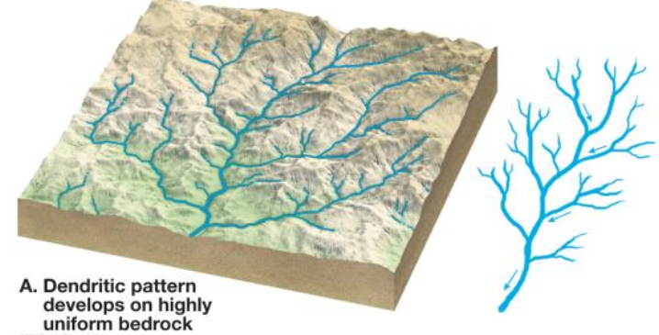
(b) bedrock containing joints intersecting at right angles,
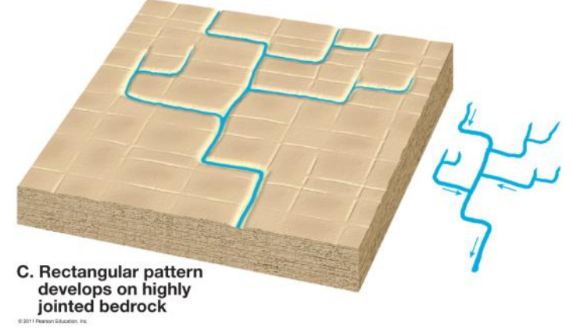
(c) folded terrain, and
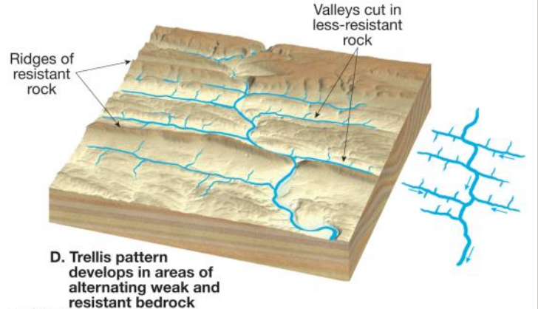
(d) volcanoes.
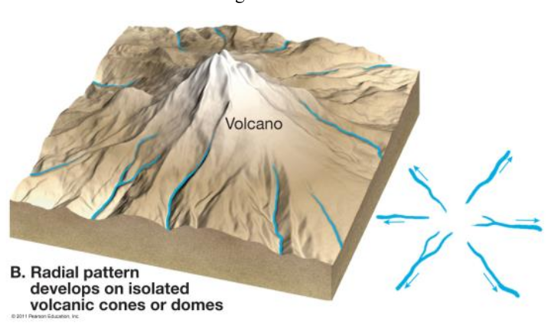
19. What is meant by stream piracy? How does stream piracy create a wind gap?
One stream is diverted into another one
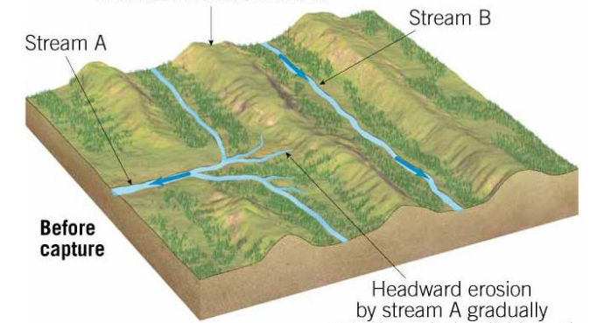
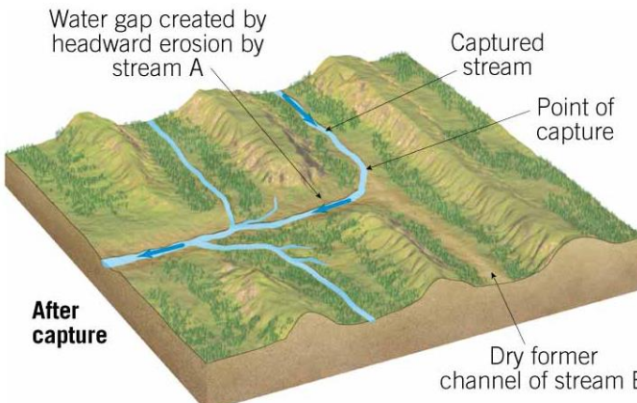
20. What is a water gap? Describe two ways by which a water gap may form in terms of antecedent stream versus superposed stream.
A water gap is a notch where a river cuts through a ridge that lies in its path
methods of formation:
- antecedent stream: stream existed before the ridge was formed
- Superposed stream: stream lets down upon a preexisting structure
21. What causes floods? Identify and describe four types of floods? What are some of the ways that floods can be controlled?
Happen when a stream is unable to accommodate dramatic increase in discharge
- Regional Floods
  - seasonal
  - Rapid melting of snow or heavy spring rains
- Flash Floods
  - rapid rise in water level and velocity
  - Mountainous areas are expecially susceptible
- Ice Jam Floods
  - frozen rivers
  - rising stream level breaks up ice
  - Water traped upstream overflows into the channel banks
- Dam Failure Floods
  - when dam or artificial levee breaks
  - a large flood can allow this to happen, when the levee breaks the water that is released is a flash flood
22. What are deltas? Where do deltas form? What are distributaries?
Sediment deposited right at entrance to larger body of water
form when sediment charged stream enters still waters and dumps the sediment load
23. What is an alluvial fan? How and where do alluvial fans form?

CHAPTER 17: GROUNDWATER
Terms to Remember:
Aquifer  permeable rock strata or sediment that transmit groundwater freely | Aquitard  impermeable layers (like shale) that prevent water movement | Artesian well  groundwater under pressure rises above the level of an aquifer  Two necessary conditions: aquifer must be inclinded with one end receiving water, aquifer confined with aquitards below and above | Cavern
Cone of depression | Darcy's law | Flowing artesian well | Gaining (effluent) stream
Geyser | Groundwater  water in the pore spaces or other openings within bedrock and regolith | Hot spring | Hydraulic gradient  based on slope of water table  water is slow moving under the surface, takes a long time to reach streams and such
Karst topography | Porosity | Nonflowing artesian well | Losing (influent) stream
Permeability | Sinkhole | Perched water table | Speleothem
Spring | Stalactite | Stalagmite | Water table
Well | Zebra | Zone of aeration | Zone of saturation

Concepts to know:
1. Sketch a cross section showing soil, regolith and bedrock. Indicate the unsaturated zone, saturated zone and water table. Describe the characteristics of the pore spaces (water versus air filled) between grains for both zones.
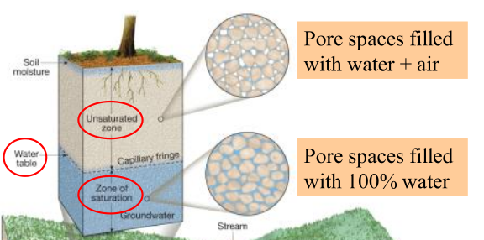
2. Sketch a cross section of the water table. Show how the water table is related to overlying topography. What features are found where the water table intersects the land surface? Also show how the height of the water table changes during alternating periods of drought and heavy rainfall.
When groundwater intersects the land you see
lakes, marshes, springs and streams

Height of the water table will change depending on how much rain there has been

3. What is the difference between rock porosity and permeability?
Porosity is the percentage of open spaces withing a given volume of rock
Sand has very high porocity

Permeability is the measure of how easily rock allows fluids to pass through it

So a rock can have high porosity (lots of open spaces) but not allow much water through (low permeability)

4. What is the difference between an aquifer and aquitard? Give two examples of rocks that make good aquifers? Give an example of a rock that is typically an aquitard.
Aquitards to not allow water to flow through (SHALE)
Aquifers are permeable rock that transmit groundwater freely (gravel, sandstone, porous limestone)

5. Describe characteristics of gaining and losing streams.
With a gaining stream, the water table is connected to the stream even across the land
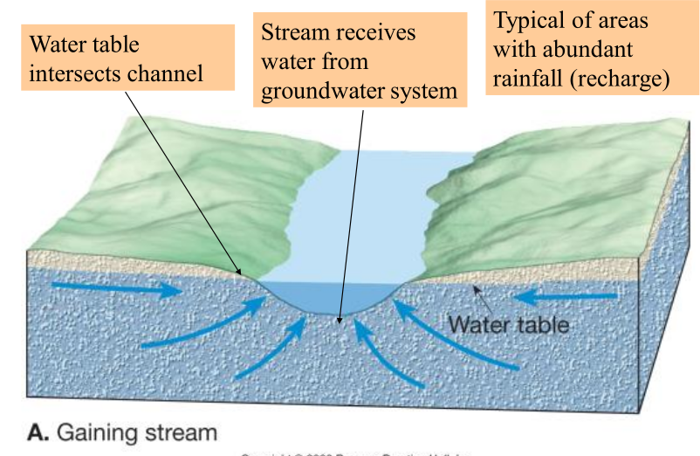
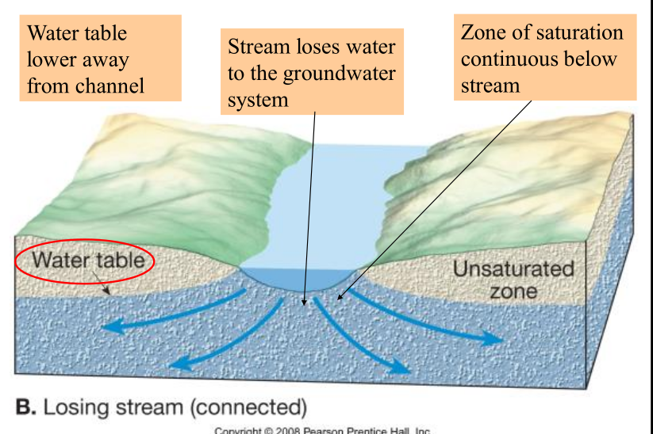
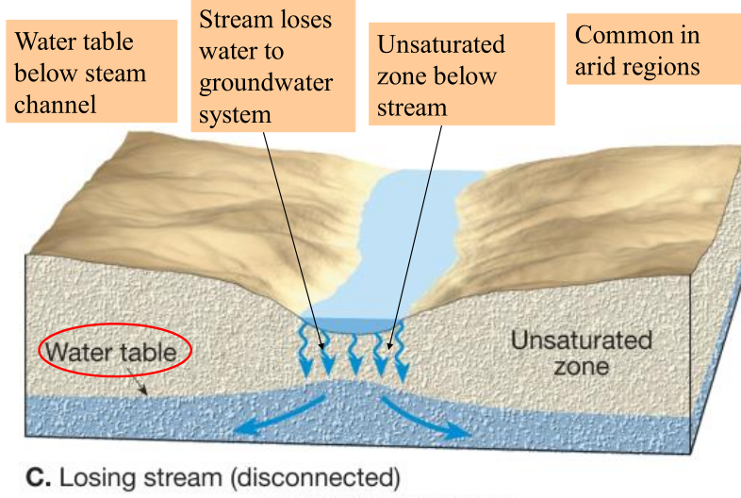
With a losing stream, the stream is not touching the water table over land and some times even under stream

6. What is the hydraulic gradient? Based on Darcy's law, how is the hydraulic gradient of the water table related to groundwater discharge?
The hydaulic gradient is the water table slope, determined by the elevation difference of the water table between two points.
Darcy’s Law: Q = k * A * [ (h1 – h2) / d ]
Discharge is proportional to the hydrolic conductivity of a surface, the cross sectional area of an aquifer and the hydrolic gradient.

7. What is a spring? Under what geologic circumstances do springs form?
Spring: A natural flow of water that occurs when ground water emerges at the ground surface
Springs mostly come from fractured lava, limestone and gravel

8. What is a well? What determines whether a well pumps water or not in terms of the water table? What is a cone of depression? What causes a cone of depression to form around a well?
A well supplies water when it penetrates the water table and enters the zone of saturation

9. Sketch a cross section of a confined aquifer that is inclined with one end serving as the recharge zone. Include the pressure surface, a flowing artesian well and non-flowing artesian well. What determines whether an artesian well is flowing or non-flowing.
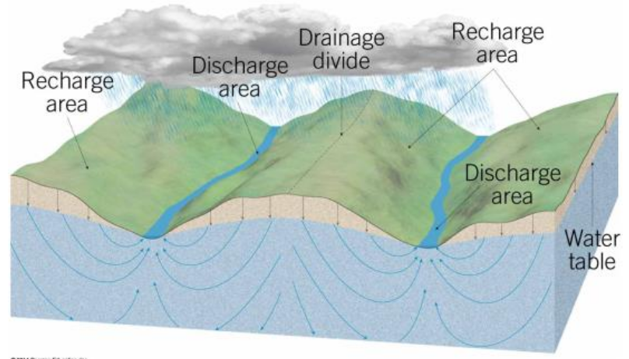
Non Fowing: pressure surface is below ground and water does not reach the surface
Flowing: Pressure surface above ground creates a flowing artesian well
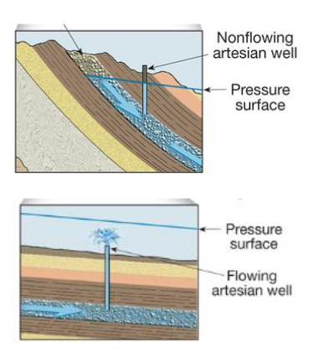
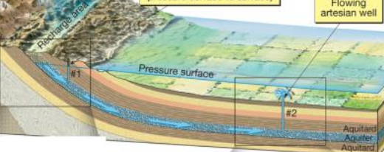
10. Identify two ways by which a water table can be lowered. What are some of the problems associated with withdrawing groundwater faster than it can be recharged? How does extensive irrigation affect groundwater supply and land subsidence?
Humans pulling out too much water. Causes land to sink, potholes and such

11. Describe three ways by which groundwater can be artificially recharged.
- Channel runoff in Urban area to basins (water seeps down and recharges aquifer)
- Spread biodegradable liquid wastes over land surface (the water percleates down)
- withdrawn water is pumped back into ground

12. Describe five sources of groundwater contamination. Sketch and describe how wells near the coast can be contaminated by saline seawater.
- Drainage from septic tanks (broken sewers and barnyards)
- agricultural posions
- highway salts
- buried hazardous wastes
- invading seawater on costal areas

13. What type of bedrock is generally associated with karst topography? What causes karst topography to form? Describe the various features associated with karst topography, including caves, sinkholes, disappearing streams and springs. How is the distribution of caves related to the water table?
Karst Topography comes about when slightly acidic ground water dissolves limestone bedrock
Happens with limestone bedrock

14. How does a stalactite differ from a stalagmite? What causes these cave features to form? What is travertine?
Stalactites grow down, like icicles
Stalagmites grow up, because mites jump
15. Under what geologic conditions do and geysers form? What are the eruptive stages of a geyser?
Geysers are intermittent hot springs, they occur where groundwater fills extensive underground chambers
groundwater is heated, expands to steam and then erupts with great force

CHAPTER 20: SHORELINES
Terms to Know and Define:
Backshore | Barrier island | Baymouth bar | Beach
Beach drift | Beach face | Beach nourishment | Berm  flat platform that marks change in slope of beach
Breakwater | Breakers | Coast | Coastline
Ebb current | Emergent coast | Estuary | Foreshore
Groin | Jetty | Longshore current | Marine terrace
Neap tide  lowest tides, occur when moon and sun are at right angles | Nearshore | Offshore zone | Sea arch
Sea stack | Seawall | Shore | Shoreline
Spit | Spring tide  largest tides.  When moon and sun are aligned and pull most on earth.  Full and new moons | Submergent coast | Surf zone
Tidal current | Tidal delta  created by currents that flow through inlets in barrier island | Tidal flats | Tide
Tombolo | Wave-cut cliff | Wave-cut platform | Wave height
Wavelength | Wave period | Wave refraction

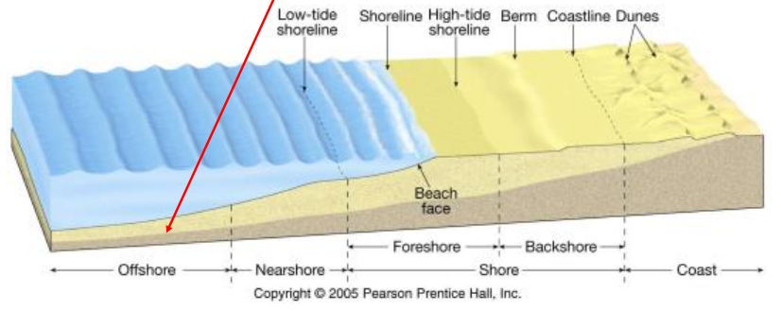
Concepts to know:
1. What causes waves to form? Describe the movement of water particles beneath waves.
Waves are created by wind blowing over the surface of the water

2. Describe the changes in waves in terms of velocity, wavelength, and wave height as they approach the coastline.
Waves far away from storm center are called Swells: Broad Rounded waves
Waves become higher as they approach the shoreline and start decreasing in velocity
Bottom part of waves starts dragging as they get closer and closer to the shore line
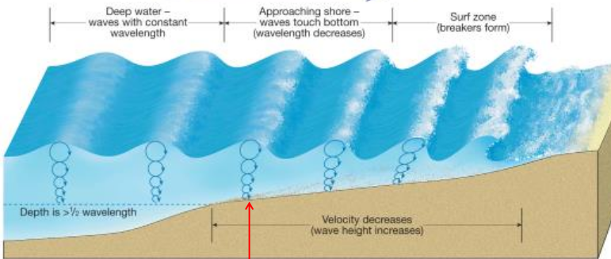
Waves turn into sharp crested features called breakers really close to the shore line
Breakers role forward and turn into a foamy, bubbly surface called surf
Beakers hit the beach and become swash. When then roll back down they are called backwash

3. Describe the behavior of waves as they hit the coast in terms of breakers, surf zone, swash and backwash.
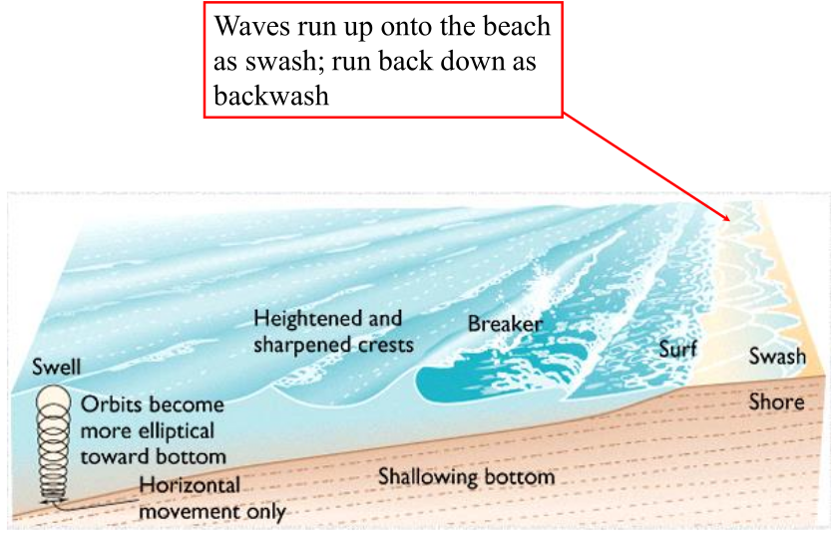

4. What is meant by wave refraction? What happens to the orientation of wave crests relative to the shoreline as the waves approach the shore?
Waves slow down and become parallel to beach as they approach the shoreline
5. Describe longshore currents and beach drift. How are these features related to wave refraction?
Longshore currents are created parallel to the coast but far off
Occur in shallow water parallel to the shore line
The longshore current cause particles to move in a particular direction along the beach

6. What causes tides? How do tides vary on a daily basis? How do tides vary throughout a month? What causes these changes in tides?
The sea rises and falls twice daily along many coastlines
Tides are because of the moon’s gravitational pull on earth. Tides happen on opposite sides of the earth at same time
7. What is a tidal flat?
8. What are the factors that influence the shape, size and configuration of a shoreline?
- Composition of rock or sediment
- whether coast is stable, shrinking or rising
- Currents
- Wave intensity
9. What are the depositional features related to beach drift and longshore currents? How does a spit differ from a baymouth bar? What is a tombolo? Describe a typical barrier island. Where is the lagoon located with respect to the barrier island?
- Spit
  - ridge of sand that projects from land ito the mouth of an adjacent bay
- Baymouth Bar
  - completley crosses a bay, closing it from the ocean
- Tombolo
  - ridge of sand that connects and island to the mainland
- Barrier Islands
  - long sandbars not connected to onshore beaches
  - constructed by longshore currents
  - Galveston is an example

Sides of Barrier Island
Seaward side: high energy wave and current action, straight shoreline, clean well sorted sand on beach
Lagoon Side: Quieter, low energy, ocasional storm washover deposits
Salt marshes and open bay, algal mats

10. What are some of the erosional features associated with coastal erosion? Describe the following: Wave-cut cliff, wave-cut terrace, sea cave, sea arch and sea stack.
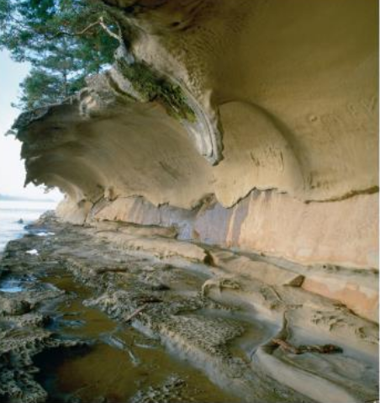
- Wave Cut Cliffs
  - Surf cuts into cliffs, rounded abcess

- Wave Cut Terrace
  - Uplift of wave cut platform
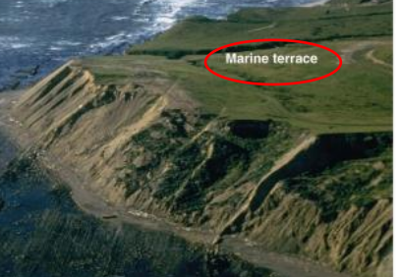
- Sea Cave
- Sea Stack
  - remenants of cave erosion
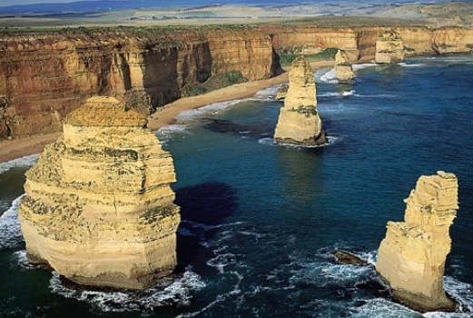
11. Describe each of the following man-made structures and its function: breakwater, seawall, groin, geotube and jetty. What is meant by beach nourishment?
Meant to deal with shore erosion
- jetty
  - two barriers perpendicular to the land, used to keep waves and sediment out of ship channel
- Groin
  - Single structure perpendicular to the land used to make deposition happen
  - Not always very effective
- Seawall
  - constructed behing beach to protect structures
- Breakwall
  - parallel to coast offshore
- Geotubes
  - used to keep vegetation line from eroding back
Beah nourishment is when you add sand

12. What are the characteristics of a submergent coast? Give an example of a modern submergent coast.
Results from coastal subsidence or sea rise
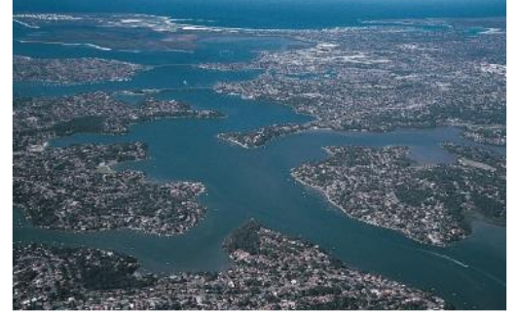
Irregular shorelines and downed river mouths
Atlantic Coast

13. What are the characteristics of an emergent coast? Give an example of a modern emergent coast.
Results from uplift / sea level fall
exposed wave cliffs and platforms
Pacific Coast
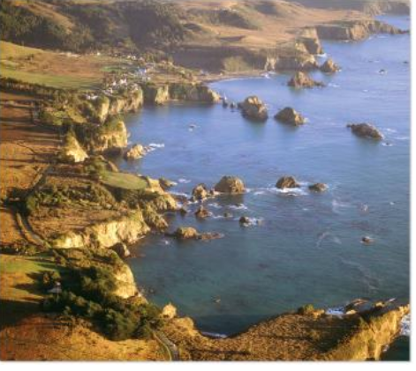
14. What is the ultimate coastal hazard?
Hurricanes
Needs:
- Warm ocean water
- converging lower level winds
- ascending humid air
- calm aloft winds
- trade winds steering it

