cochLP vector illustration, 20ms constant time window, on events only:

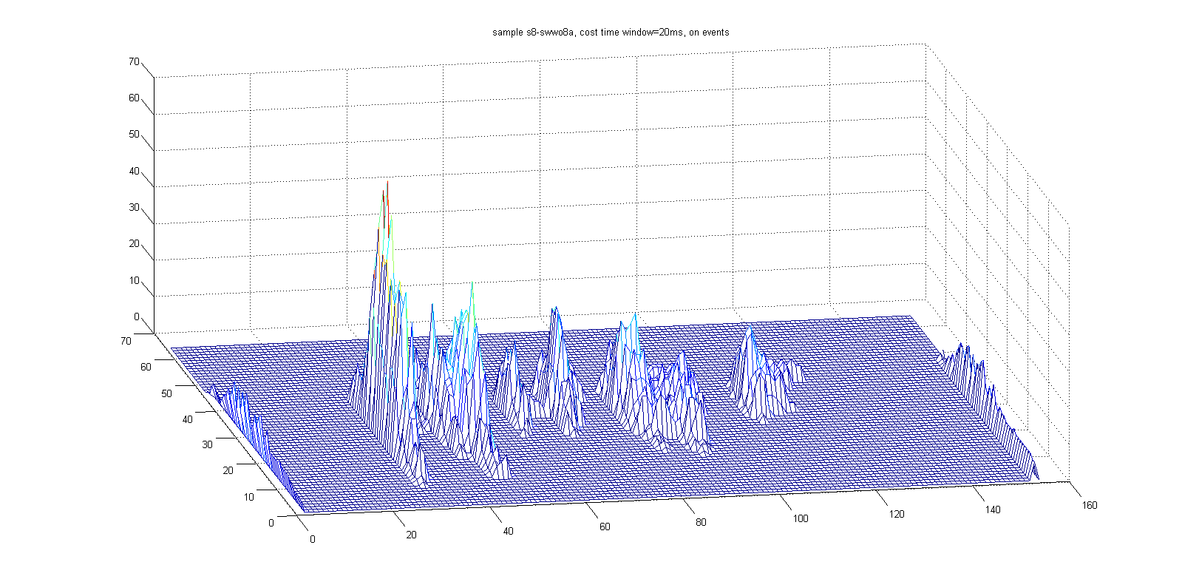

cochLP vector illustration, 20ms constant time window, off events only:

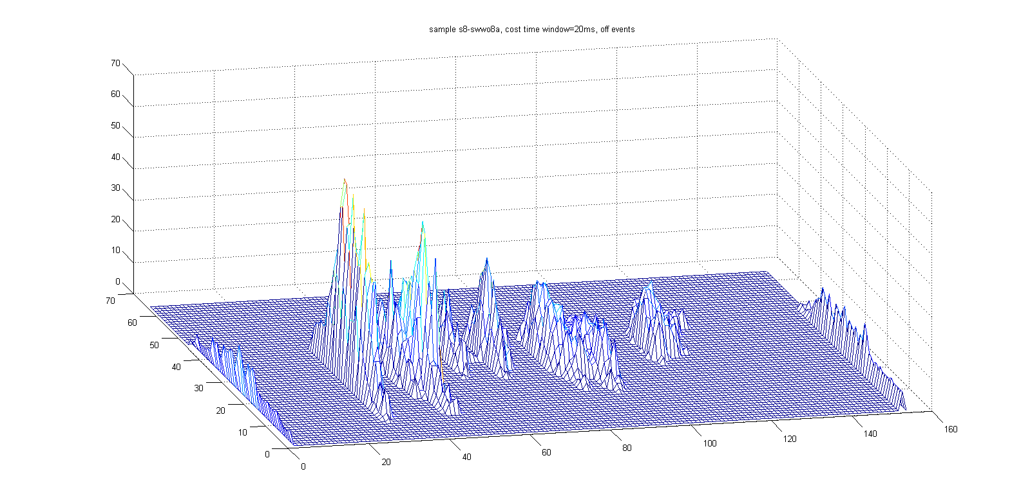

cochLP vector illustration, 20ms constant time window, on+off:

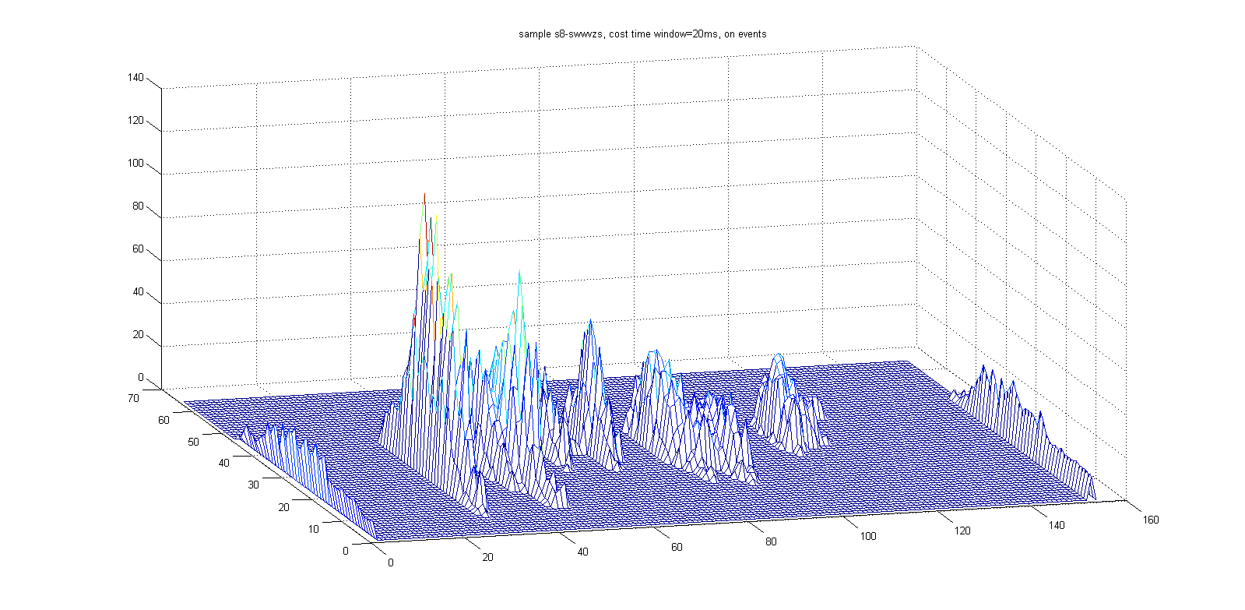

cochLP vector illustration, 20ms constant time window, on-off:

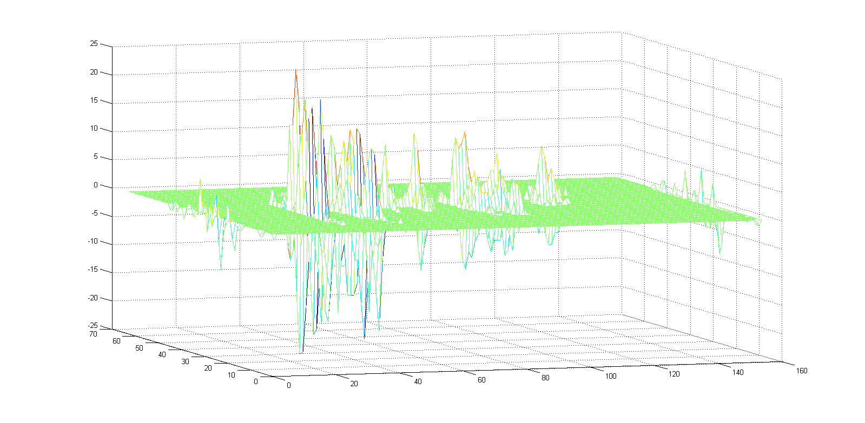

cochLP constant events, 66, on:

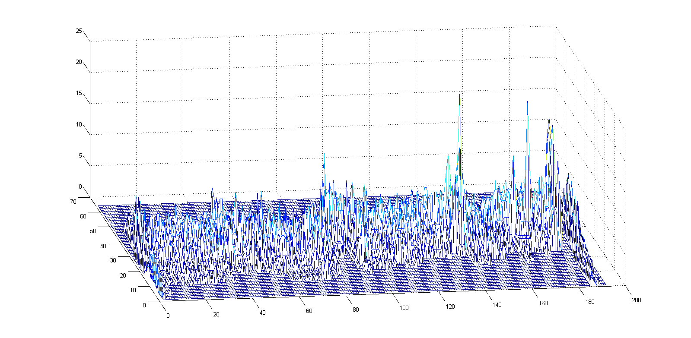

cochLP constant events, 66, off:

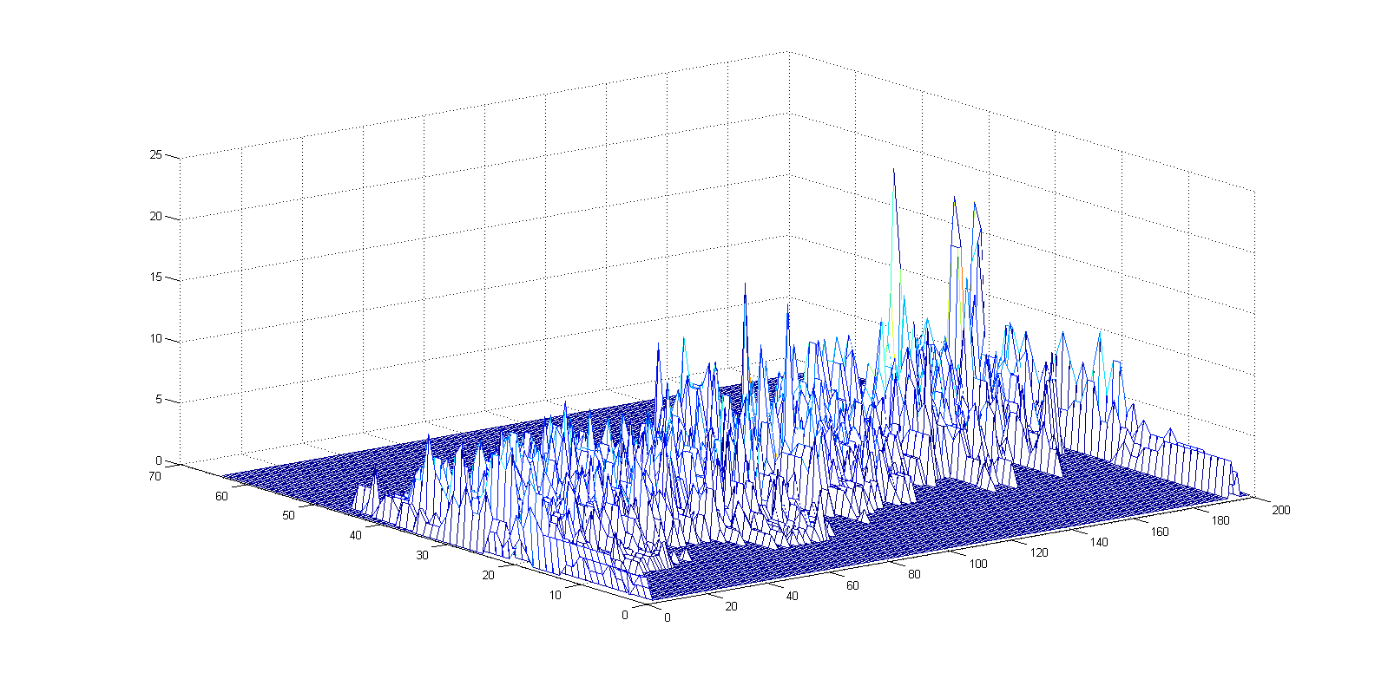

cochLP constant events, 66x2, on+off:

